
AOL Quest
November 6th – 8th
Camp Euchee, STSR
AOL Weekend of Fun Scout Skills
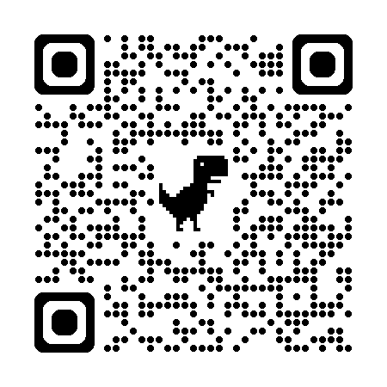
Experience troop life and the activities you can do when you join - like outdoor cooking, outdoor skills, knots, and more. AOLs will be put into patrols to spend the weekend as if they were on a troop campout and cook their meals in the campsites.
Throughout the weekend, AOLs can work on Outdoor Adventurer with their units.
On Saturday morning adventures, AOLs can choose Knife Safety and outdoor skills, or First Aid and High-Tech Outdoors.
They will choose one afternoon adventure: Champions for Nature, Estimations, Into the Wild, or Into the Woods.
Registration is limited so sign up now on the GCC website. Register at https://scoutingevent.com/773-AOLquest2026.
$30 for AOLs and $15 for adult partners. Includes 1 Saturday evening meal and Cracker Barrel. Participants have an option to purchase a Friday night meal of ravioli for $5.
All other meals are the responsibility of attendees. Please plan to bring food and cook in the campsites. If this is not an option, you may purchase a meal plan for an additional $20 to cover Saturday breakfast and lunch, and Sunday breakfast.
All participants MUST BRING A MESS KIT!
This event is for AOLs only with activities designed as an introduction to troop life. It is being held at the same time as WEBELOS Weekend. If parents have an AOL and WEBELOS scout, they can camp together.
There will be an AOL Crossover during the campfire. Please let Maria Randolph know if your AOL would like to participate.
Be sure to read the parent-leader guide for preparation notes, packing list, and how to prepare scouts for a great time.
If you have questions, please contact the Event Coordinator, Maria Randolph, program.chair@gulfcoastcouncil.org, 937-286-2289.

