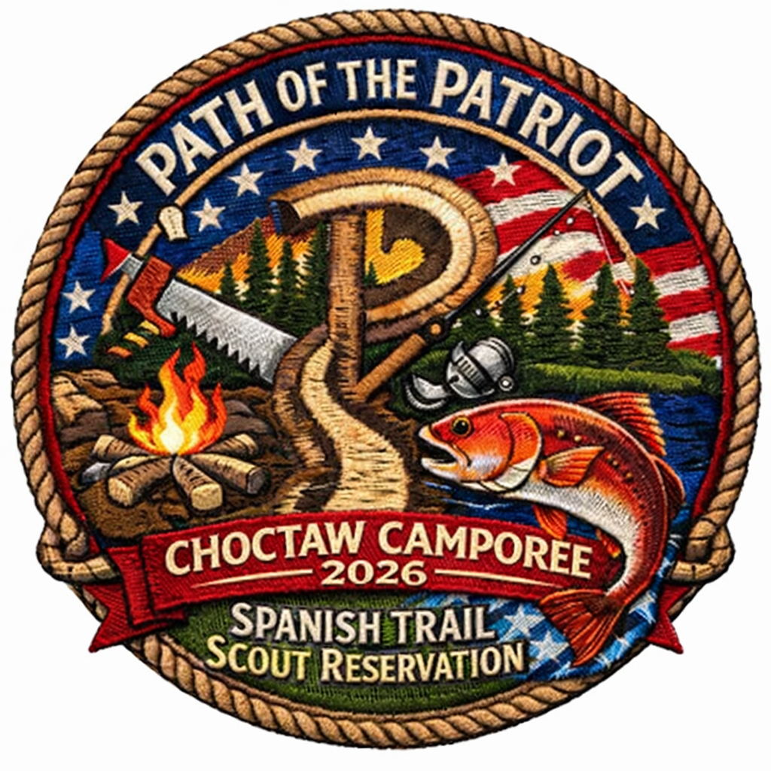

Path of the Patriot Camporee

Leader’s Guide revised 2/15/26
  - Gulf Coast Council – Spanish Trail Scout Reservation
March 6-8, 2026

Welcome
Welcome to the Path of the Patriot Camporee, hosted at Spanish Trail Scout Reservation. This camporee is designed to challenge Scouts through hands-on activities that explore patriotism, civic duty, leadership, outdoor skills, and American heritage. Units will rotate through themed stations that emphasize teamwork, problem-solving, and Scout spirit while enjoying the unique setting of Spanish Trail.
This guide provides unit leaders with all the essential information needed to prepare Scouts, plan logistics, and ensure a safe and successful weekend. Please review each section carefully to help your unit make the most of this unique Scouting experience.

Camporee Objectives
- Reinforce the values of citizenship, self-reliance, and stewardship through hands-on outdoor programming.
- Develop leadership and teamwork skills within Scout units.
- Foster an understanding of American heritage and patriotic service.
- Promote safe outdoor practices and respect for the environment.

Event Overview
The Path of the Patriot Camporee is a district-level Gulf Coast Council event designed for Scouts to live out the Scout Oath and Law through a variety of challenging activities. The theme of the event centers on patriotism, leadership, and outdoor skills, with each station crafted to provide practical learning and memorable experiences. Expected outcomes include improved self-reliance, enhanced teamwork, and a deeper appreciation for civic duty.

Preparation Checklist
- Complete all required registration forms for Scouts and adults.
- Review and distribute event schedules and station information to your unit.
- Ensure all medical forms and emergency contacts are up-to-date.
- Pack appropriate camping gear: tents, sleeping bags, weather-appropriate clothing, personal items, and Scout uniforms.
- Prepare patrol flags, notebooks, and activity supplies as indicated in the station descriptions.
- Bring unit first aid kits.
- Arrange transportation and confirm arrival/departure times with all participants.

Logistics
- Arrival: Units should arrive at Spanish Trail Scout Reservation between 5:00 and 8:00 PM on March 6^{th,} 2026. Follow posted signs for parking and unloading.
- Check-In: Leaders will check in at the designated registration area, submit Patrol rosters, and receive campsite assignments.
- Parking: Vehicles must remain in designated parking areas for the duration of the event.
- Departure: Units may depart after the closing ceremonies or on March 8th by 10:30 AM. Campsites must be inspected and cleared before leaving.

Station Descriptions
- Patriotism Challenge: Scouts participate in flag ceremonies, learn flag etiquette, and discuss the meaning of patriotism.
- Civic Duty Station: Interactive activities focused on community service and citizenship responsibilities.
- Outdoor Skills Station: Scouts practice fire building, shelter construction, and basic survival techniques.
- Leadership & Teamwork: Problem-solving games and scenarios that develop leadership and cooperative skills.
- American Heritage Trail: Scouts explore historical displays and complete heritage-themed challenges.

Safety Guidelines
- Review the Guide to Safe Scouting and ensure all activities comply with BSA safety standards.
- Emergency procedures will be reviewed at the Scoutmaster meeting. Leaders should familiarize themselves with the nearest first aid station and emergency exits.
- All medications must be stored and administered according to BSA policy.
- Report any incidents, injuries, or safety concerns immediately to camp staff.
- Maintain two-deep leadership and adhere to Youth Protection policies at all times.

Leadership Tips
- Encourage Scouts to take initiative and participate actively in each station.
- Model positive behavior and reinforce the Scout Oath and Law throughout the event.
- Support patrol leaders in organizing tasks and promoting teamwork.
- Monitor Scouts’ well-being and provide guidance as needed.
- Foster a supportive environment where every Scout feels included and valued.

Contact Information
- Camporee Chair: Jaime Johnson, Blueeyeshy1@yahoo.com, (850) 578-5413
- Gulf Coast Council Office: (850) 473-9945

Thank you for your leadership and commitment to Scouting. With your preparation and support, Scouts will have a rewarding experience on the Path of the Patriot. If you have any questions, please contact the camporee staff listed above.

“Prepared. Patriotic. Proven.”

This guide provides unit leaders with all the essential information needed to prepare Scouts, plan logistics, and ensure a safe and successful weekend.

2. Camporee Objectives

The Path of the Patriot Camporee is a Gulf Coast Council (GCC) Scouting event designed to reinforce the values of citizenship, self-reliance, and stewardship through hands-on outdoor programing at Spanish Trail Scout Reservation (STSR).

This camporee supports the mission of Scouting America and the Gulf Coast Council by providing Scouts with opportunities to live the Scout Oath and Scout Law in action.

Scout Oath & Law Integration

Throughout the weekend, Scouts will be challenged to demonstrate:

Duty to Country – Patriotism, respect for the flag, and civic knowledge

Helpful & Loyal – Patrol teamwork and service-based challenges

Thrifty & Clean – Responsible use of resources and Leave No Trace

Brave & Prepared – Fire building, emergency skills, and self-reliance

Every station intentionally ties back to one or more points of the Scout Law.

3. Event Overview
Event Name: Path of the Patriot Camporee
Location: Spanish Trail Scout Reservation
Audience: Scouts BSA Troops and AOLs (for the day)
Program Format: Patrol-based competition with rotating stations
Uniform: Activity uniform during events; field uniform for flag ceremonies
4. Camporee Theme
The Path of the Patriot theme focuses on historical and modern expressions of patriotism, including service, leadership, preparedness, and respect for country and community. Stations and activities will reflect these ideals while maintaining strong outdoor and Scouting skill components.
5. Camporee Schedule

FRIDAY EVENING
5:00–8:00 PM
SPL and Scoutmaster check-in at Henson Hall
Units proceed to campsites and prepare camp
9:00 PM
SPL / Scoutmaster meeting – Dining Hall
11:00 PM
Lights Out / Quiet Hours Begin
SATURDAY
6:00–8:00 AM
Break your fast and eat a good meal (unit campsites)
8:15 AM
Opening Ceremony & Flags – Parade Grounds
8:45–11:45 AM
Report to assigned activity sites (morning rotations)
11:45 AM–12:45 PM
Adjourn for Rest & Relaxation / Lunch at campsites
1:00–3:15 PM
Resume camporee activities (afternoon rotations)
4:00–5:00 PM
Patrol time / Prepare for evening activities
5:15 PM
Flagpole inspection (athletic field)
5:00–5:15 PM
All patrol score sheets turned in – Trading Post
6:00 PM
Scavenger hunt item turn-in – Trading Post
Cooking contest turn-in – Trading Post Picnic Area
7:30 PM
Campfire Program & Awards – Whipple
SUNDAY
6:30–8:00 AM
Break your fast at unit campsites
8:00–8:15 AM
Interfaith Religious Services – Whipple
9:00–11:00 AM
Camp breakdown and checkout

6. Program Stations & Challenges
All events are patrol-based unless otherwise noted. Patrols will rotate through stations according to the schedule provided at check-in.

🇺🇸 Patriot Foundations
Colors of Freedom
Location: Athletic Field
Description: Patrols construct a tall flagpole using lashings. Judges will evaluate height, stability, and proper flag etiquette. Discussion includes patriotism and respect for the flag.
Scoring (20 points):
Lashing technique & stability – 10 pts
Height achieved – 5 pts
Flag etiquette knowledge – 5 pts
Scout Law Focus: Loyal, Reverent, Obedient
Trail of Traditions
Location: Dining Hall
Description: Trivia challenge covering Spanish Trail Scout Reservation history, Scouting heritage, and council traditions.
Scoring (20 points):
Correct answers – 15 pts
Patrol teamwork & participation – 5 pts
Scout Law Focus: Trustworthy, Loyal
Heritage Watch
Location: Program Area
Description: Knowledge-based station aligned with American Heritage Merit Badge topics such as founding principles, symbols, and historic documents.
Scoring (20 points):
Knowledge accuracy – 15 pts
Patrol discussion & engagement – 5 pts
Scout Law Focus: Loyal, Helpful

🐟 Provisioning the Patriot
The Angler’s Post
Location: Waterfront
Description: Fishing competition focused on skill and ethics. Patrols earn points for the most fish caught and largest fish (per camp rules).
Scoring (20 points):
Most fish – 10 pts
Biggest fish – 5 pts
Proper fishing ethics & safety – 5 pts
Scout Law Focus: Thrifty, Clean
Cast for the Cause
Location: Parade Grounds (dining hall)
Description: Casting accuracy challenge using fishing and fly-fishing equipment. Includes practice and scored rounds.
Scoring (20 points):
Target accuracy – 15 pts
Safe equipment handling – 5 pts
Scout Law Focus: Careful, Obedient

Bounty of the Waters
Location: Ted Shed
Description: Identification of local fish species and discussion of which are edible, protected, or invasive.
Scoring (20 points):
Correct identification – 15 pts
Edibility & conservation knowledge – 5 pts
Scout Law Focus: Thrifty, Clean

🔥 Self-Reliance on the Trail
Spark of Independence
Location: Square Grounds
Description: Patrol tinder box inspection evaluating preparedness, organization, and appropriate materials.
Scoring (15 points):
Proper materials – 10 pts
Organization & explanation – 5 pts
Scout Law Focus: Prepared, Thrifty

Flame of Freedom
Location: Square Grounds
Description: Patrols build and light a fire using their tinder kits. Fire must be sustained long enough to complete a task.
Scoring (20 points):
Successful ignition – 10 pts
Fire structure & safety – 10 pts
Scout Law Focus: Brave, Careful

Frontier Feast
Location: Trading Post (Turn-in)
Description: Cooking challenge using a secret seafood ingredient. Patrols prepare and present a finished dish.
Scoring (25 points):
Taste & creativity – 10 pts
Proper food handling – 10 pts
Presentation – 5 pts
Scout Law Focus: Thrifty, Clean, Helpful
🐍 Know the Land
Sentinels of the Trail
Location: Across from Trading Post
Description: Identification of local snake species and discussion of safety, venomous vs. non-venomous, and proper response.
Scoring (20 points):
Correct identification – 15 pts
Safety knowledge – 5 pts
Scout Law Focus: Brave, Careful

Scout’s Eye Recon
Location: Trading Post Area
Description: STSR-specific scavenger hunt emphasizing observation, navigation, and teamwork.
Scoring (20 points):
Items found – 15 pts
Patrol cooperation – 5 pts
Scout Law Focus: Helpful, Trustworthy

🪵 Strength & Skill
Liberty Timberworks
Location: Pathfinder area
Description: Timed patrol event using a two-man crosscut saw to safely cut a log.
Scoring (20 points):

🧩 Final Challenge
The Redfish Run
Location: Camp-wide
Description: A large-scale clue hunt. Patrols solve challenges from previous stations to locate the hidden redfish.
Scoring (30 points):
Clues solved – 20 pts
Final discovery – 10 pts
Scout Law Focus: Trustworthy, Loyal, Helpful
Scout Law Focus: Brave, Obedient

7. Scoring & Awards
Patrols earn points at each station
Bonus points may be awarded for Scout spirit and uniforming
Awards presented for top patrols and special recognitions
Scoring details will be provided at check-in.

8. Campsites & Facilities
Campsites are assigned at check-in
Latrines and potable water are available throughout camp
Units are responsible for campsite cleanliness
Firewood policies will follow reservation guidelines

9. Equipment & Packing List
Unit Equipment
Patrol flags
Cooking gear and food
Water containers
First aid kit
Lanterns and camp lighting
Personal Gear
Tent and sleeping gear
Weather-appropriate clothing
Refillable water bottle
Field and activity uniforms
Notebook and pen

10. Health & Safety
All units must have current health forms for each Scout and Scouter per council policy. The leaders will retain forms in the campsite.
Two-deep leadership is required at all times
SYT guidelines will be strictly enforced

Emergency procedures will be reviewed at the leaders’ meeting
Spanish Trail Scout Reservation emergency contacts will be provided at check-in.

11. Leadership Responsibilities
Unit Leaders
Ensure Scouts are prepared and informed
Maintain discipline and safety
Attend the leaders’ meeting
Youth Leaders
Lead patrols through stations
Encourage teamwork and Scout spirit
Manage time and accountability

12. Registration & Fees
Registration details and deadlines will be announced separately
Fees cover program materials, awards, and facility use
Refund policies following council guidelines

13. Contact Information
For questions before the event, contact:
Camporee Director: Jaime Johnson 850-758-5414
Ranger and Medic James Odom 850- 357-2090
Reservation: Spanish Trail Scout Reservation

14. Final Notes
The Path of the Patriot Camporee is a district-level Gulf Coast Council event intended to challenge Scouts, strengthen leadership, and celebrate the values of Scouting and citizenship. Thank you to our volunteers, staff, and unit leaders for delivering a safe and meaningful program at Spanish Trail Scout Reservation.
Station Number Key
Station # Station Name Location
1 Youth round table Big Heart
2 Trail of Traditions Dining Hall
3 Heritage Watch Program Area
4 The Angler’s Post Waterfront
5 Cast for the Cause Parade Ground
6 Bounty of the Waters Ted Shed
7 Spark of Independence Square Grounds
8 Flame of Freedom Square Grounds
9 Frontier Feast Trading Post Picnic
Patrol time activity Colors of Freedom Athletic Field
Appendix A – Printable Patrol Scorecards

(One page per patrol – copy as needed)

Unit: ____________________ Patrol: ____________________

Station Max Pts Score Judge Initials
Colors of Freedom 20
Trail of Traditions 20
Heritage Watch 20
The Angler’s Post 20
Cast for the Cause 20
Bounty of the Waters 20
Spark of Independence 15
Flame of Freedom 20
Frontier Feast 25
Sentinels of the Trail 20
Scout’s Eye Recon 20
Liberty Timberworks 20
Redfish Run 30
Total Score: ____________

Appendix B – Station Staff Guides
General Staff Expectations
Wear staff identification at all times
Emphasize safety first, then scoring
Coach and encourage youth leadership
Tie activities back to the Scout Law

Appendix C – Leader Appendix
Leader Checklist
☐ Health forms collected
☐ Patrols briefed on schedule
☐ Two-deep leadership maintained
☐ Scouts understand scoring & expectations

Quiet Hours
11:00 PM – 6:00 AM

Uniform Guidance
Field uniform: flags, ceremonies
Activity uniform: program stations

Appendix D – Emergency Information
Emergency Procedures
Report all emergencies to the Camp Ranger/ Medic
Follow Spanish Trail Scout Reservation emergency protocols
A full STSR map will be provided at check-in.
Appendix E – Webelos Adaptation Notes

Adaptations

AOLS operate as patrols
Hands-on demonstrations preferred over timed events
Approved Stations for AOLs
Trail of Traditions
Heritage Watch
Scout’s Eye Recon
Bounty of the Waters

PATH OF THE PATRIOT CAMPOREE
Gulf Coast Council – District Level Event
Spanish Trail Scout Reservation

FRIDAY EVENING
5:00–8:00 PM
SPL & Scoutmaster Check-In – Henson Hall
Units set up campsites
9:00 PM
SPL / Scoutmaster Meeting – Dining Hall
11:00 PM
Lights Out / Quiet Hours Begin

SATURDAY
6:00–8:00 AM
Breakfast at Campsites (“Break your fast”)
8:15 AM
Opening Ceremony & Flags – Parade Grounds
8:45–11:45 AM
Morning Activity Rotations
11:45 AM–12:45 PM
Lunch & Rest – Campsites
1:00–3:15 PM
Afternoon Activity Rotations
4:00–5:00 PM
Patrol Time / Prep for Evening Events
5:15 PM
Flagpole judging -- Athletic field
5:00–5:15 PM
Score Sheets Due – Trading Post
6:00 PM
Scavenger Hunt Items Due – Trading Post
Cooking Contest Turn-In – Trading Post Picnic Area
7:30 PM
Campfire & Awards – Whipple

SUNDAY
6:30–8:00 AM
Breakfast at Campsites
8:00–8:15 AM
Interfaith Religious Service – Whipple
9:00–11:00 AM
Break Camp & Checkout

ACTIVITY ROTATION BLOCKS – MASTER SCHEDULE

Stations are numbered 1–9. “Free Time” indicates patrol break/travel buffer.

Patrol 1
Time Station
8:45–9:15 1
9:20–9:50 2
9:55–10:25 3
10:30–11:00 4
11:05–11:35 5
12:45–1:15 6
1:20–1:50 7
1:55–2:25 8
2:30–3:00 9
3:05–3:35 Free Time

