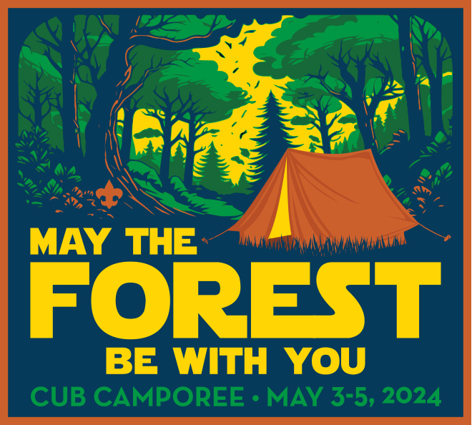

Welcome to the Spring 2024 Cub Camporee - “May the Forest Be With You!”

Registration is open and can be found at scoutingevent.com/763-cubspring24
Families should register individually for this event. Packs will be placed in campsites together. Coming Solo (not Han Solo) that is fine! We will group you with others. You can stay for one or two nights.

Schedule: Packs can arrive starting at 4 pm on Friday night and registration will also open Saturday morning at 8 am. See detailed schedule attached.

What to Bring: Each family should bring their own tent and all the essentials for camping. This event will happen rain or shine so Be Prepared!

Meals: The Pack is responsible for providing meals during the event. We will be offering lunch on Saturday in the dining hall for a nominal charge.

Trading Post: The Trading Post will be open Friday and Saturday!

Medical: Please make sure that all participants have their medical forms Part A and B.

Cub Camporee Schedule 2024

Friday, May 3rd
4:00 - 8:00 pm Registration open
7:00 pm Opening Campfire
10:00 pm Lights Out

Saturday, May 4th
8:00 am Registration Open
8:45 am Opening Ceremony on Parade Field
9:00 - 11:30 am Morning Activity Sessions
11:30 - 1:00 pm Lunch
1:30 - 4:00 pm Afternoon Activity Sessions
4:00 pm Campwide Activity on Parade Field
5:00 - 7:00 pm Dinner in Campsite
7:30 pm Closing Campfire
9:00 pm Star Gazing on Parade Field
10:00 pm Lights Out

Sunday, May 5th
9:00 am Vespers at Campfire Ring
10:00 am Service project
11:00 am Depart from Camp

Activities include:
Crafts
Fishing
Shooting Sports
Nature
Conservation
Rockets
And much more!!!

