CUB SCOUT LEADER’S GUIDE

NOLACHUCKEY DISTRICT

CHUCKWAGON DERBY
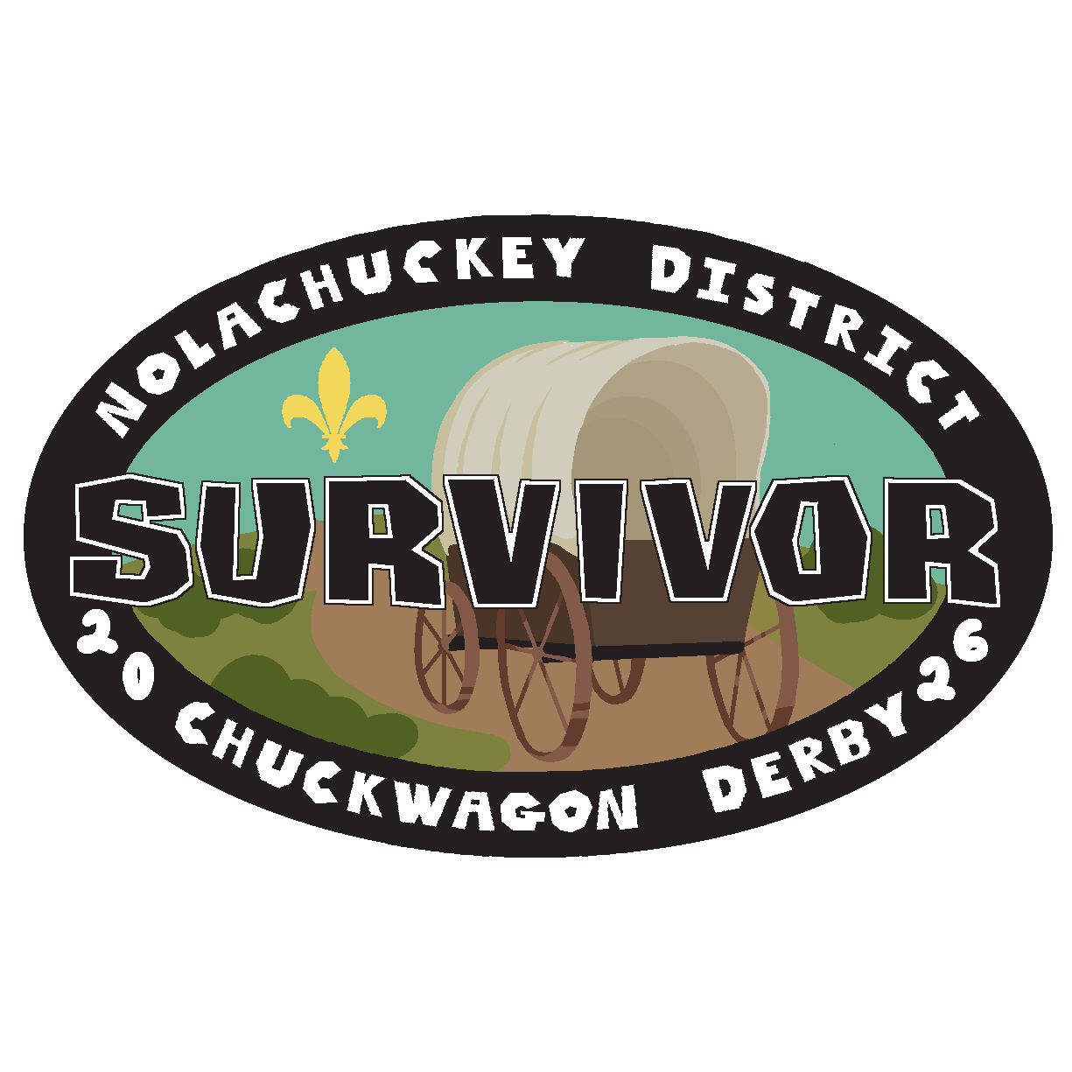
Saturday, April 25, 2026
9:00 A.M. - 4:00 P.M.
Baileyton Community Park

For more information contact:
Jessica Brown
(423)823-7681
CUB SCOUT
CHUCKWAGON DERBY

This event is open to all Cub Scouts in the Nolachuckey District.

The chuckwagons used are scaled-down models of the Old-West Chuckwagons. These chuckwagons can be built, or any existing pull-behind wagon (such as a Red-Flyer) can be used and converted into a chuckwagon. The design, materials, and workmanship can be creative.

Each Chuckwagon can have a maximum of ten Cub Scouts working as a team. If a Pack has more than ten Scouts participating, they will need more than one chuckwagon. Each wagon should have a mix of the age group of the Cub Scouts. Only Cub Scouts are allowed to compete. Registered Scouts who start on a chuckwagon must stay with that chuckwagon for the entire derby. Scouts may not switch chuckwagon teams.

Each Chuckwagon must have two adult volunteer guides to help the Chuckwagon Staff. These volunteers will assist the Staff at each challenge station as the Scouts pull into the challenge station. All information and some supplies will be furnished by the Chuckwagon Staff at each challenge station. Each challenge station will have a skill or physical task for the Scouts to do. Scouts must work together as a team to complete each challenge. NO ADULT IS ALLOWED TO ASSIST DURING CHALLENGES.

Scouts must pull and/or push their Chuckwagons to each challenge station in the order they are given. Trotting along are their volunteer guides, Pack leaders, parents, and families. Everyone is encouraged to cheer the Scouts on. The Wagon Guide is allowed to assist the Scouts if the wagon breaks down, but otherwise NO ADULT IS ALLOWED TO HANDLE THE WAGON.

Each challenge station will award points based on time, teamwork, Scout spirit, and following instructions. The Chuckwagon team with the highest score at the completion of all stations wins the Chuckwagon Bull Trophy for the year. This trophy is passed from winning Pack to winning Pack each year. (In case of a tie, there will be a tie-breaker challenge station.)

Registration sheets must be filled out before coming to the registration table.

CUB SCOUT CHUCKWAGON DERBY
INSTRUCTION SHEET

To All Wagons in the Chuckwagon Derby:

1. Read or listen to ALL instructions carefully. It may mean a higher score.

2. All Cub Scouts must be in proper clothing. Class B shirts and closed-toe shoes are recommended.

3. Registration begins at 9:00 A.M. and will continue until 9:30 A.M.

4. After registration, go immediately to the starting/inspection line.

5. Wagon inspection begins at 9:30 A.M.

6. Wagons MUST contain the following items to compete and complete the day:
- Each wagon must have a banner or sign displaying your unit and town.
- A Scout handbook for each rank participating on your wagon crew.
- Each Scout’s personal pack or bag containing their six essentials.
- Each Scout’s bag lunch. (Every person attending will need a bag lunch, but these do not have to be on the wagon. Only the wagon crew’s lunches need to be inside the wagon.)
- At least 1 blanket or towels large enough to have a picnic lunch on.
- A minimum of one extra bottle of water for each Scout.
- Rain gear for each Scout.
- A trash bag.
- Hammer.
- Screw Driver.
- Adjustable wrench.
- 6 - Plastic Solo Cups - 18oz. size.
- 3 - Tennis Balls.
- Roll of Twine - sufficient to tie sticks together
- Scissors.

7. Opening Ceremony will begin at 9:45 A.M.

8. Rain will not interfere with the Chuckwagon Derby - in case of thunderstorm, please follow the emergency plan and get the Scouts to shelter.
9. Each Chuckwagon crew will appoint one Scout to serve as “Wagon Master.” The wagon master is responsible for getting the scorecard completed at each challenge station.

10. After the opening ceremony, wagon crews will be given an instruction packet. This packet will contain your scorecard and the order in which your wagon crew is to visit each challenge station. Make sure you go to the correct challenge station each time. Going to the wrong challenge station will cost you valuable time and points.

11. At the sound of the starting horn, proceed directly to your first challenge station as indicated in your instruction packet. Give your scorecard to the Chuckwagon staff and listen carefully to their instructions.

12. When you arrive at a challenge station, you will be asked to complete a certain task or skill. ALL team members MUST participate and help. Any adult with you including your guides CAN NOT help.

13. At each challenge station, your success will be rewarded with points on your scorecard. DO NOT LOSE YOUR SCORECARD!!! It is the only one you will have. MAKE SURE TO TAKE YOUR SCORECARD WITH YOU WHEN YOU LEAVE EACH CHALLENGE STATION!!!

14. Each team will be given 20 minutes at each challenge station to complete the challenge. After 20 minutes, the horn will sound. You will have 5 minutes to collect your scorecard and proceed to the next challenge station.

15. The next horn sound will signal the beginning of the next 20 minutes for the next challenge station. If you are late arriving at your next challenge station, you will not have as much time to complete the challenge.

16. Approximately half-way through the challenge stations, the horn will sound twice signaling lunch time. Each Chuckwagon team should collect their scorecard from the challenge station they are currently at and find an area near the challenge station to spread their blanket or towels for their picnic. Lunch break is 30 minutes.

17. The next horn sound signals the beginning of your five minutes to travel to your next challenge station. Remember to clean up all trash from your picnic. A Scout leaves no trace. Points will be taken for any trash left behind.

18. There are 10 challenge stations. Your team must visit all 10 challenge stations in the proper order.

19. Be sure you have completed all challenge stations before heading back to the start/finish line.

20. Once you have completed all challenge stations and returned to the start/finish line, the wagon master should bring your completed score card to the registration table so that your final score can be tallied and recorded.

21. In case of a tie there will be one additional challenge station at the registration table. Winner takes home the trophy!

22. If you have any questions in regards to the rules or challenges, please ask any Chuckwagon Staff.

23. Spirit and teamwork are critical factors for the challenges. Chuckwagon yells, chants, or cheers are a great way to move from challenge station to challenge station and just might get you a higher score.

Please remember that Chuckwagon Derby is a family event so please have as many parents and family members as can come along to cheer our Scouts on!

***We also want to remind all participants that the rules of Good Sportsmanship apply to all Scouting events. We take the “Do Your Best” motto seriously. So please be supportive!

NOLACHUCKEY DISTRICT CHUCKWAGON DERBY
SCHEDULE OF EVENTS

9:00 A.M. Registration begins

9:30 A.M. Chuckwagon Inspections

9:45 A.M. Opening Ceremony

10:00 A.M. Chuckwagon Derby Begins!

12:15 P.M. Lunch

12:45 P.M. Chuckwagon Derby Continues

3:00 P.M. Scorecards turned in at registration table

3:30 P.M. Results/Closing Ceremony

CHUCKWAGON DERBY 2026
REGISTRATION FORM
ROSTER

This form must be filled out and turned in at time of registration.

Pack # _____________ Wagon # ______________

Wagon guide (adult volunteer) Name: ___________________________________

Wagon guide (adult volunteer) Name: ___________________________________

Wagon master (elected Scout) Name: ___________________________________

Wagon Crew (Youth) (print names) Current Rank
(include Wagon master)

1. ___________________________________ _________________

2. ___________________________________ _________________

3. ___________________________________ _________________

4. ___________________________________ _________________

5. ___________________________________ _________________

6. ___________________________________ _________________

7. ___________________________________ _________________

8. ___________________________________ _________________

9. ___________________________________ _________________

10. __________________________________ _________________

