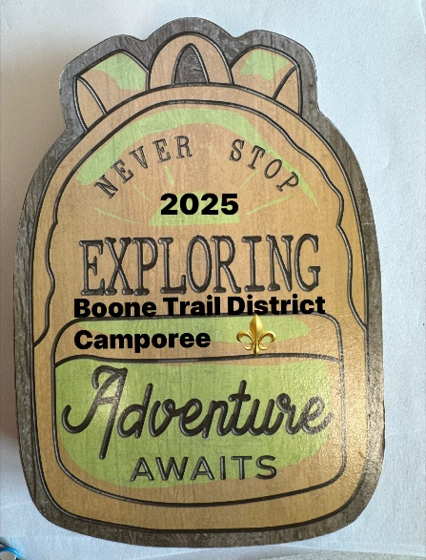

Boone Trail

District Camporee 2025

Adventure Awaits

Leader's Guide

Tipton Haynes State Historical Site

All Scouts, May 9-11, 2025

Dear Leader,

Enclosed is all the information that you will need to make your plans for the 2025 Boone Trail District Camporee.

Please note that this event is open to registered scouts and scout leaders and registered AOL cub scouts and leaders. Only AOL cub scouts can attend.

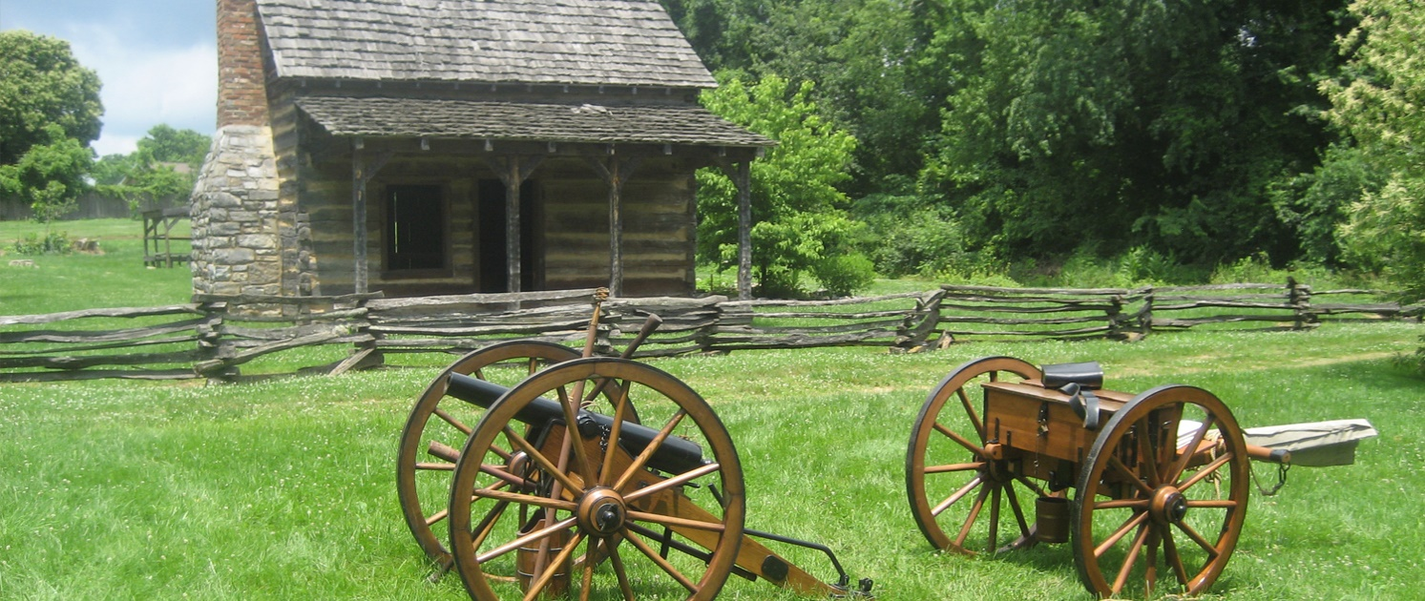

The theme for this District Camporee is “Exploring - Adventure Awaits”. You will see this theme in many of the things that we have planned for this event.

We have many exploring activities for our Scouts at this Camporee, all of which will develop, build, and expand on many of the scouting skills they have already learned and enjoy. Hopefully, we have added twists that introduce new topics and will keep the scouts interested in what we’re doing. I am looking forward to meeting all of you at this Camporee. We have lots of fun in store for you and your Scouts. If you have any questions, please call John Mayros at 731-707-3828. See you at camp!

Yours in Scouting,

Jerry Browning

General Info

Contacts

Address: Tipton Hayes State Historic Site

2620 South Roan St.  
 Johnson City, TN, 37601

**Event Contacts:**

Sequoyah Council Outdoor Programs

John Mayros

John.Mayros@scouting.org

731 707 3828

Jerry Browning

Camporee Chair

Jbrownig5886@gmail.com

423 579 4569

David Doan

Program Director

[daviddoan@hotmail.com](mailto:daviddoan@hotmail.com)

423 366 8091

General Info

Before Camp

**Before coming to camp, each troop should hold a scout orientation meeting. At this meeting, this Leader’s Guide should be discussed in its entirety.**

**REGISTRATION & FEE INFORMATION**

Dates:

Camporee, May 9-11, 2025

Fees:

Scouts: $20

Venture Crew: $20

Adult Leader / Parent: $20

N**O walk-ons.**

Each Troop and Crew must have two-deep leadership with appropriate gender leaders. Troops and Venture Crews from the same Chartered Organization may provide two-deep leadership that covers both units. Units that can’t provide two-deep leadership may discuss options with the Director of Safe Scouting Programs. All two-deep leaders must be 21 years or older and registered with Scouting America. Non-registered parents can accompany their Scout for day activities only, no overnight camping for non-registered adults.

Registered AOL Cub Scouts can attend as a patrol with their two-deep leadership, or attend as single AOL scouts, under two-deep leadership by the Council.

Fees for both youth and adults will include a Camp Patch.

To register, go to (include link to event on Sequoyah Council website. Your Troop/Venture Crew should register as a group rather than individually.

Check-in: Your unit must check in at the Tipton Haynes Visitor Center at the assigned time. Staff will escort everyone to their campsites. Each group will be given a camp tour.

Personal vehicles can unload at the camping area but then must be parked in the designated parking area (field).

General Info Before Camp

**Medical Forms**

Parts A&B of the official BSA Medical form must be fully completed for each youth and adult attending camp. If any Scout has medication needing refrigeration, make this known to the camp doctor at the time of check in.

Medical forms are available online: <https://www.scouting.org/health-and-safety/ahmr>

Registration How to Register Your Unit

Step 1: On your web browser, <https://scoutingevent.com/713-89580>

Step 2: Click on the green “register now” button in the upper right corner.

Step 3: Click on the log-in Button

Step 4: Enter your login credentials.

If you do not already have an account, click on the “create an account” button and create one.

Step 5: Enter the number of each category you will be registering for the Camporee.

Step 6: Click on the green “Register Now” button in the lower right corner.

Step 7: In the Registration Contact section, click on the red “Update Information” button

Enter all required information (the test will be red), then click on the “Save” button at the bottom right of the box.

Step 8: On each participant, click on the red “Update Information” button and enter all the required information (text will be in red). Then click on the save button at the bottom right of the box.

Step 9: Proceed to Check-out or the check-out tab at the top.

Step 10: Select your payment option and click on the green “Check out” button.

Step 11: Enter your billing information.

Step 12: Read and agree to the policies check box.

Step 13: Select and enter the payment information.

Step 14: Click on “Finalize Payment”

**Schedule**

|  |  |
| --- | --- |
| **Friday** | |
| 5:00 – 7:00 PM | Check In at Visitor Center |
| 5:00 – 8:00 PM | Camp Tour, Site Assignment, Set up Camp |
| 8:00 PM | Leaders meeting at the Visitor Center |
| 6:30 – 8:00 PM | Dinner provided by Troops |
| 9:00 PM | Camp Welcoming at Visitor Center |
| 10:00 PM | Lights Out |
|  | |
| **Saturday** | |
| 7:00 – 8:00 AM | Saturday Check In at Visitor Center |
| 7:00 – 9:00 AM | Camp Tour, Site Assignment, Set up Camp |
| 7:45 AM | Flag Raising |
| 8:00 – 9:00 AM | Breakfast by Troops |
| 9:00 – 12:00 PM | Morning Activities |
| 12:00 – 1:00 PM | Troop Lunch |
| 1:00 = 4:00 PM | Afternoon Activities |
| 5:00 PM | Flag Lowering |
| 6:00 PM | Camporee Feast |
| 7:00 – 9:00 PM | Arena Show |
| 10:00 PM | Lights Out |
|  | |
| **Sunday** | |
| 7:00 – 8:00 | Breakfast by Troops |
| 9:00 AM | Chapel Service |
| 10:00 AM | Break Camp, LNT |
| 10:00 – 11:00 AM | Check Out |
|  | |

**Camp Wide Activities**

**Reveille –** Reveille will be played Saturday and Sunday morning at 7:00 AM as a wakeup call for all campers.

**Taps -** All campers should be at their campsite at 9:45 each evening. Taps will be played at 10:00 PM and will be the start of quiet time. That means lights out, camp quiet, tent checks, etc.

**Flag Ceremonies –** The US Flag will be raised Saturday morning at 7:45 AM and lowered Saturday evening at 5:00 PM. Troops will be asked to volunteer to conduct the flag ceremonies.

**Chapel –** A universal service will be conducted at 9:00 AM on Sunday morning. Troops wishing to participate in or lead this service should inform staff by Saturday afternoon. Sunday dismissal from camp will allow individuals to attend their regular services at their home church.

**Leaders Meeting –** One leaders meeting will be held at 8:00 PM Friday to go over logistical and last-minute information prior to Saturday activities. A short briefing will be held with Saturday morning registrants. It is recommended that the Scoutmaster, Crew Advisor, Senior Patrol Leader, and Crew Chief attend this meeting.

**Recommended Flag Ceremonies**

It is recommended that standard color guard commands be used for flag ceremonies:

**Raising the Flag**

Caller: Camp Attention

Caller: Color Guard Advance

All members of the Color Guard advance toward the flagpole. Once positioned at the pole, they should untie the rope and attach the flag. Once the flag is attached the caller continues.

Caller: Camp Salute

On this cue, the color guard will raise the American flag quickly. Once the flag is up, the caller will continue.

Caller: Two

The color guard should tie the rope and form into a squad facing the caller.

Caller: Color Guard Post

The color guard should march back to the caller and halt.

Caller: About Face

Caller: Camp At Ease

**Lowering the Flag**

Caller: Camp Attention

Caller: Color Guard Advance

All members of the Color Guard advance toward the flagpole. Once positioned at the pole, they should untie the rope.

Caller: Camp Salute

On this cue, the color guard will slowly lower the American flag. Once the flag is down, the caller will continue.

Caller: Two

The color guard should retie the rope and fold the flag and form into a squad facing the caller.

Caller: Color Guard Post

The color guard will march back to the caller and halt.

Caller: About Face

Caller: Camp At Ease

**Recommended Camp Graces**

It is recommended that each Troop/Crew precludes their camp meals with grace to bless their food. Common Graces from Camp Davy Crockett are provided below.

**Camp Davy Crocket Grace**

Lord of our majestic hills, valleys, lakes and streams, Grant that we may fully appreciate Thy created beauty, and that we may eat and drink to Thy eternal glory. Amen

**Philmont Grace**

For food, for raiment, for fellowship and friendship, We thank the Oh Lord. Amen

**Packing List**

* Sleeping Bag or Quilt
* Sleeping Pad
* Pillow
* Tent
* Flashlight
* Camp Chair
* Foot Locker or Backpack
* Hat
* Rain Gear
* Jacket or Sweatshirt
* Clothes (Class B) appropriate for the weather
* Extra socks
* Toiletries
* Towel
* Insect Repellant
* Sunscreen
* Class A Uniform (for Flag Ceremonies)
* Water Bottle
* Sunglasses
* Pencil and Pad
* Day Pack
* Medications
* Medical Forms
* Cooking Gear for Troop
* Food for Troop
* Coolers, Water Containers

**Please remember to label all personal and troop gear**

**CPAP Machines and Medical Devices**

There will be no electricity in the campsites. Bring battery operated equipment.

**Refund Policy**

This event will follow the Council refund policy.

Full refund greater than 60 Days before event

Fifty percent refund 30- 60 days before the event

No refund 30 days or less for cancellation

Requests for refund must include the scouts or adult’s name, unit number, and reason for the cancellation.

Include site map.

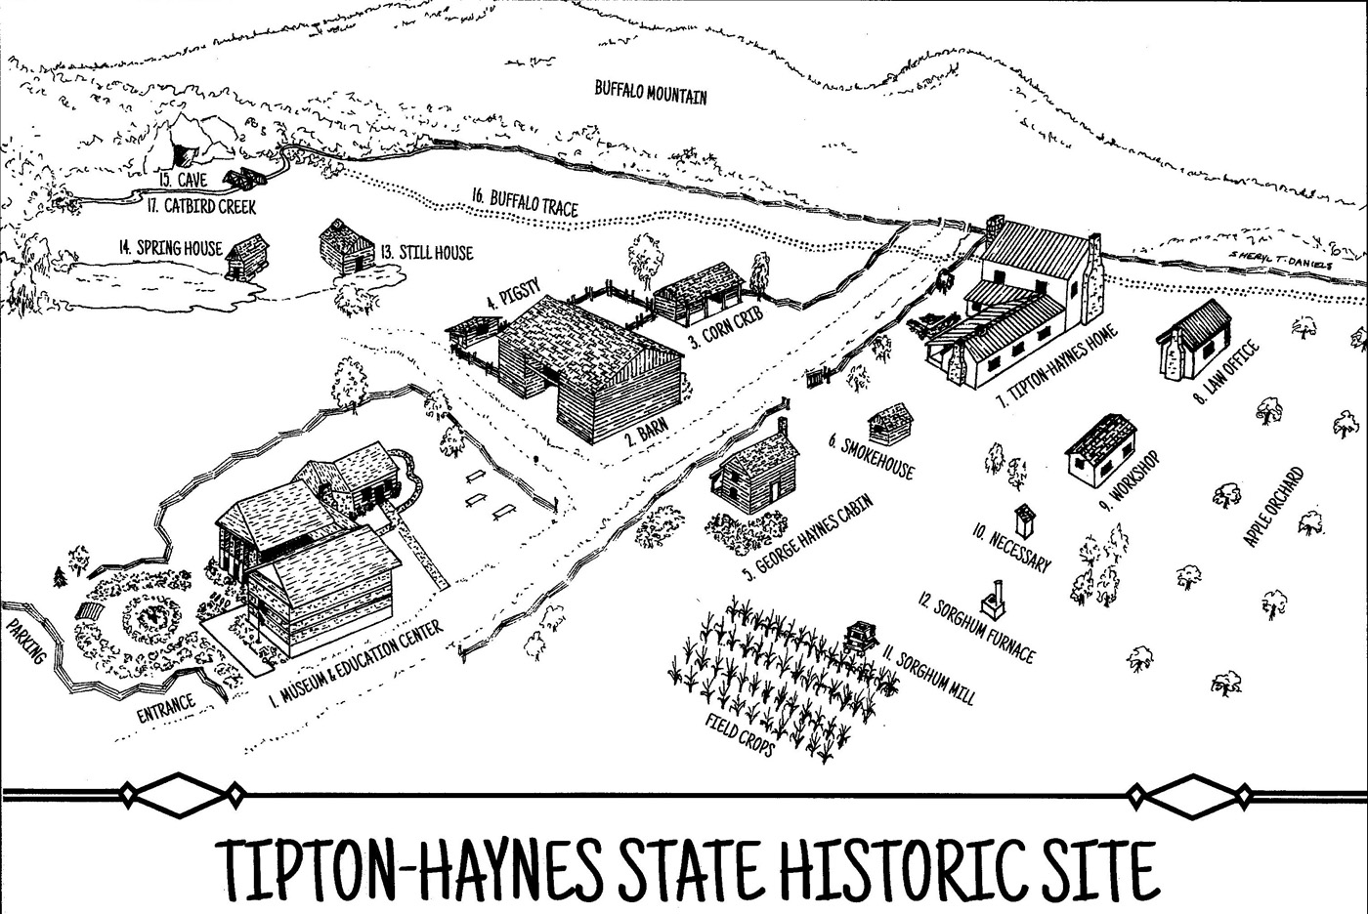

**Program Activities**

* **Camping & Cooking**
* **Hiking**
* **Guided Tour of the Historical Site**
* **Self-Guided Tour of Buildings**
* **Limestone Cave Tour**
* **Nature Trail**
* **Activity Boxes**
* **Field Games**
* **Colonial Era Exhibits**
* **Story Telling (Arena Show)**
* **Live Band (Arena Show)**
* **Campfire Skits (Arena Show)**