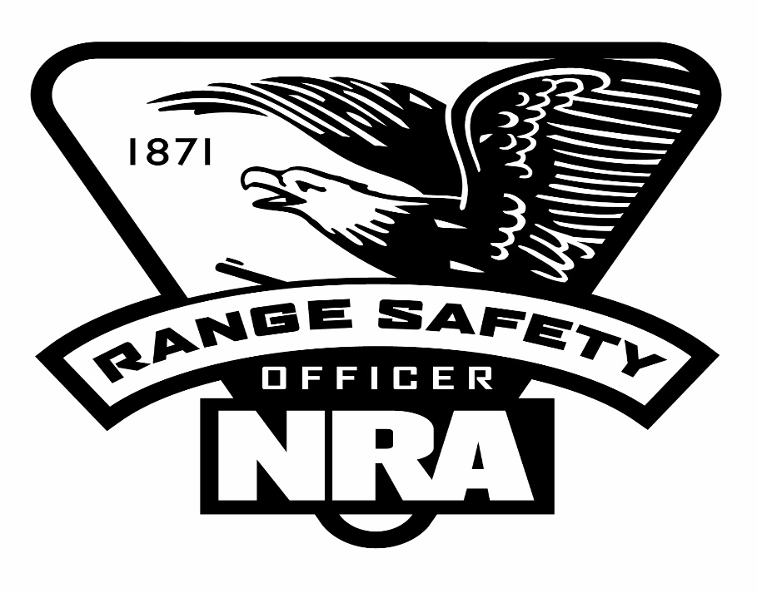

This is your chance to become a Range Safety Officer to help out your unit or the council by being able to run a Rifle or Shotgun Range. It will be your responsibility to keep the range safe and organized by enforcing the gun and range rules.

The course will be conducted on June 5, 2022 at RSR (Rainbow Scout Reservation) training Center.
The cost will be $90. Dollars and will run from 8:30:AM to 4:30PM
This cost for registered scouters only
Register at rainbow council.org, under June calendar, it is not necessary to be a scouter to register. Please bring lunch & pen. Minimum of 4 participants bring a friend.

For more information contact Don Cameron at 708 302 8566 or dcameron431@comcast.net

