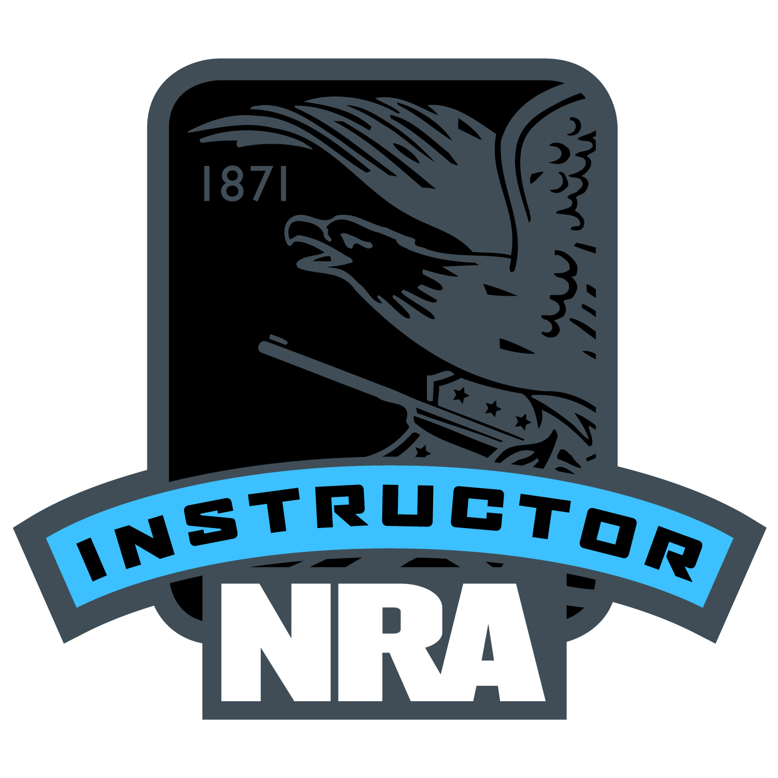

Boy scouts of America requires that you must be an NRA Certified Rifle Instructor therefore
Rainbow Council offers the following at a special rate: (open to all Scouters)
May 7th, 2022 Basic
May 8th ,2022 Instructor
The BSA requires all shooting sports merit badge councilors must be NRA certified Instructors
Rainbow Scout Reservation:
The costs are: Basic $ 90.00
Instructor $155.00
Tack both class your total cost will be $155.00
Registration is on Rainbow council.org, under calendar
For additional information contact Don Cameron:
dcameron431@comcast.net or 708 302 8566
(Minimum number of participants required 4)

