RSR 2024 Fall Camporee
Leaders Guide

Registration and Check-in Procedures
Registration Fee: $25 per Scout, $18 per Adult
Note: $3.50 paid on-site fee, for Shooting Sports (see details on page: )
Register at: https://scoutingevent.com/702-Fallcamporee
Registration fee is for a full weekend of theme-based activities and, of course, a patch! (Note Shooting Sports is an extra fee, paid on site: $3.50)
Female troops and female lone scouts must be accompanied by a registered female adult (that has completed YPT) to all stations of the event.

Check-In at the RSR Main Office
All units will check into the camporee at the Main Office. At this time, you will be assigned a campsite. If you sponsor a campsite please let us know ahead of time. Please be prepared to pay for all registration and late fees not yet submitted. We will verify the name and number of people in your unit attending the Camporee at the time of checkin.

Registration opens at 5:00pm and closes at 8:00 pm
- Each unit will be assigned a troop camping area by the camporee staff. Depending on the size of your unit, it is likely that you will have to share a site with another unit.
- Each Troop should have the appropriate medical forms (BSA Part A and B only) for each person attending the camporee.
- 1 trailer and tow vehicle per troop will be allowed at the campsite. For troops with no trailer, 2 vehicles will be allowed to unload but must be returned to the parking lot.

Location
The Camporee will be held at Rainbow Scout Reservation
Address: 2600 Winterbottom Rd, Morris, IL 60450
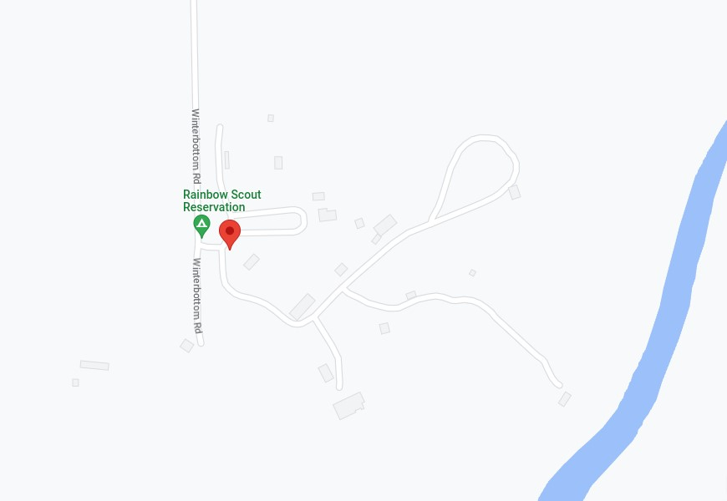
3
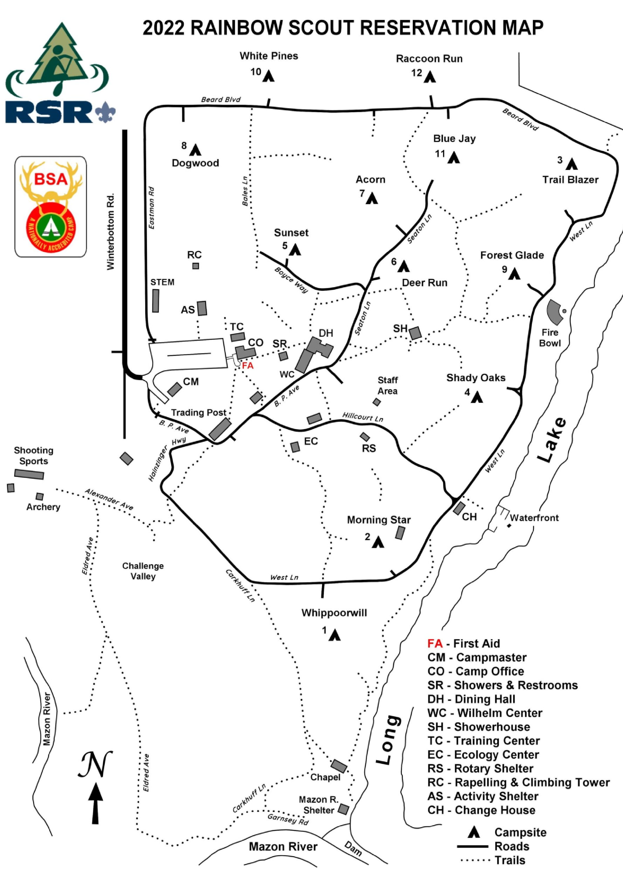

BSA Requirements for 2024 Fall Camporee
Medical Forms - Each registered Scout and Scouter must have a completed BSA Annual Medical Form Part A and Part B. Part C requiring a doctor’s exam is NOT required for this weekend event. These forms can be found online at http://www.scouting.org/scoutsource/HealthandSafety/ahmr.aspx
It is the responsibility of each Troop leader to maintain control of the medical forms for each of their Scouts participating, and to provide Camporee Staff with quick access in case of an emergency. If the Troop leader must leave the grounds for any reason they need to transfer control of the medical forms to another Troop leader or parent. The Part B of the medical form includes the BSA Talent Release Agreement. If any participant elects not to sign the Talent Release Agreement, please bring this to the attention of the Camporee Staff when you check-in. If there are any medical conditions or considerations for any of your Scouts, please bring these to the Camporee Medic’s attention at check-in as well.

Camporee General Information
Check-in- Friday October 11th, 2024 5:00pm to 8:00pm- The Scout Master and SPL should be the only Troop representatives at the check-in/registration table.
Campsites will be assigned and will be determined by the number of campers in each Troop. Space will need to be made to neatly park your Troop trailer within your designated campsite boundaries. Parking will be at a premium, so it will be more important than ever to rideshare and economize travel to include as few vehicles
as possible. Please be Kind and Courteous to our Staff as they do their best to facilitate a fun event for you and our Scouts. *Campsites do not have electricity. Those needing a CPAP machine should have a battery pack for night time usage. We can provide a location to charge these batteries if needed
Check-Out- Sunday October 13th, 2024 8:30 am until complete- Sunday morning will consist of your Troop’s breakfast, campsite clean- up and clearing by our Staff, and finally the check-out with Camporee Staff.
Scout Spirit - Scout Spirit is the core of everything we do as Scouts and Scouters. It is the embodiment of the Scout Oath and Scout Law, and it is the cheerful and positive attitude displayed in all we do. Scout Spirit is the beacon that sets Scouting apart from other youth programs. It is an expectation that all those participating in the 2024 RSR Fall Camporee be ambassadors of the Scouting Spirit in all we do.
Uniform - The uniform for Camporee is the BSA Field (Class A) Uniform. The Field Uniform is expected for all Scouts and Scouters during registration, flag ceremonies, and Campfire. The Activity (Class B) Uniforms can be worn during campsite set up, competition, and meals. Please stay aware of the weather for Camporee weekend. It is the responsibility of the Troops to have weather appropriate clothing on hand, as well as a change of uniform if necessary.
Troop/patrol Flags - Each Unit is expected to have their unit flag at the camporee to help identify their unit and show scout spirit. We encourage each unit to bring their flags to the opening and closing flags. Patrol flags should be brought to each station to identify your patrol(s). Flags should be presented in the campsite for easy identification.
Emergency Medical Service - Camporee does provide an event Medical staff for firstaid situations. Scout specific medication and other medical issues should be handled within the Troop. Each Troop should also be outfitted with a campsite first-aid kit that is centrally located.
Campfires - Campsites must use a pre-made fire area and are not allowed to create their own fire pits. All these sources of flame should be clearly marked and away from tent areas.
Campfire Program - There will be a campfire program on Saturday evening. Patrols are welcome to perform a skit, song, or story at the campfire. The skit, song, or story must follow the BSA campfire regulations and is required to be approved by the
camporee staff. (form for skit, song, or story submission below)
Cooking/Meals - It is each Troop’s responsibility to provide all meals and snacks for themselves. Each Troop is responsible for the cleanliness of their campsite and for packing away their own trash after the event.
Food Storage - Each Troop is responsible for supplying their own food and secure food storage containers.
Camporee Service - It is strongly encouraged that Scouters and older Scouts from each Troop help to contribute to the Camporee Program in some way, be it through
Honor Guard detail, event sponsorship, or volunteering for staff. This is YOUR Camporee and your help is greatly appreciated.
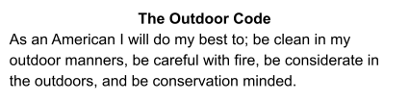
Site Management - We want to continue to show this appreciation by properly respecting the grounds during our event. This means staying within our area of operation and keeping it, and all its facilities, clean. BSA’s Outdoor Ethics should be embraced in full during the Camporee. We clean up after ourselves as well as police random litter as we come across it.
We would like to ask that we are vigilant regarding YPT, our Scouts utilizing the buddy system, our PLCs and adult Leaders having accountability of their Patrols/Troops, and All our attendees stayed in our assigned areas for the event.
Principles of Outdoor Ethics
- Plan ahead and be prepared
- Travel and camp on durable surfaces
- Dispose of waste properly
- Leave what you find
- Minimize campfire impacts
- Respect wildlife
- Be considerate of other visitors

FALL CAMPOREE OCTOBER 11-13TH AGENDA:
Friday, October 11th, 2024
- 5:00-8:00 pm: Arrival and Sign in
- 8:15 pm: SPL meeting @ activity shelter
- 8:30pm: Movie @ parade field
- 11:00 pm: lights out
Saturday, October 12th, 2024
- 8:30am: Flags @ parade field
- 9:00 am-11:30am: morning stations
- 11:30-1:00 pm: LUNCH @ campsites
- 1:00- 3:30pm: afternoon stations
- 4:15pm: FLAGS @ parade field
- 4:30 -7:30 pm: Free Time and Dinner
- 4:30-6:30pm: Goomba Shoot (Open Shoot: Requires $3.50 fee to be paid on site)
- 4:30-5:00 pm: staff vs. camper kickball @ activity field
- 6:15pm: Adult Leader Cook Off @ activity shelter
- 7:50pm: CAMPFIRE & awards @ fire bowl
- 11pm: lights out
Sunday, October 13th, 2024
- 8am: chapel service
- 8:30-10:30 am: checkout begins

BSA Camporee Events
** Each event description is an overview of the task to be completed in the competition. Target type and count as well as round count may be adjusted depending on the total amount of participants and the supplies on hand. If changes are made to any of the competitions from what is described below, the scoring card for said event will reflect the change, and the changes will be described in detail by the event staff before competition begins. We thank you for your understanding.
Cracker Barrels/Movie FRIDAY night- depending on weather that Friday night, scouts will have the choice on watching a movie. Scouts can bring camping chairs or blankets to sit on as the movie will be at the parade field. If rain is a possibility that night, there will be no movie but instead trivia at the activity shelter.

Toads Tunes- Scouts will walk around the chairs as the music plays. When the music stops, everyone tries to sit in a seat. Each round, a chair will be removed. The last person left sitting wins.
Bowsers Battle Ship- Scouts strategically place their ships on a life size grid. Each troop will take turns calling out coordinates, it’s like launching fireballs at Bowser’s minions. When a ship is sunk, the game continues until one troop sinks all of their opponent’s ships, winning the game. (Depending on the temperature, water balloons will we used. It will be an option whether the scout wants the water balloon popped over their head or not)
Luigi’s Ghosts- Scouts will be blindfolded while guided with words by another scout to navigate through a marked path. At the end, the player will have to knock down as many of Luigi’s ghosts as possible with rolling a ball while still blindfolded.
Mushroom Kingdom Telephone- scouts will be given different messages that they then have to travel through the warp pipes to their team to deliver the message in a certain amount of time
Mystery Box: troop against troop try to get as many mushrooms as they can in the other teams mystery box. While also trying to guard their own mystery box
Mario Maker Course: Troops will have to navigate through a course and complete different tasks such as restate the scout oath, fill out the missing word, and more as fast as they can through each level of the game
Rainbow Road- during the day, troops will be set times to decorate and create a box kart. A scout will then race on a track in the afternoon representing their troop to try and win the race and get a spiffy trophy, but watch out, there might be some challenges along the track. Troops will be given one box, construction paper, paper plates, markers, tape, scissors, streamers, and string to decorate. It is also highly recommended for troops to bring anything else from home to add onto their kart.
Goomba Shoot- During a designated time, scouts will be given the option to head down the shooting range to shoot at Goombas to win a SEPARATE award. (see special notes below)

Camporee 2024 Competition Scoring
Each Scout and Patrol is encouraged to participate in all the events to be able to achieve the maximum number of points. Every Troop should carry their Troop or patrol Flag with them to every competition, work as a team and involve each member of the Troop in all events to demonstrate their Scouting Spirit wherever they go. In all activities and challenges, every Scout should keep SAFETY FIRST as their first goal awards are based on the Patrol’s achievements based on the standards below.
Scoring will be based on how the patrol does at each event. There will be a score sheet given to each patrol at the start of the camporee. It is the responsibility of each patrol to hold on to their score sheet. Patrols must turn in the score sheet at the end of the activity period.

Fall Camporee Campsite Inspection
Unit #:________
Campfire  - Out or watched  - Safe distance from tents  - Properly marked  - Safety tools within area  Patrol Areas  - Clean  - Properly marked  - Organized  - Duty roster posted  - Tents set up correctly  - Personal gear stowed  General campsite  - Organized  - Clean  - First aid kit visible and marked  - Flags properly displayed  - Food stored properly  - Trash stored properly | Possible  - 20 - 20 - 20 - 10  - 70  Possible  - 15 - 10 - 20 - 10 - 15 - 10  - 80  Possible  - 20 - 20 - 15 - 10 - 10 - 10 - 85 | Score  _____ _____ _____  _____  Score  _____ _____ _____ _____ _____  _____  Score  _____ _____ _____ _____ _____ _____ | Subtotal  _______  Subtotal  _______  Subtotal  _______
 | Total- 235 | Total-_______
Site:________________

Goomba Shoot Notice!!
(Shooting Sports)
$3.50 ON-SITE “power-up”/”in-game” purchase

The Goomba shoot is a separate event, that will have it’s own award. Participation is heavily encouraged, but not required for the overall championship award for the weekend.
This $3.50 is NOT included in your event registration, this is an add-on “in-game” purchase.

Due to the costs of the shooting range, this event will carry an additional $3.50 cost, that is payable ON-SITE only. It will be paid in the trading post, which will include a pair of safety glass, cover the costs of the ammunition, maintenance of the range and equipment, and continue to support the training of our safety staff on the range.
Cash is preferred as charge may not be available at all times during the day, and EXACT change is also heavily encouraged.
For more details on Shooting Sports at RSR Please check out:
https://www.rainbowcouncil.org/day-camps-pt/shooting-sports

Leaders / Troop Cookoff
Special Ingredient to Use: PEACHES
Go for the victory and make the best dish you can using the special ingredient of Peaches. Be it canned or fresh, peaches should be a main ingredient in your dish.
The judges do not need an entire dutch oven worth of your dish, they just need enough for 5-6 samples, unless you think it is going to be so good they want to eat more.
A Scout is thrifty, please plan a dish, that is going to be enjoyed by many either other troops, your own unit, or staff.
Tasting will start promptly at 6:15, and we know everyone wants to server their hot dishes hot, and that will be taken into account with the scoring if yours happens to cool a bit before it is tasted. Dishes arriving AFTER 6:15, will be deducted 1 point for every 5 minutes (so if you are 1 minute late, you lose 1 point, if you are 6 minutes late, you lose 2, 11 minutes 3, etc). Tastings will continue till the last dish is tasted.
A last note from the Judges: Peach Cobbler. We all have had campout Peach Cobbler before. If you are brining Peach Cobbler to the tasting, remember, others may bring it as well… and there is only so much Peach Cobbler that can be enjoyed…. (our subtle way of saying it needs to be the best Peach Cobbler we have ever eaten, or be creative and try something new)
Categories

Camporee 2024 Campfire Submission Form

This form is to be used to submit each tall tale, song or skit that will be performed at the Saturday night campfire program. Use of Camporee theme is encouraged when deciding the basis for your skit/song but is not required. Participation is encouraged, and Patrols may perform multiple skits/songs. Use your imagination, have fun, and keep it Scout appropriate. Depending on the total number of submissions, not every skit/song may be able to be performed.

Unit #_________
Unit/patrol Name | Skit/song/story name | Approximate time
skit/song/story brief description:

Event score sheet
Unit/Patrol:
Game | Time (if needed) | Points | Score (+1 for patrol yell when entering)(-30seconds for timed) | Signature
Toads Tunes
Bowsers Battle Ship
Luigi’s Ghost
Mystery Box
Mushroom Kingdom telephone
Mario Marker Course
Rainbow Road
Units will arrive at their designated game area at the time that they are assigned. Once teams arrive, if they have a patrol yell they will say their patrol name and do their yell. If teams do this without being reminded they will earn one extra point. If teams don't have a patrol or a patrol yell they can make one up or let the staff there know.13

