
2026 PROGRAM SECTION

SUPPORT & HELP
(605) 342-2824
reservations@blackhillsbsa.org
www.camp.blackhillsbsa.org


2026 PROGRAM SECTION
PROGRAM SELECTIONS – Table of Contents
Contents
Camp Program Schedule 6
Program Blocks 6
Block A Program Selections ( Monday & Tuesday 9-11am ) 8
Merit Badges 8
Specialty Programs 8
High Adventure Programs (14 and older) Open to Adults 8
9
Block B Program Selections ( Monday & Tuesday 1-3pm ) 9
Merit Badges 9
Specialty Programs 9
High Adventure Programs (14 and older) Open to Adults 9
10
Block C Program Selections ( Thursday & Friday 9-11am ) 10
Merit Badges 10
Specialty Programs 10
High Adventure Programs (14 and older) Open to Adults 10
Merit Badges 11
Specialty Programs 11
High Adventure Programs (14 and older) Open to Adults 11
Block E Program Selections ( Monday Evening 7-9pm ) 12
Merit Badges & Classes 12
High Adventure 12
Open Programs 12
Specialty Programs 12
Block F Program Selections ( Tuesday Evening 7-9pm ) 13
Merit Badges & Classes 13
High Adventure 13
Open Programs 13
Specialty Programs 13
Block G Program Selections ( Thursday Evening 7-9pm ) 14
Merit Badges & Classes 14
High Adventure 14
Open Programs 14
Specialty Programs 14
15
Block H Program Selections ( Friday ) 15
Merit Badge Descriptions & Info 16
Archery ~ location SHOOTING RANGES (additional fee $5) 16
Art ~ location HANDICRAFT 16
Astronomy ~ location NATURE LODGE 16
Basketry – location HANDICRAFT (additional fee $15) 16
Bird Study ~ location NATURE LODGE 17
Camping ~ location OUTDOOR SKILLS AREA 17
Canoeing ~ location AQUATICS AREA 17
Environmental Science ~ location NATURE LODGE 18
Fire Safety ~ location OUTDOOR SKILLS 18
First Aid ~ location AQUATICS AREA 18
Fishing ~ location NATURE LODGE 18
19
Fly Fishing ~ location NATURE LODGE 19
Game Design ~ location HANDICRAFT 19
Geocaching ~ location OUTDOOR SKILLS AREA 19
Geology ~ location NATURE LODGE 19
20
Indian Lore ~ location OUTDOOR SKILLS AREA (additional fee $15) 20
Kayaking ~ location AQUATICS AREA 20
Insect Study ~ location NATURE LODGE 20
21
Metalwork ~ location HANDICRAFT (additional fee $15) 21
Mining in Society ~ location NATURE LODGE 21
Orienteering ~ location OUTDOOR SKILLS AREA 21
Pioneering ~ location OUTDOOR SKILLS AREA 21
Photography ~ location HANDICRAFT 21
22
Reptile & Amphibian Study ~ location NATURE LODGE 22
Offered During: D 22
Rifle Shooting ~ location SHOOTING RANGES (additional fee $7) 22
Shotgun Shooting ~ location SHOOTING RANGES (additional fee $15) 22
Signs, Signals & Codes ~ location OUTDOOR SKILLS AREA 22
23
Small Boat Sailing ~ location AQUATICS AREA 23
Offered During: A, B, C, & D 23
Soil and Water Conservation ~ location NATURE LODGE 23
Space Exploration ~ location NATURE LODGE (additional fee $12) 23
Swimming ~ location AQUATICS AREA 23
Weather ~ location NATURE LODGE 23
24
Wilderness Survival ~ location OUTDOOR SKILLS AREA 24
Wood Carving ~ location HANDICRAFT (additional fee $20) 24
HAWK Area – Flight, Glide, & Soar Programs 24
HAWK Programs – What Requirements Are Completed? 24
25
Specialty Programs Information 25
Duct Tape Merit Badge ~ location HANDICARFT 25
Chit & Chip’s Class ~ location OUTDOOR SKILLS AREA 25
Patch Trading ~ location PICNIC SHELTER 25
Medicine Mountain Hike ~ meet at PICNIC SHELTER 25
26
Flag Retirement Ceremony ~ location AMPHITHEATER 26
Dutch Oven Cooking ~ location OUTDOOR SKILLS AREA 26
Deadwood Gulch Paintball ~ location DEADWOOD GULCH 26
Expedition: Black Hills 27
28
Adult Training 28
Knot Masters ~ location OUTDOOR SKILLS AREA 28
Leave No Trace ~ location NATURE LODGE 28
Swimming & Water Rescue ~ location AQUATICS AREA 28
Paddle Craft Safety ~ location AQUATICS AREA 28
29
Life to Eagle Seminar 29
Mountain Fest 29
Theme Days At MMSR 29
Daily Camp Schedule 32
Signing Up for Program 33
Program Capacities 33
Switching Merit Badges 33
34
Blue Cards 34

2026 PROGRAM SECTION
PROGRAM SELECTIONS

Let’s be real…
The program is where it is at. A camp without a program is just another empty field or a quiet wooded area. A program is what breathes life into a camp and is what causes Scouts and Scouters to drive hours on end. Since 1976, we have been delivering exceptional opportunities to the youth and adults who have come through our gates.
Medicine Mountain is chock full of exciting program elements and opportunities that both Scouts and Scouters can take part in. From the exciting programs that our High Adventure base offers to our ATV program and our outstanding merit badge offerings, Medicine Mountain’s program is wide-ranging and is sure to deliver excitement to the youth and those adults, young at heart.
With 6 different high adventure programs, over 40 merit badges, adult training opportunities, evening program, & our Expedition: Black Hills, Medicine Mountain is ready to deliver an exciting program to your unit this summer in one of the most famous areas of our nation. The hills are alive with adventure, an adventure that is just waiting for your unit to grab it.
We’ll see you and your unit soon at the Medicine Mountain Scout Ranch & Adventure Base.
In Scouting,

Amber Schweigert
MMSR Camp Director MMSR Program Director

Camp Program Schedule
Medicine Mountain utilizes a block schedule for all the merit badges, high adventure, adult training, and specialty programs. Programs will either be assigned (1) one or multiple blocks.
For example, if a Scout chooses to take the canoeing merit badge in block A, he will attend his class Monday & Tuesday, 9:00 AM to 11:00 AM for a total instruction time of 4 hours. He will earn his merit badge, provided all the prerequisites are completed, in this time frame.
Most high adventure programs will span across two blocks: either blocks A&B or blocks C&D.
Our Paha Sapa high adventure program (backpacking) will require participants to spend either Monday or Thursday night out on the trail.

Program Blocks
Block | Day | Time Slot
A | Monday & Tuesday | 9:00 AM-11:00 AM
B | Monday & Tuesday | 1:00 PM-3:00 PM
C | Thursday & Friday | 9:00 AM-11:00 AM
D | Thursday & Friday | 1:00 PM-3:00 PM
E | Monday | 7:00 PM-9:00 PM
F | Tuesday | 7:00 PM-9:00 PM
G | Thursday | 7:00 PM-9:00 PM
2026 PROGRAM SECTION
PROGRAM SELECTIONS – Block Schedule Chart

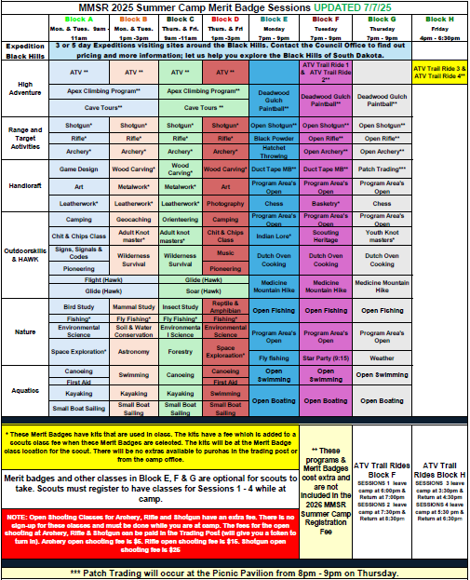

2026 PROGRAM SECTION
PROGRAM SELECTIONS – Block A

Block A Program Selections (Monday & Tuesday, 9-11 am)

Merit Badges
PROGRAM AREA | MERIT BADGE | PRE-REQUISITES
Aquatics | Canoeing | BSA Swimmer
Aquatics | First Aid | 1st class, 5a & 5b
Aquatics | Kayaking | BSA Swimmer
Aquatics | Small Boat Sailing | BSA Swimmer
Nature | Environmental Science | 4b & 5
Nature | Bird Study | 5, 8 & 11
Nature | Fishing
Nature | Mining In Society | 2 & 8a, b or c
Nature | Space Exploration | 5b & 7
Handicraft | Metalwork
Handicraft | Leatherwork
Handicraft | Art
Outdoor Skills | Chit & Chip’s
Outdoor Skills | Signs, Signals & Codes | 7
Outdoor Skills | Camping | 3, 4b, 5e, 7b, 9a, 9b & 9c
Outdoor Skills | Pioneering | 2a
Shooting Sports  Outdoor Skills | Rifle
Shooting Sports  Outdoor Skills | Shotgun | 13 years old
Shooting Sports  Outdoor Skills | Archery

Specialty Programs
PROGRAM NAME | SPECIAL NOTES/REQUIREMENTS
Flight Program | First Year Camper Program for scouts working on the Scout & Tenderfoot ranks. Covers blocks A & B.
Glide Program | First Year Camper program for scouts working towards the Second-Class rank. Covers blocks A & B.

High Adventure Programs (14 and older) Open to Adults
Climbing Program | Covers blocks A & B. Limited to 10. $75.00 fee.
Caving (14 & older) | Covers blocks A & B. Limited to 10.  $75.00 fee
ATV Program | Monday & Tuesday 9:00 AM to 11:30 AM. Limited to 8. $75.00 fee. Must sign a release form.
2026 PROGRAM SECTION
PROGRAM SELECTIONS – Block B

Block B Program Selections (Monday & Tuesday, 1-3 pm)

Merit Badges
PROGRAM AREA | MERIT BADGE | PRE-REQUISITES
Aquatics | Kayaking | BSA Swimmer
Aquatics | Small Boat Sailing | BSA Swimmer
Aquatics | Swimming | BSA Swimmer
Nature | Fly Fishing
Nature | Mammal Study | 5
Nature | Nature
Nature | Weather
Handicraft | Leatherwork
Handicraft | Wood Carving | 2a Totin’ Chip
Handicraft | Game Design | 6, 7
Outdoor Skills | Wilderness Survival | 5
Outdoor Skills | Paul Bunyan Award
Outdoor Skills | Geocaching
Shooting Sports | Archery
Shooting Sports | Shotgun | 13 years old
Shooting Sports | Rifle
ADULT LEADER CLASSES OFFERED DURING BLOCK B
Outdoor Skills | KNOT MASTERS PROGRAM | Knowledge of Basic Knots
Nature | LEAVE NO TRACE
Aquatics | PADDLE CRAFT SAFETY | BSA Swim Test

Specialty Programs
PROGRAM NAME | SPECIAL NOTES/REQUIREMENTS
Flight Program | First Year Camper Program for scouts working on the Scout & Tenderfoot ranks. Covers blocks A & B.
Glide Program | First Year Camper program for scouts working towards the Second-Class rank. Covers blocks A & B.

High Adventure Programs (14 and older) Open to Adults
Climbing Program | Covers blocks A & B. Limited to 10. $75.00 fee.
Caving (14 & older) | Covers blocks A & B. Limited to 10.  $75.00 fee
ATV Program | Monday & Tuesday 1:00 PM to 3:30 PM. Limited to 8. $75.00 fee. Must sign a release form.
2026 PROGRAM SECTION
PROGRAM SELECTIONS – Block C

Block C Program Selections (Thursday & Friday, 9-11 am)

Merit Badges
PROGRAM AREA | MERIT BADGE | PRE-REQUISITES
Aquatics | Canoeing | BSA Swimmer
Aquatics | Small Boat Sailing | BSA Swimmer
Aquatics | Kayaking | BSA Swimmer
Nature | Insect Study | 5, 6, 9, 10 & 13
Nature | Fly Fishing
Nature | Environmental Science | 4b & 5
Nature | Weather
Nature | Forestry
Handicraft | Metalwork
Handicraft | Leatherwork
Handicraft | Wood Carving | 2a Totin Chip
Outdoor Skills | Wilderness Survival | 5
Outdoor Skills | Orienteering
Outdoor Skills | Fire Safety | 6, 11, 12
Shooting Sports | Archery
Shooting Sports | Shotgun | 13 years old
Shooting Sports | Rifle
ADULT LEADER CLASSES OFFERED DURING BLOCK C
Outdoor Skills | KNOT MASTERS PROGRAM | Knowledge of Basic Knots
Aquatics | SWIMMING & WATER RESCUE | BSA Swim Test

Specialty Programs
PROGRAM NAME | SPECIAL NOTES/REQUIREMENTS
Soar Program | First Year Camper Program for scouts working on the Scout & Tenderfoot ranks. Covers blocks C & D.
Glide Program | First Year Camper program for scouts working towards the Second-Class rank. Covers blocks C & D.

High Adventure Programs (14 and older) Open to Adults
Climbing Program | Covers blocks C & D. Limited to 10. $75.00 fee.
Caving (14 & older) | Covers blocks C & D. Limited to 10.  $75.00 fee
ATV Program | Thursday & Friday 9:00 AM to 11:30 AM. Limited to 8. $75.00 fee. Must sign a release form.

2026 PROGRAM SECTION
PROGRAM SELECTIONS – Block D

Block D Program Selections (Thursday and Friday, 1-3 pm)

Merit Badges
PROGRAM AREA | MERIT BADGE | PRE-REQUISITES
Aquatics | Swimming | BSA Swimmer
Aquatics | First Aid | 1st class, 5a & 5B
Aquatics | Canoeing | BSA Swimmer
Aquatics | Small Boat Sailing | BSA Swimmer
Nature | Environmental Science | 4b & 5
Nature | Fishing
Nature | Soil & Water Conservation
Nature | Reptile & Amphibian | 8a or b, 9a or b
Nature | Space Exploration | 5b & 7
Handicraft | Art
Handicraft | Wood Carving | 2a Totin Chip
Handicraft | Photography | 6 & 7. Must bring a camera
Outdoor Skills | Camping | 3, 4b, 5e, 7b, 9a, 9b & 9c
Outdoor Skills | Chit & Chip’s
Outdoor Skills | Pioneering
Outdoor Skills | Music
Shooting Sports | Rifle
Shooting Sports | Shotgun | 13 years old
Shooting Sports | Archery
ADULT LEADER CLASSES OFFERED DURING BLOCK D

Specialty Programs
PROGRAM NAME | SPECIAL NOTES/REQUIREMENTS
Glide Program | First Year Camper program for scouts working towards the Second-Class rank. Covers blocks C & D.
Soar Program | First Year Camper program for scouts working towards the First-Class rank. Covers blocks C & D.

High Adventure Programs (14 and older) Open to Adults
Climbing Program | Covers blocks C & D. Limited to 10. $75.00 fee.
Caving (14 & older) | Covers blocks C & D. Limited to 10.  $75.00 fee
ATV Program | Thursday & Friday 1:00 PM to 3:30 PM. Limited to 8. $75.00 fee. Must sign a release form.

2026 PROGRAM SECTION
PROGRAM SELECTIONS – Block E

Block E Program Selections (Monday Evening, 7-9 pm)

Merit Badges & Classes
PROGRAM AREA | MERIT BADGE | PRE-REQUISITES
Nature | Astronomy
Handicraft  *Spoof Merit Badge | Duct Tape MB*
Handicraft  *Spoof Merit Badge | Chess
Outdoor Skills  *Spoof Merit Badge | Indian Lore

Open Programs
PROGRAM AREA | ACTIVITY | NOTES
Aquatics | Open Swim
Aquatics | Open Boating
Shooting Sports*  Tokens for open shooting are purchased at the trading post | Open Shotgun* ($25) | Scouts in shooting sports merit badges are prioritized.
 | Open Rifle* ($15) | Scouts in shooting sports merit badges are prioritized.
 | Open Archery* ($5)
Nature | Open Fishing

Specialty Programs
PROGRAM AREA | ACTIVITY | NOTES
Outdoor Skills | Dutch Oven Cooking
High Adventure | Deadwood Gulch Paintball | $10 Fee
HAWK | Medicine Mountain Hike

2026 PROGRAM SECTION
PROGRAM SELECTIONS – Block F

Block F Program Selections (Tuesday Evening, 7-9 pm)

Merit Badges & Classes
PROGRAM AREA | MERIT BADGE | PRE-REQUISITES
Nature | OPEN AREA
 | Star Party (Starts at 9:15 pm)
Handicraft  *Spoof Merit Badge | Duct Tape MB*
Handicraft  *Spoof Merit Badge | Basketry
Outdoor Skills  *Spoof Merit Badge | Scouting Heritage

High Adventure
ACTIVITY | REQUIREMENTS | COST
ATV Trail Ride 1  6:00 PM - 7:00 PM | Participants must have completed our ATV program for Blocks A or B, or have been through the ASI ATV course at another camp, and have a certificate of training. | $30
ATV Trail Ride 2  7:30 PM – 8:30 PM | Participants must have completed our ATV program for Blocks A or B, or have been through the ASI ATV course at another camp, and have a certificate of training. | $30

Open Programs
PROGRAM AREA | ACTIVITY | NOTES
Aquatics | Open Swim
Aquatics | Open Boating
Shooting Sports*  Tokens for open shooting are purchased at the trading post | Open Rifle* ($15) | Scouts in shooting sports merit badges are prioritized.
 | Open Shotgun* ($25) | Scouts in shooting sports merit badges are prioritized.
 | Open Archery* ($5)
Nature | Open Fishing

Specialty Programs
PROGRAM AREA | ACTIVITY | NOTES
Outdoor Skills | Dutch Oven Cooking
High Adventure | Deadwood Gulch Paintball | $10.00 Fee
HAWK | Medicine Mountain Hike
Amphitheater | Flag Retirement Ceremony | In the Amphitheater, starting at 9:15 pm
Nature | Star Party | 9:15 pm

2026 PROGRAM SECTION
PROGRAM SELECTIONS – Block G

Block G Program Selections (Thursday Evening, 7-9 pm)

Merit Badges & Classes
PROGRAM AREA | MERIT BADGE | PRE-REQUISITES
Nature | Geology
Handicraft | Chess
Outdoor Skills | Indian Lore

Open Programs
PROGRAM AREA | ACTIVITY | NOTES
Aquatics | Open Swim
Aquatics | Open Boating
Shooting Sports*  Tokens for open shooting are purchased at the trading post | Open Shotgun* ($25) | Scouts in shooting sports merit badges are prioritized.
 | Open Rifle* ($15) | Scouts in shooting sports merit badges are prioritized.
 | Open Archery* ($5)
Nature | Open Fishing
Handicraft | Patch Trading

Specialty Programs
PROGRAM AREA | ACTIVITY | NOTES
Outdoor Skills | Wilderness Survival Overnight
Outdoor Skills | Dutch Oven Cooking
High Adventure | Deadwood Gulch Paintball | $10.00 Fee
HAWK | Medicine Mountain Hike
Adult Leader Hub | Life to Eagle Seminar | Starting at 9:15 pm

2026 PROGRAM SECTION
PROGRAM SELECTIONS – Block H

Block H Program Selections (Friday)
ACTIVITY | REQUIREMENTS | COST
ATV Trail Ride 3  4:00 PM – 5:00 PM | Participants must have completed our ATV program for Blocks A or B, or have been through the ASI ATV course at another camp, and have a certificate of training. | $30
ATV Trail Ride 4  5:30 PM – 6:30 PM | Participants must have completed our ATV program for Blocks A or B, or have been through the ASI ATV course at another camp, and have a certificate of training. | $30

2026 PROGRAM SECTION
PROGRAM SELECTIONS – Merit Badges

Merit Badge Descriptions & Info
Listed in this part of the guide are descriptions of all the merit badges. Full merit badge requirements can be viewed by visiting the following website on Scouting.org;
www.scouting.org/programs/boy-scouts/advancement-and-awards/merit-badges/
and scrolling down and clicking on the merit badge that you want to view the requirements for. Medicine Mountain Scout Ranch does not endorse the use of merit badge worksheets found on third-party websites. These worksheets are not updated regularly and can cause issues at camp.

Archery ~ location SHOOTING RANGES (additional fee $5)
Archery is a fun way for Scouts to exercise minds as well as bodies, developing a steady hand, a good eye, and a disciplined mind. This merit badge can provide a thorough introduction to those who are new to bow and arrow - but even for the experienced archer, earning the badge can help to increase the understanding and appreciation of archery.
Offered During: A, B, C, & D

Art ~ location HANDICRAFT
This merit badge concentrates on two-dimensional art, specifically drawing and painting in various media, including an introduction to design applications in the fields of graphic arts and industrial design, history and design principles, and how these fields relate to fine art.
Prerequisites: 6
Offered During: A & D

Astronomy ~ location NATURE LODGE
In learning about astronomy, Scouts study how activities in space affect our own planet and bear witness to the wonders of the night sky: the nebulae, or giant clouds of gas and dust where new stars are born; old stars dying and exploding; meteor showers and shooting stars; the moon, planets, and a dazzling array of stars.
Prerequisites: Requirements 5b & 6b
Offered During: B (Scouts Must Attend the Star Party to complete the badge)

Basketry – location HANDICRAFT (additional fee $15)
Basketry is a handy skill for a Scout. A basket can be a sturdy companion on campouts, carrying clothes snugly and efficiently, holding potatoes and corn for roasting over a campfire, or carrying the day's fishing catch back to camp for dinner. Baskets and basket-weaving projects also make great gifts for family and friends.
Offered During: F
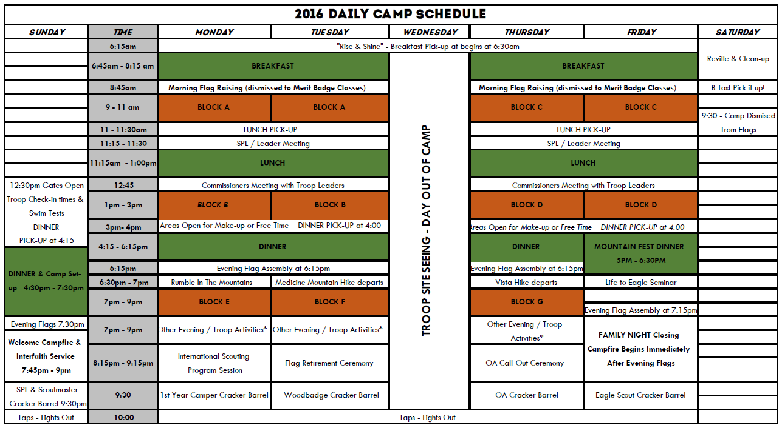
2026 PROGRAM SECTION
PROGRAM SELECTIONS – Merit Badges

Bird Study ~ location NATURE LODGE
Birds are among the most fascinating creatures on Earth. Many are beautifully colored. Others are accomplished singers. Many of the most important discoveries about birds and how they live have been made by amateur birders. In pursuing this hobby, a Scout might someday make a valuable contribution to our understanding of the natural world.
Prerequisites: Requirements 5 (bring field notebook to camp to complete 6), 8, 11
Offered During: A

Camping ~ location OUTDOOR SKILLS AREA
Camping is one of the best-known methods of the Scouting movement. When he founded the Scouting movement in the early 1900s, Robert Baden-Powell encouraged every Scout to learn the art of living outdoors. He believed a young person able to take care of himself while camping would have the confidence to meet life's other challenges, too.
Prerequisites: Requirements 3, 4b, 5e, 7b, 9a, 9b, 9c.
Offered During: A

Canoeing ~ location AQUATICS AREA
For several centuries, the canoe was a primary method of travel for explorers and settlers. Today, it remains an important part of the wilderness experience and an enjoyable leisure activity that teaches communication, teamwork, and physical fitness.
Prerequisites: BSA Swimmer Required. Swim tests are required to be taken in our lake due to the cold temperatures. Our lake averages 50-55 degrees. No outside swim tests will be honored.
Offered During: A, C & D

2026 PROGRAM SECTION
PROGRAM SELECTIONS – Merit Badges

Environmental Science ~ location NATURE LODGE
While earning the Environmental Science merit badge, Scouts will get a taste of what it is like to be an environmental scientist, making observations and carrying out experiments to investigate the natural world.
Prerequisites: Requirements 4b & 5
Offered During: A, C & D

First Aid ~ location AQUATICS AREA
First aid - caring for injured or ill people until they can receive professional medical care - is an important skill for every Scout. With some knowledge of first aid, a Scout can provide immediate care and help to someone who is hurt or who becomes ill. First aid can help prevent infection and serious loss of blood. It could even save a limb or a life.
Prerequisites: Must be First Class Rank, 5a, 5b (bring home first aid kit or a photo of it to camp)
Offered During: A & D

Fishing ~ location NATURE LODGE
In Scouting for Boys, Baden-Powell offers this advice: "Every Scout ought to be able to fish to get food for himself. A tenderfoot [beginner] who starved on the bank of a river full of fish would look very silly, yet it might happen to one who had never learned to catch fish."
Offered During: A & D

Fly Fishing ~ location NATURE LODGE
Fly-fishing is a specialized form of fishing that emerged centuries ago, as far back as 1653, when Sir Izaak Walton wrote The Compleat Angler, and perhaps to the time of the Roman Empire. Long before there was spin fishing or bait casting, there was fly-fishing.
Offered During: B & C
2026 PROGRAM SECTION
PROGRAM SELECTIONS – Merit Badges

Game Design ~ location HANDICRAFT
Games also come in almost every shape, size, format, and flavor imaginable. Games can be fast-paced, slow, or anything in between. Some are competitive. Some are cooperative. They may be for individuals, small groups, or thousands of players at a time. They might take seconds to complete or last for years. However you slice it, everyone has played games, and games help make us who we are.
Prerequisites: Requirements 6 & 7
Offered During: A

Geocaching ~ location OUTDOOR SKILLS AREA
The word geocache is a combination of "geo," which means "earth," and "cache," which means "a hiding place." Geocaching describes a hiding place on planet Earth - a hiding place you can find using a GPS unit. A GPS (Global Positioning System) unit is an electronic tool that shows you where to go based on information it gets from satellites in space.
Prerequisites: Requirements 7, 8, & 9 *Requirement 8 can be started at camp during your unit's day off on Wednesday.
Offered During: B

Geology ~ location NATURE LODGE
Geology is the study of the Earth. It includes the study of materials that make up Earth, the processes that change it, and the history of how things happened, including human civilization, which depends on natural materials for existence.
Prerequisites: Requirements 5c.3a, b or c
Offered During: G

Indian Lore ~ location OUTDOOR SKILLS AREA (additional fee $15)
Far different from the stereotypes or common images that are portrayed on film, on television, and in many books and stories, American Indians have many different cultures, languages, religions, styles of dress, and ways of life. To learn about these different groups is to take an exciting journey of discovery in which you will meet some of America's most fascinating people.
Offered During: E
2026 PROGRAM SECTION
PROGRAM SELECTIONS – Merit Badges

Kayaking ~ location AQUATICS AREA
This watersport involves paddling a small, narrow watercraft using a double-bladed paddle. Scouts will learn the techniques and skills needed to be successful in this rapidly growing watersport.
Prerequisites: BSA Swimmer Required. Swim tests are required to be taken in our lake due to the cold temperatures. Our lake averages 50-55 degrees. No outside swim tests will be honored. ***Must have completed first class requirements 9a-9c.***
Offered During: A, B, C

Insect Study ~ location NATURE LODGE
In earning the Insect Study merit badge, Scouts will glance into the strange and fascinating world of the insect. There, they will meet tiny creatures with tremendous strength and speed, see insects that undergo startling changes in habits and form as they grow, and learn how insects see, hear, taste, smell, and feel the world around them.
Prerequisites: 5, 6, 9, 10, 13
Offered During: C
Leatherwork ~ location HANDICRAFT (additional fee $15)
Scouts who complete the requirements to earn the Leatherwork merit badge will explore leather's history and its endless uses. They will learn to make a useful leather item using the same types of raw materials that our ancestors used; be challenged to master skills like hand stitching, lacing, and braiding; and learn how to preserve and protect leather items so they will last a lifetime and beyond.
Offered During: A, B & C
Mammal Study ~ location NATURE LODGE
A mammal may weigh as little as 1/12 ounce, as do some shrews, or as much as 150 tons, like the blue whale. It may spring, waddle, swim, or even fly. But if it has milk for its young, has hair of some kind, is relatively intelligent, and has warm blood, then it is a mammal.
Prerequisites: 5
Offered During: B

Metalwork ~ location HANDICRAFT (additional fee $15)
Mastering the metalworker’s craft cannot happen overnight. Learning the skills and techniques of a metalworker requires knowledge of the basics – and lots of practice. (Under requirement 5, option 1 will be what is done at camp
Prerequisites: Requirements 4
Offered During: A & C
2026 PROGRAM SECTION
PROGRAM SELECTIONS – Merit Badges

Orienteering ~ location OUTDOOR SKILLS AREA
Orienteering, the use of a map and compass to find locations and plan a journey, has been a vital skill for humans for thousands of years. Orienteering is also a recognized sport at the Olympic Games, and thousands of people participate in the sport each year in local clubs and competitions.
Prerequisites: Requirements 7, 8 & 9
Offered During: C

Pioneering ~ location OUTDOOR SKILLS AREA
Pioneering-the knowledge of ropes, knots, and splices, along with the ability to build rustic structures by lashing together poles and spars, is among the oldest of Scouting's skills. Practicing rope use and completing projects with lashings also allows Scouts to connect with past generations, ancestors who used many of these skills as they sailed the open seas and lived in America's forests and prairies.
Offered During: A & D

Photography ~ location HANDICRAFT
Beyond capturing family memories, photography offers a chance to be creative. Many photographers use photography to express their creativity, using lighting, composition, depth, color, and content to make their photographs more than snapshots. Good photographs tell us about a person, a news event, a product, a place, a scientific breakthrough, an endangered animal, or a time in history.
Prerequisites: Participants must bring their own camera. Requirements 6 & 7
Offered During: D

Reptile & Amphibian Study ~ location NATURE LODGE
Those keeping reptiles or amphibians are affectionately called 'herpers.' The name is derived from herpetology, which is a branch of zoology that studies reptiles and amphibians.
Prerequisites: Requirement 8a or b, 9a or B (9c will be competed at camp)Offered During: D
2026 PROGRAM SECTION
PROGRAM SELECTIONS – Merit Badges

Rifle Shooting ~ location SHOOTING RANGES (additional fee $7)
Unless a rifle is handled incorrectly or recklessly, it is not dangerous. A rifle, like any other precision instrument, is manufactured to perform a specific task and can do so at no risk to the user or others. By earning this badge, Scouts can develop their shooting skills while learning safe practices.
Offered During: A, B, C, & D

Shotgun Shooting ~ location SHOOTING RANGES (additional fee $15)
A shotgun is a precision instrument, designed to shoot a shot charge in a specific pattern to cover a designated area at a certain distance. Unlike a rifle, the bore of the shotgun is not rifled, so the shot emerging from the muzzle is not spinning.
Prerequisites: Must be 13 or older to participate
Offered During: A, B, C, & D

Signs, Signals & Codes ~ location OUTDOOR SKILLS AREA
Explore different ways people communicate with each other. How are these communication styles similar, different, or unique?
Prerequisites: 7
Offered During: A

Small Boat Sailing ~ location AQUATICS AREA
Sailing is one of the most enjoyable pastimes on the open water. The quiet and peacefulness of the water can provide a pleasant break from everyday life. However, smooth sailing requires paying careful attention to safety.
Prerequisites: BSA Swimmer Required. Swim tests are required to be taken in our lake due to the cold temperatures. Our lake averages 50-55 degrees. No outside swim tests will be honored.

Offered During: A, B, C, & D

2026 PROGRAM SECTION
PROGRAM SELECTIONS – Merit Badges

Soil and Water Conservation ~ location NATURE LODGE
Conservation isn't just the responsibility of soil and plant scientists, hydrologists, wildlife managers, landowners, and the forest or mine owner alone. It is the duty of every person to learn more about the natural resources on which our lives depend so that we can help make sure that these resources are used intelligently and cared for properly.
Offered During: B

Space Exploration ~ location NATURE LODGE (additional fee $12)
Space is mysterious. We explore space for many reasons, not least because we don't know what is out there, it is vast, and humans are full of curiosity. Each time we send explorers into space, we learn something we didn't know before. We discover a little more of what is there.
Prerequisites: 5b & 7 (5b Bring scrapbook to camp and 7 bring inhabited base design to camp)
Offered During: A & D

Swimming ~ location AQUATICS AREA
Swimming is a leisure activity, a competitive sport, and a basic survival skill. Scouts who earn this badge will learn about safety when swimming and diving, how swimming can contribute to overall fitness and health, and gain some basic competitive swimming skills.
Prerequisites: BSA Swimmer Required. Swim tests are required to be taken in our lake due to the cold temperatures. Our lake averages 50-55 degrees. No outside swim tests will be honored.
Offered During: B & D

Weather ~ location NATURE LODGE
Weather Meteorology is the study of Earth's atmosphere and its weather, and how temperature, the wind, and moisture act together in the environment. In addition to learning how everyday weather is predicted, Scouts can learn about extreme weather such as thunderstorms, tornadoes, and hurricanes, and how to stay safe.
Offered During: B & C

Wilderness Survival ~ location OUTDOOR SKILLS AREA
In their outdoor activities, Scouts learn to bring the clothing and gear they need, to make good plans, and to do their best to manage any risks. But now and then, something unexpected happens. When things go wrong, the skills of wilderness survival can help make everything right again.
Prerequisites: Requirement 5
Offered During: B & C
2026 PROGRAM SECTION
PROGRAM SELECTIONS – Merit Badges

Wood Carving ~ location HANDICRAFT (additional fee $20)
As with any art, wood carving involves learning the basics of design, along with material selection, tools, and techniques, as well as wood-carving safety. The requirements of the Wood Carving merit badge introduce Scouts to an enjoyable hobby that can become a lifetime activity.
Prerequisites: Must have a Totin Chip and present it to the instructor.
Offered During: B, C & D

HAWK Area – Flight, Glide, & Soar Programs
In our HAWK Program, Scouts will have the chance to work on basic Scout skills and requirements for the first four ranks of Scouting. Scouts should choose the appropriate program based on what rank they will be working on during summer camp. Participants in our HAWK program area will have opportunities to enroll in merit badge courses in their open block program slots On the days scheduled. Please only sign up for 1 Hawk program per scout.

HAWK meets in a location near our Outdoor Skills area. A top-notch staff and plentiful training equipment will excite your Scouts. Please note that because of National BSA policy, our staff cannot sign off on requirements in handbooks. Rather, Scouts will learn the skills under the supervision of our staff and then can demonstrate the skill to an approved person from their troop who can sign them off. Our HAWK Program is ready to facilitate the advancement needs of your troop.

HAWK Programs – What Requirements Are Completed?

FLIGHT PROGRAM | GLIDE PROGRAM | SOAR PROGRAM
For Scouts working on the Scout & Tenderfoot Rank | For Scouts working on the Second-Class Rank | For Scouts working on the  First-Class Rank
Complete Requirements: | Completed Requirements: | Completed Requirements:
Scout Rank: 1d, 2a, 2b, 2c, 2d, 4a, 4b  Tenderfoot Rank: 3a, 3b, 3c, 3d, 4a, 4b, 4c, 5a, 5b, 5c, 7A, 7b, 8 | Second-Class Rank: 1b, 2a, 2b, 2c, 2d, 2f, 2g, 3a, 3c, 3d, 4, 5a, 5b, 5c, 5d, 6a, 6b, 6c, 6d, 6e, 8a, 8b, 9a, 9b | First-Class Rank: 1b, 2d, 3a, 3b, 3c, 3d, 4a, 4b, 5a, 5b, 5c, 5d, 6a, 6b, 6c, 6d, 6e, 7a, 7b, 7c, 7d, 7f
2026 PROGRAM SECTION
PROGRAM SELECTIONS – Evening Block Activities

Specialty Programs Information
For our 2026 season, Medicine Mountain is offering a variety of specialty programs during the evening on Monday, Tuesday, and Thursday. Please see the descriptions of each specialty program below.

Duct Tape Merit Badge ~ location HANDICRAFT
While this may not be a “real” merit badge, Scouts will have a blast learning about the exciting things they can do with a roll of duct tape. Scouts who sign up will receive enough duct tape to build a project. Different colored duct tape and duct tape with patterns will be sold in the Trading Post. Alternatively, Scouts can bring their own roll of duct tape.
Offered During: E & F

Chit & Chip’s Class ~ location OUTDOOR SKILLS AREA
This class will cover both the Firem’n Chit and the Totin’ Chip requirements in each session. You must be registered to attend this session for it to show up on the unit advancement detail report.
Offered During: A & D

Patch Trading ~ location PICNIC SHELTER
Patch trading started as a way to show friendship even across state or country lines, with Scouts exchanging patches with those they positively interacted with. It has evolved into a frenzy of young bodies rapidly surrounding blankets set out on the ground and scanning the area for the perfect patch set.
Offered During: G

Medicine Mountain Hike ~ meet at PICNIC SHELTER
This three-hour round trip to the top of Medicine Mountain is one for all Scouts and Scouters. Lace up your boots and pack a water bottle for the adventurous hike up Medicine Mountain.
Offered During: E, F & G

2026 PROGRAM SECTION
PROGRAM SELECTIONS – Evening Block Activities

Flag Retirement Ceremony ~ location AMPHITHEATER
All youth and adults are invited to take part in a special Flag Retirement Ceremony at our amphitheater while at camp. If your unit is interested in being a part of this ceremony, please let our Camp Program Director know prior to the ceremony.
Offered During: F

Dutch Oven Cooking ~ location OUTDOOR SKILLS AREA
Youth and adults are invited down to our Outdoor Skills Area on Monday, Tuesday, or Thursday evening to learn about Dutch Oven Cooking. Participants will learn about proper techniques while cooking up a scrumptious dessert! This program has no extra charge.
Offered During: E, F & G

Deadwood Gulch Paintball ~ location DEADWOOD GULCH
Who doesn’t like paintball? Both youth and adults can participate in our walk-through paintball range, which is modeled after the western town of Deadwood. As you walk along the trail, participants will take aim at buildings, interactive targets, and various other items. There is no limit on the number of people who can participate. An additional fee of $10.00 will be required to participate in this program.
Offered During: E, F & G

Youth Knot Masters ~ location OUTDOOR SKILLS AREA
Knots are a skill taught at every level of scouting. The Knot Master Program is designed to provide each scout with an opportunity to learn fun & useful knots that they can use for the rest of their lives.
Offered During: G

2026 PROGRAM SECTION
PROGRAM SELECTIONS – Expedition Program

Expedition: Black Hills
Our local team of experts will plan a 3-day (Mon – Wed or Wed – Friday) or 5-day (Mon – Fri) adventure for your unit where you visit the sights and sounds of the Black Hills. This program is entirely customized to your unit. Our pilot group visited the following sights:
Mammoth Site | Wind Cave | Evan’s Plunge
Crazy Horse Memorial &  Light Show | Mount Rushmore | Evening Lighting of  Mount Rushmore
Minuteman Missile Silo  Historical Site | South Dakota Air & Space Museum | Devil’s Tower
Adams Museum | Sylvan Lake | Custer State Park
Hill City, SD | Keystone, SD | 1880 Train

Since this program is customized, our team will produce a free custom itinerary based on what your unit is interested in, with a quote. The quote will include:
• 17 Meals
• 6 Nights at Medicine Mountain
• A Personal Tour Guide
• Admission to all Attractions & Locations
• Insurance
• Trip Planning Support
• Camp Patch

If your unit is interested in the Black Hills Expedition program, please let us know ASAP, as this program is very popular and will have limited tour guides.
Please note that the Expedition: Black Hills program must be booked through our reservation team and cannot be booked solely through the online registration system. Give our team a call at 605-342-2824 or send an email to reservations@blackhillsbsa.org

2026 PROGRAM SECTION
PROGRAM SELECTIONS – Adult Training

Adult Training
The camp is just not for the kids; adults are going to have plenty of opportunities to have fun in the Black Hills as well. From participating in our high adventure programs to some of our evening activities, there are a plethora of options out there to take advantage of during their stay at camp. However, many adults participate in our training program. We hire a dedicated Training Director to help train the adult leaders attending camp. We want your unit to leave camp stronger and more prepared than when they arrived.
Adults will utilize the online registration system to enroll in training sessions. Below is a list of the training offered at camp. Please note that we may add additional training throughout the year if resources become available.

Knot Masters ~ location OUTDOOR SKILLS AREA
Knots are a skill taught at every level of scouting. The Knot Master Program is designed to provide each scout with an opportunity to learn fun & useful knots that they can use for the rest of their lives.
Offered During: B or C

Swimming & Water Rescue ~ location AQUATICS AREA
Training for BSA Swimming & Water Rescue provides BSA leaders with information and skills to prevent, recognize, and respond to swimming emergencies during unit swimming activities.
Offered During: Aquatics director will schedule
Prerequisites: BSA Swim Test, Completed SAFE SWIM DEFENSE Training & complete Reading material links posted with the course

Paddle Craft Safety ~ location AQUATICS AREA
BSA Paddle Craft Safety expands Safety Afloat training to include the skills, as well as the knowledge, needed for a unit leader to confidently supervise canoeing or kayaking excursions.
Offered During: Aquatics director will schedule
Prerequisites: BSA Swim Test, Completed SAFETY AFLOAT Training & complete Reading material links posted with the course

2026 PROGRAM SECTION
PROGRAM SELECTIONS – Other Programs

Life to Eagle Seminar
Our Life to Eagle Seminar is on Thursday evening in the HUB at 9:15 PM. This seminar will walk Scouts through the process of planning their Eagle Scout project. From planning all the way through the Eagle Court of Honor. It’s guaranteed to help your Life Scouts get off on the right foot and for them to plan for success.

Mountain Fest
On Friday night, troops will select a premium meal to prepare in their campsite. Premium meal options can be viewed in our Food Services section. After eating a hearty meal, there will be numerous activities for Scouts and Scouters to participate in. This includes: a variety of field games, a branding station on the trading post patio, and the closing campfire. Program areas will also give out their awards during the closing campfire program.

Theme Days At MMSR
MMSR 2026 theme is “Mystery at Medicine Mountain”. Throughout the week, clues will be given about historic scouting figures. Troops will work to solve our mystery throughout the week. Each day will have a theme that goes along with this. (Each week will have a different mystery).
Monday- Hats of the past- Let’s see who can come up with a great hat from before your time.
Tuesday- Celebrate your leaders
Wednesday- Troop Day- Wear your troop gear as you head out to explore the Black Hills.
Thursday- Scout Forensic day- make a mysterious dish to share at 9 pm. Meet in the Pavilion.
Friday – Order of the Arrow / Wood Badge / Scout Spirit Day

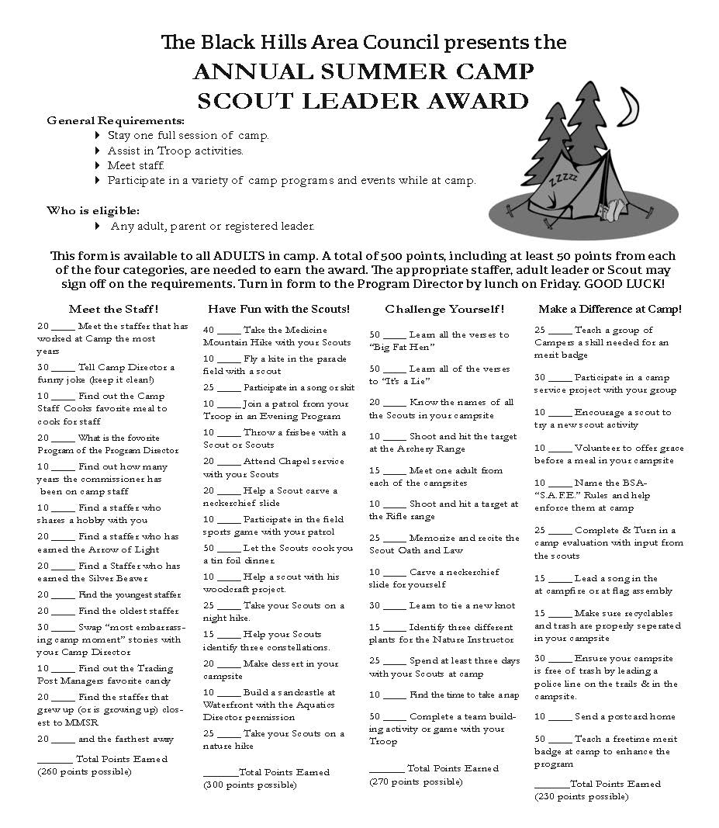
2026 PROGRAM SECTION
PROGRAM SELECTIONS – Leader Award
2026 PROGRAM SECTION
PROGRAM SELECTIONS – White Buffalo

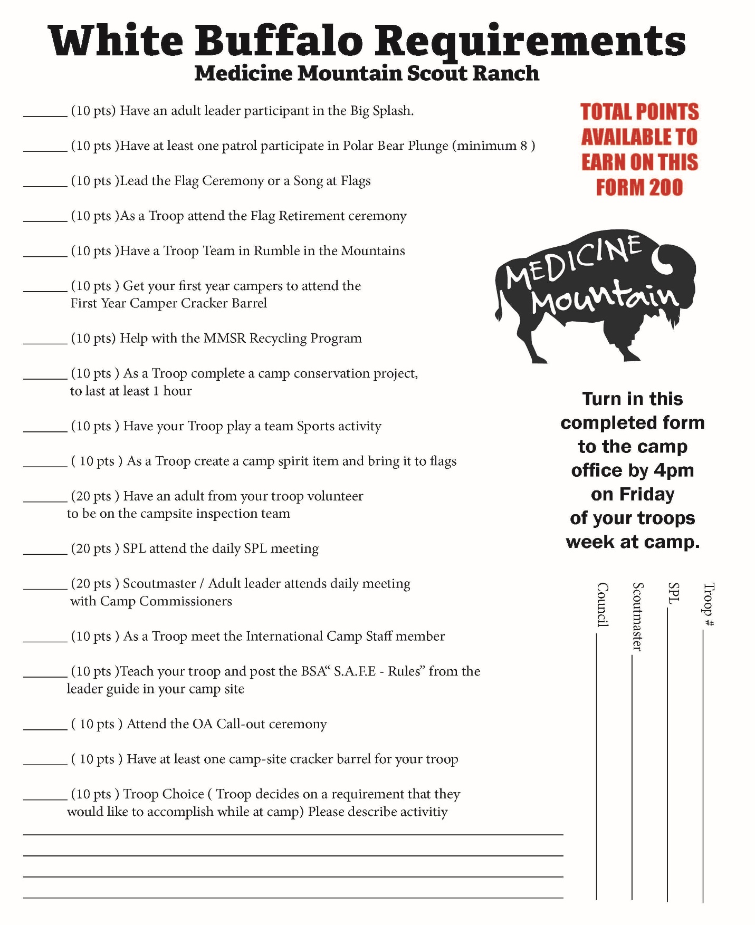

Daily Camp Schedule
2026 PROGRAM SECTION
PROGRAM SELECTIONS – Camp Schedule

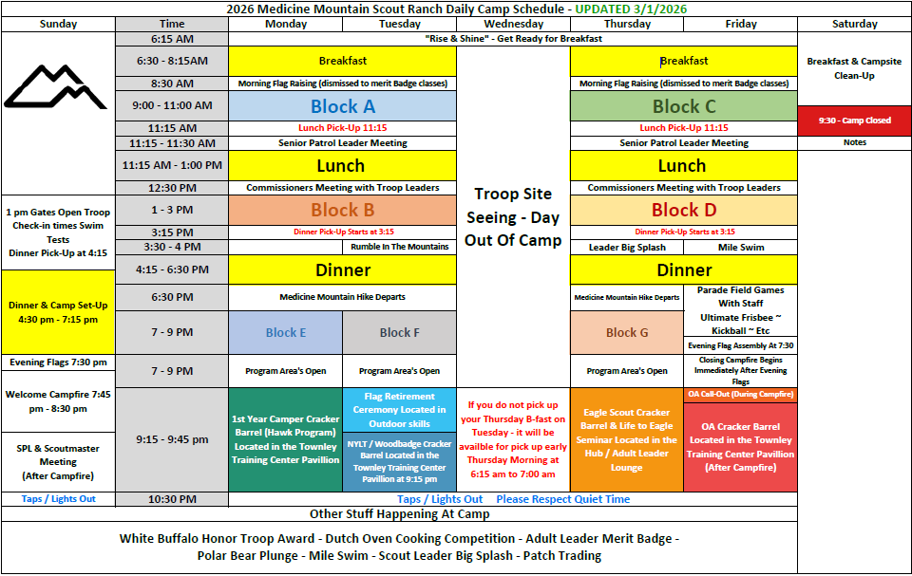

2026 PROGRAM SECTION
PROGRAM SELECTIONS

Signing Up for the Program
Scouts and Scouters can sign up for programs (merit badges, specialty programs, HAWK, etc.) as soon as they are paid in full for camp. As soon as payment is made in full for the Scout, go to the “attendees” tab of your unit’s online registration and click on the individual who has paid in full. A schedule will drop down where you can schedule the scout’s program for the week.
Please be aware that only the registration contact for your unit will be able to access the online registration system. However, if the parent portal is enabled, a parent of a Scout would be able to log in and sign up their Scout for the program.
Merit badge and program signup are locked after May 23, 2026.

Program Capacities
Each merit badge and program has a capacity per class. Slots will be reserved on a first-come, first-served basis. Capacities are determined based on equipment, staff, and program demands and limitations. Under no circumstances will Medicine Mountain authorize the expansion of capacities. If capacities are expanded, it will negatively affect the program quality for other Scouts. Please “be prepared” and plan to ensure your unit does not end up in a “last-minute” situation.

Switching Merit Badges
Before May 23, 2026, Scouts can switch merit badges, space permitting, as many times as they want.
After arriving at camp, Scoutmasters may come to the Camp Office to switch merit badges for their Scouts after the opening campfire on Sunday night. Typically, we see this from Scouts who were originally signed up for aquatic-related merit badges due to our cold-water temperature. Please be aware that merit badge availability is limited due to capacities, staffing requirements, supplies, and other variables. It is for this reason that Scouts will have a limited choice of what merit badges they may switch to.

2026 PROGRAM SECTION
PROGRAM SELECTIONS – Blue Cards

Blue Cards
Medicine Mountain is a 100% electronic blue card camp. This means that there is no reason to bring blue cards to camp. Our staff will keep track of requirements completed at camp, and they will be uploaded nightly to our registration system. Leaders then can log onto the registration system the next morning and view completed requirements throughout the week. Leaders can keep track of their Scouts and ask questions if they have any.
After the unit’s week of adventure at Medicine Mountain, the registration contact can go to their online registration and print off the blue cards from the “reports” tab.

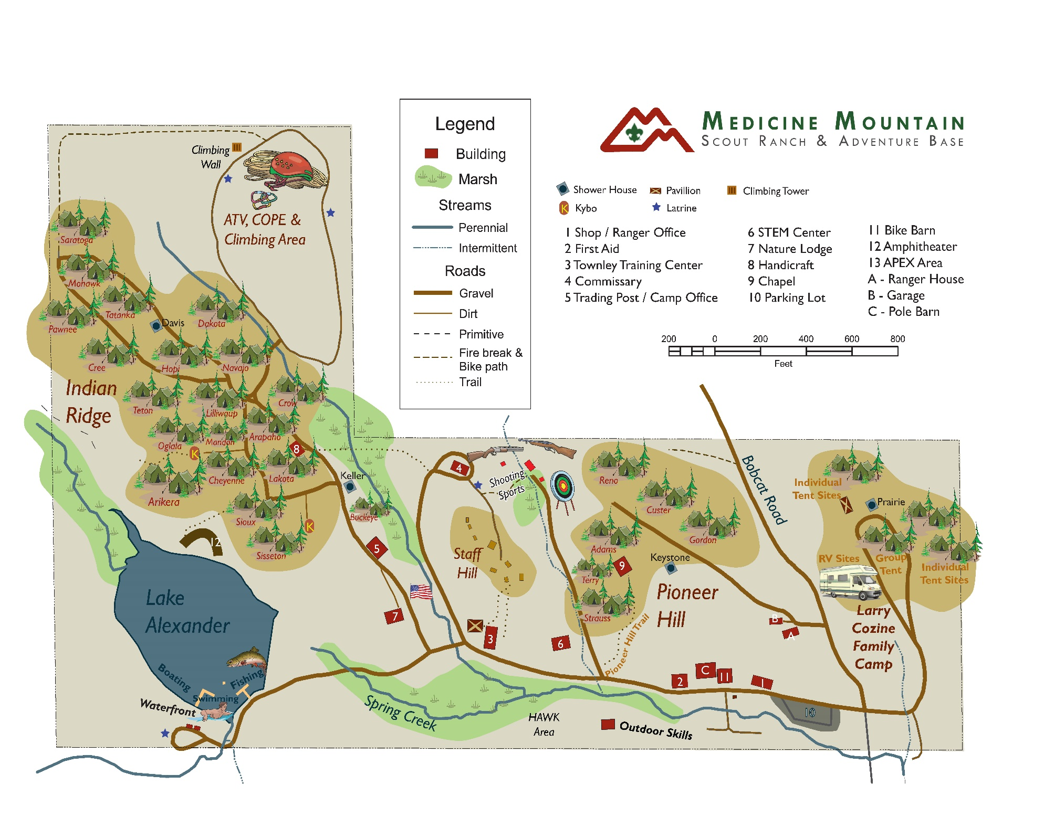
2026 PROGRAM SECTION
PROGRAM SELECTIONS – Camp Map

