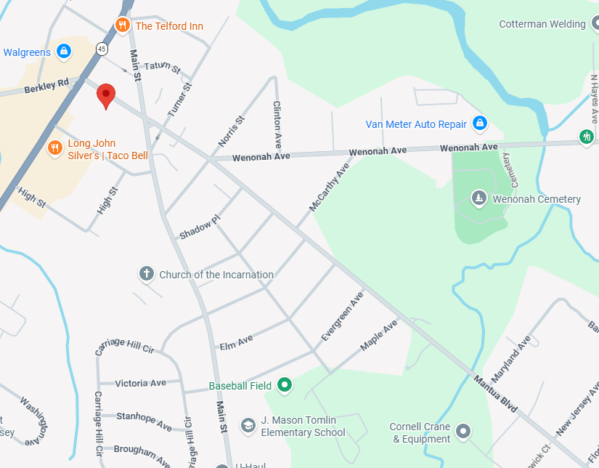
Masonic Hall
45 mantua Blvd
Mantua NJ 08051

