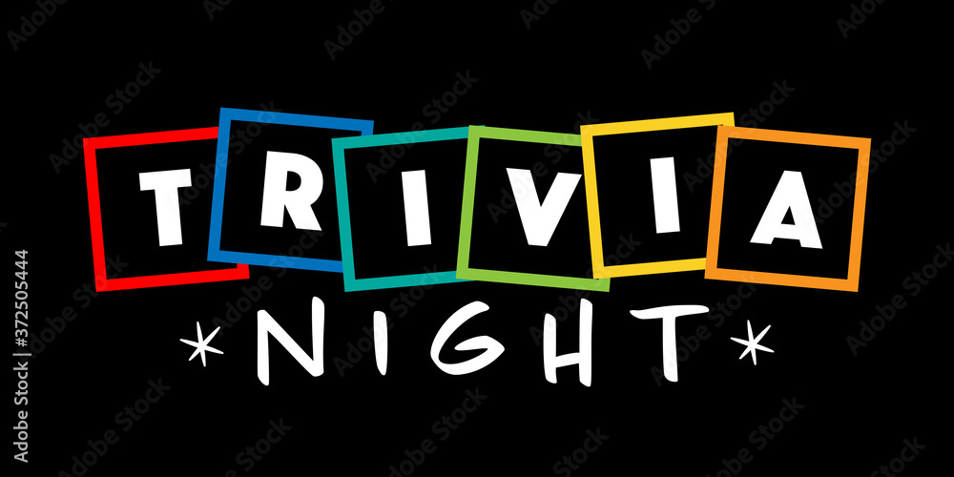
The Crossroads District presents our annual Trivia Night.
Come join us for a fun filled Adults Only Trivia Night.
Trivia, Basket Raffle,Food,Fun,Adult beverages
Tickets are only $30.00 per person or
$25.00 for a table of 8 seats
December 12th
Masonic Hall , 45 Mantua Blvd, Mantua NJ
Your text hereHere is your chance to prove it

Are you good at Trivia?
Your text here

