

WEBELOS Weekend Leader Guide 2026

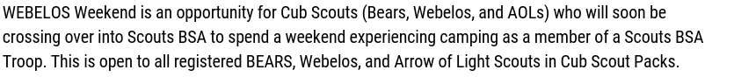
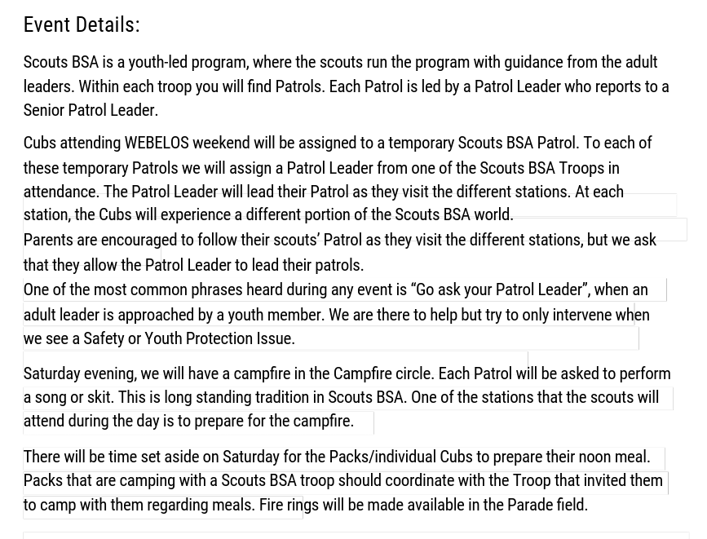

Commonly Asked Questions & Answers
- Who is allowed to attend WEBELOS Weekend
  - The Weekend is open to all Cub Scouts who currently either a Bear, WEBELO or Arrow of Light Scout.
  - Parents or guardians of the Cubs are invited to attend, but must be registered for the event
  - Boy Scout Troops and Leaders
- Who needs to register
  - Everyone needs to register
- What does it cost to attend
  - The early bird fee to attend is $15.00 for all cubs Scouts, Parents of Cubs and Cub Leaders the fee is $10.00
  - A late fee of an additional $5.00 will be applied for all registrations made after Oct 4th, 2026.
  - There is no fee for Boy Scout Troops supporting the event
- Do I need to camp overnight to attend?
  - No Cubs and families may elect to attend for Saturday events Only.
  - There is a separate registration option for both those who are camping and those attending Saturday Only.
- Do I need to have my own camping equipment?
  - Yes. Unfortunately, we cannot provide camping equipment
- Can my Cub camp with a Scouts BSA Troop?
  - Yes, a pack may camp with a troop, if invited by the Troop
- What if I am Not camping with a Troop?
  - Packs and individual Cubs may attend (with parents/Guardians).
  - Individual cub families will be using the Parade Field for camping.
- Can I pick my camp site?
  - Unfortunately, no. We will assign camp sites based on the number of campers in each unit.
  - We are also sharing the camp with BALOO training, which will occupy several sites.
- Where will the opening ceremony be held
  - At the Flagpole at 830 Saturday AM
- Do I need to Register
  - Yes, everyone present in camp must be registered.

- What time does the event start?
  - Check-in for those camping will open at 5:00 PM on Friday night
  - Opening ceremony will be at 830 Saturday morning at the Flagpole.
- Do I need to present a medical form?
  - Packs and troops should have a current medical form for all of those attending, youth and adults/parents (Part A & B) only
  - If attending without a unit, the parent/Guardian should have a completed medical form part A & B for them self and their scout.
  - Medical forms will NOT be collected
- How does my unit comply with SYT Policies
  - Two registered leaders with current SYT training must be in attendance with the units
- Will I be allowed to drive to my campsite?
  - Yes, one car at a time will be allowed to drive into the camp on Friday night, to drop off equipment and/or Supplies. The vehicle must then be moved to the parking area outside of camp.
  - Unit trailers will be allowed to remain at the campsites
  - Traffic will be one way into and out of the camp on Friday night, enter via the main entrance and exit via the back gate.
  - NO vehicles other than Staff will be allowed into the camp on Saturday.
  - People joining a unit already in camp on Saturday night will not be allowed to drive into camp until after the completion of the day’s activities.
- Hazardous Weather.
  - In the event of hazardous weather, we will shelter in place at either the Dining hall or WEBSTER Lodge. Unless directed by the Camp Ranger to vacate the camp
- Does my scout need to wear his/her Uniform?
  - No, class A uniforms are not required. Activity shirts are recommended
  - Staff members will be in Class A uniforms
- Will food or Drinks be provided?
  - No. Each Pack/troop or individual scout family will be responsible for their own food and cooking. Cub packs camping with a Troop should coordinate food with the Troop. Fire rings will be provided in each campsite and in the parade field for the individual campers.
- Cold Weather
  - There will be limited sleeping space in WEEBSTER Lodge if the overnight temperatures drop too low for comfortable cub Scout Sleeping. Priority will be given to Cub scouts and their Parents/guardians. In accordance with the Guide to Safe Scouting.

- BALOO Training
  - A BALOO Trained leader is required for each Cub Pack camping.
  - BALOO training will be offered by the Garden Ste Council at Pinehill scout camp during WEBELOS WEEKEND for those needing it.
  - A separate registration is required for the BALOO training.

