
What, When and Where

2026 Crossroads Scout College Guide
- The 2026 Crossroads Scout College will be held May 2nd and May 16th at the Pinehill Scout Reservation,
  - 120 Watsontown, New Freedom Rd, Pine Hill, NJ 08021
  - 700AM to 445 PM each Day

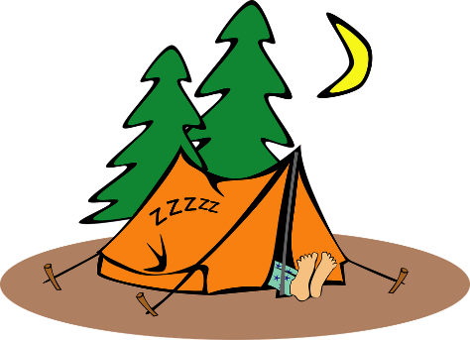
Camping

  - All of the campsites at Pinehill have been reserved for Scout College, for the weekends of May 2nd and May 16th.
  - There will be No overnight camping On Friday May 1st, Limited Camping on May 2nd.
  - There will be limited camping on Friday May 15th and May 16th.
  - Contact Dave Salow, Crossroads District Chairman, if you wish to camp the weekend of May 2nd or 16th. Do NOT connect the Council office to reserve a camp site for this event only
  - Saturday night check-in will occur after the completion of the Scout College Day.
  - Units camping must provide a complete roster at Check in

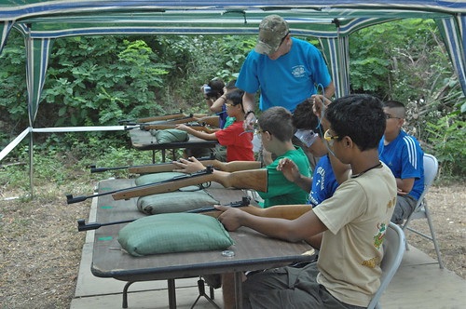
Classes
This Photo by Unknown Author is licensed under CC BY

- This year’s Scout college will offer several options. There will be the traditional single (45 Minute) Class, some Double Period Classes (105 Minute) classes as well as a few halves day (180 Minute) classes.
- There are also several Single day Only Classes.
- The Radio Merit Badge will be offered as a complete single day class on both May 2nd and May 16th. Scouts Need to register for one day Only.
- Classes may have prerequisites. Those will be listed in the class catalog.
  - Scouts who have not met or completed the prerequisites may not be allowed to attend the individual classes. This is at the discretion of the individual instructor.
- Classes will be first come first served, walk in registration will be accepted as space allow only.
- Classes are open to all registered Scouts.

Registration

- Both individual scouts and/or units may register for Scout College.
- Registration fee MUST be paid to guarantee Classes. Classes are filled on a first come first served basis.
- Walk in registrations must be paid on May 2nd. Scouts with unpaid fees will NOT be able to download completions.
- Parent or Guardian Email addresses are required for all Scouts Registering for Scout college.
- Both the Archery and Rifle shooting merit badges have an additional fee of $15.00, that must be paid to complete a registration


Medical Forms

- A Current BSA Medical form should be on hand for this and all Scouting events, for all members of your unit attending the event. This includes parents who are not registered. The Unit leader should have these forms in his/her possession, during the event.
- Medical forms will NOT be collected.
Medical Information
- An optional medical comment section has been added to the registration form. Please use this space to list any medical information or Special needs information regarding the Scout who is attending scout college.

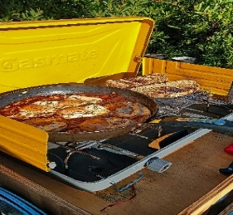
Food and Beverages
- No food or Beverages will be provided at this event.
- Scouts should remember to stay hydrated thought out the day.

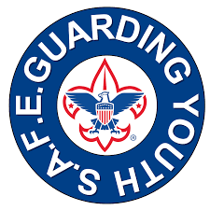
Safeguarding Youth Training

- No unaccompanied scouts will be allowed to attend Scout College.
- A parent, Guardian or Scout leader who accepts responsibility for the scout must REMAIN at Pinehill Scout Reservation for the entirety of the Event.
- No Drop and Go.

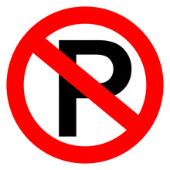
Parking

- Only Instructors and Event Staff will be allowed to drive into the Pinehill camp reservation.
- All other vehicles will be parked in the parking area.
- Accommodation will be made for Scouts with Special needs.
- Instructors and those with Special needs will be allowed to enter the Pinehill Scout Camp via the Ranger (back) Gate.

Blue Cards

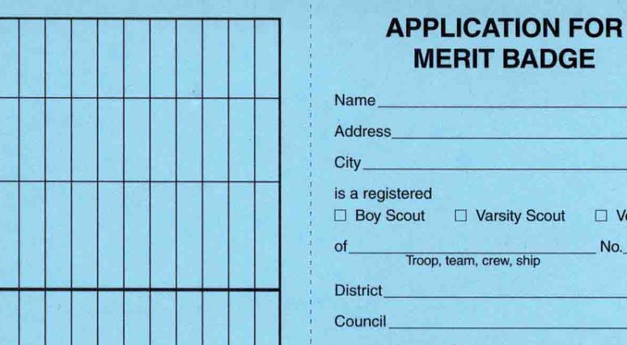
The 2026 Crossroads Scout College will be a Digital Blue Card Event.
- No manual blue cards will be processed.
- Instructors will be given a digital Completion sheet for each class period, the completion sheets will be collected during scout college and will be entered into Black Pug software at the completion of scout college.
  - Black pug software is the software package that the BSA uses for event Tracking.
  - The completion results can be downloaded and auto populated into Scout Book.
- Scouts who do NOT complete the merit badge at this Scout College will continue to work with the same instructor to complete the merit badge. Unit leaders are encouraged to link the Merit Badge counselor to the individual Scout, in Scoutbook.
  - A list of Merit Badge counselors and contact information is available on the registration page

Guides
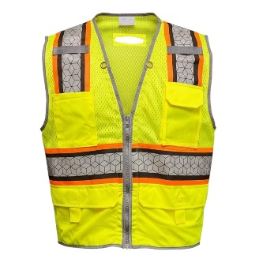
- We will have uniformed Guides located throughout the camp to assist Scouts with Directions.
- Guides will be equipped with a Yellow Vest to help identify them.
- Guides will be equipped with a radio if an emergency occurs.

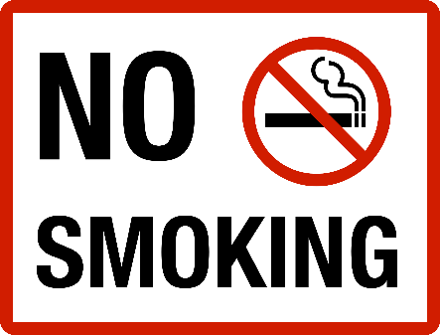
General Information
- No Alcohol, or drugs, to include medical Marijuana, will be allowed at Scout College
- No smoking is allowed at this or any scouting event.
- Personal Firearms are prohibited from this event.

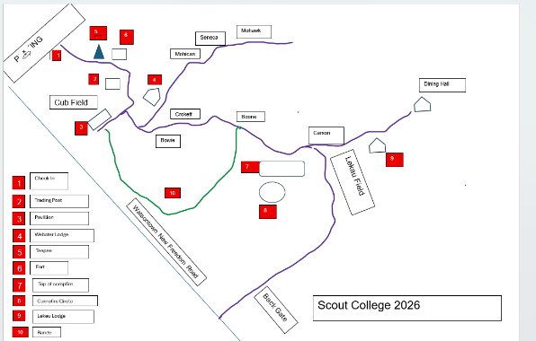
Maps
- There are maps for both days on the home registration page.
- Class location for two day classes does NOT change

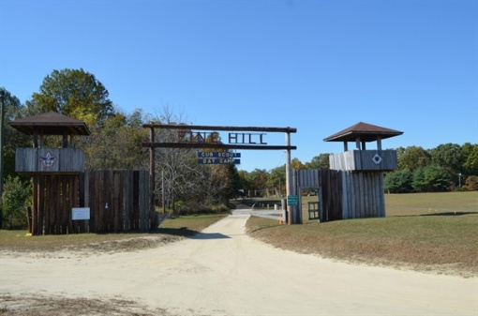
Check in
- There will be a Unit check-in location near the entrance of Pinehill Camp

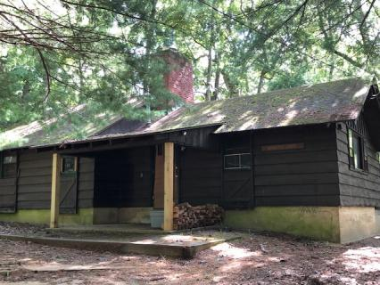
Adult Classes
- Scoutmaster specific training will be offered at the Webster Lodge starting at 100 PM on Saturday May 2nd
- The Committee training will be offered at Webster Lodge starting at 100 PM on Saturday May 16th.
- Classes are open to all Adults. Participants must register for either class

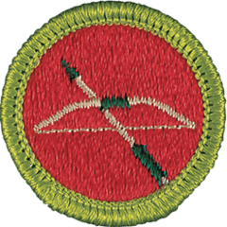

Archery Merit Badges
- This is a double period class. Scouts MUST attend both weekends.
- Class is limited to 8 Scouts per period
- Scouts Must Complete Requirements 2(d)1,” Make a complete Arrow”, from Kit supplied with Class to earn the Merit Badge
- There is an Additional Charge of $15.00 per scout for this badge, to cover the cost of the Arrow Kits
- Scout must also meet BSA score requirements to earn a completion of this Merit Badge
- BSA Activities consent form must be submitted at the beginning of the class. Consent Form MUST be signed by a parent
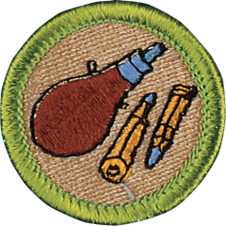
Rifle Shooting Merit Badge

- This is a double period class. Scouts MUST attend both weekends.
- Class is limited to 8 Scouts per period
- Scout must also meet BSA score requirements to earn a completion of this Merit Badge
- BSA Activities consent form must be submitted at the beginning of the class. Consent Form MUST be signed by a parent

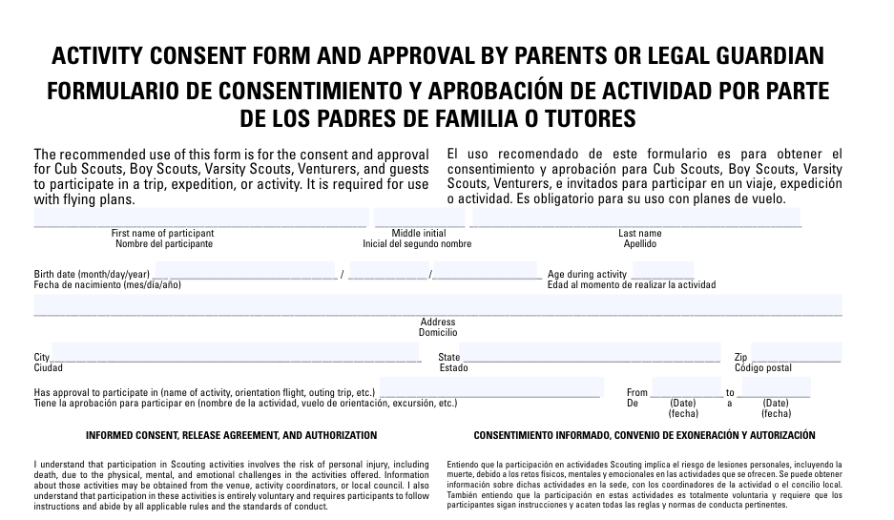
BSA Activities Consent Form
- Scouts taking wither the Archery or rifle Shooting Merit badge must present a signed copy of the BSA activities consent form to the Rangle Safety Officer before they are allowed to shoot wither Arrows or Rifles.
- Consent form MUST be signed by the Parent or legal Guardian of the Scout, NOT the Unit leader
The Consent form can be downloaded from this link
chrome-extension://efaidnbmnnnibpcajpcglclefindmkaj/https://filestore.scouting.org/filestore/pdf/19-673.pdf

Pets
- No Pets (Leashed or un leashed) are allowed on the Pinehill Scout Camp

