Wilson Lake Memorial Park is located at 1711 Clayton Williamstown Road Franklinville NJ.

Enter off of Clayton Road and follow winding road back to main Building.

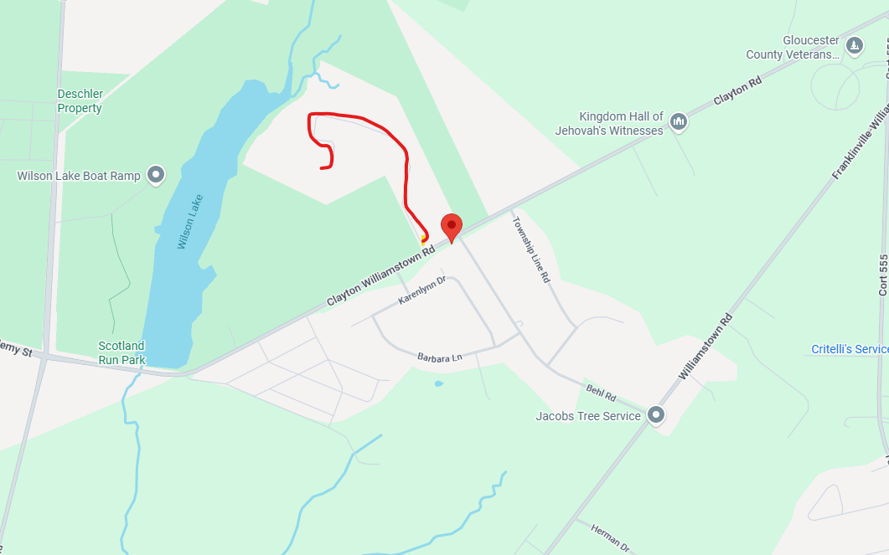
There is a Large white Cross at the Entrance of the park

