Pine Hill District Klondike
Participants Guide
2026
Klondike Committee
Pine Hill District – Garden State Council
Revised 1/1/2026
January 23rd-25th
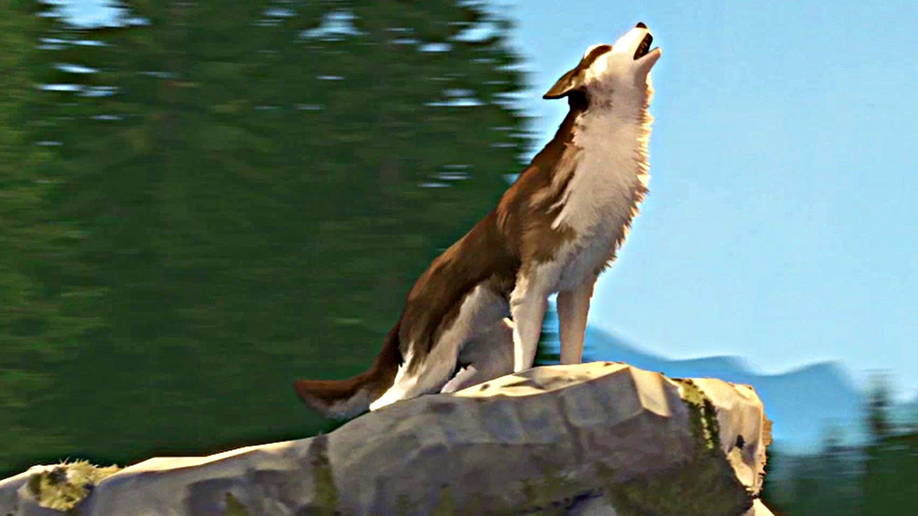
White Fang

Welcome to Klondike 2026
Welcome to the annual Pine Hill District Klondike Derby. We are building off of the success of the past few years and making a few minor adjustments. We hope this provides for a fun fill day of Friendly competition!

General Information
The information in this participant guide may change before the actual event. Final instructions for completing the Klondike will be provided Saturday morning if any changes are to take place.

Contact Information

Address
Pine Hill Scout Reservation
Official Address | GPS Address for Cub Field
12 Watsontown New Freedom Rd, Berlin, NJ 08009 | 120 Watsontown-New Freedom Rd. Berlin NJ, 08009

Emergency Numbers
Klondike Event Committee Chair
Leo Pratte
Cell: 732-778-2387
Email: leo.pratte@redcross.org

Council District Executive
Omar Colon
Cell: 856-383-1633
Email: Omar.Colon@scouting.org

Klondike Schedule

Friday
Time | Event | Location
4:00 – 8:30 pm | Check-In | Webster Lodge
8:30-9:30 pm | Mayor’s Meeting | Lekau Lodge

Saturday
Time | Event | Location
7:00-8:00 am | Registration open | Webster Lodge
7:30 – 8:30 am | Sled Inspection | Cub Field
8:30 – 8:45 am | Morning Colors | Cub field
9:00 – 9:30 am | Rotation 1 | Follow map to your assigned town
9:40 – 10:10 am | Rotation 2 | Follow map to your assigned town
10:20– 10:50 am | Rotation 3 | Follow map to your assigned town
11:00 – 11:30 pm | Rotation 4 | Follow map to your assigned town
11:30 – 12:30 pm | Lunch | Camp site or General area’s
12:40 – 1:10 pm | Rotation 5 | Follow map to your assigned town
1:20 – 1:50 pm | Rotation 6 | Follow map to your assigned town
2:00 – 2:30 pm | Rotation 7 | Follow map to your assigned town
2:40 – 3:10 pm | Rotation 8 | Follow map to your assigned town
3:20- 3:40 pm | Rotation 9 | Follow Map to your assigned town
3:40—4:30 PM | Make Up Rotation
4:00– 6:00 pm | Dinner | Individual Campsites
6:00 – 8:00 pm | Closing Ceremony, Results and Troop Skits | Camp Fire Pit
8:00 – 10:00 pm | Camp Time | Individual Camp Sites
10:00 pm | Lights out

Sunday
Time | Event | Location
11:00 am | Check-out by 11:00 am | Webster Lodge
9:00 am – 11:00 am | Clean-up | Camp Wide

General Information

Check-In
All Troops will enter camp through cub field. Check in will be at Webster Lodge
- Final Roster of Troop
- Final Sled Roster(s)
- Any outstanding Klondike fees
- Soup cans for Commissioners’ Soup. Reds and Chickens No “Cream of” soups. Once can per Scout.

Vehicle Traffic
For the safety of the youth participating in the Klondike, vehicle traffic will be restricted to foot traffic during the event. 1 trailer will be permitted per troop in each campsite (conditions permitting). All other vehicles will be required to park outside cub field.
Day | Authorized Vehicle Traffic Times
Friday | Morning till 8:00 PM
Saturday | None

Klondike Leadership Headquarters
Webster Lodge will be the Headquarters of the Klondike Staff. Anyone who needs information or contact with the event staff can either go to Webster Lodge or call 732-778-2387.

First Aid
First Aid is available at Webster Lodge throughout the event. A volunteer EMT will staff the First Aid Station for any needs.
If anyone feels they need to warm up more than they can during the events are welcome to stop in with their buddy and warm up at Webster Lodge. Event staff and scoutmasters are expected to send scouts and their buddies to the Webster Lodge if they suspect that the scout is beginning to suffer from hypothermia or other cold related injuries.
(See Scout Handbook for Cold Weather injuries)

Leaders Orientation
Scoutmasters, Senior Patrol Leaders, and their buddies will check in at Webster Lodge Friday evening from 4:00 pm to 7:30 pm to receive their Klondike Competitors packets and event schedules.
Soup cans will be collected at this time.
There will be a leaders orientation at 7:30 pm on Friday January 26th at Lekau Lodge. Any updates or schedule changes will be presented then.

Arrow of Lights
Here are the updated guidelines:
- No official competition: AOL Scouts cannot compete in the main Scouts BSA or Venturing competition. They are generally not counted as part of a Scouts BSA patrol’s sled crew in events where competition is the primary focus.
- Observation allowed: AOLs may tag along and observe the activities.
- Camping requirements:
- AOL Dens (not individual AOLs) may camp with the Troop.
- AOLs must have two-deep Cub Scout leadership from the Pack, including one needing to be a BALOO-trained leader.
- AOLs following the family camp rules of Cub Camping.

Participant Patches
- Each participant and registered leader will receive a patch.
- Additional Patches may be purchased for $ 5.00 per patch (based on availability)

Trading Post
The Trading Post will be open several times during the event. The schedule will be as follows:
Friday - 6:00 PM to 8:00 PM
Saturday - 12:00 PM – 1:00; 5:00pm-6:00 PM

Commissioners Soup and Hot Chocolate
Commissioners soup will be ready and warm throughout the day at Lekau Lodge.
Hot chocolate stations will be available at the following locations: Lekau Lodge

Sled Scoring
Most competition events will award up to 25 points. The awarding of points is completely up to the judgment of the Mayor running the event and will be made in the following areas. Adult coaching at events is strictly forbidden.
Scoring Area | Points
Teamwork/Communication | 5
Leadership/communication | 5
Scout Spirit | 5
Scout Skills | 10

Rank Adjustment
A small adjustment will be made to each sled based on their average rank of the sled. The intent is to provide incentive for Troops to mix the rank of their sleds to allow for both younger and older scouts to enjoy the day of skill and competition.

Average Rank of Sled | Percent Increase in Raw Score
Scout | 25%
Tenderfoot | 20%
Second Class | 15%
First Class | 10%
Star | 0%
Life | 0%
Eagle | 0%

Best Decorative Sled and Best Flag
An award will be presented to the sled that is the most creative/decorated sled and Best Flag. One award will be presented for this sled.

Do a good turn daily
Event staff will have additional points to award to sleds found showing scout spirit by doing spontaneous good turns around the camp.

Klondike Sleds
Most Troops already have sleds on hand. There are no wheels allowed. If you are a first timer or need to replace a sled, here are some links to recommended designs. There are a maximum of 8 Scouts per sled.
http://www.scouters.us/homesle.html
http://foxvalleytfc.org/flyers_docs/Klondike_sled_plan.pdf

Partial Klondike Competition Events Summary

Knots & Lashings Challenge
Knowledge of the basic Scout knots and then some will be needed to complete this unique challenge. A handbook or knot book may be useful. How are your lashing skills? Can you make a flagpole? Can you create a tripod for cooking? Can you make a camp gadget? Stop by and test your skills!!!

Wilderness Survival Challenge
Just what it says, survive outdoors with what’s available

Fire Challenge
Remember your Firem’n Chit? Let’s just see about that. And it’s more than just building a fire!!!

First Aid Challenge
Here’s a chance to use your acquired Tenderfoot, 2nd class, and 1st class, first aid skills in a number of different scenarios. Be prepared!

Team Work Challenge (multiple stations)
Teamwork is essential in the Klondike, but especially here. Listen carefully and think before you act.

Map & Compass/Orienteering Challenge
Hope you have a compass. Try not get lost here!

Shooting Sports
How good is your aim in the cold. Yes the firing range will be open!

Hatchet Throwing
Count your fingers and toes, sharp objects will be flying!

Bonus Station
Back by popular demand, there will be a bonus station somewhere in camp. A clue will be provided during the opening ceremony. Follow the clue and find a way to earn up to an extra 25 points!

Sled Rotations
During check in a sled packet will be assigned for each sled. This packet will contain a specific rotation of which towns you are to go to and when. Sleds will not be allowed into a town early or after their allotted times. At the end of the day there is a designated time (3:10-4:00 pm) for sleds to make up any towns they were unable to make due to unforeseen circumstances.

Additional Klondike Events

Camping Overnight
Each sled team that camps in tents overnight will earn credit towards the council Winter Camping Award.

Other Activities

Troop time
Take an opportunity in your campsites to change, warm-up and reflect.

Closing Camp Fire Ceremony
At the end of the competition, each sled will send the “sled leader” and a buddy to Webster lodge to turn in the score sheet for their sled. During that time, Troops will be able to stow their sleds and gear. Once completed, all troops will return to the campfire pit, by 6:00 pm, for the Closing Camp Fire Ceremony. Any troops wishing to perform a skit, a cheer, or a song will be invited to participate. If your troop is interested, let us know at registration and we’ll get you on the list.

Sled Packing List
Check | Item | Quantity
 | Patrol Flag (on pole) | 1 per sled
 | Extra Socks | 1 pair for each scout
 | First Aid Kit (recommended)  - Adhesive Bandages  - Gauze  - Tape  - Mole Skin  - Ace Bandages  - Scissors  - Paper  - Pencil  - “Hot Hands”  - Emergency Blanket  - Emergency Poncho  - Mirror | 1 per sled
 | Water bottle | 1 per scout
 | Matches | 1 pack
 | Tinder/Kindling | Sufficient for 1 fire
 | Drinking/Soup Cup | 1 per scout
 | Staves 6 foot length | 3 per sled
 | Blanket | 1 per sled
 | 50 ‘ Rope | 1 per sled
 | 6 ‘ Rope | 1 per scout
 | Jute | 1 roll
 | Clipboard with protective cover | 1 per sled
 | Hatchet (with axe guard) | 1 per sled
 | Knife (folding) | 1 per scout with Totin’ Chit
 | Totin’ Chit Card | At least 1
 | Dry Towel | 1 per scout
 | Rain Gear (Poncho, garbage bag, etc.) | 1 per scout
 | Scout Handbook | 1 per sled
 | Field Book | 1 per sled
 | Compass | 1 per scout
 | Small Shovel | 1 per sled
 | Tarp (at least 7’ x 9’) | 1 per sled

