Leon Valley District
Spring Camporee

April 26-28, 2024
at North Fort Cavazos

Military Engagement Camporee

Challenging events and activities. See the U. S. Army in action on the largest military installation in the USA!

Cost -Youth-$15.00 Adult-$10.00

Please feel free to contact Fulton Jones, LVD Camporee Registrar with questions.
at fultonj79@yahoo.com or (254) 681-1541.
Leon Valley District Spring Camporee
April 26-28, 2024
North Fort Cavazos

Unit #: District: Council:

Number of Scouts: X $15.00 = ___________

Number of Registered Leaders: X $10.00 = ___________
Total = ____________
Total number of patches to be received: __________
One LVD Camporee patch is included in the cost for each registration.

You can register online at:

Longhorn Council - Fort Cavazos Camporee (Multi-District) (scoutingevent.com)
REGISTRATION MUST BE COMPLETED BY April 12th 2024 – NO EXCEPTIONS!

If paying on arrival at the Camporee Check in Station, please email Fulton Jones with head count, before April 12th 2024.

Welcome to the 2024 Leon Valley District Camporee!

REGISTRATION, CHECK-IN, AND CHECK-OUT
ONLINE Registration is open at: Longhorn Council - 2023 Leon Valley Spring Camporee (scoutingevent.com).
Deadline for registration is April 12th 2024. Please submit ALL your registration forms before then!
FOR BASE ENTRY: VERY IMPORTANT: DO NOT USE THIS LINK AND ENTER INFORMATION UNTIL 18 APRIL 2024, You cannot use this link successfully until 18 April 2024.
Follow this Link: https://pass.aie.army.mil/?b=usa&i=fort_cavazos&e=6MJKRLZ4
***If you are under the age of 18, there are no requirements to fill out this form. If you are 18 or older you MUST fill out this FORM, if you have any questions or you are denied access, call the Marvin Leath Visitor Center at (254) 287-9909 for assistance**
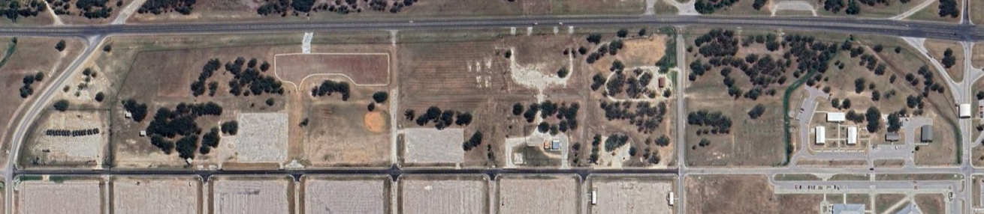
Entry will be through “ACP 19A” at North Fort Cavazos, then once you reach the stop sign take an immediate right, and drive all the way to the Camporee Site. There will be traffic controllers to guide you in! For navigation, use “931 Enfield St, Gatesville TX 76544” or look up “NFH Site Support”. Both should navigate you to North Fort Cavazos, with entry through ACP 19A (circled in green). The camporee site is marked with a red box.

On arrival, Troops will be facilitated to check-in, then sent to their assigned camping site. Please have All Forms filled out & completed before arriving at Check-in Tent/Table. Troops will provide Scout Medical Forms A and B to the medical team during check-in in addition to their unit roster (see example at end).
For Medical Forms: https://www.scouting.org/health-and-safety/ahmr/ (All Scouting Events)
NO VEHICLES MAY PARK IN THE CAMPSITES! There are parking lots available directly across from the campsites, with drive in access for offload if necessary.
Each Unit is expected to thoroughly clean the areas where they camped. Scouts, you all know the drill. Remember the Outdoor Code and “live by it”.
On Sunday morning, an Interfaith Worship Service will be held at 9 a.m. led by the Army’s Chaplain Corps, A SCOUT IS REVERENT!
Once your unit has broken camp, please arrange for a clearing inspection with the Commissioner Staff. After your site has been cleared by a commissioner, you may bring your vehicles to the campsite to load them for departure. The unit’s check-out packet with patches and ribbons will be at the Camporee Headquarters.
Camporee Map
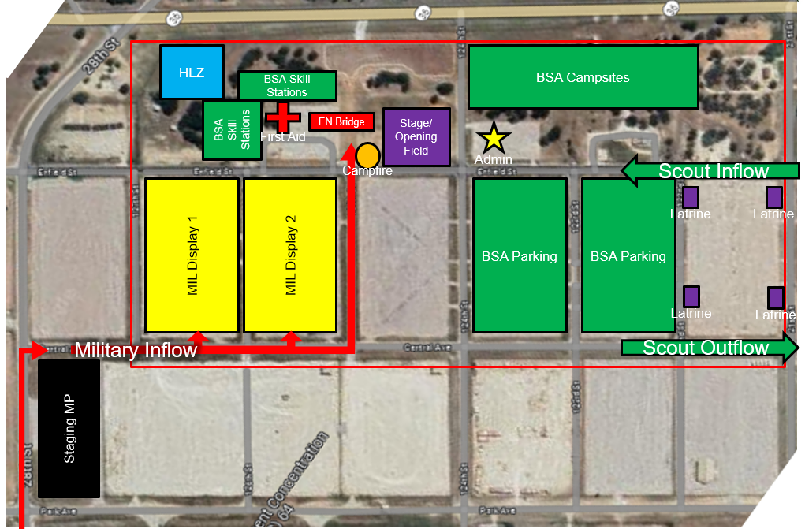

STATION CONCEPT: We are not limiting you on seeing the displays!
Stations will be completed by Patrol. There will be 4 stations for patrols to complete: First Aid, Pioneering, Orienteering, and Leadership Skills. Patrols will be scored at each station and the patrols with the highest score by station and in total will receive an award. Each patrol is encouraged to complete each Scout Skill Station at their own leisure while visiting the static displays, however not completing each scout skill station will risk forfeiting their chance at winning the title of “Grand Victory Patrol”. Final Station Scorecards will be distributed to SPLs Friday evening during the SPL meeting at 9:00pm located at the Camporee Headquarters.
Stations will be designed to last approximately 30-40 minutes and will be designed and executed by volunteer troops. Station concepts will be reviewed by the camporee committee and supplies for the stations will be provided. Each station will develop an objective based rubric based on the skills assessed at each. Scores will be out of 100 and contribute to points earned toward the Grand Victory Patrol.
Assigned Troops
Station 1, First Aid:
Station 2, Pioneering:
Station 3, Orienteering:
Station 4, Leadership Skills:

***Patrols are encouraged to visit the Military Static Displays and interact with Soldiers throughout the day from 9am to 4pm. ***

UNIFORM POLICY
The BSA Scout uniform, (Field or Activity), will be worn by all Scouts and Leaders during the Camporee. Weather-appropriate clothing should be brought and worn as needed. Headgear will be worn when outdoors by all. Everyone will have a canteen/water bottle while on camp.

COMPETITION FORMAT
Several activities will be a competition. Healthy competition encourages risk-taking, persistence, communication, and teamwork – qualities all necessary for success. This speaks to a Scout developing solid character. Competition gives youth a reason to motivate themselves and when pressed to compete by Patrol, brings youth to the realization that others are depending on them. This mindset develops goodwill towards others, and in short, develops good citizenship.
Many activities are both physical and mental challenging - speaking to fitness of mind and body.

SCORING METHOD
Scoring is by Patrol. No Unit wins – rather, the top scoring Patrol becomes the GRAND VICTORY PATROL!
Scoring for most activities is based on TIME and/or PERFORMANCE. These are easy to measure and easy to score. Each activity has a simple rubric with most being published here. However, scoring of some activities may be largely based on subjective evaluation.
Completing each event should be a collective effort by the entire patrol. All patrol members are expected to actively participate and share leadership completing the challenge.
Each Patrol can win points towards the GRAND VICTORY PATROL.
Earning Points with your Score Card (Given to Patrol Leaders)
Skill Stations (By Patrol) 100pt/ea (Points awarded by Station Facilitators)
Display Visits (By Patrol) 50pt/ea (Points awarded by Military Unit)
Campsite Inspection (By Unit) (Points awarded via Commissioner Corps)

It is the earnest goal of the District Camporee Committee to provide a weekend of unprecedented, new challenges, high quality and well-managed activities for all Scouts, in keeping with the true purpose and values promoted within the Scouting program. The participation of all Scouts is encouraged for a rewarding and memorable Scouting experience.
CAMPSITE SELECTION, MAP & DIRECTIONS
Campsites will be assigned at check-in, pre-designated by the size of the Troop/Patrol in attendance (from registration). The check-in tent will facilitate showing your unit its pre-marked plot of land to camp on. Female units will be separated from male units so make sure you identify your unit correctly with a B or G at registration.
We will be camping Jamboree style, not existing campsites. Be prepared with tents and rain shelters. These are general guidelines for setting up your campsite.
- Do not block access road with vehicles or gear.
- Troops/Patrols set-up Campsites
- Set up dining fly first – put gear under it to protect from weather.
- Set up tents – then move personal gear into tents. Lay out sleeping gear.
- Set up cooking and eating area, secure water and fuel supply.
- Remember no ground fires
Commissioner Staff will conduct Standard Campsite Evaluations. The “Troop Campsite Inspection Sheet” found below will be the scoring rubric. They will award points to be applied to the final score to determine the GRAND VICTORY PATROL. Units should plan to improve their campsites with scout-produced decorations and devices (gateways, flag displays etc.).
The Guide to Safe Scouting http://www.scouting.org/healthandSafety/Gss.aspx is our guiding document. Please don’t cause us to have to enforce safety rules! All Scouts BSA policies will be followed.
CAMPFIRE PROGRAM
Saturday Night there will be a campfire conducted, Units will be asked to provide program elements for the campfire to be provided to the Campfire Master at Check-In. Items must conform to BSA guidelines and will be approved before presentation. Each patrol must come prepared with a skit or song to be conducted at the campfire prior to its execution.
**TBD- Tentatively planning for a 10’x10’ pallet bonfire coordinated via North Fort Cavazos. Please understand that the actual campfire is TBD based on an evaluation conducted by the fire department regarding weather conditions (Burn Ban/”Red” conditions” 10 days prior to the event!**

LIST OF MATERIALS NEEDED FOR EACH PATROL:
Traditional supplies to sustain a three day two night camping event!
1x Scout Handbook per patrol
1x or more compasses per patrol
1x set of first aid supplies
1x patrol flag
3x 6’ poles for pioneering
3x sets of rope for lashings
A Scout uniform for each member of the patrol (Class B or Troop Tee)
Lots & Lots of Scout Spirit

PACKING LIST:
Small tent and a small tarp or ground cloth
Sleeping bag/bedding/pillow
Cot/sleeping pad (optional)
Camp chair
Class B activity T-shirt and scouting uniform
Pants/jeans
Hat & gloves for cold weather
Rain gear
Appropriate undergarments
Appropriate sleeping clothes
Socks (3 pair minimum)
Shoes for camp (crocs/tennis shoes)
Toiletries (deodorant/toothbrush/toothpaste/hair brush/ponytail holder)
Towel & wash cloth
Flashlight x2, with extra batteries
Personal sized first aid kit
Personal care kit (medicines, lady products, etc.)
Scout approved knife (if you have Toten Chip)
Manual compass
Safety whistle
Scout book
Pen/pencil
Daypack
2 refillable water bottles MINIMUM
1 camp cup/mug for hot drinks
Mess kit (plate and bowl) & reusable silverware
Non-aerosol sunblock
Non-aerosol bug spray
Hot hands hand warmers
Offering for World Friendship Fund at Interfaith Worship (optional)
Binoculars for sky viewing (optional)

*Please remember troops represent their charter organization, all scouts in scouting and the Boy Scouts of America. No inappropriate logos, graphics or themes allowed.*

CAMPOREE RULES:
Leadership: At least two registered adult leaders must accompany and remain with each unit at the Camporee. The Camporee Committee wants to remind all adults that this Camporee is for the scouts to enjoy. Please use the Patrol Method at all times.
Scout Oath & Law: The Scout Oath and Law are expected to be practiced by all attending the Camporee.
Fires: No fires will be allowed in the campsite. Fuel stoves and lanterns are allowed.
Fireworks: Fireworks are NOT allowed.
Patrol Size: Patrols should have no more than 8 Scouts. It’s recommended that if the patrol is larger than 8 scouts that you split them up into a 2nd patrol. All participant that leave early must notify their Unit Leader.
Parking: All vehicles will be expected to park in the designated parking lot. NO VEHICLES WILL BE PERMITTED IN THE CAMPING AREA DURING CAMPOREE. Special Accommodations can be made on an individual basis. All personal equipment must be carried in by Scouts/Adults.
Clean Up: Each unit’s adult leaders will be responsible for ensuring that their campsite is clean prior to leaving. All trash must leave with your Unit. Leave No Trace! A Camporee Staff member must inspect each campsite before the unit departs. Please notify registrar if your unit will be leaving Saturday evening.

SUSTAINMENT:
Water: Water will be provided by various water buffalos at areas designated on the camporee map. Each scout is expected to carry their own water source and remain HYDRATED.
Food: All units will be responsible for their own meals throughout the event,
Restroom facilities: Restrooms are located to the south of the camporee area, located on the map. They will be marked for either Male or Female use. KEEP THEM CLEAN!
SCHEDULE

Fort Cavazos Spring Camporee 2024
Friday April 26, 2024 | Time | Location
Check-In, Site Setup, Infill | 5:00 - 7:00 pm (or later as needed) | Check-In Tent
SPL and Scoutmaster Meeting | 9:00 - 9:30 pm (SM & SPL only) | Camp HQ
Lights-Out and Quiet Time | 10:00 pm | Troop Sites
Saturday April 27, 2024
Wake-Up & Campsite Breakfast | 6:30 - 8:00 am | Troop Sites
Opening Ceremony | 8:00 - 8:30 am | Camp Stage
Camporee Events (morning) | 8:30 - 12:00 noon | Assorted Location
Lunch | 12:00 noon - 1:00 pm | Troop Sites
Camporee Events (afternoon) | 1:00 - 4:30 pm | Assorted Location
Dinner | 4:30 - 7:30 pm | Troop Sites
Keynote Speaker(s) | 7:30 - 8:00pm | Camp Stage
Campfire Program | 8:00 pm - UTC | Campfire
Lights-Out and Quiet-Time | 10:30 pm | Troop Sites
Sunday April 28, 2024
Wake-Up, Pack-Up, Breakfast | 6:30 - 9:00 am | Troop Sites
Interfaith Worship Service | 9:00 - 10:00 am | Camp Stage
Closing Ceremony and Awards | 10:00-10:30 am | Camporee Field
Campsite Clearance, Check-Out & pick up Camporee Check-Out Package | 10:30 - 12:00 noon | Troop Sites/  Camp HQ
Troop Campsite Inspection Sheet

Troop #: .

Troop Sites | Score (0-5)
Evidence of campsite planning
Separate patrol areas
Designated dining area
Tents properly pitched
Evidence of campsite improvements
Proper display of American & Troop Flags
Tents zipped, or flaps rolled
Health and Safety
All tools and equipment safely stored
Liquid fuels properly stored
Tent lines flagged for safety
First aid kit visible and identified
Camp Kitchens
Cook stoved cleaned and stored properly
Kitchen clean and orderly
Duty roster and menus posted
Food properly and safely stored
Total

Judge 1: .

Judge 2: .
Patrol Scorecard

Troop #: .

Patrol Name: .

Stations (up to 100 pts ea)

Station | Score (0-100pts) | Station Signature
First Aid
Pioneering
Orienteering
Leadership Skills

Displays (50 pts ea for visit. Up to 1-10 points for spirit, assigned by display team)

Military Equipment | Visitation Points (50pts) | Spirit Points (1-10pts) | Station Signature
M2 Bradley Display
Mortar Section Display
Infantry Weapons Display
Engineer Bridge
Horse Detachment History Display
EOD Display
Military Police and MWD Display
Signal Display
Sniper Team Display
M1 Abrams Display
Air Defense Display
AH-64 Apache Display (TBD)
