Unit Silver Spur Award Nomination Form

Western Trails District – Potawatomi Area Council
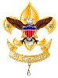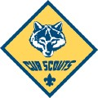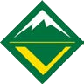

Every unit has a person that “spurs” on the unit. A person that keeps the Scouting program on the trail to success. This award will be presented at the District Award Dinner.
Note: The nomination is confidential. To avoid disappointment, please do not advise the nominee in any way of your action on his or her behalf.
General Info:
- This award recognizes someone who has been able to “spur’ on their Scouts BSA unit throughout the year and consistently provides encouragement and inspires youth & adults alike above and beyond what is expected.
- Tell us why this person deserves the award in the space provided below.
- As the nominator, it is your responsibility to make sure that the nominee attends the dinner.

Unit Making Nomination: __________________________________ Date: ________________ Committee Chair: ________________________ Contact Phone Number: (____) ____-______ Name of Nominee: ____________________________________________________________
Address: ____________________________________________________________________ Current Scouting Position: ___________________________________ with Unit: ___________
This person should receive this award because:

The nominee will be recognized at the Boots & BBQ District Awards Dinner on April 10th.

