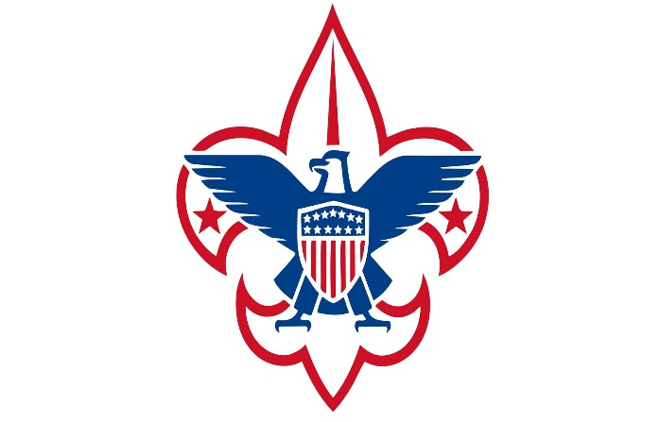

Potawatomi Area Council Dutch Oven Cookoff

Rules:
Rules are in keeping with the International Dutch Oven Society (IDOS)
General Rules:
- Adult teams may consist of two to six team members. Scouts BSA teams may consist of four to six Scouts and/or adults (may have up to two adults). A team may not consist of more than six people.
- Contestants MAY NOT BE professional cooks, chefs, or culinary instructors.
- Each team may only have one entry per category. Each team needs to submit a main dish AND a dessert dish.
- Only team members (no family or friends) are allowed in the cooking area during prep, cooking, and judging periods. One team member must stay in the cooking area at all times until the dishes are complete.
- Know and practice SAFE FOOD HANDLING PROCEDURES.
- A copy of your ingredient list is required along with your registration fee and form.
- Competitors will provide all ingredients and equipment needed to prepare their dishes.
- All ingredients must be combined, chopped, sliced, diced, and cooked on the site including garnishes, and marinades. For safety reasons, no ingredients prepared or processed at home are allowed.
- Marinating beforehand is not allowed. All preparation must happen in the cooking area at the allotted time, and no prepping of any food beforehand is permitted.
- All cooking must be done in an approved Dutch Oven.
- Teams must provide all their own cooking utensils, coolers, prep-tables, cutting boards, meat thermometers, waste containers, and other items needed to prepare, and serve food.
- Cooking may begin after the Cooks meeting, which begins at approximately 8:55AM.
- There can be no eating in the cooking area. Drinks are allowed.
- Battery operated or electrical devices, such as mixers or blenders, are not allowed in the preparation of food.
- It is the responsibility of each team member to know and understand temporary food handler regulations. Use of vinyl gloves is recommended for safe food handling.
- Dutch Oven Cookoff judges will be monitoring each team throughout the contest to ensure proper food handling and cooking procedures are adhered to.
- All food must be presented to the Judges Table on time. Points will be deducted for any late presentations.
- All judging decisions are final.
- Lastly and most importantly, the Scout Oath and Law must be followed at all times.

Registration Form

Please complete and sign the form at the bottom, acknowledging that you have red the attached rules and regulations for the competition. Return completed registration form, a copy of your recipe, and an ingredient list at team check in on the morning of the event:

Team Name:
Team Captain:
Team Members:
Pack/Troop/Patrol #:
Phone & Email:

I have read the rules and regulations for the Potawatomi Area Council Dutch Oven Cook Off and agree to abide by these rules and regulations throughout the competition. I acknowledge all judge’s decisions are final.

Team Captain Signature __________________________________

Date_________________________________

Potawatomi Area Council Dutch Oven Cookoff
Judge’s Score Sheet:

Team Name__________________________________________________

Recipe_______________________________________________________

_______/5 points---Presentation of food, Visual and Verbal Presentation/Explanation of Dish

_______/5 points---Team Uniform

_______/10 points---Cleanliness of area, sanitation procedures

_______/10 points---Interaction/Answering Questions from Judges & Teamwork

_______/30 points---Appearance of food---Uniqueness of recipe---Difficulty of recipe

_______/40 points---Overall flavor & Aroma

_______/100 points---TOTAL OVERALL SCORE
Frequently Asked Questions
Q: What will the council provide?
A: The council will provide washing stations, bowls/plates, and utensils for eating.

Q: What if we don’t have all the equipment or what if we forget something?
A: The council does have a very limited number of extra supplies. If you are going to participate but do not have the required items, reach out to your District Executive, and ask ASAP. Any equipment that we can loan out is very limited and will be first come first served.

Q: Will there be shade for the teams?
A: The council offices will be open and available to use. The tables and chairs inside are welcome for all participants. If teams want a pop-up canopy, teams will need to bring it with them.

Q: Are there going to be drinks or snacks?
A: The council will provide some drinks for the participants free of charge. Your team is highly encouraged to bring personal snacks for the day.

Q: Do teams need to provide ice?
A: YES. All teams must provide ice and a proper way to keep food at the correct and safe temperature. This is a requirement listed in the rules.

Q: What happens if we forget an ingredient?
A: The council is not able to provide any ingredient i.e., spices or anything else used in the dishes themselves. We are located near local grocery stores AND teams are allowed to get last minute items they may have forgotten. Local grocery stores: Metro Market, Pick ‘n Save, Good Harvest.

Q: Can we try another team’s recipe?
A: Absolutely. It is highly encouraged to try other team’s dishes during the Judging/eating times from 12:00-12:30!
Dutch Oven Cookoff Schedule

8:30am to 8:55am----Check in.

8:55am to 9:00am----Cooks meeting

9:00am to 12:00pm----Cooking Competition Begins

12:00pm to 12:30pm----Judging & EATING

12:30pm to 1:00pm----Awards and Cleanup

All times are subject to change.

