Boy Scouts of America Brooklyn Council
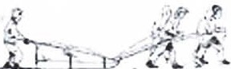
Klondike Derbv 2021

Saturday, April 10th

2021

Camporee Field @ Camp Pouch

9:00 AM To 3:00 PM
Event Registration: 9:00am - 10:00am
RACE YOUR SLED & COMPETE IN EVENTS!
Each unit is required to send one adult to assist with staffing.
All volunteers are greatly appreciated!
Online pre-registered fee: $15.00 per Scout Additional Patch: $5.00 per patch
(Includes event patch & prizes)

To pre-register for the event, go to https://scoutingevent.com/640-BKKLONDIKE Along with payment, we will need the following information: Pack number, Key leader name, Key leader contact number, Key leader e-mail address, name of adult volunteer who will assist with event and number of scouts attending. You will receive a receipt upon payment. Please print it out and bring it with you on the day of the event. Deadline for online registration is: Thursday, April 8th, 2021.
For further information and to volunteer to help, call: Chris Dono, Klondike Derby Event Chairman (347) 680-9944 Or email Cubmasterdono187@aol.com

Brooklyn Council Klondike Derby 2021
Schedule of Events:

9:00am - 10:00am |  | Registration and Event Station Set-Up
10:15am - 10:30am  10:45am |  | Opening Ceremony  Event Stations Open
1:00pm |  | Event Stations Close
1: l 5pm - 2:15pm |  | Pack Sled Race
2:30pm - 3:00pm |  | Awards and Closing Ceremony
Units should plan to arrive at Camp Pouch between 9:00am and 10:00am. Upon arrival, all units should line up their sleds on the Camporee Field for inspection. Unit leaders should proceed to the Registration Area to register their Packs for the days' events.
Dress Code: Plan for the weather accordingly. Scouts will need to dress for an outdoor winter activity. Good outdoor clothing, such as warm coats, hats, gloves, long johns (thermal underwear), multiple pairs of socks, waterproof boots, rain gear (if necessary ), etc ... should be worn. Be prepared for the cold! Dress in layers, keeping in mind that layers can be removed (if you're hot) or added (if you 'r e cold). Scouts will not be allowed to participate in sneakers or improper clothing.
Sled Guide lin es: Each Pack needs to have a sled to compete. No exceptions. Sled sharing will not be allowed! The sled that is inspected must be the same one used for competing in the event. Sleds must be made primarily of wood.
Sled/Equipment/Safety Check: Each Pack is to have their sled prepared for an equipment check (please see below for a check list of required equipment). It is suggested that the tarp be used to secure most of the equipment in the sled. The sled must be lashed prior to inspection and must contain all gear on the equipment list in order for the maximum points to be awarded. A box may be used to hold the equipment.
Sled Equipment List: (one point awarded for these items)

□ First Aid Kit
- One (sealed) gallon of water

Additional: For Boy Scouts Only:
□ Patrol Roster

- Blanket
(will be used for hot chocolate)
□ Pencil and clipboard
·□ Flashlight

□American Flag
□Pack Flag on a pole
□ Scout Handbook
- 20-foot rope (sled pulling rope accepted)
- Neckerchief (or triangular bandage)
- Digital Watch
□ 6 ropes (six feet in length each)
□Three poles (between 5 to 6 feet in length each)
□Tarp for shelter
□Shovel

Sled Race Guidelines: There will be separate races for Cub Scout Packs. Only registered scouts can participate in the sled race. 8 scouts are required for the race: 6 pullers, 1 passenger and 1 pusher. A Pack will complete the sled race when the sled crosses the finish line. This event will challenge your Scouts' physical endurance, teamwork and Scout skills. For this event you will need a sled capable of transporting one of your cub scouts plus a blanket and 20 feet of ½ or ¾ inch rope. No motorized sleds!
Scoring: First Place = 25 Points Second Place = 20 Points Third Place= 15 Points
Note: In the case of a tie in the overall scoring, the winner of the sled race will be used as the deciding factor in determining the winner of the overall competition.

Pack Events

(Max imu m time per station = 20 minutes)

- Harpoon Throw -A Cub Scout will throw a harpoon into a measured field. Each Cub Scout in turn will throw the harpoon (there will be 15 throws per pack). Points will be awarded based upon longest distance.
Scoring: Under 5 feet= 0 points 6 - 10 feet= 1 point
11 - 15 feet = 2 points 16 feet and above = 3 points

- What's on the Board? - Timed Event - The whole pack can take part in this event. Scouts will bepresented with a covered board. The items on the board will be revealed for a period of 20 seconds and then covered once again. The pack will then have one minute to name the items on the board. A Cub Scout will name one item and, in turn , each Cub Scout will name an item until the minute is complete. -
Scoring: Each correctly named item= 1 point

- Hang the Fish Out to Dry- A Cub Scout will need to hook a fish on a pole and hang it on the line to dry. Two boys from your pack will hang fish at the same time. Each Cub Scout in turn will hang fish (there will be two fish attempted per turn with a total of 15 turns perpack). Points will bebased upon number of fish hung.
Scoring: Each successfully hung fish= 1 point

- Winter Storm Obstacle -Timed Event- 8 scouts to participate from each pack. The obstacle requires two scouts, one of whom is blindfolded. There will be a number of boards put on the field. The seeing scout will verbally guide the blindfolded scout, from a position outside of the cour se, across the boards to complete the obstacle course. Each pack will have four turns at the course. Points will be awarded for the two fastest times through the course. Please provide a neckerchief to be used as a blindfold for your pack.
Scoring: 2 minutes = 10 points 3 minutes = 5 points
4 minutes = 3 points 5 minutes and over= 1 point
- Penguin Relay - TimedEvent- 8 scouts to participate from each pack. A Cub Scout will walk a distance of 20 feet with a ball between his legs. The scout will then pass the ball to the next Cub Scout. If the ball is dropped, the scout will need to start over again.
Scoring: 2 minutes= 10 points 3 minutes= 9 points
4 minutes = 8 points 5 minutes = 7 points
6 minutes = 6 points 7 minutes = 5 points
8 minutes = 4 points 9 minutes = 3 points
10 minutes and over= 2 points

RUNNER TU'OETAIL dampedbcndlnq form stop bl0<k
Option I
tw o 1¹/,' !hide ple<csof wood

t square• I

SlEAMIIE+IT AUNtlER

6 " cho.
...
DITAIL I
qol vonul
d du d •· >/; plywood
6" d10, c:-nd cop
, pipe / ' 09 , , nxed
'
i·
-.
· )
· .
/.

27"
82 "

_ runner
l40 '

tn ploc.c

apply slllconeand sccurcwflt! bnlch ts
., "" . .

N M CI"
bctld,nqform

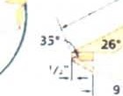

· - - 1:i "- -

1-
- 1s·- -1s·- J ,,.I_
SIOCVlCW

1¹/, dlo.
oluz;;um "--

DON'T STEAM WOOD WffHOUT AN ADULT!

,_
. - '. \
No,IOx I'/. Ra thcod screws
I.
# A (

ro ll
ha n dle

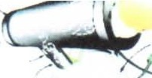
19 / , '

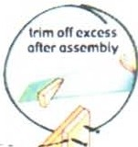
Ho.l ox I 1,· Rolhcod screws.
CC>Yntc:o lnk

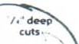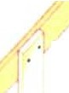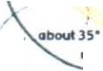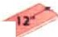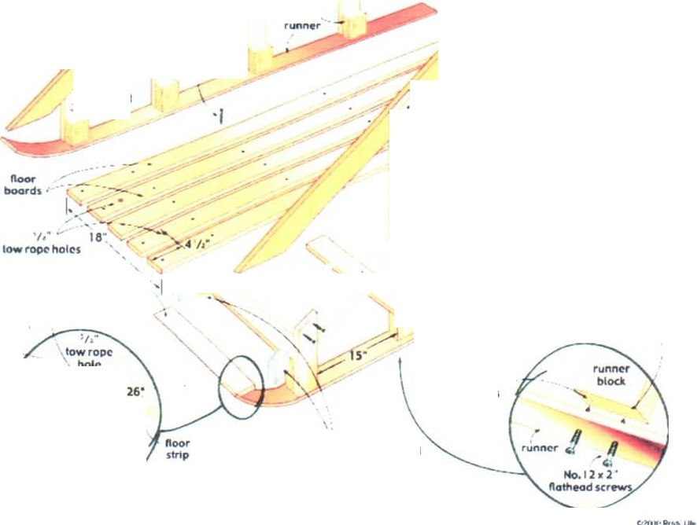.....,1·

s hort
,-- m l dd tc: upnqhl
lono mlddl•
u p rqi hl

runn• r
blod
bock ra il
, upr lqhl
screws
'h • bc:lowsurface

sloped
lop roll
•.•

fronl
- ratt
/ upri gh t

No,I Ox I / , "
sa-ew

No, 10• 1 '/,,"

Ho,1011 I '/ , "
Rolheod
screws

- main noor support

::;:;---:' r.:
ri N n er

fronlfloorsupport

Ho. l O• l"
ftoltlcad woodscrew
Ho,10 x 2 /,"
fta"1eod
Ro t h cod ...,,r b lade
1 suews ,% ' '
J ,4s• ,... , ₁ , ru n n r
pr rl ll "/,,"
scr- hot.s

wood -
i,i

sc,_

scr- front , •
floor ' :---..
u s•
tips10marl< -

suppo rt •
'I•- -
.. \
ru nn« bloclu

No. 10• ,., • •
\ slopC'd
top ra,I
1
d1090nal,,,.,..,.-.,menuore c,quol
,,,t,c,n sledIssquon.-

ftolhcad
woodscrew
runnff/ '
rROMT CORH[ R
OCTAIL

