Welcome to the Carnival of Terrors!!

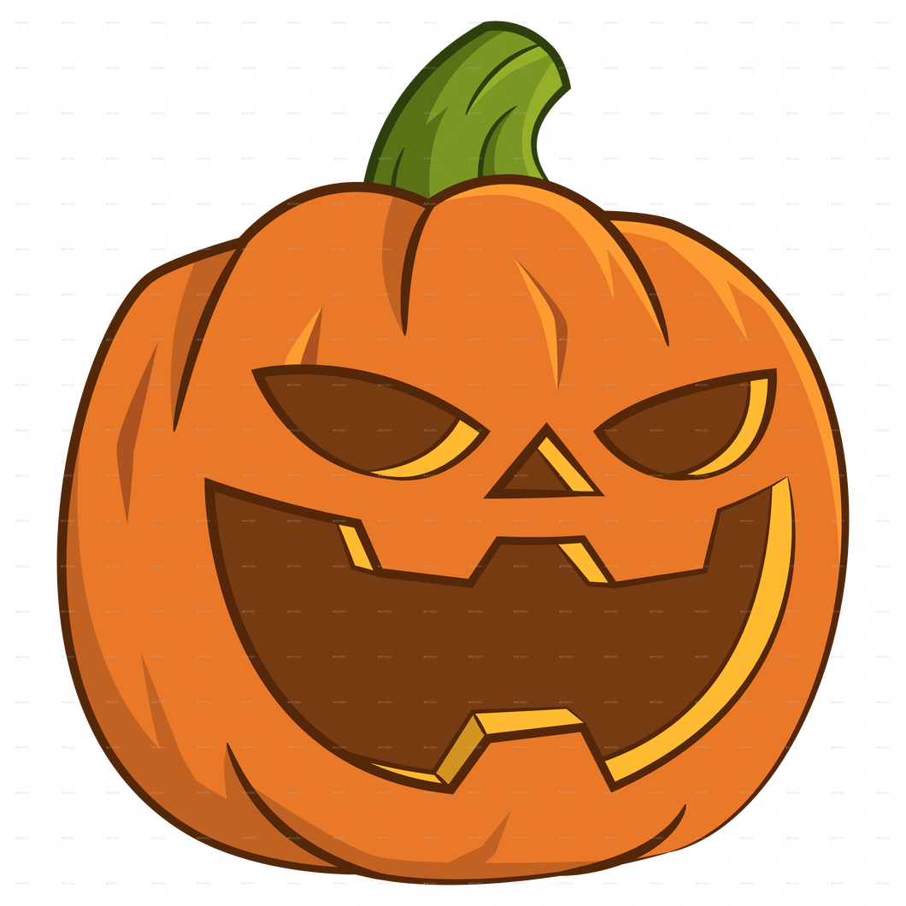

October 23-25th at Viking Bow and Gun Club

Welcome to the Carnival of Terrors Fall Camporee at Viking Bow and Gun Club. Our event chairs have been hard at work since July planning a great camporee for your unit.

Tyler Reininger Jill Ahl
Co-Chair Co-Chair
Treininger88@gmail.com jillahl@yahoo.com
920-860-7435 920-645-1184

Rules in Camp
- No liquid fuels on camp.
- No fixed blade knives
- All Scouting America Policies will be enforced
- All Safeguarding Youth Policies will be enforced
- All campfires will be above ground
- All garbage will be packed out with each unit

Order of the Arrow
The Beshkno Chapter of the Order of the Arrow, will once again run its Haunted Trail on Saturday night along with a Trading Post. Trail Location will be announced at Saturday flags.

Events:
Tomahawk Throwing, Sling Shots, Pumpkin Bowling, Nerf darts, Table Top Haunted House, Indoor Archery, and Pumpkin Toss. Units will be scored on scout spirit and Halloween Spirit.

Adult Leader Training-
Adult Leaders that need the Outdoor Portion of the Scoutmaster/Assistant Scoutmaster Training will have the opportunity to complete it at the camporee.

Adult Leader Cook Off-
Adult leaders looking for something to do on Saturday afternoon, can compete in the adult leader cookoff. Mystery judges will be supplied and the overall theme will be fall dishes. Please bring everything that you will need for the cook off.

Saturday night Movie-
Saturday night we will offer a Halloween movie inside the clubhouse for those interested.

Health Officer-
The Health Officer will be located inside the clubhouse for any health reasons.

Arrow of Light Scouts-
Please invite your Arrow of Light scouts to come join your unit on Saturday. AOLS should arrive on Saturday by 8am and can spend the night with their host Troop. Cost will be $20 for AOL’s and Leaders for the day. Each AOL Den needs to have 2-deep leadership and 1 adult needs to be BALOO trained.

Schedule:
Friday:
Check in- 4:30-7:30
Senior Patrol Leader and Scoutmaster Meeting- 8pm in Club House
Lights out- 10pm

Saturday:
Revile- 7am
Breakfast in sites- 7-8am
815- Flags
830-930- Event 1
930-1030 Event 2
1030-1130 Event 3
1130- 1:00 Lunch
130-230 Event 4
230-330- Event 5
330-430- Event 6
430-530- Event 7
550- Evening Flags
600-700- Dinner in sites
730-10pm- Movie and Haunted Trail

Sunday
7am- Reville
7am-8am- Breakfast and clean up
815am- Awards and Depart for home
ALL UNITS NEED TO BE OUT BY 9AM

