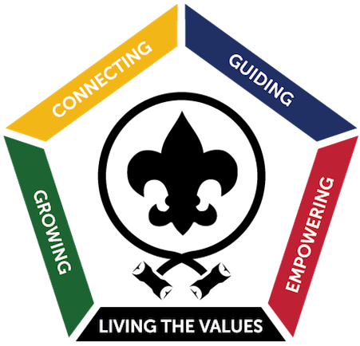
Company Name
ATTN: Supervisor
Supervisor title
address
city, WI zip

Dear Supervisor/Manager,

The Bay-Lakes Council of Scouting America is offering a course titled Wood Badge in August of 2026, and we are requesting your support in making attendance at this course possible for your employee, participant name, and other volunteer members of Scouting America.

The Wood Badge course is an advanced leadership development workshop focused on concepts that are applicable both in the workplace and volunteer organizations. Presentations and activities aimed at the development of skills including listening, communication, valuing others, team development, problem solving, and managing team conflicts are part of this five-day course.

To reinforce and hone the skills and concepts from the course, as well as to build the daily habits of leadership, participants are paired with an experienced counselor to develop a personal vision of leadership and a set of personal goals which they then work to complete in the next 18 months. Compare Wood Badge with other well-known courses listed below:

• From the Franklin Covey Solutions for Business web page:
“The Four Roles of Leadership” is an intensive workshop for leaders at all levels who want to significantly improve their strategic thinking, long-term vision, and positive influence on others.

• From the Ken Blanchard Companies Workshop web page:
“Building High Performing Teams” teaches team members and leaders how to function more efficiently, create a clear vision and purpose, empower and involve people, manage conflict and change, create an open and productive environment, and celebrate success.

These courses range from $300 to $1700 per person, and require as much as a week away from the workplace.

• From Scouting America:
Wood Badge is an extensive workshop incorporating leadership concepts that are applicable to both the workplace and as volunteers with the Boy Scouts of America.

Covering one three-day weekend and one two-day weekend, utilizing camp resources, and bearing a cost of $325 per participant, the trained volunteer staff of Wood Badge delivers an experience that resonates throughout work, volunteer interactions, and life while respecting the time, talents, and treasure of the course participants.

This is a gift of time and talent of which not all can easily take advantage. We invite you to become one of the stakeholders in your employee’s success by allowing them to attend. As part of their Employee Development Curriculum, some companies have provided all or a portion of the $325 course fee and/or granted their employees the time off with pay: I ask you and your company to consider these options.

Should you have any questions regarding this program, please contact me directly at
(920) 619-9453 or email me at gospeedbarry@gmail.com.

Thank you for your consideration.

Sincerely,

Barry Kaul

Barry Kaul
2026 Wood Badge Course Director

