Revised 9/1/2026
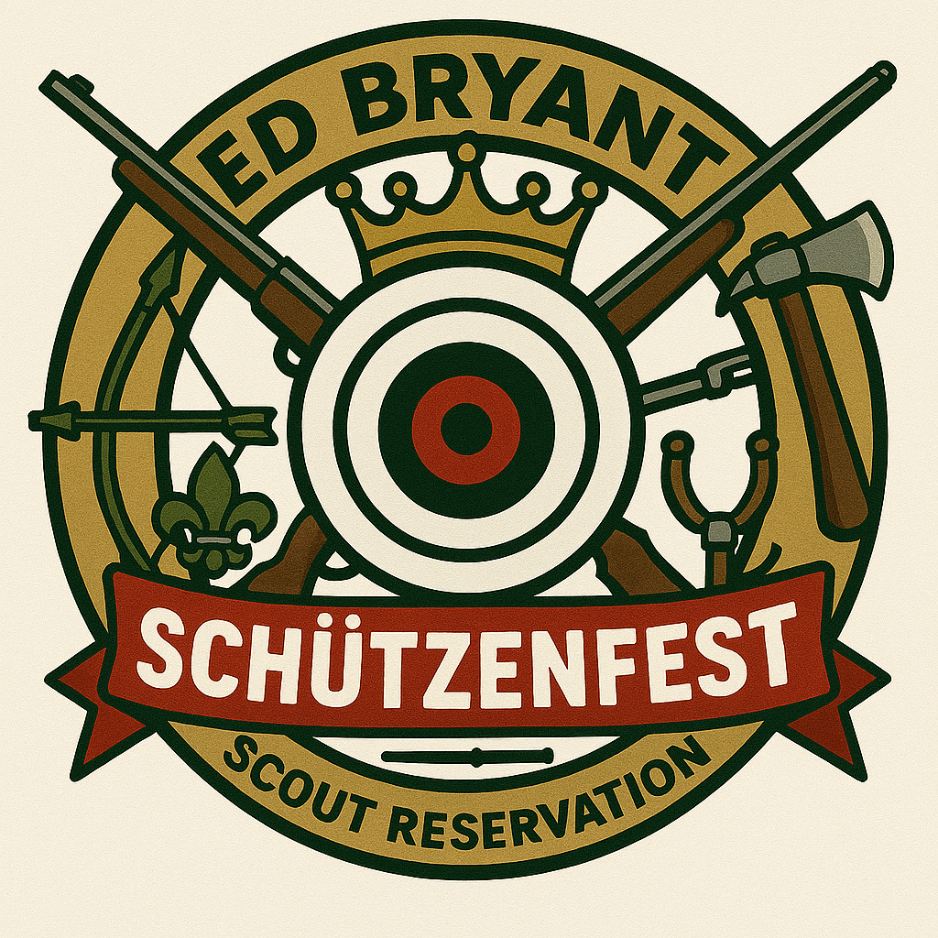

Schützenfest
Shooting Festival at Ed Bryant Scout Reservation
October 10, 2026
Event Fees
Youth or Adult Shooting Participant-$35
Adult Attendee-$10
$5 late fee if registering after September 25
Invited Staff – contact for pricing

Contact information
email scott.johnson@scouting.org
Scott Johnson 608-347-4539
What is Schützenfest?
A Schützenfest is a traditional festival or fair in the cultures of Switzerland, Germany, Austria and the Netherlands. featuring a target shooting competition
At a Schützenfest, contestants compete based on their shooting abilities. The competition's winner becomes the Schützenkönig ("king of marksmen") until the following year's competition
In keeping with the Octoberfest celebrations that are so popular in Wisconsin, The Range and Target Activities Committee is excited to bring a Schützenfest or Shooting Festival to Ed Bryant Scout Reservation on Saturday October 25. This challenge is open to youth Scouts and Adult Scouters.

Schützenfest at Ed Bryant Scout Reservation
This festival will allow Scouts and Scouters to test their shooting skills and maybe learn some new ones. This event will highlight many shooting style events from the modern era all the way back to early man. Come find out who is the Schützenkönig ("king of marksmen"). There is a youth and an adult division for the competition. Open to Scouts BSA Troops & Venture Crews only, No Cub Scout Packs.
It is highly recommended that participants have some shooting experience. Because of time constraints there will be limited skill instruction beyond what is needed to for safely shooting or throwing. It would be helpful if participants have earned at least one Range Activities merit badge.
This is one day Festival, but Troops and Crews are welcome to reserve a camp site and make a weekend event for their Unit. Some of the buildings and cabins may be open to rent as well.
Program Overview
Shutzenfest consists of 5 rounds of competition. Each round of competition participants will have the opportunity to practice and then to shoot for a score. There will be a scout division and an adult division, and a champion will be named in each of those two divisions.
Here's the list of competitions for the Shooting Fest:
- Rifle Shooting
- Shotgun Shooting
- Archery Target Shooting
- Tomahawk Throwing
- Paintball

Check-in
Check-in for the event will be in Fellowship Hall. All participants must turn in a copy of a Scouting America Heath Form Part A & B at check-in. Please park all vehicles in the camp parking lot and walk to Fellowship Hall. Anyone who needs to use a vehicle in camp for mobility issues or other reason should contact us prior to the event for a camp vehicle permit. Units who are camping on Friday or Saturday or renting and of the camp buildings must check-in with the Campmaster on duty. Camping and/or building rentals must be made separately using the Glaciers Edge reservation system.
Shutzenfest Schedule
- 8:15 Check-in – Fellowship Hall
- 8:45 Safety Briefing – Fellowship Hall
- 9:15 to 10:20 - First Session
- 10:35 to 11:35 - Second Session
- 11:45 Lunch – Fellowship Hall
- 12:50 to 1:50 - Third Session
- 1:55 to 2:55 - Fourth Session
- 3:00 to 4:00- Fifth Session
- 4:00 – Secure ranges and shutdown for winter
- 4:45 – Awards and checkout – Fellowship Hall

Range Sports Events
There will be 5 events at the camporee: Rifle, Shotgun, Archery, Tomahawk, and Knife Throwing. At each area the shooters/throwers will get specific range safety and shooting procedures briefing and then do the specified practice and scoring rounds. If time allows the shooters/throwers can do additional for fun until the rotation horn sounds.

  - Rifle Sharpshooter –Shooters will receive 15 rounds of .22 cal ammunition and fire 3 courses of 5 rounds. Courses of fire will consist of a 5 shot familiarization course, and two 5 round scored courses at a 10 place target shooting one shot at each target. Each Shooter will turn in their Target with name and unit for scoring. (up to 10 per shot, 100 points possible)
  - Shotgun Shootout – Shooters will receive 15 rounds of 12 or 20-gauge ammunition. 5 practice rounds and 10 scoring rounds. The scoring round will be 5 rounds at straight away target and 5 rounds at a crossing target. This is a Trap shooting event and each shooter will be scored by the number of clays hit. (max of 10 points per hit, 100 points possible)

  - Archery Shooter – Archery will use the standard 10-point scoring system. A hit in the center (Bulls Eye) = 10 points and each ring outward from the 10 ring declines in points 9, 8, 7, 6, 5…. Shooters will receive 5 Arrows and shoot 3 ends of 5 Arrows at 10 yards. One practice round and two rounds for score. (10 points max per arrow, 100 points possible)

  - Tomahawk Toss – Shooters will receive 5 Tomahawks and throw 3 courses at a target. One practice round and 2 rounds for Score. The hits will be scored as follows: Any Stick = 5 points, stick in the red = 10 points. (100 points possible).
Knife throwing at this station is not part of the scoring for Schützenfest

  - Paintball – Shooters will receive two cups of paintballs. One cup for practice, 20 paintballs for for score. Target will be placed at 3 distances and scored as follows: near target = 1 point, mid-range target = 3 points,
far target = 5 points.
Slingshot shooting at this station is not part of the scoring for Schützenfest

RANGE SAFETY
All Ranges will be clearly marked by fences or with yellow caution tape. No one must cross into or transit these areas as they delineate the marked boundaries of ranges. At all times Scouts and Adult Leaders must ask permission to enter any of the ranges. Everyone must follow all directions from the Range Safety Officers. Areas marked off by fencing or caution/danger tape are there for your safety and protection Do Not cross them. Please read the Firearms safety rules in this Leaders guide and ensure all of your Scouts know and Understand the Three Always.

Awards and Scoring
A “Top Shot” award will be given to the best shooters in each event for the Youth and Adult divisions. A Schützenkönig ("king of marksmen") will be awarded based on overall score from the events.

Health Forms A PRINTED copy of current health forms, Parts A and B, MUST be turned in at check-in for all participants (including adults). These forms WILL NOT be returned at the end of the Camporee. Units must also have health forms for all participants at their campsites. https://www.scouting.org/health-and-safety/ahmr/medical-formfaqs/
First Aid Units are responsible for administering medicine and basic first aid. Any injuries beyond the unit’s capability should be referred to the camp staff and medical officers. All injuries should be reported to the camp staff.
Camp Rules Units must follow the Guide to Safe Scouting, Youth Protection, and the Scout Oath and Law.
Meals A lunch will be provided on Saturday.
Gear Activity Uniforms (Troop Shirt / Scout Shirt) or other activity-appropriate wear are permitted. Please dress appropriately for the weather. Fall weather can be unpredictable, and you could be subject to temperature extremes, intense sun, rain and wind.
We Can’t Do It Without You The Shooting Fest Committee seeks adults or experienced older Scouts to assist or operate stations. In addition to people with credentials to run a range, we need volunteers to help as range assistants, with scoring, lunch and other tasks. Stations will provide all Scouts with a learning opportunity geared toward HAVING FUN. If you would like to volunteer, don't hesitate to get in touch with Scott Johnson at scott.johnson@scouting.org in advance.



FIREARMS, WHEN USED IN A SAFE AND CONSCIENTIOUS MANNER ARE A GREAT SOURCE OF FREEDOM AND RECREATION...HOWEVER, ONE CARELESS MOMENT CAN RESULT IN TRAGEDY!

PLEASE, DO NOT EVER FORGET IT!

Please review the following basic firearms safety guidelines with your Scouts before arriving to the camporee.


Eye and Ear protection is mandatory for all shooters and spectators. If you have your own eye and ear protection, plan to bring them. Ensure your name is on them.

Shooters are responsible for cleaning up after themselves, remember a Scout is CLEAN.

Never handle firearms until instructed to do so by a Range Safety Officer.

Unsafe and/or unsportsmanlike conduct is automatic grounds for dismissal from the ranges and revocation of shooting privileges.

Specific range rules for the various shooting disciplines will be explained at the start of each shooting activity.

Absolutely NO personal firearms, ammunition, archery equipment, etc. will be brought to the camporee, no exceptions. The council will provide all Firearms, Archery and other shooting event equipment for the Scouts use.

BSA, NRA and Council shooting policies and regulations will be followed at all times. All Scouts will need to know the following rules before they are allowed to enter the ranges.

ALAWAYS keep the gun pointed in a safe direction.

Safe direction shall always be down range and/or upwards

ALWAYS keep your finger off the trigger until ready to shoot

ALWAYS keep the gun unloaded until ready to use.
PLEASE REMEMBER!
Absolutely NO personal firearms, ammunition, bows/arrows, or Paintball may be brought to EBSR
10

