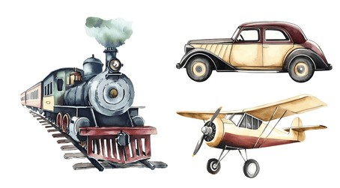
Planes, Trains, and Automobiles.

2025 Driftless District Cub Scout Overnight Camp

September 18-19, 2026

Parent’s and Leader’s Guide

Glacier’s Edge Council, Scouting America
(608) 310-7300
WWW.GLACIERSEDGE.ORG

Join us September 18–19 at beautiful Camp Carlson, near Sauk City, Wisconsin, for a fun-filled Cub Scout overnight experience! Our theme, Planes, Trains, and Automobiles, promises a variety of exciting and interactive activities that are sure to keep Scouts engaged and entertained. Can’t stay overnight? No worries — day-only participation is welcome! Register Early before all space fills up. You won’t want to miss this high-energy adventure!

Siblings are welcome to join if registered.

PRICING

OVERNIGHT
Cubs/youth overnight $25
Adults overnight $20
Includes: Friday Evening Snack, Saturday Breakfast & Lunch

SATURDAY ONLY
Cubs/youth Saturday only $20
Adults Saturday only $15
Includes: Saturday Lunch
ARRIVIAL & PARKING

ARRIVAL & PARKING
Staff will greet you and assist with getting you checked-in. Prior to arrival an email will be sent to registration contacts with more details on parking.

CHECK-IN
After you find a parking spot you will be directed to the Check-In location. At check-in you will submit your paperwork, receive a schedule, map of campground, and wrist bands, then be directed to your campsite.

SCOUTING AMERICA HEALTH FORMS
Reminder that all participants, adults and youth, are required to have parts A & B of their Scouting America health form! Please fill this out prior to arriving at camp.

OVERNIGHT CAMPSITE
Once you know where your campsite is, you'll have until 7:45 pm to get set up. Don't worry, we have staff available to help you get set up and settled.

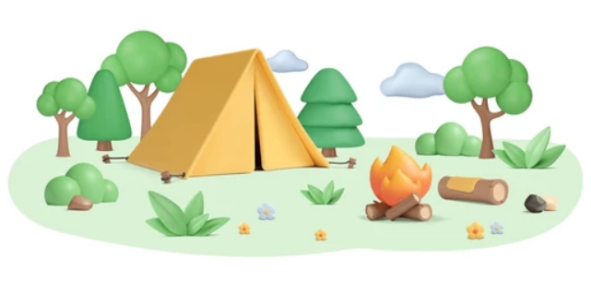
WHAT TO BRING

RECOMMENDED PACKING LIST
- Day Backpack
- Water Bottle (with your name on it)
- Hat
- Sunglasses
- Bug Spray (non-aerosol)

- Sunscreen (non-aerosol)
- Personal First Aid Kit
- Closed Toe Shoes
- Sweatshirt/Jacket
- Rain Gear
- Field Uniform or Scouting T-Shirt
- Change of Clothes
- Toiletries
- Flashlight
- Tent
- Sleeping Bag, Sleeping Pad, Pillow
- Camp Chair

PAPERWORK
- SCOUTING AMERICA HEALTH FORMS PARTS A & B (adults & youth)
- YPT or Safeguarding Youth Completion Certificate (adults)

FOOD/MEALS
- Overnight Participants: Friday Evening Snack, Saturday Breakfast & Lunch provided. Please eat supper before arriving on Friday.
- Saturday Only Participants: Saturday Lunch provided.
- So the staff can provide safe and healthy food for everyone, any dietary restrictions must be listed on the online registration form.

LEADERSHIP
Packs must provide a minimum of 2 leaders and maintain a ratio of 1 adult per 4 scouts. The only exception to this rule is if a parent wishes to attend camp with their scout individually. Siblings are allowed to attend camp with family members as long as the leadership ratio is maintained. Lions and Tigers must attend with their adult partner.

DO’S AND DON’TS FOR FAMILY CAMPOUT
- Do: Arrive early enough to check-in and set up your tent and sleeping gear prior to 7:45 pm
- Do: Scouts are encouraged to wear their field uniform or a scouting T-shirt during the event
- Do: Bring a water bottle with your name on it, basic first aid kit and personal camp chair
- Do: Use the Buddy System
- Do: Stay on trails, there is poison ivy in the woods
- Do: Follow the rules found in The Guide to Safe Scouting
- Do: Enjoy yourself and have lots of fun!

- Do Not: Bring stoves, cooking equipment or space heaters
- Do Not: Make campfires
- Do Not: Take any food into tents – critters will come into tents for food
- Do Not: Start any kind of fires in tents
- Do Not: Dig holes for any reason
- Do Not: Climb on structures or trees
- Do Not: Block the roadways – park only in designated parking areas
- Do Not: Bring fireworks, drugs, alcohol, or firearms

CAMPFIRE PROGRAM
You are welcome to perform appropriate skits and songs.

SCHEDULE


FRIDAY
Check-in – 6:00 pm
Set-up Camp – 6:00-7:45 pm
Cracker Barrel (snack) – 7:45 pm
Campfire – 8:00-8:30 pm
Lights Out – 10:00 pm

SATURDAY
Wake Up – 7:00 am
Breakfast – 8:00-8:45 am
Registration for Saturday only participants – 8:00-8:30 am
Flag & Announcements – 8:45 am
Session 1 – 9:00-9:50 am
Session 2 – 10:00-10:50 am
Session 3 – 11:00-11:50 am
Lunch – 12:00-12:50 pm
Session 4 – 1:00-1:50 pm
Session 5 – 2:00-2:50 pm
Session 6 – 3:00-3:50 pm
Closing/Awards – 4:00-4:30 pm
