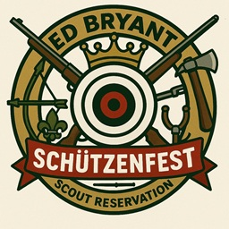
Ed Bryant Scout Reservation

Schützenfest

(Shooting Festival)

October 25, 2025

A Schützenfest is a traditional festival or fair featuring a target shooting competition in the cultures of Switzerland, Germany, Austria and the Netherlands.
At a Schützenfest, contestants compete based on their shooting abilities. The competition's winner becomes the Schützenkönig ("king of marksmen") until the following year's competition
In keeping with the Octoberfest celebrations that are so popular in Wisconsin, The Range and Target Activities Committee is excited to bring a Schützenfest or Shooting Festival to Ed Bryant Scout Reservation on Saturday October 25.
Shooting Sports are some of the most challenging and fun of the outdoor programs. This festival will allow Scouts and Scouters to test their shooting skills and maybe learn some new ones. This event will highlight many hooting style events from the modern era all the way back to early man. We will have Tomahawk Toss, Rifle Shooting, Archery, Shotgun Trap Shooting and more. Come find out who is the Schützenkönig ("king of marksmen") and the Top Troop! Open to Scouts BSA Troops & Venture Crews only, No Cub Scout Packs.

This is one day Festival, but Troops and Crews are welcome to reserve a camp site and make a weekend event. More information and the festival guide will be available on the Glaciers Edge Council website soon!

