Camping with Bigfoot

2026 Cub Scout Summer Camp
Parent & Leader Guide
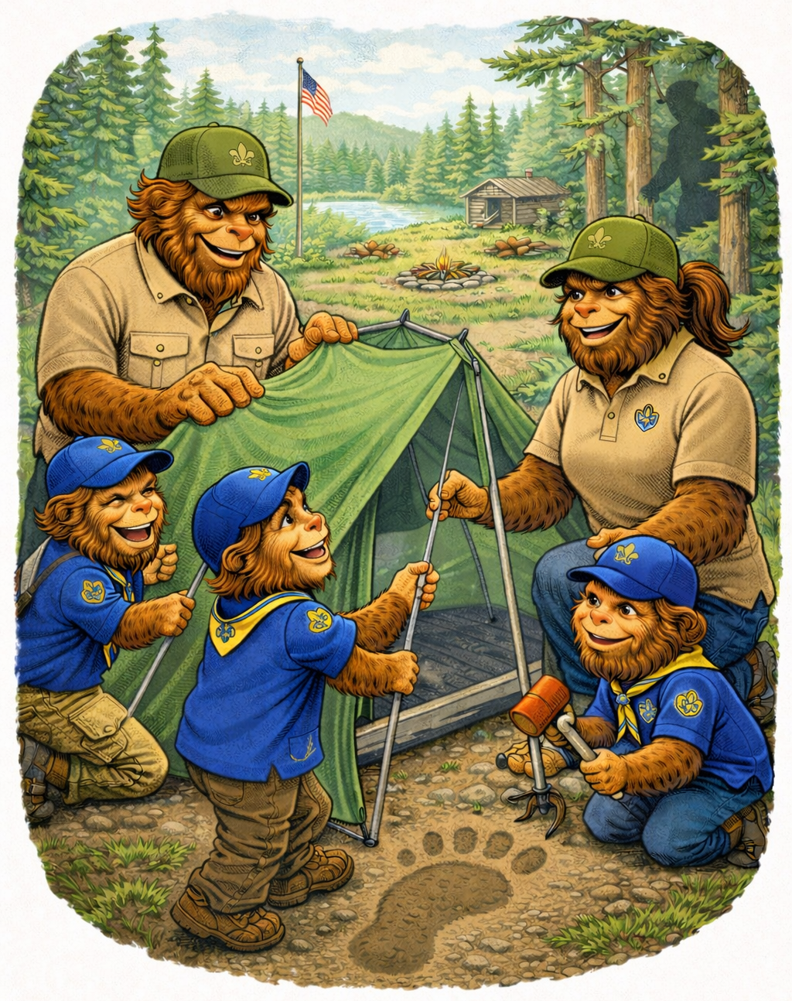
Glacier’s Edge Council, Scouting America
Ed Bryant Scout Reservation (EBSR)
Camp Begins: July 26, 2026

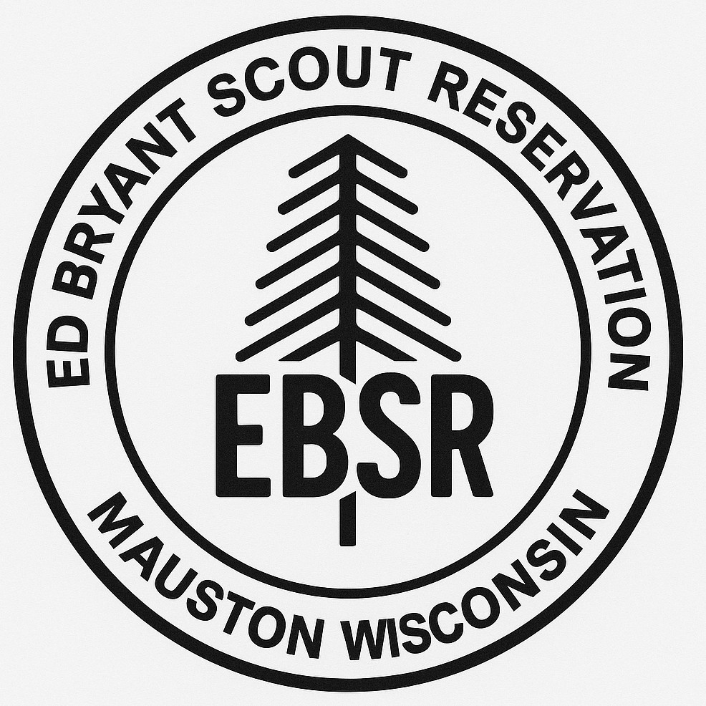
Welcome to 'Camping with Bigfoot!'

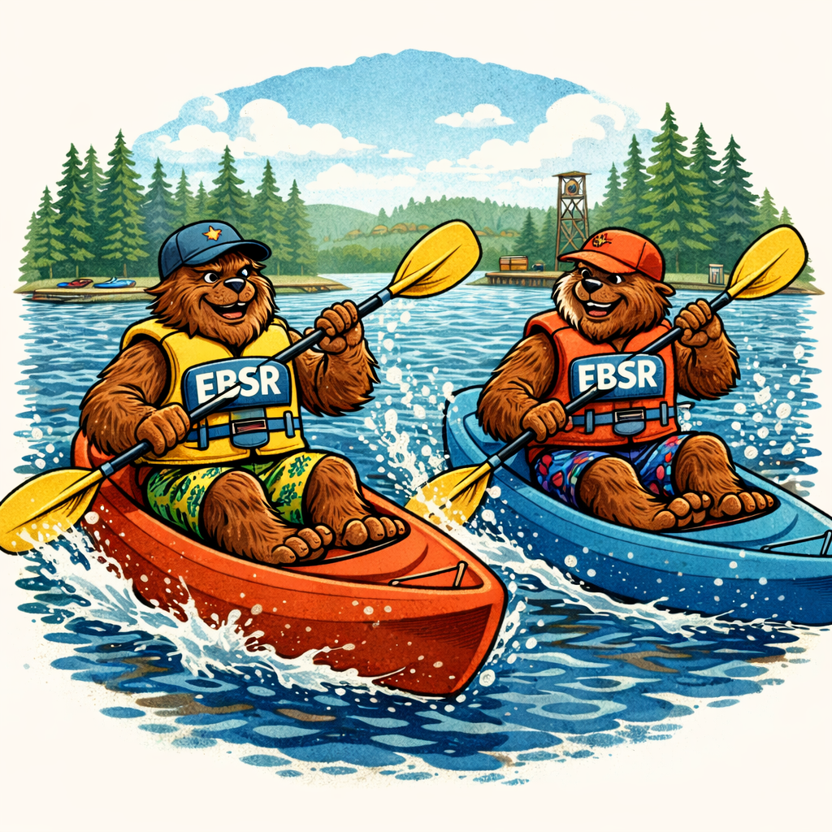
Dear Cub Scout Families and Leaders,
Welcome to the 2026 Glacier’s Edge Council Cub Scout Summer Camp at Ed Bryant Scout Reservation! This year, we invite all Cub Scouts to join us for an unforgettable adventure: 'Camping with Bigfoot!'
Legend has it that Bigfoot has been spotted exploring the woods of EBSR. Throughout camp, Scouts will learn outdoor skills, practice teamwork, enjoy waterfront activities, and participate in exciting campfire programs—all while following the mysterious trail of Bigfoot.
Our program is designed to provide a safe, fun, and age-appropriate outdoor experience for all Cub Scouts, from Lion through Arrow of Light. We are excited to partner with you to make this summer one your Scout will never forget.
Yours in Scouting,
Scott Johnson
Camp Director
Ed Bryant Scout Reservation

Camp Overview
Location: Ed Bryant Scout Reservation (EBSR)
Dates: Beginning July 26, 2026
Duration: 2 Days / 1 Night
Optional: Second overnight with departure after breakfast on Day 3
This overnight camp experience is open to all Cub Scouts (Lion through Arrow of Light).

Camp Schedule Overview

Day 1 – Arrival & Adventure Begins
12:00 AM – 2:30 PM
- Check-In
- Campsite Setup
- Swim Checks (optional for participants who want to swim in the beginner or swimmer areas)
- Program Sessions – select areas will be open
2:30 PM – Opening session, leader/parent meeting, field games for Cub Scouts
3:15 PM – 5:15 PM
- Finish Campsite Setup
- Swim Checks (optional for participants who want to swim in the beginner or swimmer areas)
- Program Sessions – select areas will be open
6:00 PM - Flags & Dinner
7:30 PM - Evening Campfire Program – presented by EBSR staff
10:00 - Lights Out
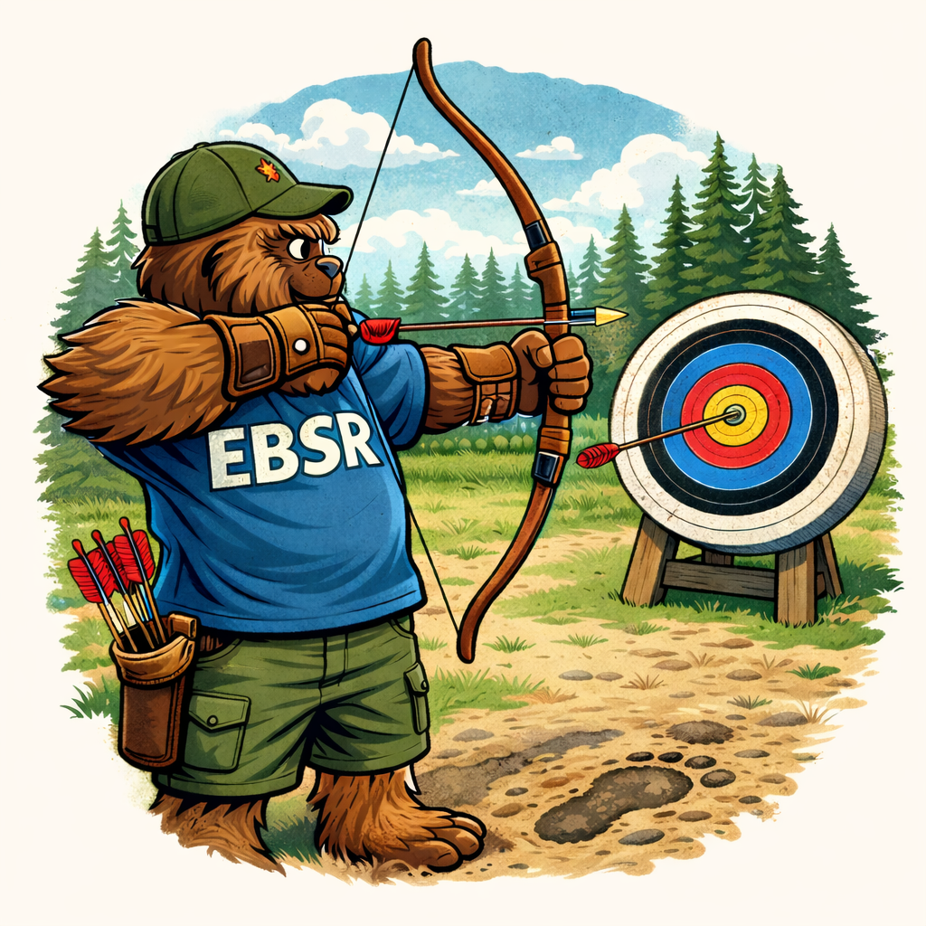

Day 2 – Bigfoot Expedition
8:00 AM- Flags followed by Breakfast
9:00 AM - Morning Program Sessions
12:00 AM - Lunch
1: 30 PM - Afternoon Activities
4:00 PM – Closing campfire – featuring Cub Scout skits, songs and stories
5:00 PM – Flags and Dinner
6:00 PM – Check out for
7:30 PM – Movie Night Under the Stars

Day 3 – Optional Departure Day
8:00 - AM Breakfast
Check out and Departure After Breakfast

Program Highlights
- Archery Range
- BB Gun Range
- Waterfront Activities & Swim Checks
- Climbing Tower
- Outdoor Skills
- Crafts & Nature Exploration
- Camp-Wide Games
- Campfire Programs
Camping with Bigfoot is a chance to relax and enjoy Ed Bryant Scout Reservation. The focus of the camp is to have fun with your family and Cub Scout’s friends rather than specific Cub Scout Adventure requirements. For the most part the various program areas will be open for participants to visit and try the activities at your own pace. Due to requirements for safety and participation limits there will be some activities that will require participants to sign up for a time slot when they arrive at camp. Some activities may only be offered at specific times. More information will be given to registered participants before arriving at camp and at the Leader/Parent meeting on Day 1.

Health & Safety Requirements
All participants (youth and adults) must provide Scouting America Health Form Parts A & B. Proof of Safeguarding Youth Training is required for all adults attending camp.

Check-in Procedures
Your Pack or group will be greeted in the parking lot by our enthusiastic Camp Staff! They will conduct a Health Screening and give the screening form to the unit leader. Staff will distribute wristbands to youth and adults. To help us ensure a safe environment, campers are provided with a wrist band to wear in camp. Your group will be assigned to a campsite and escorted to your campsite.

Aquatics
Swim checks are required for all Scouts participating in waterfront activities in the Beginner or Swimmer area of the swim beach. There will be water activities in the Non-swimmer area for those the do not take the Swim test. There will be opportunity for Cub Scout and AOL to work on aquatics related Adventures.

Meals
Meals are provided beginning with dinner on Day 1 and concluding dinner on Day 2 departure day. A grab and go breakfast will be available for those camping overnight on the second day. If you have dietary restrictions, please be sure to include them when you register for the event.

Leadership Requirements
This event is open Cub Packs Lions thru AOL and to individual Cub Scout families (all children attending must be Cub Scout age, 5-11). Packs must provide a minimum of two registered adult leaders and maintain a ratio of 1 adult per 4 Scouts.
Lions and Tigers must attend with their adult partner.
Siblings may attend with a parent. Packs with siblings attending must maintain leadership ratios.

What to Bring
Day Backpack
Water Bottle
Closed-Toed Shoes
Swim Attire
Tent
Sleeping Bag & Pillow
Change of Clothes
Toiletries
Rain Gear
Flashlight
Field Uniform & Activity T-Shirt

Pricing
Participant | Price for Day 1 & 2 | Price for Day 2 Overnight
Cub Scout or Sibling | $155 | $20
Adult | $110 | No Additional fee

Buddy System
The buddy system is to be used at all times while on camp property. Please review the buddy system guidelines with your Troop before attending camp. With the nature of open programming, special attention needs to be paid to ensure a l Scouts are prepared!

Wi-Fi and Internet
If adult leader needs wi-fi we may provide access on a limited basis. Reach out to the camp director or camp commissioner if needed.

Departures from Camp other than program scheduled check out
All Scouts and Adults are reminded they must sign out and back in each time they leave and return to camp. Sign In / Out using the Check In / Check Out Log Book, located in the Camp Office. ANY Scout leaving camp must be signed out at the office and that individual MUST be indicated as "approved" to take that Scout out of camp in Part A of the Health Form. Anyone not listed in Part A as "approved" will not be able to take that Scout out of camp without parental consent. No exceptions will be made.

Bicycles and Service Animals
Bicycles are not permitted as a means of regular transportation around camp. No pets are a lowed at camp, with the exception of service animals.

National Accreditation
The Glacier’s Edge Council Cub Scout Summer Camp at Ed Bryant Scout Reservation is a Nationally Accredited Camp.

Non-Discrimination Statement
In the operation of the summer camp program, no child will be discriminated against because of race, sex, color, national origin, age, or handicap. Any person who believes that a child has been discriminated against in any USDA related activity should write immediately to the Secretary of Agriculture, Washington, D.C.

