Cub Camp Aurora
Fun On The Frontier Adventure Trail
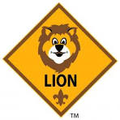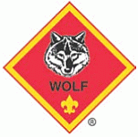
Let’s Camp Let’s Camp Let’s Camp
Build It Up, Knock It Down Floats and Boats Code Of The Wolf
On Your Mark Stories in Shapes Paws Of Skill
Count On Me Tiger Tag Race Time
Race Time Designed by Tiger Finding Your Way
Archery Race Time Archery
Slingshot Archery Slingshot
Slingshot

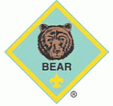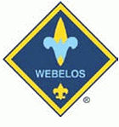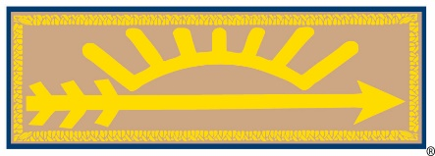
Let’s Camp Let’s Camp Into the Woods
Race Time Race Time Race Time
Marble Madness Art Explosion Archery
Archery Modular Design Slingshot
Slingshot Chef’s Knife Knife Safety
Archery Archery
Slingshot Slingshot

