Leaders Guide
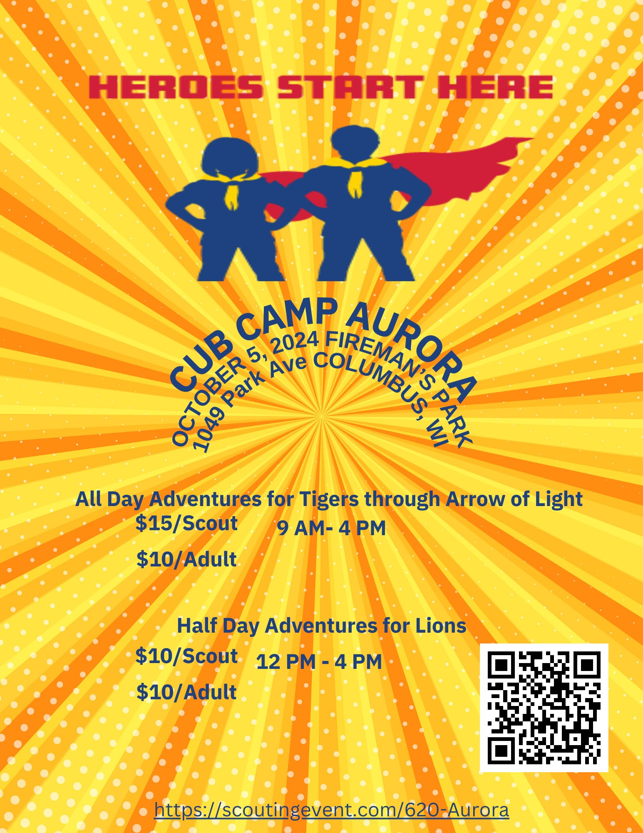
General Information
We are pleased to hold this year’s Camp Aurora (formerly known as Camp Loopy) at Fireman’s Park 1049 Park Avenue Columbus, WI. As with all Scouting America activities, we request that you follow the principles of Leave No Trace:
1. PLAN AHEAD AND PREPARE
2. TRAVEL ON DURABLE SURFACES
3. PACK IT IN, PACK IT OUT
4. LEAVE WHAT YOU FIND
5. RESPECT WILDLIFE
6. RESPECT OTHERS
The Camp Staff have chosen to govern this event by three simple rules: the Scout Oath, the Scout Law, and the Outdoor Code. We will also insist that all participants live within the Guidelines of
Safe Scouting (http://www.scouting.org/scoutsource/HealthandSafety/GSS/toc.aspx). The Camp
Chair will deal with all issues surrounding violations and deal with them on a case-by-case basis.
Camp staff are volunteers who have put in extra time to plan what we hope is a quality event. All
participants are required to respect each other.

PARTICIPANT FORMS
Each youth participant is required to have copies of parts A, B1 & B2 of their Scout Health form.
Health and Medical Record form can be found online here:
http://www.scouting.org/filestore/HealthSafety/pdf/680-001_AB.pdf
Each adult Participant is required to have copies of parts A, B1 & B2 of their Scout Health form and adult leaders should bring proof of their Youth Protection Training.
Youth Protection Training can be found at https://my.scouting.org
These forms will not be returned.

UNIFORMS
Depending on weather, your Field uniform (Class A is preferred) but Activity Uniform (t-shirt with pack logo) is acceptable. Rain gear may also be needed.

DRUGS AND ALCOHOL
Drugs and alcoholic beverages are not permitted at the camp. Standard rules from the Guide to
Safe Scouting applies with respect to prescription medications.

FIREARMS
Use of or possession of any prohibited items will result in immediate dismissal from Camp and
may result in a call to law enforcement.
ADVANCEMENT
Each scout will have the opportunity to work on requirements to earn an Adventure Loop for their Rank advancement. A list of Adventures will be provided at camp.
INCLEMENT WEATHER
During inclement weather we will shelter in the Scout Cabin or Rest Haven Shelter

Fees
All Day Adventure for Tigers through Arrow of Light
15.00 for Scout
10.00 For Adult/Scouts BSA
Half Day Adventure for Lions
10.00 for Scout
10.00 for Adult/Scouts BSA
This fee covers facility rentals, program supplies, and an afternoon snack.

Check- In & Parking
Parking will be available at the Columbus Municipal Swimming Pool (250 Folsom St.). Please plan on walking to the Scout Cabin. There will be signs placed for your convenience.
Check-in will begin at 8:30 AM at the Scout Cabin. We ask that only the registrant checks in; this will help prevent congestion in the cabin.
Each participant is required to check in when arriving at camp. Please have ready health forms for each participant (youth and adult) and Youth Protection Training certificate for each adult. These forms will not be returned.
All Lions and Tigers must have a legal guardian present at the event. Guardians are recommended for all ranks and ages.

Camp Schedule All Day Adventure (Subject to change)
8:30 Check In
9:00 Opening Ceremony/Welcome
9:10- 9:50 Session 1
10:00- 10:40 Session 2
10:50- 11:30 Session 3
11:30- 12:00 Lunch -Bring your Own lunch
12:00- 12:40 Session 4
12:50- 1:30 Session 5
1:40- 2:10 Session 6
2:20- 3:00 Session 7
3:00- 3:30 Snack -will be provided
3:30- 4:00 Closing Ceremony

Camp Schedule Half Day Adventure (Subject to change)
11:30 Registration
12:00- 12:40 Session 1
12:50- 1:30 Session 2
1:40- 2:10 Session 3
2:20- 3:00 Session 4
3:00- 3:30 Snack -will be provided
3:30- 4:00 Closing Ceremony

What to Bring
A successful camp begins with having the right equipment. For Camp Aurora, please dress appropriately for the weather. Our goal is to be outside for most of the day and proper clothing is how we ensure that.
Proper clothing for October in Wisconsin can vary from day to day, hour to hour. Please wear layers so that you can adapt to changing weather. These layers may include gloves and a hat, a long sleeve shirt, extra socks, long pants, a jacket, and much more.
In addition to proper clothing, scouts should bring the following:
Lions: Scout Book, 6 essentials: First aid Kit, Water Bottle, Flashlight, Trail Food, Sun Protection, and whistle; a pen or pencil and paper to write on
Tigers: Scout Book, 6 essentials: First aid Kit, Water Bottle, Flashlight, Trail Food, Sun Protection, and whistle; a pen or pencil and paper to write on
Wolf: Scout Book, 6 essentials: First aid Kit, Water Bottle, Flashlight, Trail Food, Sun Protection, and whistle; a pen or pencil and paper to write on
Bears: Scout Book, 6 essentials: First aid Kit, Water Bottle, Flashlight, Trail Food, Sun Protection, and whistle, Small Pocket Knife (Only if registered for Bear Claws), a pen or pencil, and something to write on
Webelos: Scout Book, 10 Essentials: Pocket Knife, Rain Gear, Trail Food, Flashlight, Extra Clothing, First Aid Kit, Sun Protection, Map and Compass, Fire Starter, Water Bottle, a pen or pencil and something to write on
Arrow Of Lights: Scout Book, 10 Essentials: Pocket Knife, Rain Gear, Trail Food, Flashlight, Extra Clothing, First Aid Kit, Sun Protection, Map and Compass, Fire Starter, Water Bottle, a pen or pencil and something to write on

Closing Ceremony
Scouting families and units are welcome to perform skits and songs.
BEHAVIOR
Closing ceremonies are for the enjoyment of attendees and should be run in observance of the Scout Oath and Law. All songs, skits, etc. will be pre-screened by the staff. Inappropriate content will not be tolerated.

Staff Contacts
District Executive: Jace Demeranville; (308) 672-2160, jace.demeranville@scouting.org
Camp Aurora Chairperson: Becky Golueke 608-712-5598 rebgolucky@gmail.com
Event Host: Anne Raeder, Pack 99
Health Officer: Alex Schlub, Glacier’s Edge Council Employee

