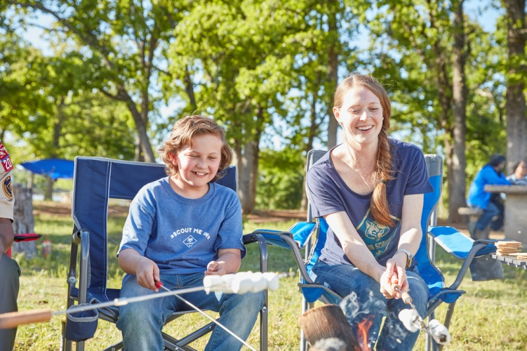
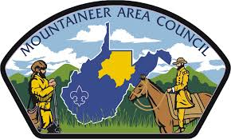
Mountaineer Area Council, BSA
August 8th 2020
Camp Mountaineer Cub Scout Day Camp Leader Guide

BOY SCOUTS OF AMERICA 187 Camp Mountaineer Rd. Morgantown, WV 26508
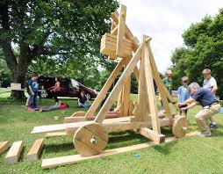
Welcome
Welcome to Camp Mountaineer Day Camp 2020. Our goal in 2020 is to make Day Camp both fun and convenient for our parents and exciting for all Scouts who attend. It is very important that all of our Cub Scouts attend at least one day camp during their time in Cub Scouts.
For many, this is the highlight of their Scouting year. It is the time that we fulfill the promise that we make to the Cub Scouts when we ask them to join the Boy Scouts of America. It is the time where our Scouts get to do all sorts of fun things from shooting a BB gun to learning how to make a fire.
2020 will be a year full of all new things. After evaluating 2019 we hosted several meetings and talked to a wide variety of families to redesign and change Day Camps as we hope to reach more Cub Scout Families than ever before. There will be a larger focus on advancements in shooting sports that include slingshots, BB guns, and archery. In addition to a STEM portion that has been added to help our Scouts learn the science behind shooting sports.
This guide is designed to provide dates and pertinent information for our Day Camps this year.
We look forward to seeing you at Day Camp this year!
Yours in Scouting,

Roger Plyman Christina Wiley
Stinger_68_1999@yahoo.com Corwin2015@yahoo.com
Camp Director Program Director

OUR WEBSITE
This guidebook is designed to offer basic information that can be shared with parents and used by camp coordinators to help Scouts to Day Camp!
The most in-depth information, schedules, policies, can be found at the website https://scoutingevent.com/615-CMDayCamp and if you have any questions you can always call the office at 304-366-3940.
This site will hold all things Day Camp including: forms, maps, programs, and links to registration. Be sure to check it out.
Be sure to like us on Facebook for up to date and news from our Day Camp!
Mountaineer Area Council Boy Scouts of America
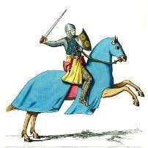
DAY CAMP DATE & PRICING

Camp Mountaineer Day Camp Date August 8th,2020
Pricing:
- Early Bird Fee ($25.00 if paid by June 12th)
- Registration- $35.00
- Late Fee ($45.00 if paid after July 10th)

DAY CAMP LEADERSHIP
Any packs attending must provide a minimum of 2 Leaders. Only exception being a Parent asks to attend camp with their child individually, if so please contact the camp Director! Any Scout entering the 1st grade in the fall may only attend with their adult partner.
EARLY DROP OFF, LATE PICKUP

We realize that it can be difficult to get your Scout to and from day camp within our check-in and out times. If you wish to arrange an alternate time please contact the Camp Director or the Scout office. Without prior arrangements, all Scouts must be picked-up by the end time of camp.
Come to Day Camp without Leaders
If your Scout wants to attend Day Camp but your Leader cannot go, please arrange leadership for your Scout. All Scouts are welcome to attend without their pack as long as leadership has been arranged.
To Register for Day Camp, Follow the link: https://scoutingevent.com/615-CMDayCamp
CAMPERSHIPS
Camperships

There are camperships available for those in need of assistance in attending camp. If you wish to apply, your Cubmaster or Committee Chair should make the request for the campership with the help of the Scout applying. Applications can be found on the council website or please contact the Scout office at 304-366-3940 and ask for the Council Representative Evan Siefke for more information. Submissions must be completed by April 3rd 2020

PROGRAM
Program
9:00-9:15 | Check in
9:15-9:30 | Opening Ceremony
9:45-10:30 | Program
10:45-11:30 | Program
11:45-12:30 | Program
12:30-1:00 | Lunch
1:15-2:00 | Program
2:15-3:00 | Program
3:15-4:00 | Program
4:00-4:15 | Closing/ lowering of flag
4:15-4:30 | Check out

Above is a typical schedule for Camp Mountaineer Day Camp. Program Rotations will include: BB Guns, Archery, Sling Shots, Field Games, Crafts, STEM and More
2020 Theme: Knights of the Roundtable
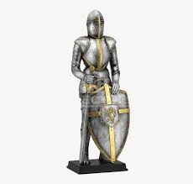
ADVANCEMENT

Each Scout will leave Camp earning 1 adventure loop for their rank AND level 1 pins for Archery, BB Guns, and Slingshots.

What to Bring
WHAT TO BRING

Please ensure that each Scout in your pack brings the following items for Camp Mountaineer Day Camp:
- Water bottle
- Hat
- Rain Gear
- Sunscreen
- Bug Spray
- Closed-toed shoes
- Backpack
- Lunch
- Some money for trading post
- Health form parts A&B
- All adults must be registered and have completed Youth Protection Training

CHECK IN/ CHECK OUT

Check in for Day Camp will be 9:00am and check out will be 3:30pm. Please ensure that all Scouts have transportation to and from Day Camp.

MEALS & FOOD

Scouts will need to bring a lunch. Please remember we do not have storage space to keep food cold, so plan accordingly.

SIBLING & WALK-ALONG POLICY

We will not be offering a sibling or tag-a long program. All children 5 years and older will need to be registered Scouts to participate.

REFUNDS
Partial refunds will only be given due to illness with a doctor’s note or a death in the family. See the Refund Request form for additional details.

