Leader Guidebook & Registration Information
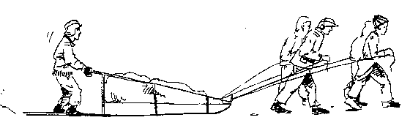
Saturday, January 18, 2020

CAMP MOUNTAINEER
187 Camp Mountaineer Rd.

Dear Scouter:

The Yukon Race is upon us again, and hopefully this year is bigger than last year. This year we will be focusing more on the basic skills all Scouts should know. Too often we rely on technology to get through everyday life. This year will be harder, it will test everyone’s skills equally. All I can say is prepare for the worst. Study up on fire building, knots and lashings, first-aid, measuring, Scout History and if you had any troubles in the previous years in any event, try to focus on improving there. We will be having the same basic stations, with just a few slight changes.
Please take the time to read the Leader Guidebook and become familiar with its contents. The rules, events, and structure differ slightly from year to year so please review it thoroughly.
As always:
- Adults have the option to purchase a hot lunch so they don’t have to go find their unit’s location.
- Units will be given a course, however, they are permitted to skip a station that is backed up and return to it.
- The race will go until 3:30 PM, the end of the event being 4:30 PM( or earlier, depending on how quickly the teams return)
- Friday night camping and First Year Participation will be counted as bonus points. Friday Night camping will only be counted as a bonus if in tents or Adirondacks. Camping in buildings will not count as a bonus!!!
This year we would like to extend an invitation to any Venture Crews or Explorer Posts to attend and compete as well.
As we have done in the past, we will have a shotgun start at 9:00AM on Saturday. Camping is encouraged Friday night, but not required. No program is provided Friday, so units must make provisions for accommodations and meals.
Additional Reminders:
Food will not be provided. Patrols need to pack their lunches (MUST BE A HOT LUNCH). Hot chocolate and coffee will be available in the Dining Hall all day for adults and after the race for youth.
Section 3 lists the personal, Patrol and event equipment. HOWEVER, Patrols are not limited to those materials. Additional materials can be brought, but you may or may not be able to use it depending on the event. Some events are based on limited resources and some will be based on being prepared. It’s a gamble, but it’s yours to make.
Each Unit is required to provide two-deep adult leadership per Scouting guidelines. The event will also need extra help staffing the stations and other areas throughout the day. Older Scouts not participating in the Yukon Race are encouraged to volunteer at the stations or scoring.
We will also need volunteers for sled registration, scoring and hospitality crew for the Towns. For information on how to volunteer please contact Clay (contact information below).
Don’t be afraid to ask questions prior to the event. Having your Patrols prepared will help make this event fun for all. Any questions should be addressed to Clay Zinn, (304)777-8214, clayzinn15@yahoo.com.
Yours in Scouting,
Clay Zinn Yukon Territory Governor
Date: | Saturday, January 18, 2020  Rain date, if necessary, will be Saturday, February 1, 2020
Time: | Registration is 7:30 AM to 8:30 AM. Event ends at 4:30 PM
Place: | Camp Mountaineer, Cub Scout Pavilion (pavilion next to parking lot, top of hill)
Start: | All Patrol Leaders must arrive with their Patrol members and sled by 8:30 AM and report to the Cub Scout Pavilion for registration and initial inspection. All “towns” will open promptly at 9:00 AM. NOTE: Vehicles must stay at the top of the hill unless camping overnight.
Teams: | Patrols must be more than four Scouts but less than ten Scouts. One Scout is to be the driver; all remaining Scouts pull the sled. If a Patrol has less than four Scouts, they will be combined with another Patrol.
Cost: | $11 per person if pre-registered by January 10th, $13 thereafter and at the door. Adult lunches can be purchased for $5. Anyone planning on volunteering will not be required to pay, but please contact Clay Zinn prior to the event so we have an idea of how many volunteers we need to feed.

YUKON RACE SCHEDULE

TIME | EVENT
7:30 – 8:30 AM | Inspection \ Registration
8:45 – 8:55 AM | Welcome \ Introductions
9:00 AM | Race Starts
3:30 PM | Race Ends
4:00 – 4:30 PM | Awards and Closing

BASIC INFORMATION / SAFETY
- Fee for the Race includes a Yukon Race patch, hot beverages at the Dining Hall, program materials, facility usage fees and insurance costs.
- For emergency reasons, we require that at least two adult leaders per Unit (both must be over the age of 21) remain on Camp property during the Race.
- Patches and awards will be given at the closing of the event.
- Adult leaders are strongly encouraged to help staff the stations. To volunteer at a station, contact Clay Zinn at (304)777-8214 or clayzinn15@yahoo.com.
- If a Patrol fails to complete the trail, they must check with a station judge BEFORE leaving Camp to confirm withdrawal and departure.
- Patrols must follow trails and/or roads to reach all stations. Pushing, shoving, harassing, blocking, or hindering any other Patrol will not be tolerated. As always, proper Scout conduct is expected throughout this event.
- Be prepared for all stations. Additional material for the stations will be provided, but at a cost to the final score. Everything should be “packed in” by your sled team.
- In the event of someone getting hurt, you should contact the nearest Town (station) adult. There will be medical personnel on site.

RULES

- This is a race and the entire event is timed. There will be a shot gun start and a finish line.
- COURSE ROUTE
  - All possible course routes will be written down and placed on 3X5 cards
  - Each Patrol will draw their course. This will happen immediately after the Patrol checks in on a first come first serve basis.
  - The Patrol should keep the course route on them at all times and present the route to each Town Mayor for signature before participating in the event. Units will be allowed to skip stations but all stations must be met before completion.
- Sled rules are discussed in Section 4.
- There will be a total of eight Towns (stations)
- Adult leaders who are not staffing stations should not be in the station areas while Patrols are competing. Station volunteers are NOT to be involved in scoring their own Unit’s Patrols. Any adults caught assisting their Patrols in the race, whether it is pulling the sled or completing the activities, will be disqualified. Adults are encouraged to attend the training and discussions in the Dining Hall to avoid issues.
- Each Town will host an event and be scored based on three criteria:
  - Skill Level – The quality of the events final outcome and how it was accomplished
  - Group Participation – Were multiple people involved or did one or two Scouts complete the task on their own? Was delegation and leadership skills used?
  - Scout Spirit – Was there fighting and yelling amongst the Patrol or did they work together to accomplish the task? Did they seem cheerful and glad to be there?
- Each of the three criteria will be given a score from 1 to 5, with 1 being “Poor” and 5 being “Excellent.” A Patrol can earn a total of 15 Points per event. If a Patrol cannot complete the event, the maximum they can receive is 7 points. Some of the stations are setup to test individual skills, where each individual score contributes to the overall Patrol score. Patrols should ask for the scoring criteria before they begin the task. All points given by the event judges (town mayors) are final.
- If a Patrol does not have the material, or runs out of the material needed to complete a “town activity”, they can use material provided, but will lose points based on preparedness
- It is the responsibility of the Patrol Leader to confirm the Town Mayor (station adult) checks you in and awards you the correct amount of points.
- LUNCH
  - Patrols are to pack their own lunches on their sled along with any material necessary to cook it. They must have a “hot lunch” using a back packing stove or hobo stove.
  - Patrols will eat lunch after completing their fourth town. They must eat at that location so the mayor of that town can sign off that the Patrol met the requirements. The Patrol will be REQUIRED to stay in the town for 30 minutes for lunch. The mayor will give 10 min, 3 min, and 30 second countdown.
  - Failure to meet these requirements will result in a 15 point penalty.
- FINISH
  - Patrol and their sled (not just the Patrol) must cross the finish line to complete the race.
  - Those Patrols that do not finish the race cannot win the race no matter how many points they received.
  - The race ends at 3:30 PM. The only exception is if only two Patrols have crossed the finish line by 3:00 PM. In that case, the race doesn’t end until a third Patrol cross the finish line or 4:00 PM, whichever comes first.
- Scores
  - Once a Patrol’s sled crosses the finish line, the time will be recorded.
  - The Patrol will turn in their score sheets and the points will be tallied, along with any penalties and bonuses.
  - For each point under 120(perfect score), 4 minutes will be added to the total time.
  - If a team earns more than 120 points (perfect score on each event + safety bonuses/overnight camping/first year participants), then 4 minutes for each point over 120 is subtracted from their final time.
  - The Patrol with the shortest time wins!
Example:
The Persian Patrol crosses the finish line at 12:14 PM. They left the start line at 9:00 AM so their total time is only 3 hours 14 min. After scores are tallied they received a total of 55 points because they weren’t prepared, didn’t show Scout Spirit, and thought they could just run through the competition to finish first. Take 55 points and subtract it from 120 possible and you get 65. 65 missing points at 4 min per missing nugget is 260 minutes. The new time for the Joker Patrol is 7 hours 34 min.
The Spartan Patrol crosses the finish line just at 3:00 PM. They left the start line at 9:00AM so their total time is the maximum amount of 6 hours 0 min. After scores are tallied they received a total of 100 points because they are made up of Vigil Eagle Scouts who prepared for a month in the snow. Take 100 points and subtract it from 120 possible and you get 20. 20 missing points at 4 min per missing nugget is 80 minutes. The new time for the Spartan Patrol is 7 hours 20 min.
Sparta wins.
NOTE: It is better to be prepared, stay motivated, work as a team, and conduct all events to the best of your ability while keeping Safety as your top priority to win this race.
- Bonuses – The following are additional Bonuses that can be earned by each Patrol
  - Camping out Friday night -4 min
  - For each First Year Participant -4 min
- Tiebreaker - If a tie occurs, a knot challenge will be completed by each Patrol. The fastest Patrol wins.

EQUIPMENT
PERSONAL EQUIPMENT

- Mess Kit and eating utensils for each Scout
- Rain/snow gear
- BSA Folding pocketknife (NO FIXED BLADES ALLOWED, ONLY FOLDING BSA 3 3/8” max blade or less)
- Cold weather clothing, gloves and cap, extra pair of socks in coat pocket
- Weatherproof shoes or boots
- Paper and pencil
- Sunglasses (optional)
- Hot Warmers (Hand, Body, Toe) (optional)

GENERAL PATROL EQUIPMENT:

Sled
- Water
- Patrol cooking gear
- Hobo stove with firewood/charcoal or backpacking stove (for cooking lunch)
- Lunch for each member
- Patrol first aid kit
- Sled repair kit (RECOMMENDED!!!)
- Water jug(s) to hold 2 gallons of water
- Watch
- Paper/mechanical pencil or regular pencils, clipboard within a plastic bag (Pens may freeze)
- Complete roster of all Scouts

EVENT EQUIPMENT:

- Qty 5 minimum – 3 ft pieces of rope
- Patrol Flag
- Minimum of 2 compasses
- BSA Handbook
- 1 blanket – full size minimum
- Plastic zip lock bag
- Fire Starting Implements (Flint and Steel, Battery and Steelwool, Ferrous Rod, Matches, etc.) More points will be awarded for more primitive methods.
- Fire starter – tinder
- Kindling
- 6 triangle bandages
- Backpacking first aid kit
- Axe or Hatchet (with sheath)
- Bow saw (with sheath)
- Pocket knife
- 2 splints
- Water pot
- Drinkable water
- Paper and pencil
- 4 wooden staves (approximately the size of a hiking staff)
- Clipboard (Recommended)
- Sled Repair Kit

SLED INFORMATION
Sleds can be made in all sorts of styles and shapes as the Patrol desires. The only requirements for the sled are:

Sled must have rope for the sled to be pulled.

Sled can NOT have wheels, moveable treads, or any other means of assist in moving the sled. If a sled is brought with wheels, they must be removed. If the wheels cannot be removed, the Patrol will be given the option to pack their gear to each station in backpacks, just as long as it is done safely.

Sled repair kits for your particular sled are highly recommended as the rugged trails of Camp Mountaineer can take a toll on the sled… especially if there is no snow.

The following pages give examples of different sled designs:

GENERIC SLED SPECIFICATIONS:

If commercial skis are used as runners, they should be reinforced with a 1” x 4” or heavier boards (preferably oak or other hardwood). Sleds should have wire or cloth on the sides to prevent the loss of Patrol gear. Side rails make lifting of the sled easier over ditches or logs. The drawing of the sled below should only be used as a guide by the Patrols in designing their personal sleds.

TIPS: Use screws instead of nails. Drill screw holes first to avoid splitting wood. Varnish the bottom of the runner if you use wood, and then wax it up before the derby. If you wish, add wire netting or a canvas snow curtain to hold the Patrol gear on the sled. Old skis may be available free from ski shops for the asking. Countersink and metal screw skis to bottom rail.

Secure the towing bridle firmly so that the "huskies" don't become separated from the sled.

BILL OF MATERIALS

A. 2 pieces 2"x6"x6'6" runners
B. 4 pieces 2"x2"x18" cross supports
B1. 1 piece 2"x2"x20" cross support
C. 4 pieces 1/2"x4"x5' floor planks
D. 2 pieces 1"x2"x40" rear uprights
E. 2 pieces 1"x2"x31" second rear upright
F. 2 pieces 1"x2"x22" second front upright
G. 2 pieces 1"x2"x18" front uprights
H. 2 pieces 1"x2"x6' hand rails
I. 1 piece 1"x4"x16" tow bar
J. 1 piece 1"x2"x20" handlebar

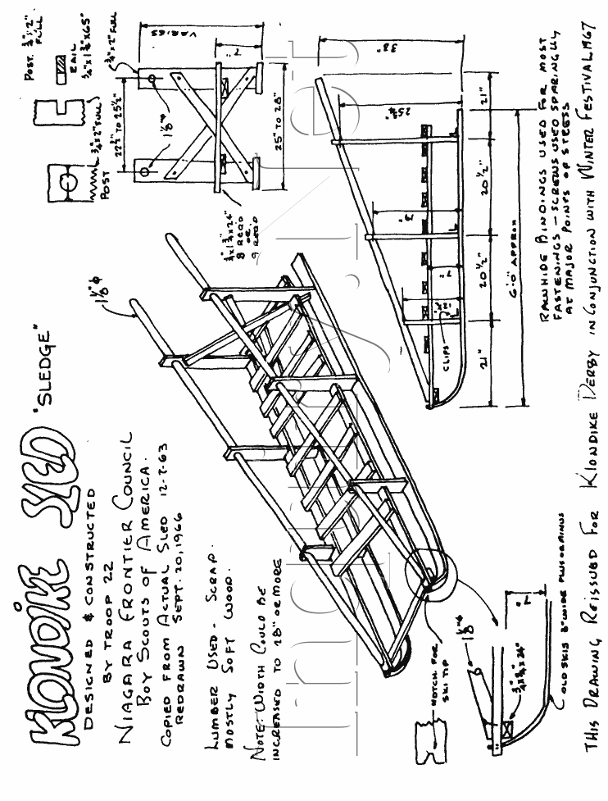
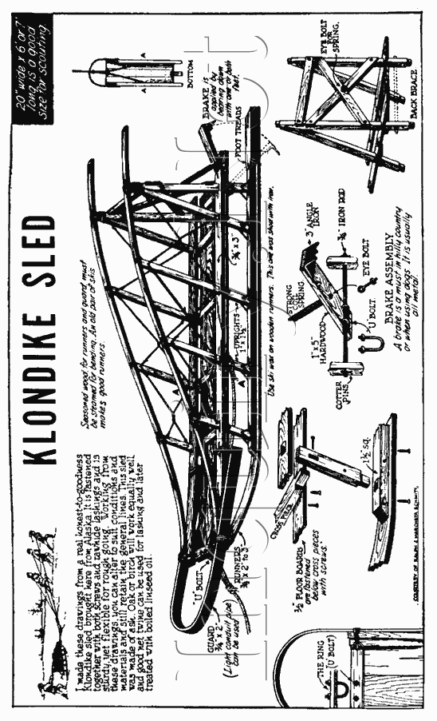
2020 GREAT YUKON RACE
January 18, 2020
Camp Mountaineer

The gold is out there and any Patrol can win!

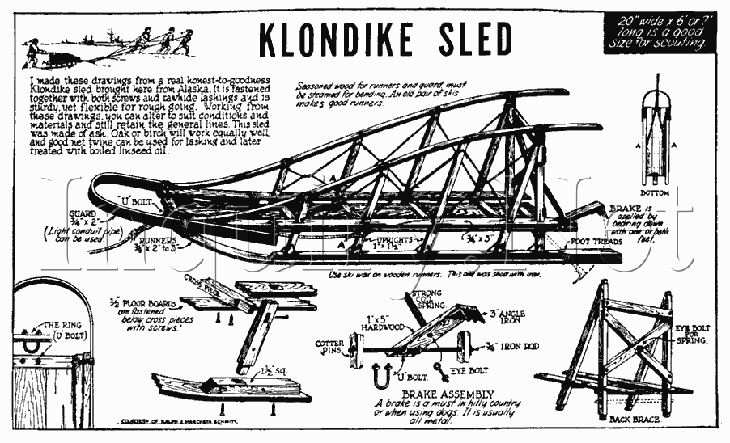
Mountaineer Area Council’s Great Yukon Race registration begins at 7:30 AM, with a Shotgun Start at 9:00 AM sharp. Camping is encouraged Friday night but program is not provided, so units must make provisions for accommodations and meals. Each Patrol (more than four Scouts but less than ten) competing will be asked to demonstrate knowledge in different Scouting skill areas and will be judged based on their level of performance and how quickly they complete the course.

Schedule of Events
7:30-8:30 AM - Registration and check-in for units not camping
8:45 AM – Welcome \ Introductions
9:00 AM - Event Start
3:30 PM - Event End
4:00-4:30 PM - Awards and Closing
New Challenges for Scouts!
Patrols bring their own lunch. Adults can opt for a hot lunch! Hot Chocolate & Coffee provided all day for adults, after the event for youth.
Please complete registration and submit to Mountaineer Area Council by January 10th, 2020 to receive the Early Bird fee. This also assists coordinators in planning and purchasing for the event.

Reminder: All participants need to bring a current copy of their
BSA Annual Health and Medical Record to events

Great Yukon Race Registration Form
Saturday, January 18, 2020
Camp Mountaineer

Please complete and submit to the Mountaineer Area Council by January 10th, 2020

Troop / Crew #_____________ Number of Patrols_____________

Unit Contact Name ___________________________ Phone _______________________
E-mail Address ________________________________________________________________

Name of Patrol(s) __________________________________________________________________

Friday Night Camping: Yes____ No _____ Campsite Requested: 1st Choice____________
2nd Choice____________
3rd Choice____________

Fees Early Bird After the 10th & Day Of
Number of Youth Attending _________ (x $11.00) = __________ (x $13.00) = _________
Number of Adults Attending _________ (x $11.00) = __________ (x $13.00) = _________
Number of Adult Hot Lunch _________ (x $5.00) = __________ (x $5.00) = _________
Form of Payment
Cash______ Check # _______ Credit [Circle One] Visa / MasterCard / Discover
Name (as it appears on the card) _________________________________
Number ________-________-________-________ Expiration date ____/____ CVC code______
Billing Address ______________________________________________
______________________________________________

Total Submitted ______________

Online Registration available at http://www.macbsa.org

YUKON RACE PATROL ROSTER
(Kept with the Patrol Leader of the Sled)

For units entering more than one patrol: Copy this page and fill out for each patrol

Unit Number

Patrol Name

Scout Name | Totin’ Chip (circle Y or N) | Fireman Chit (circle Y or N)
PL - | Y N | Y N
APL - | Y N | Y N
 | Y N | Y N
 | Y N | Y N
 | Y N | Y N
 | Y N | Y N
 | Y N | Y N
 | Y N | Y N
 | Y N | Y N
 | Y N | Y N
Total Youth In Patrol:

 | Must Be Turned In At Registration
 | Troop: |  | Patrol Name:
 | Campsite (if camping overnight):
 | Number of Youth: |  |  |  | Number of Adults:
 |  |  |  |  | Number of Adult Lunches:
 | Name: |  |  | Youth/Adult (Y/A) |  | First Year Participant Y/N (Youth Only) | Camped Overnight Y/N (Youth Only)
1
2
3
4
5
6
7
8
9
10
11
12
13
14
15
16
17
18
19
20
 | *Specify Senior Patrol Leader (SPL) and Assistant Senior Patrol Leader (ASPL)
 | ** Early bird Price: $11 After 10 January 2020: $13 Adult Hot Lunch Available $5
 | ***Staying overnight in any building will NOT be counted as bonus points. Camping must be done in tents or Adirondacks

