Mountaineer Area Council, BSA
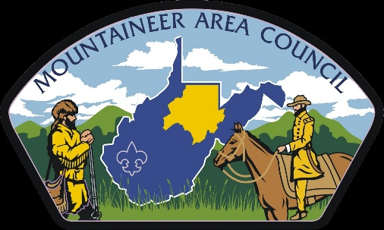

2019
Cu b Scout Day Camp
Leader Guide

Welcome

Welcome to Day Camp 2019.
Our goal in 2019 is to make day camp convenient for our parents, and exciting for our Scouts. It is vitally important that all our Cub Scouts attend a day camp at some point when they are a Cub Scout. For many, this is the highlight of your scouting year.
2019 will be a year of new format and change in Day Camp as we found that what we were offering did not fit the needs of our Cub Scout Families in the previous year.
For 2019, we have changed the program to ensure this year truly meets the wants and needs of our Cub Scout families. We are proud of what we are presenting for day camp in 2019.
New this year, we are experimenting with offering day camp where we provide the leadership for your Scouts.
This guide is designed to provide dates and pertinent information for our day camp this year.
We look forward to having you camp with us!

Camp Director Program Director
Evan Siefke Christina Wiley
Evan.Siefke@scouting.org Corwin2015@yahoo.com

Website
This guidebook is designed to offer basic information that can be shared with parents and used by camp coordinators to get packs to camp! The most in-depth information, exact schedules, policies, can be found at the website http://www.MACBSA.org This site will hold all things day camp including: forms, maps, programs, and links to registration. Be sure to check it out.
Be sure to like us on Facebook for up to date and news from our Day Camp!

Mountaineer Area Council Boy Scouts of America

Dates and Pricing
Day Camp Dates
August 1-3 Fairmont, East Marion Park
August 5-7 Morgantown, TBD
Day Camp Pricing
Early Bird Fee ( pay by May 31st) - $50.00
Late Fee ( if paid after June 15th)- $70.00
Day Camp Leadership
Packs must provide a minimum 2 leaders. The only exception to this rule is for Tigers who Must have an parent with them at all times.
Pick up
All Scouts must be picked up at 4:30pm.
Come to Day Camp without Leaders
If your Scout wants to attend day camp, but you or your pack cannot provide leadership, they can come anyways! Remember Tiger Scouts must have a parent with them.
To Register for day camp follow the link

Program
Day 1 | Day 2 | Day 3
Check in Daily
Opening Ceremony
Program Rotation
Three
45min stations
Lunch and Lunch Program
Program Rotation
Three
45 min stations
Family day on Saturday/ Camp Fire
Closing/ Lowering of Flag

Above is a typical schedule for Day Camp. Program Rotations will include: crafts, archery, slingshots, and more.
2019 Theme: Beneath the Sea
Advancement
Each scout will leave Day Camp earning a partial loop for there rank and Level 1 pins for Archery and Slingshots.

Tigers- Games Tigers Play/ Team Tiger
Wolves- Call of the Wild / Council Fire
Bears- Bear Necessities/ Baloo the Builder
Webelos- Into the Wild / Castaway
What to bring
Please ensure that each person in your Pack brings the following items for Day Camp
- Water bottle - Hat- Rain Gear- Sunscreen – Bug Spray
- Closed toe shoes – Backpack -Lunch – Towel – swimsuit (girls must be in one piece swimwear – some cash for Trading Post
Check in/ Check out
Check in for day camp will from 8:15am and check out 4:30pm each day program will begin at 8:45am. Please plan for check-in on day one to take more time then the rest of the camp.
Camp wraps up everyday at 4:15pm and all Scouts need to be picked up by 4:30pm. Please ensure that all Scouts have transportation to and form day camp.
Meals and Food
Lunches will not be provided Thursday and Friday. So Scouts will need to bring a lunch. Please remember we don’t have any places to keep food cold so plan accordingly. Saturday there will be pizza provided for lunch. This is for Scouts only. If families want to attend they will need to plan accordingly. Also new this year is a Trading Post. Please remember this will only have small things and should not be used for lunch.

Pets
With the exception of service animals, no pets are allowed at Day Camp.

Sibling and Walk-Along Policy
Per Scouts BSA we can not allow siblings who are not Registered. (Siblings can be registered day of camp)
Refunds
There will be No Refunds given.

