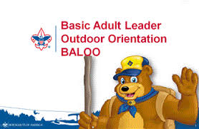**When: June 21st & 22nd, 2025**

**Where:** Sandscrest

**Cost: $60.00** by June 4th

$70.00 June 5 – June 16

**Time:** Registration 8:30- 9:00 Sat.

Classes run to about 1:00 on Sunday.

**Who:** Any and all registered adults.

*You MUST have at least one BALOO trained adult leader present for your pack to be able to go camping. Recommend several leaders from the pack be trained. Remember our motto – Be Prepared. You cannot camp unless BALOO trained leader is present.*

**Pre-requisite** – take online BALOO courses. If unable to do so, let us know ahead of time and arrangements will be made for you to take it during course.

Go to Myscouting.org and click on Training then Position Specific Courses. Scroll down to BALOO and click “click here” to access the training. Enroll and take the four modules. This will take about 35 minutes

**NEED TO BRING**: tent, sleeping bag, sleeping pad or mattress, water bottle, flashlight, rain gear, change of clothes, sturdy shoes, sleeping clothes, toiletries, camp chair, pen or pencil. Face masks recommended but not required.

For more info please contact:

Nina Cleaver, n2scouts@gmail.com or Melissa Reinbold 304-277-2660 x104

**Registration opens May 31st and closes Monday June 16th.**

**Must have a minimum of 8 registered or training will be cancelled**

Register ONLINE at mountaineerscouting.org. Click on Events then Calendar. Go to event date – click on BALOO or go to

https://scoutingevent.com/619-BALOO25

**NOTE:** Health forms are required. Please bring with you and they will be returned at end of event. Forms are available on the event calendar.