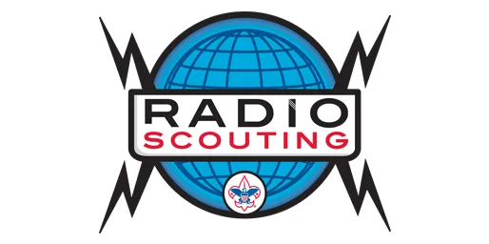

**Jamboree On the Air Camporee 2025**

October 17th-19th 2025

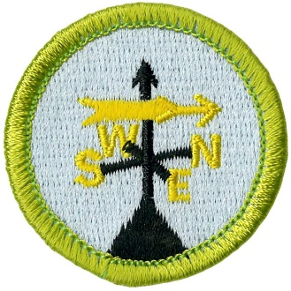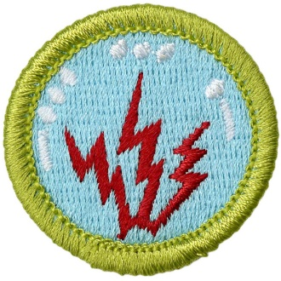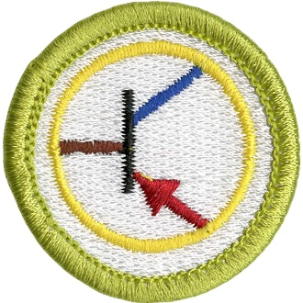

More information to come but plan to offer Radio merit badge, Weather merit badge and Electronics merit badge. Will also have fox hunts ballon launches and lots of opportunities to talk to scouts worldwide.

