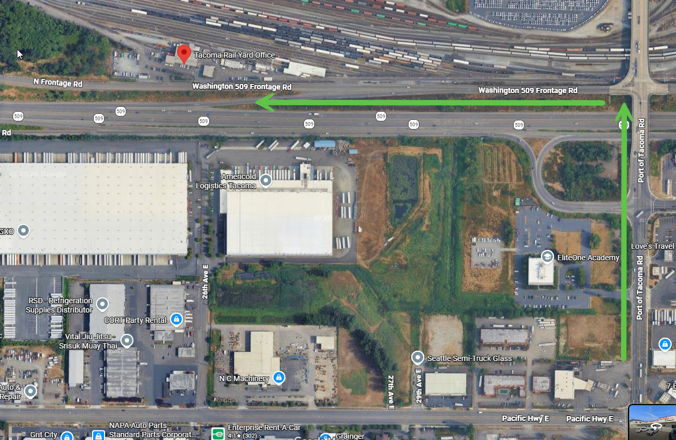
You have to come in via Port of Tacoma Road. If you are coming from the south then you make a left onto S Frontage Road.
You have to travel on Frontage Road; there is no access from 509 itself.
Often (but unfortunately not always) “Tacoma Rail Yard Office” works to get folks there on Google maps.
Tacoma Rail is located at 2601 State Route 509, South Frontage Road, Tacoma, WA.

