What is Wood Badge
Started in 1919 by Robert Baden-Powell, Wood Badge combines leadership development, teamwork, and the patrol method.
Participants gain practical leadership skills that can be applied in:
- Scouting
- Work
- Home
- Community Leadership

Leadership Topics Include
- Know Thyself
- Communicate Effectively
- Learn to Listen, Listen to Learn
- Managing Conversations
- Plan with a Bias for Action
- Embrace and Lead Change
- Inspire the Heart

The Wood Badge Ticket
During the course, participants create five meaningful goals designed to strengthen their unit and grow their leadership skills.
Complete your ticket within 18 months to earn the Wood Badge beads, neckerchief, and woggle.
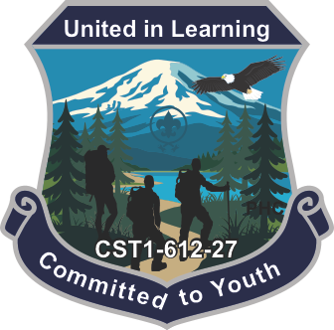
For More Info
Contact the Course Director
Justin Lewis
406-437-4410
WoodBadge@PacificHarbors.org

Scan the QR code or register online:
https://scoutingevent.com/612-2027WoodBadge
Challenge yourself.
Grow as a leader.
Build lifelong friendships.
Experience the best leadership training Scouting has to offer.
Register today – courses fill quickly!

Wood Badge Course
CST1-612-27
It’s challenging and it’s fun!
Imagine spending five unforgettable days with passionate Scouters from across the council, learning, growing, laughing, and building lifelong friendships.
Are you ready for the challenge?
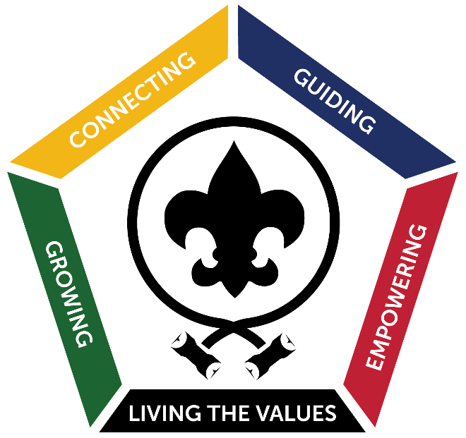
When
Weekend #1: Aug 6th to Aug 8th 2027
Weekend #2: Aug 14th to Aug 15th 2027
You must attend both weekends
Where
Camp Thunderbird
11740 Summit Lake Rd NW,
Olympia, WA 98502

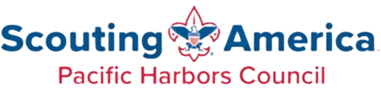
Why Attend Wood Badge
The leadership skills taught at Wood Badge are based on modern leadership principles used by successful teams, organizations, and businesses throughout the country.
You will:
- Strengthen communication skills
- Improve team leadership
- Build lifelong friendships
- Gain practical leadership tools
- Rediscover your passion for Scouting
- Grow personally and professionally
Many Scouters describe Wood Badge as:
- The best training they have ever attended
- Life-changing
- The highlight of their Scouting journey

Who Attends Wood Badge
Wood Badge is designed for adult leaders in:
- Cub Scouts
- Scouts BSA
- Venturing
- Sea Scouts
- District Committees
- Council Committees
Whether you are brand new to Scouting or have decades of experience, Wood Badge will challenge and inspire you.
FAQs
Who is eligible?

- Any registered adult leader age 18+
- Completed Safeguarding Youth
- Completed Position Specific Training
- Can participate safely in an outdoor environment.
- Must have & turn in A, B & C Medical forms.

Are we camping the whole time?

No. Participants stay in cabins during the first weekend and camp with their patrol during the second weekend.

Where do we eat?

- First weekend all meals will be provided in the mess hall.
- Second weekend you will camp and cook most meals with your patrol.

What is a typical day like?

- Days are filled with leadership sessions, patrol activities, and team development from morning through evening

How difficult is the ticket?

- Each participant creates five personal goals based on their own vision and abilities. The ticket should challenge and inspire you while remaining achievable.
- Staff members will guide and support you throughout the ticket process.
Cost

$50.00 deposit to register today!
Discount Type | Cost | Paid By:
Super Saver | $340 | 5/31/2027
Early Bird | $360 | 6/30/2027
Regular Fee | $380 | 7/22/2027

*Scholarships of up to 50% of the cost may be available. Apply on the registration website.

