Eagle Advancement Training

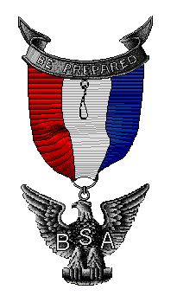
For: Scouters working on or assisting with Eagle advancement

- Eagle Board of Review Members
- Eagle Advisors (required training)
- Council Advancement Committee
- District Advancement Committee
- Unit Leaders and Advancement Committee
- Scouts/Parents preparing for Eagle

Date: Saturday, October 18, 2025
Time: 8:00 AM – 12:00 Noon
Place: Tacoma Scout Office
Refreshments and handouts provided
Register in advance or at the door
Cost: $15, at the door $15 cash only

For more information, please call
Bill Woodard (253) 208-1516 or Darrin Nicholson (509) 595-6429

