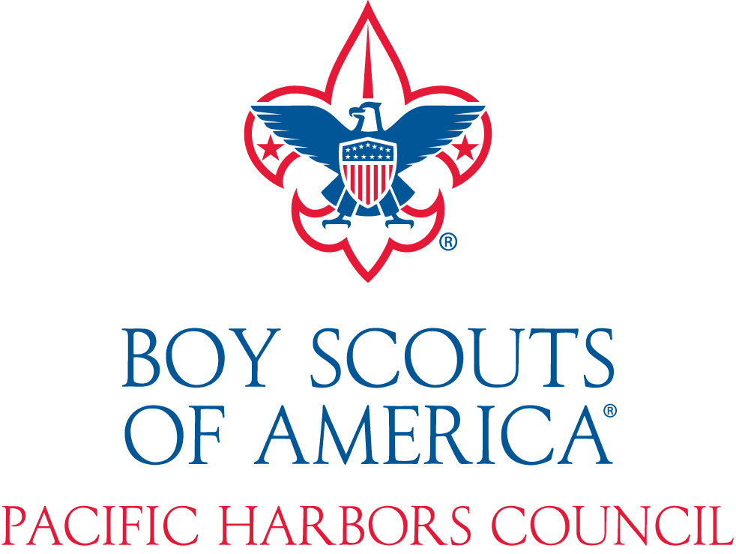
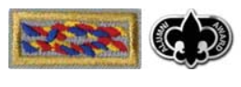
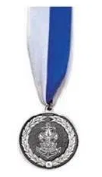
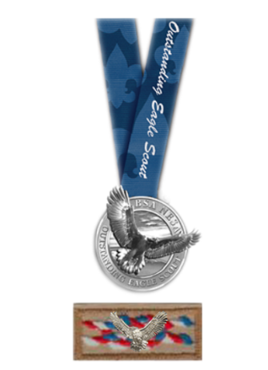
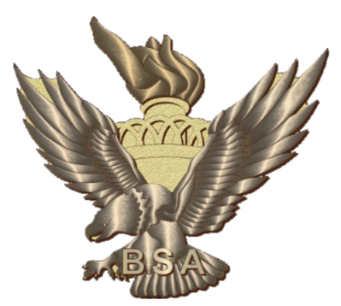
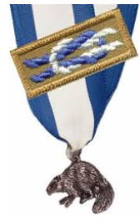
2023 ANNUAL
AWARDS BOOKLET
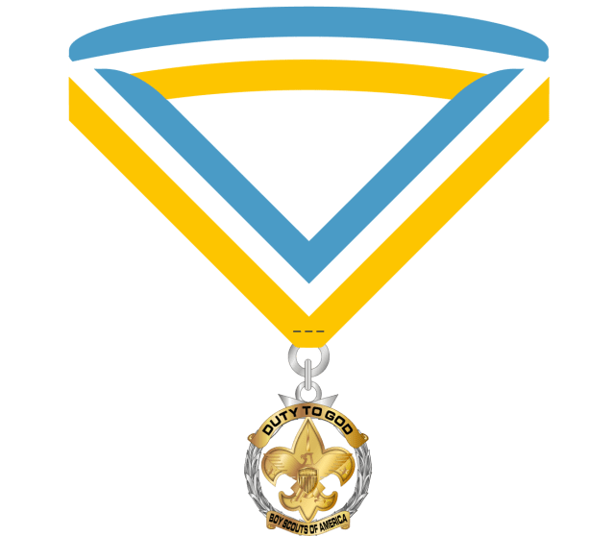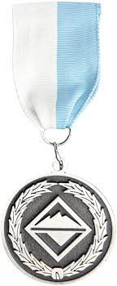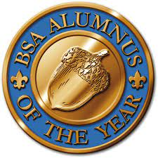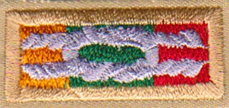
2024 ANNUAL AWARDS (FOR 2023)
The deadline for All Submissions is January 8, 2024
Annually councils have an opportunity to recognize adult Scouters who have been truly dedicated to the local Scouting program. The council is limited to 1 Silver Beaver award per 50 units or a fraction thereof.
Silver Beaver Award
Of the hundreds of awards that are presented each year, the Silver Beaver is the highest and most prestigious honor awarded to a volunteer by a local council. As a movement whose leadership is overwhelmingly volunteer, the Boy Scouts of America recognizes the need to acknowledge those individuals who truly go above and beyond to guarantee the availability of a quality Scouting program. Selectees are individuals who have demonstrated outstanding and continued service to youth and community in and out of Scouting. The official BSA Silver Beaver application is available at https://filestore.scouting.org/filestore/pdf/92-103.pdf.
Email nominations directly to PHC@scouting.org.

Glenn and Melinda Adams Service Project of the Year Award
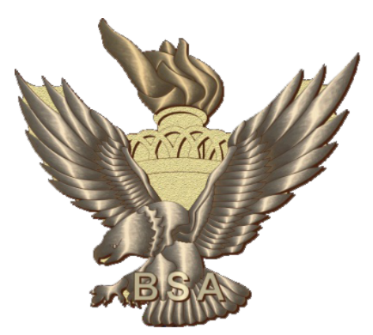
The National Eagle Scout Association established the Glenn A. and Melinda W. Adams National Eagle Scout service project of the year award (ESSPY) to recognize valuable service of an exceptional nature by an Eagle Scout candidate to a religious institution, a school, community, or other entity through completion of an Eagle Scout project.
Examples of projects that have been selected for the ESSPY include projects that have benefited underprivileged children, recognized veterans, been international, and have required significant time and resources.
The selection of recipients begins at the local level and is conducted through the council NESA committee. The council NESA committee selects a recipient for their respective council from the list of submitted nominations and then forwards a worthy candidate to the National Eagle Scout Association for regional consideration. Information and the application can be found at https://nesa.org/awards-and-recognition/service-project-of-the-year-award/
Email nominations directly to phc@scouting.org.

NESA Outstanding Eagle Scout Award (NOESA)

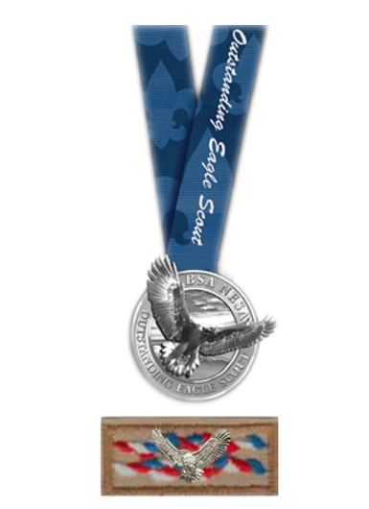
Overview
Recognition granted by the local council’s NOESA committee to Eagle Scouts who have demonstrated outstanding achievement at the local, state, or regional level; unlike the Distinguished Eagle Scout Award, which is a national award, the NOESA recognizes Eagle Scouts whose efforts have been made closer to home.

Who Can Earn This Award?
Presented by council NESA committees to deserving Eagle Scouts.

How to Get the Award
Each council NESA committee may present two NOESA honors per year, with the option of awarding an additional NOESA for every 100 Eagle Scout Awards or fraction thereof over 100 awards certified the previous year. Unused quotas will be forfeited in the following year.
For example, a council with 101 Eagle Scouts would be able to award three NOESA honors, 201 Eagle Scouts would be able to award 4 NOESA honors, etc.
Details for this award can be found at https://nesa.org/awards-and-recognition/outstanding-eagle-scout-award/.
Email nominations directly to PHC@scouting.org.
Alumni Award
The award recognizes registered Scouters who help unregistered alumni rejoin the program. This task breaks down into four categories of requirements:
- Alumni identification and promotion, such as contacting former members, planning alumni activities, and/or presenting to non-Scout groups.
- Alumni engagement, including helping two former members become registered Scouters or recruiting alumni to volunteer at Scouting events.
- Personal participation, which could mean serving on an alumni committee or sharing your experiences at the BSA Alumni Web site.
- Personal education, such as completing the online alumni training or taking an alumni course at the Philmont Training Center.
If you’re an Eagle Scout, you’ll also need to become a registered member of NESA, the National Eagle Scout Association. The requirements are tough, and that’s by design. We expect folks to
work just as hard as alumni as they did as Scouts.
More details and the application can be found at https://www.scouting.org/awards/awards-central/alumi-award/. The application is a link at the bottom of the webpage.
Venturing Leadership Award

Details for this award can be found at:
https://www.scouting.org/programs/venturing/venturing-awards-and-advancement/leadership/venturing-leadership-award/

In order to recognize Venturers and Venturing Advisors who have made exceptional contributions to Venturing and who exemplify the Scout Oath and Law, councils, territories, and the BSA National Council may present individuals with the Venturing Leadership Award.
The council, territory, and national awards are selected by a task force of youth and adults from the respective tier and are processed by a committee that is formed by the respective level. Awards can be purchased through Scouting Supply and certificates can be made with the template below for presentation to the awardees.
Email nominations directly toPHC@scouting.org

Sea Scout Leadership Award

Details for this award can be found at:
https://seascout.org/news/sea-scout-leadership-award-2/

The Sea Scout Leadership Award is presented by councils, territories, and the BSA National Council to Sea Scouts and Sea Scouters who have made exceptional contributions to Sea Scouting and who exemplify the Scout Oath, the Scout Law, and the Sea Scout Promise.
To be eligible for the SSLA, one must:
- Be registered and involved as a Sea Scout or Sea Scouter for at least one year.
- Hold a leadership position or an office at the unit, district, council, service territory, or national level.
- Show exceptional dedication and give outstanding leadership and service to Sea Scouting and to Sea Scouts (at the level appropriate for the award).

Email nominations directly to PHC@scouting.org.

Council Duty to God Award

Details for this award can be found at:
https://www.scouting.org/awards/awards-central/council-duty-to-god-award/

The Council Duty to God Award was created to recognize registered Scouters who have demonstrated an exemplary history of transformational leadership in supporting and promoting the spiritual foundation of Scouting at the local Council level. It acknowledges the unswerving dedication to faith, fellowship, and service of those whose character embodies the moral principles and shared ideals of the Boy Scouts of America (BSA).
The award distinguishes Scouters who selflessly work to prepare youth for life by perpetuating the merit and legacy of a Scout’s duty to their Creator. Nominations are open to candidates from all faiths and religious groups.

The Boy Scouts of America Council Alumnus of the Year Award is the Scouting Alumni Association’s highest council recognition. The award was established to recognize alumni of the Boy Scouts of America (BSA) who, over a sustained period of time, have used the skills and values they learned through their association with Scouting to make significant and long-lasting contributions to their local communities through their careers, avocations, and Scouting.
A BSA alumnus includes anyone positively and personally impacted by the BSA—former Scouts, family members of Scouts past and present, community leaders, and the millions of Americans who benefit from Scouting in their communities everyday
Alumnus of the Year Award

Details for this award can be found at:
https://www.scouting.org/awards/awards-central/council-alumnus-of-the-year-award/
Email nominations directly to PHC@scouting.org.

William D Boyce New-Unit Organizer Award

Details for this award can be found at:
https://www.scouting.org/awards/awards-central/william-boyce/
The William D. Boyce New-Unit Organizer Award is presented to recognize volunteers who organize one or more traditional Scouting units. The award may be worn on the adult uniform. The award is a square knot placed over the three colors representing the three phases of our program—Cub Scouting, Scouts BSA, Venturing, and Sea Scouting. A volunteer can earn the knot by organizing one traditional unit, and a program device can be earned for up to three additional units organized.

Email nominations directly to PHC@scouting.org.

