STEP-BY-STEP: HOW TO GROW SCOUTING
Use this resource to help your pack GROW! Select someone to be responsible for each task this year. Utilize the list of active and
passive recruitment methods to enhance this plan (see reverse side).
PACK NUMBER ____________ CURRENT # OF YOUTH ___________ TOTAL GOAL BY OCT. 31 ________________

TIMELINE | TASK |  |  | WHO | DATE |  | TIME | PLACE
1st Quarter  Jan-March | Principal visit to secure relationship, join scouting date, boy talks, open houses, etc.,
1st Quarter  Jan-March | Winter Pinewood Derby “Invite a friend campaign”
April, May  Early June | Schedule Spring Recruitment Event (April, May)  Verify date work in the community
April, May | Order recruitment materials  Flyers, Posters, Signs, Geofencing: Completed __________  Schedule Scout Talks (per school)
April, May  Early June | Finalize and review “How to Guide” then Execute Join Scouting Night. Invite troops to assist in entertaining youth  ***Turn applications and payment into Council***
July 2020 | Invite New Scouts to:  Wild West @ Camp Cowles (overnight camp)  Day Camps
August | Attend School Open Houses
August/September | Schedule Fall Recruitment Event late September early October.
August/September | Order recruitment materials  Flyers, Posters, Signs, Geofencing: Completed _______  Schedule Scout Talks (per school)
September/October | Finalize and review “How to Guide” then Execute Join Scouting Night. Invite troops to assist in entertaining youth  ***Turn applications and payment into Council*** |  |  |  |  |  |  | .
October/November | 2nd Round recruitment night dates & Plans
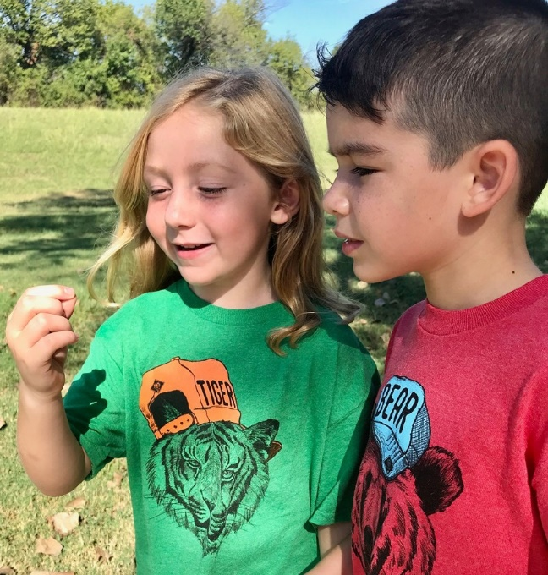  SCOUTING ADVENTURE  BEGINS WITH YOU!  Unit Leaders,  As a Unit leader you have taken on one of the most important and meaningful assignments in Scouting. Your district membership team can help. Together, we can develop a plan that encourages youth to join your pack and begin building their adventure.  To kick off your plan, there are many resources available to you: on-line resources as well as training opportunities throughout the year. Begin by utilizing this document as a tool to reach out to every available boy and girl in your community.  School Kinder TAY 1st Grade TAY 2nd-5th Grade TAY # of Youth to Reach GOAL 2% |  |  | REACH EVERY BOY AND GIRL  Design a plan that shows you care about reaching every child. The council will provide you with a variety of tools. The more active recruitment methods we use, the more successful we will be.  We are looking forward to our partnership with you as we grow Scouting together.  Active Recruitment  - Principal Visits  - Distribute Flier a week before event  - Scout Talks: Classroom, lunch, recess, classroom (within 3 days of event)  - Recruit a Friend campaign (peer to peer) all year round  - Hold recruitment separate from pack meeting (create a fun environment with help from your local troop)  Passive Recruitment  - School Newsletter advertising  - Posters in school, churches, libraries (throughout your community)  - Yard signs in neighborhoods, schools,  - Wear Scout uniforms to school day of recruitment  - Social media ads (Facebook, Twitter, Geofencing)  - Press Releases (newspaper, radio, etc.)  - Council marketing through media |  |  |  | BUILD AN ADVENTURE IN  CUB SCOUTS

