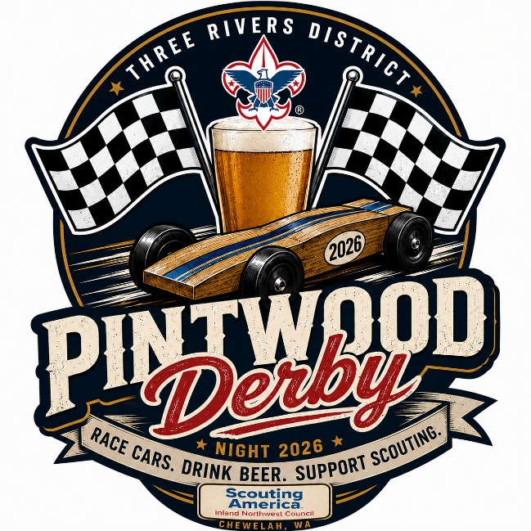
Three Rivers Pintwood Derby Outlaw Class
Think you can build something faster, heavier, stranger, or downright ridiculous? The Outlaw Class is where the rulebook loosens up and creativity takes over. Motors, extra weight, custom engineering, and unconventional designs are welcome, as long as the car still fits the track and can race safely. This is your chance to push the limits, surprise the crowd, and see what happens when Pinewood Derby ingenuity goes completely off the rails. Outlaw Class Rules
The Outlaw Class is for builders who want to go beyond standard Pinewood Derby limits and get creative.
- Cars may exceed the standard 5-ounce weight limit.
- Motors, batteries, fans, and other powered systems are allowed.
- Modified wheels, axles, bearings, bushings, and alternative materials are allowed.
- The car must still fit safely within one lane of the Pinewood Derby track.
- The car must fit behind the starting gate and pass beneath any timing equipment.
- The car may not interfere with another lane, damage the track, or create a hazard for racers or spectators.
- All weights, batteries, motors, and other components must be securely attached.
- No flames, combustion engines, pressurized gas, rockets, explosives, hazardous chemicals, or loose projectiles are permitted.
- No system may intentionally attach to, grip, cut, scratch, or otherwise alter the track.
- Cars must be capable of being safely staged, released, stopped, and retrieved by race officials.
- Race officials may require a test run or safety inspection before allowing a car to compete.
Creativity is encouraged, but safety and track protection come first. Race officials have final authority regarding whether an Outlaw Class car is safe and compatible with the track.

