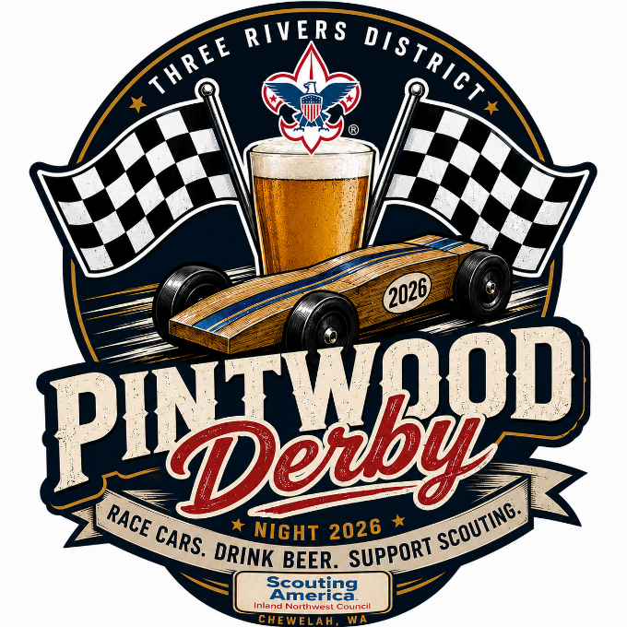
Three Rivers Pintwood Derby rules Stock Class
Stock Class
The Stock Class follows standard official Scouting America Pinewood Derby rules. Cars must be built from an official Pinewood Derby kit and meet standard stock specifications, including a maximum weight of 5.0 ounces, maximum length of 7 inches, and maximum width of 2.75 inches. Only official kit wheels and axles may be used, with dry lubricant only. No bearings, springs, washers, motorized devices, or moving weights are permitted. All cars will be inspected before racing, and race officials will have final authority on rule compliance.
All cars must pass the following inspection to qualify for the race:
- Width shall not exceed 2-3/4 inches.
- Length shall not exceed 7 inches.
- Weight shall not exceed 5 ounces.
- Axles, wheels, and body shall be from the materials provided in the kit. Additional wheels can be purchased separately.
- Wheel bearings, washers, and bushings are prohibited.
- No lubricating oil may be used. Axles may be lubricated with powdered graphite or silicone.
- The car shall not ride on any kind of spring.
- The car must be free-wheeling, with no starting devices.
- No loose materials of any kind are allowed in the car.

