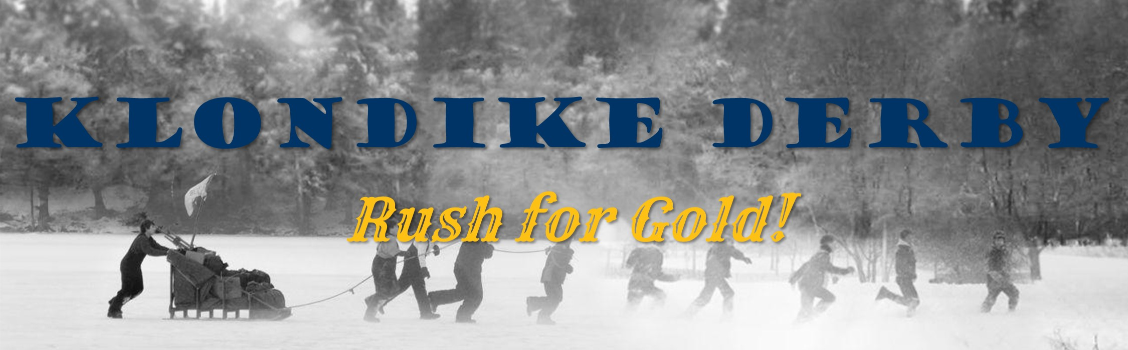
-INFORMATION PACKET-

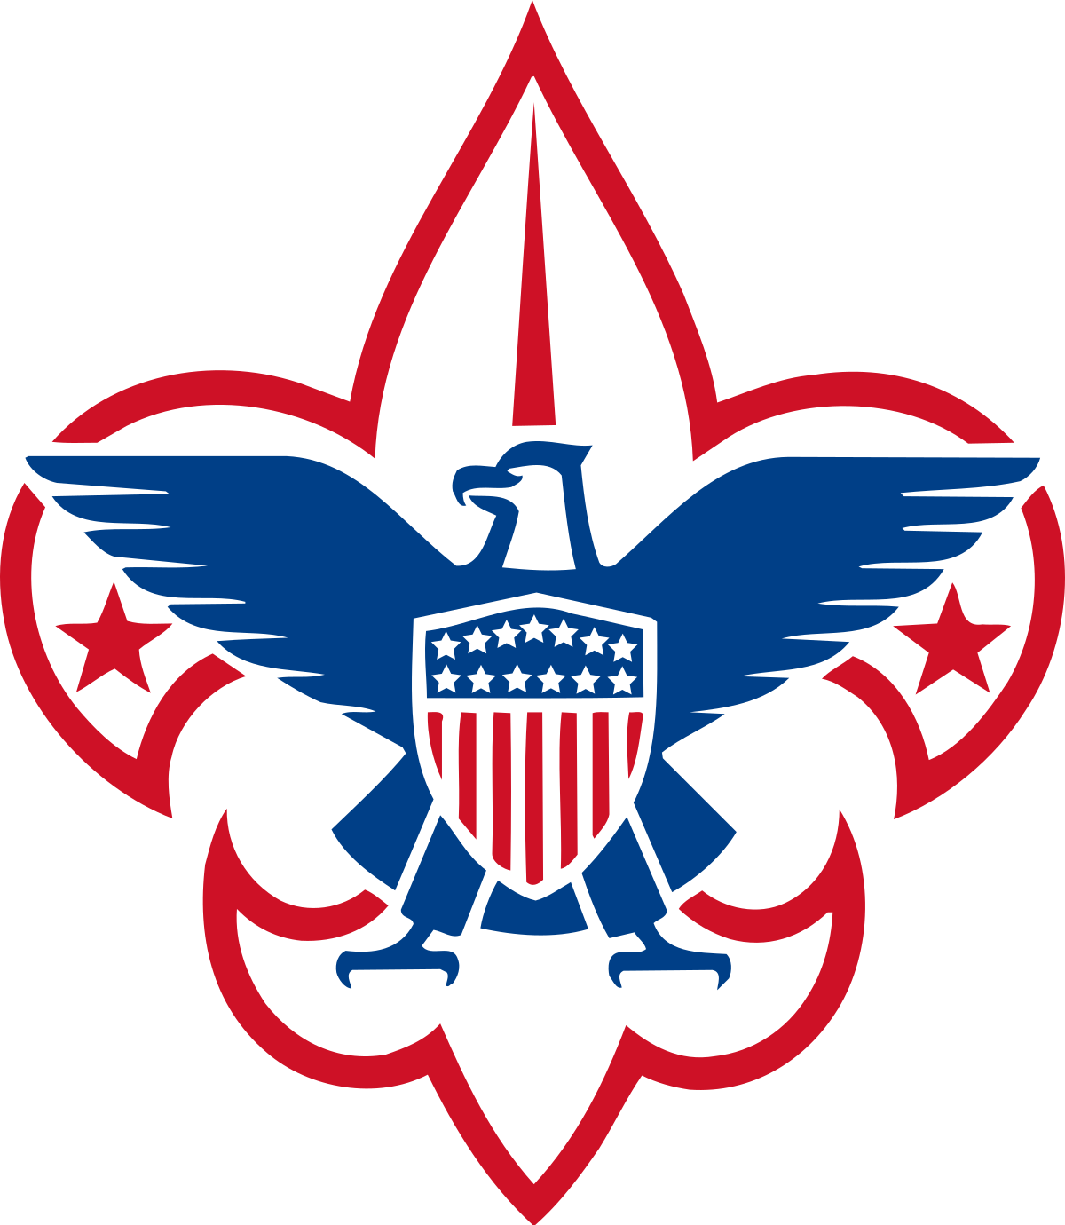

2023

Inland Northwest Council

Camp Easton, Idaho - January 20-22, 2023
FRIDAY
4:00 PM to 9:00 PM Check-in and campsite assignments (Easton Dinning Hall)
(PLEASE: use upper parking lot 2 for check in and campsite assignments)
No vehicles in campsites, please---plan to use sleds to haul gear!

8:00 PM - Shooting Sports Orientation for Scouts wanting to shoot on Saturday (REQUIRED to attend either Fri PM or Sat AM class)
9:00 PM - SPL and Scoutmaster Meeting (Dinning Hall) ---bring your own cups please
9:30 PM - Cracker barrel for SPLs & all adult leaders (Dinning Hall)
9:30 PM - Mayor’s meeting in Dinning Hall

SATURDAY
7:00 AM - REVELLE (7:00 AM to 8:00 AM - Late Check-in at Easton Dinning Hall)
8:00 AM - Shooting Sports Orientation for Scouts want to shoot today (REQUIRED to attend either Fri PM or Sat AM class)

8:45 AM - Opening Flag Ceremony bring your troop flag plus, your fully equipped sleds for each patrol (see required equipment list in packet)
- Troop Roll Call---Yells----Announcements

9:15 AM - Let the Klondike Games Begin – Report to your assigned starting Town
NOON - Troops will prepare their own HOT meals on the trail at the Town they are visiting at NOON. Units will be judged by the Mayor based on hot, healthy & complete meal planned and prepared by the Scouts (not the adults)
3:00 PM - Troops turn in their nuggets for judging for awards (Easton Dinning Hall)

4:30 PM - Award Ceremony (Parade Ground) must be present to win!
6:00 PM - Dinner in your campsites (be sure to include your Webelos guests/Commissioners)

SUNDAY
9:00 AM Break Camp, Clean Up, Pack out

Cost: $20 per Scout & $15 for Adults - includes Klondike Patch, Troop Ribbons, Camp Easton usage fee, Awards. Please pay at the Scout Service Center or register online by 5pm Fri. Jan 6th-2023;
Late registration or at the door will be $25 Scout/$20 Adult and with no guarantee of a patch.

Important note: Cost is same for everyone who wants a patch (if registered by 6 January) or using facilities (even if not staying overnight)
Welcome to Klondike 2023

We always have a great turn-out for Klondikes, whatever the weather. The more, the merrier. As you will see on the enclosed pages, a lot of planning has gone into this year’s event. Please take a few minutes to read this packet and share all the information with your Troop and especially your youth leaders so they know what to plan for.

WEBELOS – Webelo Patrols are invited to attend as well and can participate with a host troop or operate as a separate patrol. Some separate activities will be available for the Webelos. Webelos groups should plan on arriving early Saturday morning. They are encouraged to stay for the awards campfire. Each Webelos den will face several tasks as they travel from town to town. Keep in mind that this is a learning experience for the Webelos Scouts. They are encouraged to do their best.

CAMPING - It is not necessary to camp overnight to fully participate in the Klondike Derby. Camping is optional and is up to each unit. The camping does add to the Klondike experience. Camping space maybe limited. Remember to set up camp in a small area. Be courteous to other Troops. No camping in the parking lot areas. Arrange the patrols with enough space to camp by the patrol method. Set up a warming tent to serve all patrols. To gain protection from the wind, dig tents down into the snow or pile up snow walls. Pitch tents so that the wind does not blow smoke or snow into them. Be sure that the tents are anchored securely. After selecting a campsite, please advise headquarters of your unit’s location.

WOOD STOVES - Questions have come up about Wood Stoves in tents. IN THE GUIDE TO SAFE SCOUTING – “No flames in tents. This includes burning any solid, liquid, gel, or gas fuel—including tents or teepees that feature or support stoves or fires; and any chemical-fueled equipment or catalytic heaters.” http://scouting.org/healthandsafety/gss/gss07.aspx

FIRES –Permitted in establish fire pits or elevated burn barrels.

LUNCH – Lunch preparation is part of the day’s program events. Lunch should be planned and prepared by the Scouts, not the leaders. Lunch will be judged as part of the competition, so ensure it is hot, healthy and will sustain the Scouts while on the trail. Patrol or Den must eat at a station with a Mayor to get judged.

BE PREPARED - Please note the schedule. There might be some further adjustments necessary depending on the weather & other logistics, so as someone said (I think his name was Baden Powell), Be Prepared. As usual there will be an SPL/Scoutmaster Meeting on Friday night (the 20th at 9:00PM in the Dinning Hall to give you the most current information.

CLOTHING – Safety first! Dress for the conditions! Clothing and equipment list for winter camping can be found in your Scout book and nobody will be allowed on the course wearing cotton clothing or tennis shoes.

DIRECTIONS - Almost everyone has been to Camp Easton before but if you need directions or a map, Look at the Council web site at https://www.nwscouts.org/campeaston

PARKING – Please attempt to carpool as much as possible and keep the number of parked vehicles to a minimum. Parking is very limited. No RVs, Campers or Camping Trailers will be allowed. Troop trailers must remain in the parking lots. Be prepared to transport your gear to your campsite using your sleds.

NEED A SLED - Folks always ask if we have Klondike sled designs available. There are many on the Internet but if you have any trouble finding them, we have a couple paper copies that can be emailed to you upon request. If your troop needs a sled (ie, do not have time to build one, can’t find last year’s, etc.) or if your troop has an extra sled that you won’t be using, please email the Klondike Committee. Sled designs available at:
Site for Sleds: http://www.inquiry.net/outdoor/winter/gear/sleds/

REGISTRATION - Be sure to use the enclosed roster form to register at the Scout Service Center by January 6th. Please bring your updated roster to the registration table in Dining Hall on Friday evening or Saturday morning. Registration is also available on-line at www.nwscouts.org.

CHECK IN – Check-in must be done as a unit. Anyone wishing to participate in the event must arrive by 8 am on Saturday at the latest. It is impossible for the derby volunteers to know where a unit is on the course.

(If shooting sports is offered) Shooting Sports Orientation Training – ALL scouts that wish to participate in any of the many shooting sports activities, MUST complete a 30-minute orientation, offered 2 times, at 8:00 pm on Friday OR at 8:00 am Saturday in the Dining Hall.

BAD WEATHER – Special note: Klondike will not be cancelled due to any weather conditions except if the roads are closed or we are so advised by governmental agencies or if Camp Ranger says that camp in not accessible. We have camped in -20 below weather before and everyone had a great time.

BE PREPARED!

Your patrol may be assigned a guest to travel with the patrol; he or she will need to complete the course with your patrol.

More info at the Klondike!

On the Klondike Trail

Years ago, during the great gold strikes in Alaska, brave men raced across the frozen tundra in search of riches, fame, and fortune. Some reached their goal and others perished in the trackless cold, never to be seen again. The challenge has remained long after the memory of men and gold have faded. The Klondike Derby is a test of Scout skills, knowledge, and patrol teamwork. What better way to challenge Scouts than by asking them “Be Prepared?” It’s also a lot of fun.

Each sled team of 5-8 Scouts (up to 10 for the Webelos) will be given a map before they set out on the trail. They will follow the map and travel from town to town in search of gold. Each town will have a MAYOR who will give the patrol a problem to solve. Nuggets will be given for skill and Scout spirit. You MUST stop for lunch in the nearest town, and lunch will also be scored. Always watch for bandits! Answer their questions and they will not take any of your gold. The “good bandits” might even give you some gold. The total nuggets earned by the team will be kept by the team leader. They must be turned in at headquarters at the end of the Derby for scoring.

Teamwork and spirit count as much as skill.

All Scouts should be prepared to demonstrate or have knowledge of the following subjects: hiking, first aid, camping, communications, emergency preparedness and any basic Scout skill found in your handbook. Going “above and beyond” or demonstrating proficiency in skill usually earn your patrol bonus nuggets.

Towns must be followed in the order listed on the map. If you lose your map, you can purchase a new one at headquarters (in Easton Dinning Hall). This may cost you a few nuggets.

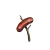

2023 KLONDIKE SLED SUPPLIES

(Checklist for supplies for your sleds)
Each patrol needs a sled. The sled must be able to carry one rider and be of solid construction. It must fly the patrol flag and unit number. All sleds that are new to this year’s derby become eligible for award and will be judged for craftmanship and ingenuity. Remember that our local winters are unpredictable and modifications to sleds (like wheels) to match the conditions are not discouraged. All patrols should be prepared with a patrol yell.

Each sled must carry the following equipment:

- Food (Lunch MUST BE COOKED on the trail at Noon and will be scored by the town’s mayor. Plan hot, nutritious meals and leave not trace of having cooked there to score well. Patrols must provide their own fire container and pack out all ashes or cook with a stove. Do not forget patrol trail snacks. Hot cocoa mix and cups
- Water bottle/canteen (one per Scout)
- Ax or saw
- Lashing twine (100 feet or so)
- Scout knife
- Extra dry socks (one pair per Scout)
- Scout handbook (Webelos should also bring a Webelos book)
- Compass
- Notebook and pen or pencil
- Mess kit
- Matches (waterproof) and dry tinder
- Flint and steel fire starting kit
- Patrol first-aid kit with splint material
- Shelter building material
- 6 ft length of rope, ¼” or larger (one per Scout)
- Bundle of dry firewood (enough for both fire building and cooking lunch)
- Shovel
- Scout staves (poles 1” or 2” diameter and 6’ long, one per scout
- Blanket
- Plastic Garbage Bags – for Poncho/rain cover for each Scout
- Candle
- Positive attitude (bring enough to share)

Note: your sled supplies may be checked at various points during the day.
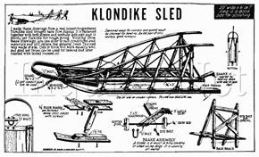

Rules and Instructions for Keeping Warm in the Sack
1. REMEMBER: The sleeping bag doesn't heat you; you heat it. So, use this rule, "Thickness is warmth", to keep this heat. If you are cold, add some more insulations (blankets, clothes, more newspaper).
2. DO NOT SLEEP IN BOTTOM OF BAG: Your breath contains water. If you close your bag with your head inside, then this water sticks to the bag. Wear a hat to keep your head warm.
3. CHANGE CLOTHES: NEVER sleep in wet clothes. Even perspiration will chill you at night.
4. EAT A CANDY BAR: This increases your metabolism (moves your blood faster) and it helps keep you warm.
5. GO TO THE BATHROOM BEFORE BED: This saves you a middle of the night trip in the cold.
6. DO NOT DRY "WET" CLOTHES IN BAG: Moisture will travel from wet clothes to sleeping bag.
7. PUT TOMORROW'S CLOTHES UNDER BAG: This heats up clothes for tomorrow's cold morning and provides more insulation.
8. FLUFF UP YOUR BAG: Always fluff up bag before using to create the thickness important in keeping warm.
9. MOST IMPORTANT, KEEP IT DRY: Keep all your sleeping gear dry and follow these rules, and winter camp should prove to be a rewarding experience.

IMPORTANT STUFF TO KEEP IN MIND
1. Clothing does not make you warm; it is your body processes that keep you warm. Clothing merely provides the insulation to preserve your warmth.
2. Layered thickness is warmth.
3. Keep your torso warm so that it can send heat to the extremities.
4. Avoid sweating by ventilation.
5. Keep rain and wind out of your insulation.
6. Use your head. Keep it covered when you're cold; remove cap as you warm up to avoid sweating.
7. Strain one muscle against another to maintain metabolism.
8. Wool clothing is best but needs wind protection, synthetics are next best. Down is OK, as long as it stays dry. Cotton is a poor choice.
9. If your feet are cold, put a hat on.
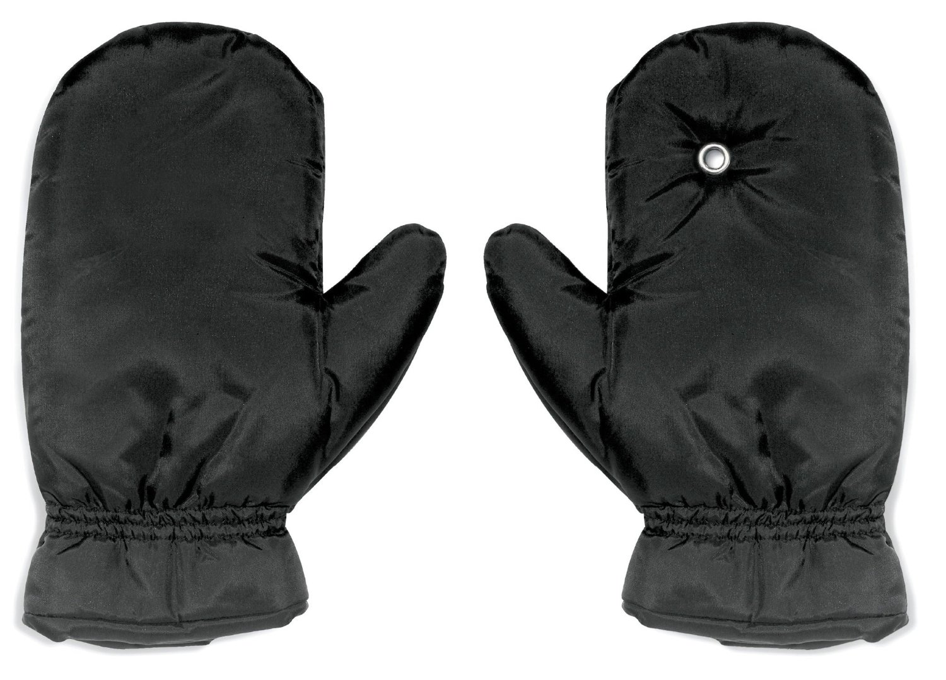
10. Remember the word "COLD" -
Keep your clothing - Clean.
Avoid -------------- Overheating
Wear clothing ------ Loose
Keep it ------------ Dry

RECOMMENDED CLOTHING FOR TWO DAY WINTER CAMP
in addition, or in substitution to what you would normally bring to camp, bring:
- 2 shirts (wool is best, or flannel)
- 2 pairs wool or synthetic pants (Strongly recommend against cotton pants like jeans. They absorb moisture like a sponge).
- Thermal or polypropylene underwear
- Boots (WATERPROOFED)
- 2 pairs of heavy socks (wool recommended)
- 2 pairs lighter socks (polypropylene is best)
- Windbreaker (as is or part of heavier jacket)
- Stocking cap (wool is best)
- Parka or heavy jacket
- Wool mittens or gloves
- Extra Boots
It is always best to stay dry when camping in the snow, but you can expect to get wet and should be prepared. Boots or other shoes which are not waterproof will normally start getting the feet wet and cold after less than 15 minutes in the snow (depending on temperature, the colder it is, the longer the feet stay dry). Low top shoes will not keep the snow out of the shoes. Gaiters can be made from plastic bags and a strong tape like duct tape. Do not cover the bottom of your shoes with plastic, doing so will cause you to lose all your traction (and you will fall down!).
Unless your parents are planning to buy some of the items on this list, anyway, do not run out and start spending lots of money on clothing and equipment. If you are in doubt or have questions, call one of the troop leaders for advice.

2023 Winter Klondike Camporee Registration Form

Turn in to Scout Office with fee paid by January 6th, if any changes, bring updated form to Klondike.

Late registration or at the door will be charged and with no guarantee of a patch.

Troop # Scoutmaster Name
Patrol Name
1. 2.
3. 4.
5. 6.
7. 8.
Patrol Name
1. 2.
3. 4.
5. 6.
7. 8.
Patrol Name
1. 2.
3. 4.
5. 6.
7. 8.
Patrol Name
1. 2.
3. 4.
5. 6.
7. 8.
Names of Other Adult Leaders
1. 2.
3. 4.
5. 6.

Number of Scouts x $20 = ($25 after January 6th)
Number of Other Adult Leaders x $15 = ($20 after January 6th)
TOTAL PAID IN ADVANCE = TOTAL AMOUNT PAID

(Please bring a copy of this form with you to the Camporee stamped paid by the Scout Office or receipt if paid online as proof of payment)

