Okpik, 2016

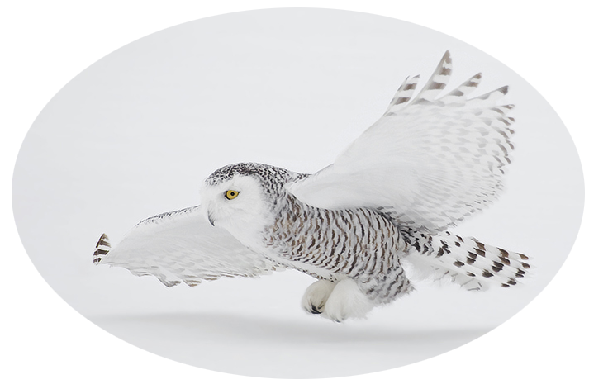

Okpik or ukpik (the Inupiaq word for snowy owl, pronounced ook pick) is the Great Alaska Council’s winter weather training program. This year, Okpik will take place on the first weekend of December and will be an overnight. Participants, who should include adult leaders with limited winter camping experience and senior scouts in leadership positions will learn principles of staying warm in a cold environment through proper hydration, nutrition, clothing, shelter and gear. Training will also cover the prevention and treatment of cold weather injuries. Lessons will take place on cooking and sanitation in a winter setting as well as the recognition of winter risks in planning unit activities. Leave No Trace in a winter setting will also be discussed.

Participants will arrive at 7:30 on Saturday morning in Camp Gorsuch (not in Carlquist!) with opening ceremonies beginning at 8. Instruction, both lecture and hands-on work will continue throughout the day with both lunch and dinner provided. Testing for certification will take place at about 7:30 p.m. In the evening there will be a guest lecture or film. On Sunday morning, a quick breakfast and optional activities will be provided. The closing ceremony and awards will follow.

The cost is estimated at $30 with reservations required.

Questions or applications to serve as staff (see back) should be directed to:

Dorn Van Dommelen

744-6968

[dvandommelen@alaska.edu](mailto:dvandommelen@alaska.edu)

More information on reverse

**Okpik Staff needed!!!**

If you are an adult or experienced winter camping scout, over the age of 16, please consider applying to serve as a staff member at Okpik. If you are interested, please send a short letter of interest, outlining your interest, expertise and winter camping experience to Dorn Van Dommelen ([dvandommelen@alaska.edu](mailto:dvandommelen@alaska.edu)). Applications should be made by September 30th.

**Okpik Participant Learning Outcomes**

By the end of Okpik training, participants will be able to:

* Explain the role of hydration and nutrition in maintaining the body’s thermal homeostasis.
* Identify key differences and strengths and weaknesses of insulating materials used in winter gear.
* Describe winter sleeping systems, including the use of insulating pads, sleeping bags, liners, tents, etc.
* Describe and/or build various kinds of winter shelters.
* Discuss the prevention and demonstrate treatment of cold weather injuries.
* Prepare winter camping menus and demonstrate preparation of food in a cold weather setting.
* Discuss the challenges of supplying and using sanitary water sources in a winter setting.
* Implement Leave No Trace in a winter environment.
* Address winter risks in a unit setting including weather, ice, and basic avalanche risk

**Okpik Tentative Schedule**

Saturday

0730 Arrival

0800 Opening ceremonies

0815 Lecture – homeostasis, hydration, nutrition

0845 Lecture – Insulating material

0915 Lab – heat loss experiments, followed by break

1000 Lecture – Clothing Systems/Sleeping Systems

1030 Lab – Hands-on examination of systems

1100 Lecture – Winter shelters

1130 Lab – Tents/Snow shelter construction

1230 Lab – Outdoor lunch

1400 Discussion – Food/Menu planning

1430 Lab – Menu planning in small groups

1500 Lecture – Water and sanitation

1530 Lecture – Leave No Trace

1600 Break

1615 Lecture – Risks

1700 Lab – Risk scenarios

1730 Break, study for exam

1800 Dinner – Dutch Oven dinner

1900 Clean-up

1930 Short answer exam

2000 Guest speaker, film, campfire program

2200 Taps

Sunday

0800 Breakfast

0900 Short chapel service

0930 Wrap-up

• Discussion of other activities – skis and snowshoes, winter games, tracking and nature observation, campfires, astronomy

• Awards

1100 Cleanup and departure