Blue Mountain Council
Webelos-Ree
September 25-26, 2026


Under the Waves
2026 Parent/Leader Guide
Westminster Woods, Meacham Oregon

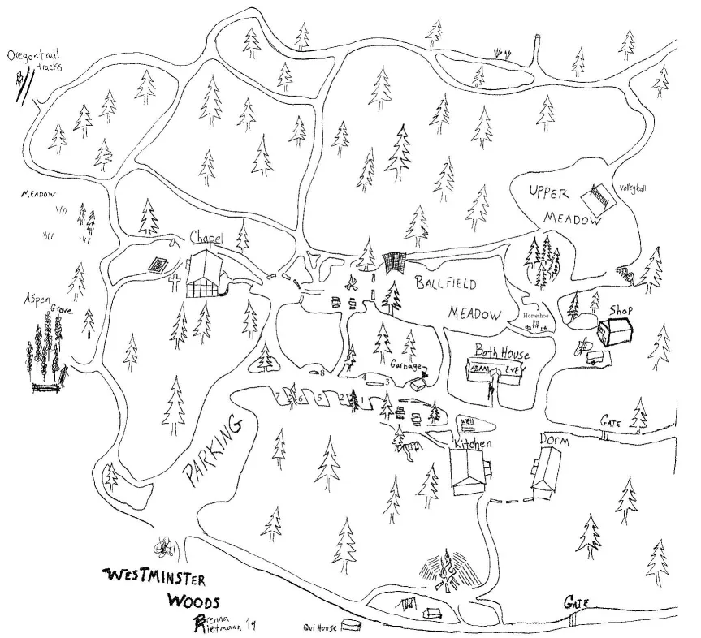

Interstate 84 take exit 284 (pass Emigration Springs State Park down dead end)
Enter in first gate (second gate is closed)
Camping for Webelos Groups will be in the Ball Meadow. (no vehicles allowed)
Park in Parking lot. (please back into your parking spot)
Breakfast in the morning will be in the kitchen building.
Opening/Closing flag ceremony at flagpole in front of Bath House
Campfire in fire bowl
Stations will be announced in the morning (including BBs, Archery etc.)

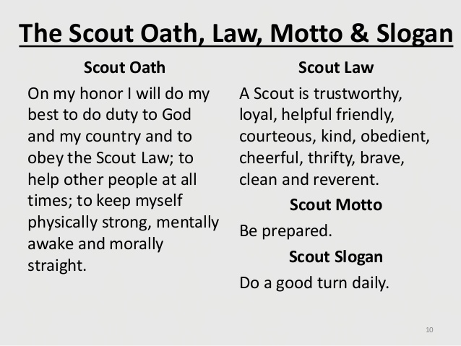
MISSION STATEMENT
The mission of the Boy Scouts of America is to prepare young people to make ethical and moral choices over their lifetimes by instilling in them the values of the Scout Oath and Law.
Code of conduct: Leaders and parents are responsible for their scout’s behavior. Adults are held to the same standard and asked to set the right example.
Webelos-Ree
Webelos-ree is a fun event for 4th and 5th grade scouts. It offers opportunities to participate in activities specifically for them. Webelos and parents will be staying overnight, outdoors. Some for the first time. Packs can register together. We can also take in lone scouts if your pack is not attending. We will be putting scouts into patrols to attend the events. If your den has already done patrols that is great and you can continue in your patrol in your future pack events but for this event we will be mixing things up. We have first year webelos who are just getting started and this may be their first event, so they have not learn about the patrol method. We plan on giving the patrols time on Friday night to name their patrol and make a yell and prepare something for the campfire. We hope to have older scouts to help with this, but we may have to have leaders help us.
If things go as planned, Cub Scouts may meet a requirement or two but a Webelos-Ree is not an advancement centered activity. Below is a tentative schedule. It is not set in stone so plan on being flexible. We can’t control weather. We also do not know how many Webelos we will have attending until the week before.
Blue Mountain Council will be hosting breakfast on Saturday morning. All other meals (dinner Friday and lunch Saturday) are the cub scouts and packs responsibility. This would be a great time to do the Chef’s Knife.
Registration
It is very important that you register early. Registration Fee is $30 per Scout and $7 per leader. We need to know how many to expect for breakfast and how many supplies we need to have on hand. Online registration is available at https://scoutingevent.com/604-webelosree. Registration fee must be paid before camp. Youth and leaders need to be registered with BSA. All Adults need to take Youth Protection Training.

Annual Health and Medical Records
All participants (adult and youth) must have a BSA Annual Health Medical Record-A&B. These will be checked when entering the camp.
Youth protection
(Effective September 1, 2023) Two registered adult leaders 21 years of age or over are required at all Scouting activities, including all meetings. There must be a registered female adult leader 21 years of age or over in every unit serving females. A registered female adult leader 21 years of age or over must be present for any activity involving female youth or female adult program participants.
Cub Scout Programs – Overnight Exception: Cub Scout’s parents or legal guardians taking part in an overnight Cub Scout program with their own child or legal ward are not required to register as leaders. All adults must review the “How to Protect your Children from Child Abuse: A Parent’s Guide” that can be found in the front of each Cub Scout Handbook. In addition, the parent or legal guardian must be accompanied by a registered leader at any time they are with youth members other than their own child/ward. All other overnight adults must be currently registered in an adult fee required position. (Effective September 1, 2023, Update)]
Leaders must ensure that all participating in Scouting activities abide by the Scout Oath and Scout Law.
Adult leaders and youth members share the responsibility for the safety of all participants in the program, including adherence to Youth Protection and health and safety policies.
Adult leaders are responsible for monitoring behavior and intervening when necessary.
Physical violence, sexual activity, emotional abuse, spiritual abuse, unauthorized weapons, hazing, discrimination, harassment, initiation rites, bullying, cyberbullying, theft, verbal insults, drugs, alcohol, and pornography have no place in the Scouting program and may result in revocation of membership.
All leaders are required to adhere to the Scouter Code of Conduct.
Separate tenting arrangements must be provided for male and female adults as well as for male and female youth.
Youth sharing tents must be no more than two years apart in age.
In Cub Scouting, parents and guardians may share a tent with their family.
In all other programs, youth and adults tent separately.
Spouses may share tents.
We will be doing the buddy system during camp.

What to bring:
Camping Equipment
❑ Tent or tarp, poles, and stakes
❑ Waterproof ground cloth or plastic sheet or cot
❑ Sleeping bag, pillow, air mattress or pad
Clothes Bag
❑ Cub Scout uniform
❑ Poncho or raincoat
❑ Warm jacket or coat
❑ Pajamas or sweatshirt, sweatpants
❑ Underwear
❑ Durable shoes, No open toe shoes

❑ Hat or cap

❑ Extra socks, shoes, other extra clothing
Toilet Kit
❑ Toothpaste, toothbrush, comb
❑ Washcloth, towel
❑ Soap in container
❑ First aid kit
❑ Water bottle
❑ Flashlight & batteries
❑ Sunscreen
❑ Insect repellent
Optional
❑ Lawn chairs
❑ Cooler or ice chest

Friday | Event | Where
5pm-6pm | Check in/Set up | Gate 1
6pm-7:00pm | Patrol Meeting and Prepare for campfire Program | TBD
7:30pm-8:30pm | Campfire program | Fire-bowl
8:30pm-9;pm | Fellowship | camps
10:00 | Lights out
Saturday
7:30-8:30am | Breakfast | Kitchen
8:30-9:00pm | Opening Flag ceremony/Inspiration/Worship | Flagpole
9:00am-10:00 | Station #1 | According to patrol
10:00-11:00am | Station #2 | According to patrol
11:00-12:00am | Station #3 | According to patrol
12:00 | Lunch Break | Camps
1:00pm-2:00pm | Station #3 | According to patrol
2:00—3:00pm | Station #4 | According to patrol
3:00-4:00pm | Station 5 | According to patrol
4:00-4:30 | Closing Flag Ceremony | Flagpole
4::45-5:00 | Homeward Bound

Here are some of the events we will be doing on Saturday; fishing and fishing knots, BBs, archery, wood burning, metal rubbings, putting together a sailboat, and a rain gutter regatta. Just having fun at the sea.
If you have any questions or suggestions, please feel free to contact: Sheila Graham- sheila.graham@scouting.org (509)-735-7306, EvahAnn Powelson: evahann@yahoo.com (509-531-7087)

