Angler Educator Class

at T Brady Saunders

October 18, 2025

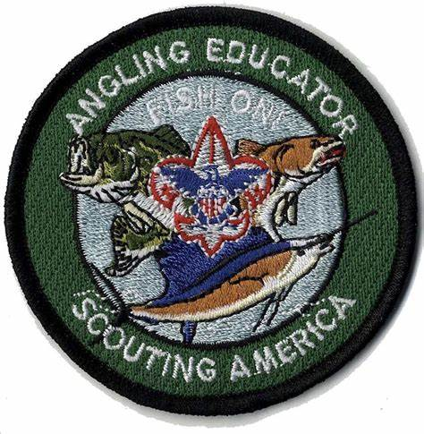

**What's an Angling Educator?**

Everything you need to know to take your Scouts Fishing!

The program is designed to give a student who has never fished the skills and knowledge, both practical and ethical, to go to a pond and be immediately successful. Class is for adults and scouts 15 or older (exceptions at discretion of the course coordinator but scouts must be mature enough to teach other scouts)

**Comments:** This course provides basic fishing information as well as information on how to teach fishing to scouts. For people who are already anglers or fishing merit badge instructors this will be a good review and add on it techniques that work better with younger anglers. **The expectation is that people attending this class have the intention of teaching fishing to scouts either at their troops, packs, council events or other scouting venues.**  
  
**Where:** Stem building at T Brady Saunders

**When:** October 18, 2025 8:30 am till 6 pm  
  
**What to Bring**: your favorite fishing gear, sunscreen, water, eye protection, a hat, a bagged lunch

**Where to sign up:**