**Why Become an AE?**

Fishing is one of the most popular youth activities. In a 2018 survey, Cub Scouts were asked what activities they most wanted. They answered in this order:

1. Camping
2. Pinewood Derby
3. Hiking
4. STEM
5. **Fishing**

The same question was asked of Scouts BSA participants. They wanted:

1. Camping
2. Hiking
3. High Adventure
4. **Fishing**

BSA fishing programs are very cost-effective recruitment and teaching tools!

***BSA Owns Outdoor Adventure!***

***Help Fishing lead the way!***

***Become an AE today!***

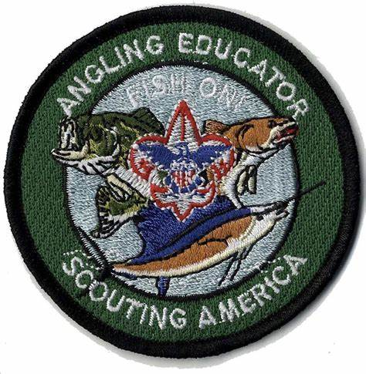

**Where:** Stem building at T Brady Saunders

**When:** October 18, 2025 8:30 am till 6 pm  
  
**What to Bring**: your favorite fishing gear, sunscreen, eye protection, hat, water, a bagged lunch

**Where to sign up:**

**What is an Angling Educator Course**

AE Training Courses are facilitated by the BSA National Fishing Committee. Courses cover Cub Scout and Scouts BSA Fishing Basics

Fishing helps you to “Deliver the Promise of Scouting”. AEs learn age-based and skills-appropriate fishing tools and techniques, for simple cane pole and spin cast fishing. The course highlights best practices in both the classroom and in the field.

*“A fisherman does not bait his hook with food he likes. He uses food the fish likes.”*

*~ Robert Baden Powell*