Huguenot Trail District 2025 Pinewood Derby Rules

# Pinewood Derby Race

These rules have been developed over the years to help ensure fair and fun competition by everyone.

1. HAVE FUN!!! - The idea behind the Pinewood Derby is for SCOUTS to enjoy a fun, friendly and fair competition in a community environment.
2. It is recommended that each Scout be dressed in a neat, clean, Class A uniform to participate in the District Pinewood Derby. Each unit can mandate their own dress code for their Pinewood Derby held at the Pack level.
3. Arrive in plenty of time to have your car checked in and inspected and no later than 30 minutes before the designated race start time. Late arrivals will be entered into the race at the discretion of the race officials as long as the races have not yet started. **At the district races, cars must be checked-in >15 minutes prior to the race start time.**
4. There is **no requirement that cars race or place at the Pack level** to race in the district races. All Cub Scouts are welcome to participate. **Scouts at the district race must be present in order to race.**
5. **Cars MUST follow the following rules to participate in the district Den-level races.**
6. **ALL participants MUST pre-register online** to allow pre-creation of heats.

**Car Specifications**

1. All car designs will be **non-offensive and in good taste**.
2. All cars **must be newly built**, previous year cars cannot be used.
3. The block of wood, wheels and axles **must come from the official BSA kit**. With the exception of BSA internet purchases, internet purchased body, wheel and/or axle parts are **not** permitted. With the exception of the BSA store, store-purchased body, wheel and/or axle parts are **not** permitted.
4. Any specially designed parts (be they internet purchased or from someone with access to sophisticated machining capabilities) which are judged by track officials as contributing to the speed of the car are **not** permitted. The spirit of the event is for parents and the Scout to work together with the materials in the official BAS kit to build a car. It is not intended to be a competition of who can purchase the latest gadgets or has the best tools and equipment. **If you are not sure, ASK at registration.**
5. The wheels shall **not be modified** in any way except for the removal of the burr as shown in Figure A. Examples of illegal modifications are shown in Figure B.
6. The axle shall **not be modified** in any way except of the removal of the burr (Figure C). Removal of excess material from the axle and reducing the diameter of the axle shall not be permitted (Figure D). Polishing of axles is permitted. **Grooved/beveled axles are strictly prohibited.**
7. **Gluing wheels is strongly discouraged**, due to the need to inspect axles **under the wheels** after racing. **Removing axles secured with glue usually damages cars**.
8. The race car may not be constructed or treated in such a way that the track's starting mechanism imparts momentum to the car.
9. The race car may not be constructed or treated in such a way that the track's starting mechanism imparts momentum to the car.
10. The race car may not be constructed or treated in such a way that the track's starting mechanism imparts momentum to the car.
11. **Only dry powder lubricants such as graphite powder or white lube T102 type-lubricants are allowed.** **Grease, oils, liquid or gel lubricates of any kind will result in disqualification.** Cars will not be allowed to be lubricated after they have been impounded or between races.
12. The cars cannot exceed the following dimensions by more than 1/16 of an inch
    1. **Width: 2 ¾ inches**
    2. **Length: 7 inches**
13. The weight of the car **cannot exceed 5.0 ounces (using District scale)**.
14. The placement of weights so that they project into the wheel cavity is not allowed.
15. Springs, washers, bearings, starting devices, power assistance devices or rubber bands are **not** permitted.
16. Cars must have four free spinning wheels.
17. Cars may not have a flexible suspension system.
18. No portion of the car can be modified to give an unfair advantage at the start or finish (Figure F)
19. All 4 wheels **must** contact the track at the same time.
20. The wheels must sit flat on the track. Axles **cannot** be tilted upward or downward so that only the edges of the wheels are in contact with the track.
21. Any type or size of weights may be used as long as they do not conflict with the above specifications. Weights must be secured to the car. Weights that fall off during racing may **not** be reattached unless caused by track officials during transport.
22. Any attachments can be used as long as they do not conflict with the above specifications. Attachments must be secured to the car. Attachments that fall off during racing may **not** be reattached unless caused by track officials during transport.
23. Cars cannot be designed to cause interference with any other car during the race.
24. Cars cannot be designed with break-away wheels or any other parts.
25. Recognizing that not every speed improving gimmick can be anticipated, within accordance of the spirit of this event, track officials have the discretion to make judgments about the fairness of any car. **All track official decisions are final.** It is likely that parents and Scouts working only with the parts supplied by the kit with the addition of weights (unless the weights themselves are part of a new gimmick design) need not be too concerned with this rule.

# Inspection:

1. All cars will be inspected and impounded prior to the race at check-in.
2. Any Scout, whose car does not meet these specifications, will be allowed to modify their car to meet specifications before being re-inspected. The race official MAY allow cars to race, even though they do not meet the above standards and cannot be modified to meet the standards.
3. Limited tools and materials will be available for on-sit modifications.
4. All cars will be impounded after the inspection. Cars cannot be modified following inspection and impoundment.
5. At the discretion of race officials, “emergency” repairs may be allowed between races to permit cars to complete racing if damage is caused by track officials. Modifications to increase speed are **not** permitted as part of emergency repairs.

# Remember the most important rule – Have Fun!!

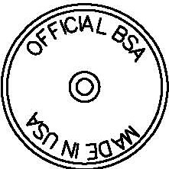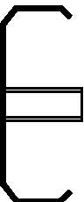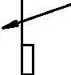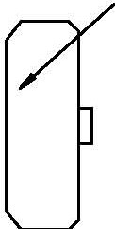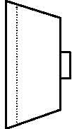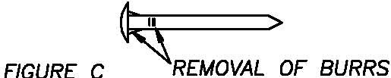

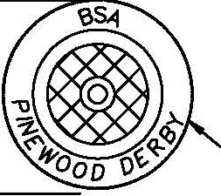

|  |  |
| --- | --- |
| *OFFICIAL BSA "FROM THE Klr WHEEL*  *----+--•13/32"*  *HUB*  *"DOTS"*  *FRONT VIEW SIDE VIEW BACK VIEW* CROSS *SECTION*  *ALLOWED MODIFICATIONS*  *REMOVAL OF DIE*  0 *MOLD PROJECTION*  IS *ALLOWED*  *FIGURE* A | |
| *ILLEGAL MODIFICATIONS REMOVAL OF "DOTS"*  *CHAMFERED DISHED AXLES AXLES*    *ROUNDED CONED*  *WHEELS WHEELS*  *FIGURE B* | |
| *OFFICIAL FROM THE KIT AXLE ALLOWED MODIFICATIONS NOT TO SCALE*  > | |
| *EXAMPLE OF SOME ILLEGAL MODIFICATIONS* |  |
| *====:::::::>* | 1111111 > |
| *REMOVAL OF* " *CUPPING AXLE* |  |
| *MATERIAL HEAD* | *FIGURE D* |

*EXAMPLE OF SOME ILLEGAL CAR SHAPES AND MOD/FICATIONS*



ii Ii

II II

II- *OFFICIAL Kl I*

II

II *LOCATION* II

II II

II II

II II

" "

*ILLEGAL WHEEL BASE MODIFICATIONS*

*ALL 4 WHEELS MUST MAKE CONTACT WITH TRACK. NO "TRICYCLE"* CARS *ALLOWED*

0e:



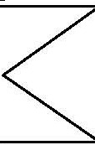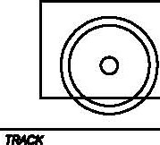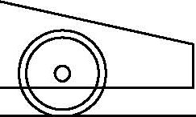

*FIGURE F*

**Additional information - Rules include but are not limited to the following pictures:**

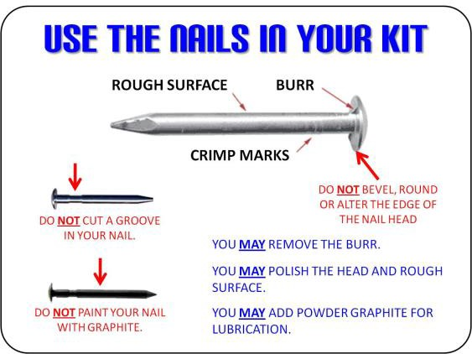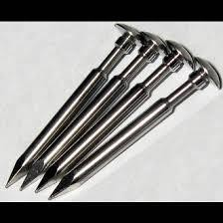

Follow these guidelines Axle grooves are not allowed

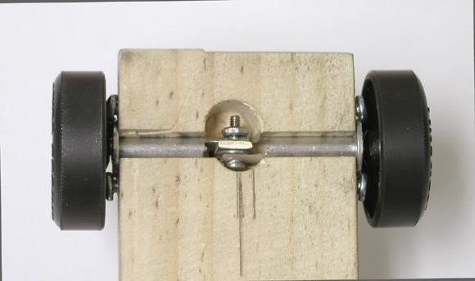

(not allowed) Axles must be supported by factory cut wood slots in car from kit

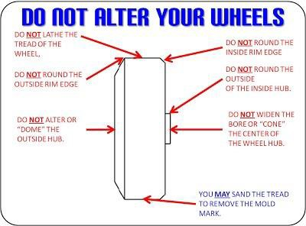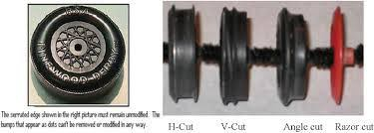

Follow these guidelines Other than removal of burrs, wheels may not be modified.

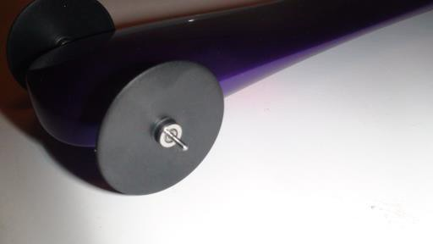 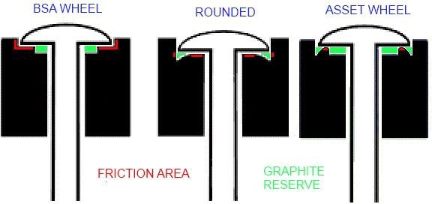

Wheel modifications and Bearings Wheel modifications are not allowed are not allowed.

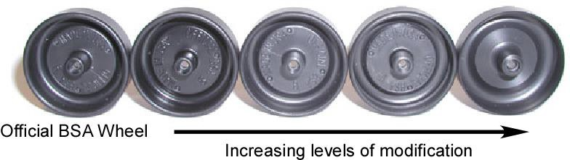

Wheel modifications are not allowed

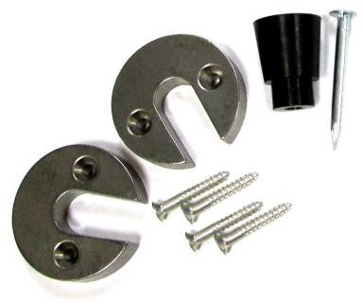

Weights designed to fit inside wheel cavity are not allowed.