**A Guide for**

**VIKING Tribes**

**NOVEMBER 22-24, 2024**



**HUGUENOT TRAIL DISTRICT CAMPOREE**

We thank Troop 163 of the Mark Twain District, Connecticut Rivers Council, Boy Scouts of America for allowing use of their 2021 Viking Camporee Leader’s Guide as the basis for this document.

# TABLE OF CONTENTS

**Table of Contents** **2**

**THE DAYS OF VIKINGS** **3**

**VIKING VERNACULAR** **3**

**REGISTRATION** **4**

A Note to the Elders (That is you Adults) 4

**ARRIVING AT CAMP AND PARKING** **5**

**2023 Days of VIKINGs CAMPOREE SCHEDULE (Tentative)** **6**

**PREPARING FOR THE days of vikings CAMPOREE** **7**

Decorating your Viking Long Boat 7

The Right Apparel 7

Danish Oven Cooking Competition 8

**SATURDAY ROUND ROBINS** **8**

Viking Injury Repair 8

Viking Ethics & Leave No Trace  8

Viking Field Games8

Viking Battlement Climbing 9

Viking Boat Building 9

Viking 3-D Archery & Hatchet Throwing 9

Viking Runic Puzzle Solving to Locate Gold Caches 9

Viking Long Boat Decorating 9

**OTHER ACTIVITIES 10**

Viking Camp Fire 10

Viking Gold 10

Scout Museum and Trading Post 10

Interfaith Worship Service 10

**VIKING COMPETITION RECAP** 11

**PACKING LIST** **12**

**VIKING GAMES AND CONTEST RULES** **13**

3D-Archery 13

Ax Throwing 13

Danish Oven Cook-Off 13

**ADVANCEMENTS** **14**

Camping (in Tribe) 14

Cooking (in Tribe) 15

Fire Building (in Tribe) 15

Knots/Lashings 15

First Aid 16

Archery 16

Climbing 16

Leave No Trace/Outdoor Ethics 17

Geocaching 17

**DRUG, WEAPOn, behavior, and adult ypt POLICY** **18**

**CAMPOREE MAP 19**

**ROUND ROBIN AND OTHER JUDGING RUBRICS 20-27**

# THE DAYS OF VIKINGS

Farmers, explorers, and merchants. But to some, they were considered pirates. Vikings were the Scandinavian warriors of the sea, known as barbarians by those who feared them. Travel back with us again, to the tenth century - to the days of the Vikings!

<https://www.britannica.com/topic/Viking-people>

# VIKING VERNACULAR

**Vikings**: Scouts registered for the Huguenot Trail Vikings Camporee and want to have a fantastic time competing in tenth century Scandinavian-related games.

**Clan**: Vikings in the same Scout Patrol. **All Clans must bring a Clan Flag and have a Clan Cheer/Yell as well as a Skit for Saturday night.**

**Chief**: Viking Clan Patrol Leader.

**Tribe**: Viking Clans in the same Scout Troop.

**Head Chief**: Viking Tribe’s Senior Patrol Leader. **Assistant Head Chief** is the ASPL.

**Elders**: Adults registered for the Viking Camporee.

**Lendmenn:** Camporee Senior Patrol Leaders (Emily Davis and Ben Brown)

**Flagmenn**: Camporee Assistant Senior Patrol Leaders (Alyssa Kennedy and Elliott Marshall)

**Hildingr**: Viking King/Camporee Director (Bill Eggleston, [weggls011@gmail.com](mailto:weggls011@gmail.com), 804-300-0472).

**Lachs**: Health Officers (Billy Eggleston, 804-714-6155 and Frederick Molter IV, 804 920-4315).

**Judges**: Adults on the Viking Committee who have a specific responsibility. If you want to be a Judge, contact Hildingr.

**Viking Long Boat**: **Camp** Canoe decorated as a Viking Long Boat (with **no** permanent changes). Done by Tribe.

**Long House:** Cub Adventure Camp Dining Hall

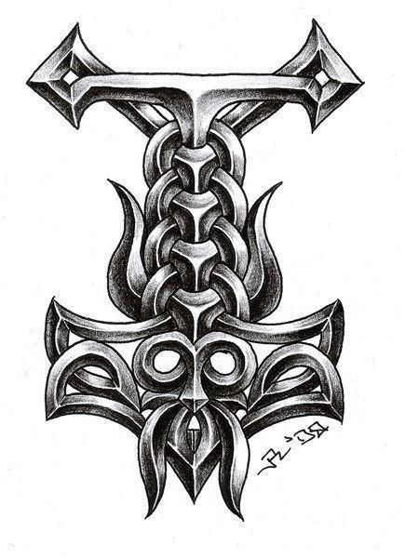

# REGISTRATION

While playing on the river bank in the early morning of a hot summer day, a Tenderfoot Scout discovered a clay jar containing a parchment with strange characters. Experts believe it to be in Old Norse.

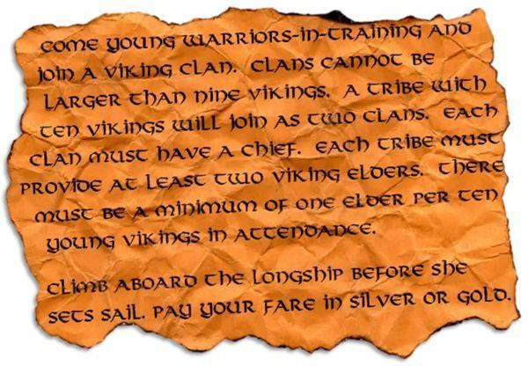

*(English Translation)*

Clans will each contain ~**eight** Vikings. If a Clan has significantly fewer than eight Vikings, Vikings from more than one Tribe will be combined into a Clan prior to the Camporee, provided each other’s contact information, and encouraged to collaborate prior to the Camporee. This will allow the maximum number of Vikings to participate in the Camporee and will make competitions more equitable.

Each Clan must have a Chief and an Assistant Chief. Each Tribe must provide a minimum of two Elders. There must be a minimum of one Elder per ten Vikings in attendance. Tribes contributing to a combined Clan will be assigned nearby camping areas as best possible. At least one adult leader from your unit should help volunteer at a station.

Registration is $7.50 per Viking and $7.50 per Elder. Units must pre-register and payment in-full is due by October 25th when registration closes.

AOL Scouts are welcome to attend as **guests** of a Tribe during Saturday’s activities, and must be registered as part of a Tribe ($7.50). They should be registered as AOLs in Black Pug. **They may camp overnight with the Tribe and must be accompanied by two registered Cub Leaders, at least one of whom must be BALOO trained.** AOLS **MUST** stay with their assigned Clan during their visit and be a fully participating member of the clan for all round robin stations and all competitions.

**Anyone leaving Camp before Sunday’s Closing Ceremony MUST check out at the Cub Camp Admin Center, and must check back in if you return, to keep an accurate head count in case of an emergency.**

Register on-line: <https://scoutingevent.com/602-80985>

## A Note to the Elders (That is you Adults)

Elders are welcome to participate in activities. Your presence is appreciated. If you see something unsafe, you have the right and responsibility to take corrective action. You may take pictures, cheer for the youth, and give encouragement.

There are some things you may not do however. Don’t aid your Vikings in the competitions. Don’t give advice, answers, or provide them with any advantage. Let the Chiefs be responsible for their Clans and Head Chiefs for their Tribes. Your role between now and November 22nd is to coach and mentor your Chiefs to be prepared to lead their Tribes and Clans. Please see the activities and rank advancements that you can help your Vikings prepare for.

We will be asking each Tribe/troop to have AT LEAST one adult who can help this camporee be the best one yet! This adult(s) can be a volunteer at a station, help with check-in, monitor traffic, or follow other assigned tasks.

Thank you for allowing the Vikings to have the best experience during this year’s Camporee!

# ARRIVING AT CAMP AND PARKING

Check-in is from 5 PM to 9 PM on Friday at the **Cub Adventure Camp Welcome Center**. Arrive as a Tribe (Troop) to make check-in easier. The Head Chief of the Tribe (Senior Patrol Leader) will make an accounting of Tribe members in attendance and submit the completed attached roster with Scout names and emergency contact numbers. The Tribe Elder (Scoutmaster) will submit parts A and B of the standard BSA health form for each Scout, guest and adult attending (even when arriving later or On Saturday). All registered participants will receive a wristband and the Tribe will be assigned a campsite. Have your camp site set up before the 8:30 PM Campfire and Chief's Council in the Viking LongHouse (Cub Adventure Camp Dining Hall). **At check-in, identify AOLs and Cub leaders and any other late arrivals**. AOLs and their leaders will receive an alternate-colored wristband.

**Up to two vehicles can enter camp to transport gear, and one trailer per unit** may remain in the campsite during the Camporee-**BUT NO OTHER VEHICLES**. Only approved staff and emergency vehicles are permitted beyond the Long House between 9 PM Friday night and 7 AM Sunday morning for safety and due to lack of space. Other Troop vehicles should be parked in **one of two lots to the right of the Welcome Center noted on the map**.

Campsites will be assigned and Vikings and Elders are welcome to use the Pit Latrines and the bathrooms/showers in the Fort. Water to the Fort and to Spigots in campsites will be turned off by the camporee. Water will be available from a hose run out the back of the Fort into the parking lot.

Fire Rings are available in or near to some campsites and split firewood will be available at several sites. Please do not bring firewood from outside camp as this can transport insects, fungi and other unwanted hitchhikers nor create a fire other than in existing fire pits.

# 2024 Days of Vikings II CAMPOREE SCHEDULE (Tentative)

**Friday**

5:00 PM Earliest you may arrive and set up camp

5:00-9:00 PM Registration for all units and individuals at Welcome Center,

Begin Decorating Viking Long Boats

8:30-9:00 PM Opening Campfire

9:05 PM Head Chiefs and Elders meet at LongHouse for Head Chief Council (PLC)

10:00 PM Quiet in camp - All Vikings in their campsites

10:30 PM LIGHTS OUT

*When you have completed unloading, please move your vehicle to the designated parking area. One Trailer per Troop may be parked in front of your assigned campsite.*

Vikings are urged to bring trail snacks for both the morning and afternoon Round Robins

**Saturday**

7:00 AM Wake up, breakfast, continue decorating Viking Long Boat

8:30 AM Welcome and Opening Flag Ceremony

8:45 AM Viking Attire Judging

9:00 AM Round Robin Session 1 begins

9:50 AM Round Robin Session 2 begins

10:40 AM Round Robin Session 3 begins

11:30 AM Round Robin Session 4 begins

12:20 PM **TRAIL LUNCH**

1:00 PM Round Robin Session 5 begins

1:50 PM Round Robin Session 6 begins

2:40 PM Round Robin Session 7 begins

3:30 PM Round Robin Session 8 begins

4:20 PM Round Robin Session 9 begins

5:10 PM Viking Long Boat Judging and Races

5:40 PM DINNER TIME, prepare Danish Oven dish

7:00 PM Danish Oven Judging

8:00 PM Viking Campfire Program and Awards

10:30 PM LIGHTS OUT - All Vikings in their campsites

**Sunday**

7:00 AM Vehicles allowed in campsite for loading (carefully)

8:45 AM Interfaith Worship Service

9:15 AM Closing Flag Ceremony and awards

By 11:00 AM All campsites inspected and Troops released to leave

**It would be appreciated if some troops stayed after to help clean-up.**

# PREPARING FOR THE DAYS OF VIKINGS II CAMPOREE

Vikings, this camporee will take some preparation. Use this section of the Leader’s Guide to plan your Clan and Tribe meetings in the time leading up to the Camporee. Have fun, build memories, and take many pictures along the way. Bring clothes for the expected and unexpected weather, trail snacks for the morning and afternoon Round Robins and a Trail Lunch for Saturday as you will only have 40 minutes for that meal before the fun begins again! Water jugs will be located at many of the stations to refill your water bottles.

## Decorating your Viking Long Boat

Each Tribe will be provided a camp canoe to turn into a Viking Long Boat **(DO NOT BRING A CANOE FROM HOME)**. Every good Viking knows how to handle their Long Boat. But our camp canoes don’t look like Viking ships. That part is up to you! With your Tribe, plan how you will decorate your camp canoe and **bring the materials with** you, including tape to **temporarily** attach items to canoes**.** 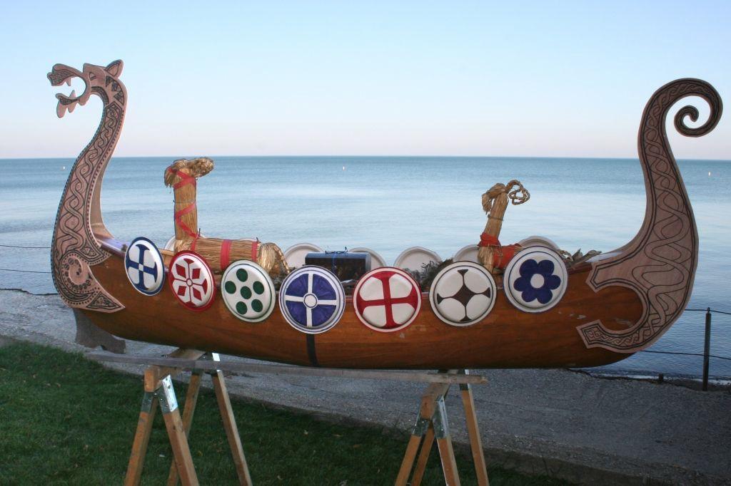

Tribes should use time Friday and Saturday (including free period) and during their Long Boat Decorating period during the Round Robins to decorate. **Please do not use paint, glue or anything that will damage the canoes or that is permanent.**

Tribes will collect a camp canoe from canoe trailers parked near the starting point for the Long Boat race (and must return to them the trailers after removing decorations) and are welcome to decorate their Longboats in their campsite or at the starting location for the race. DO NOT TOUCH THE LONG BOATS OF OTHER TRIBES WITHOUT THEIR PERMISSION.

Following judging for authenticity and creativity, Vikings will transport their Tribe’s LongBoat back and forth across a lake of grass. All Scouts (including AOL’s) physically capable are expected to participate in the race. Vikings may carry or push their Long Boat, but may not use wheels or wheeled devices/rollers to move their Long Boat. **Do not drag your Long Boat on or across the gravel road as this will damage it.**

Viking Gold will be awarded for the most authentic Viking Long Boats as well as for the fastest to complete the Portage race.

## The Right Apparel

How far you want to take this is up to you! Attend in Class “A” uniform or in **full** Viking costume (not ½ or ⅓). Do not bring any real weapons - that could go bad quickly. Vikings are heavily encouraged to make, decorate and bring shields and pool-noodle mjölnirs to decorate their Long Boat, but no other swords, axes, hatchets, spears, hammers or similar weapons. Make the shield from wood, cardboard, cardboard wrapped in foil… It’s up to you, but do not bring unaltered store-bought shields. If Vikings choose to create shields or mjölnirs, they must be **used appropriately throughout the entire event**, otherwise, they will be taken until the end of the Camporee. Viking attire will be judged for authenticity and creativity, with Viking Gold awarded for best dressed. But, **NO ONE is required to wear Viking-themed clothing.**

As for headgear, we strongly encourage authentic, historically accurate versions, Vikings did not include horns on their helmets, but……….



## Danish Oven Cooking Competition

Each Clan is expected to research, prepare and present an as authentic as possible “Danish Oven” or other type of dish for Judging Saturday evening immediately after dinner. Elders may coach and mentor in advance, but the decision on the dish and all preparation MUST be by Vikings, including fire building. **Elders MAY help by starting coals in advance of dinner time for Danish oven dishes that would not otherwise be ready by 7:00 PM Saturday night, but youth should prepare the coals in advance in a chimney or otherwise.** Submissions for judging may be a dish, a meal, dessert-Scout’s choice, and are not required to be made in a Danish (Dutch) oven. Vikings ate very hearty meals and there are many online resources to validate authenticity. Elders may prepare and share a Danish Oven dish as well, but it will not be judged against Viking submissions. Vikings will be asked show documentation of the authenticity of their dish digitally or hard copy.

# SATURDAY ROUND ROBINS

## Viking Injury Repair

Whether Vikings were using their blades for work or in battle, there was always the risk of an errant throw or swing of the ax resulting in injury. These injuries range from possibly a small nick of a blade to a life threatening loss of a limb. Your Clan will learn and demonstrate what to do in the unfortunate chance that something goes astray and you have a fellow Viking down and in need of assistance. Leave no Viking behind! Be familiar with first aid skills from Tenderfoot, Second Class, and First Class. Viking Gold will be awarded based on a Clan’s 1st aid skills and other factors. **Clans should carry their Clan 1st aid kit with them Saturday, and present it for review at the Viking Injury Repair Station.**A black and white circle with symbols

When not treating injuries, Vikings will be participating in various relays, including Fireman Carries, Stretcher Races and more! All requirements can be found in ranks Tenderfoot through First Class.

## Leave No Trace & Outdoor Ethics

All Vikings were very respectful of their surroundings, including the people around them and the nature surrounding their homes. They believed it was extremely valuable to understand and know how to care for their environment. In this station, clans will learn more about how to explore sustainable practices in a safe manner while going through various activities!

## Viking Stealth & Team Games

Vikings must be able to travel stealthy and steadily. There are many ways to strengthen these skills, including games and competitions among the Clans and Tribes. Don’t Ring the Bell is a team-building game that focuses on patience and communication. Vikings will be put in rows with their clans and must navigate through a course of ropes connected to loud bells that will announce their location to the opposing team. If the entire clan can make it throughout the course without the opposing team finding them, they win! Seems simple! But, this takes practice and development of strategy, communication, and endurance. There will also be other various team games available during this station.

Prior to the camporee, please visit :

<https://www.tllbgw.com/don't-ring-the-bell> or a similar online site to learn more about this game!

## Viking Battlement Climbing

Vikings have the opportunity to “Storm the Battlement” (climb the Climbing Tower with a belayer). Vikings are encouraged to try climbing the Tower, but are not required to. AOLs may Climb the Tower. Viking Gold will be awarded for a Clan’s performance.

When not climbing, Scouts will be playing Kubb which consists of two teams (2-7) throwing small pieces of wood to knock down the opponents large wooden Kubbs. The first team to knock over all of their opponents Kubb blocks, gets to attempt to knock over the wooden King.

## Viking Boat Building

Each Clan will assist in the building of one of Danique’s Epic Longboats, which translates as “Morning Star” used to cross the vast ocean with only sail and oar. Almost 75 lashings of varying types will be needed to create the framework of the longboat, and then sheer strength of every warrior to transport it to display the heraldry of our flag to start our closing ceremony. Viking Gold will be awarded for a Clan’s knot tying/lashing skills and other factors.

If time allows, Scouts will also be able to enhance their knot-tying skills in various competitions and games with their fellow vikings.

## Viking Archery & Hatchet Throwing

In addition to a spear, ax and/or sword, Vikings were expected to carry and be proficient with a bow and arrows. As Vikings, you will have an opportunity to practice your archery skills using specialized targets. Vikings are welcome to draw onto their targets with appropriate motifs prior to using them for archery practice. Viking Gold will be awarded based on accuracy and other factors.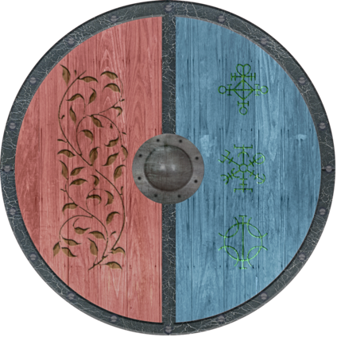

When Vikings are not learning to aim, draw, and care for the bow and arrows, they will be able to test their strength and aim with throwing hatchets! All Vikings rode the waves and leaped into battle more often than not with a Viking Axe in their hands. The ax was one of the most popular items for Vikings to carry into battle. Viking axes were often sharpened and Vikings would practice their ax-throwing in competitions before heading off to war. Your Clans will learn this Viking tradition by throwing hatchets and learning ways of keeping them sharp for everyday tasks or for battle should the need arise.

If time allows during this station, clans will work together to build the most structural sufficient, strong fire that will cook all of their future hearty meals, without the aid of modern technology.

## Viking Runic-Puzzle Solving

Vikings must have advanced navigational skills in order to explore nearby areas and make it back home safely. To improve our navigational skills, Vikings will use appropriate electronic devices and puzzle solving skills to complete the Runic Puzzle Solving Course to collect additional Viking Gold.

## Viking Long Boat Decorating

In addition to Friday night and free periods, Vikings will be able to decorate their Viking Long Boat prior to Long Boat Judging and the Long Boat Race before dinner on Saturday. If they have time, Vikings are highly encouraged to visit the Handicraft Building to visit the amazing items in the Scout Museum and Trading Post!!

# OTHER ACTIVITIES

## Viking Camp Fire

Clans will develop, practice and present a **Viking-themed campfire skit, song or other** during the Saturday night Campfire. Each must be approved by one of the four Lendmenn before or after the Friday night PLC or during the day on Saturday. Viking Gold will be awarded based on audience enthusiasm for each skit, song or other Clan contribution. All members of a Clan must have a part in the presentation, including any AOL guests. Elders are welcome to participate too, and must also have their “Viking-themed contribution” approved by one of the Lendmenn.

## Viking Gold *

Clans will be awarded “Viking Gold” based on their performances and Scout Spirit during the competitions, at activity stations, and at the Campfires. A coin pouch will be provided to each Clan to hold their Viking Gold.

A scout is Trustworthy. We ask that troops not bring or use the gold they acquired from last year’s camporee to this event.

Prizes and awards from earning gold will be decided soon. (TENTATIVE)

## Scout Museum and Trading Post

During free time, Vikings are invited to visit the nearby Scout museum containing Scout memorabilia and Scout collectables, which are NOT for sale (in what is known as the Cub Camp Handicraft Center the rest of the year). However, this is a perfect opportunity to learn more about scouting’s history and see some amazing patches!

Adjacent to that will be a Trading Post with Scout-related collectable items for sale at reasonable prices (US currency, not Viking Gold). The Trading Post and Scout Museum will be on display before, during, and after round robin sessions.

Make sure to visit to see all of the special memorabilia and to learn more about Scouting History!

## Interfaith Worship Service

Prior to the Closing Ceremony, the Camporee Lendmenn will lead an interfaith Worship service adjacent to the where the closing ceremony will be held - bring a camp chair. If Vikings have an interest in reading a section of this chapel service, contact the Hildingr.

## Viking Competition Recap

All rubrics (drafts) can be found at this link :

<https://docs.google.com/document/d/1O9Tc04XCMuhdBESnZs0tcWfkRZx7uel8EaYZlxDfvGc/edit?usp=sharing>

**Viking Attire :**

Throughout the event, Vikings will be encouraged to wear their decorated gear that was made prior to the camporee. Shields and pool-noodle Mjolnirs, also known as Thor’s hammer, should also be created and decorated before Saturday's Round Robins. These can be made of cardboard, foil, paper, or any similar material. However, please remember that these items must be used appropriately throughout the entire event, if this becomes an issue, all gear will be taken, a scout is obedient!

**Long Boat Decorating :**

Similar to the Days of Vikings I Camporee, canoes will be decorated as Viking Long Boats and used in various competitions and judgings! Before Round Robins, Long Boats will be judged by the Lendmenn and Flagmenn on many aspects, including : creativity, authenticity, and other factors listed on the rubric.

After Round Robins, we will be having a camporee-wide race along the BMX field, all physically capable Vikings will join their tribes team in order to carry their Long Boat to and from the finish line! The first three teams who cross the finish line, will earn extra gold coins along with a prize!

Remember that these canoes must not have any permanent damage or materials on them, this means no glue, paint, nails, wheeled-devices or any other material that will leave a mark or be difficult to remove!

**Danish Oven**

Directly following dinner, we will be hosting a Danish Oven competition, and we encourage everyone to be involved! This can both enhance cooking skills and allow for exploration in foods! However, this dish does NOT have to be made in a dutch oven, it can be cooked on a camp stove, or served cold.

To get the points in this competition, your tribes’ dish must be authentic, creative, well-presented, appetizing, and ready to eat by 7:00PM, Saturday night! To get the authenticity point, you must be able to show the judges a reliable source showing that Vikings commonly used these ingredients back in the day!   
Again, Elders MAY help by starting coals in advance of dinner time for Danish oven dishes that would not otherwise be ready by 7:00 PM Saturday night, but youth should prepare the coals in advance in a chimney and work on preparing the food throughout the day.

**Spirit, Races, and Station Results**

Throughout the entire camporee, Vikings will be judged on spirit both within their clans and other tribes during each station, competition, or activity! Sunday morning, one troop will be awarded the annual Spirit Stick for the 2024-2025 year!

Again, the first three tribes to cross the finish line of the Long Boat Race on Saturday, will be awarded a prize and extra gold coins to be used later in the camporee! The goal is to have everyone switch in and out throughout the race with their other VIkings in their tribe to ensure everyone gets the chance to support their team during the race!

At the end of the campfire on Saturday night, multiple tribes will be awarded a prize for their outstanding effort and spirit during the camporee! These tribes will be awarded due to their effective communication, discipline, teamwork, spirit, and leadership! Your job is to strive to be one of the few groups who can withstand the challenges during this camporee!

# PACKING LIST

**Tribes**

❏ Troop box

❏ Gateway

❏ Troop Flag

❏ Campfire song/skit

❏ Lanterns

❏ Tables

❏ [BSA Medical forms](http://www.scouting.org/filestore/HealthSafety/pdf/680-001_AB.pdf) parts AB for all scouts and adults

**Clans**

❏ Patrol Flag + Clan Flag

❏ Shovel

❏ Viking Boat supplies

❏ Cooking gear

❏ Dishwashing supplies

❏ Trash bags

❏ Tables

❏ At least 1 gallon drinking water per scout each day.

❏ At least 5 gallons washing water per day.

❏ Food storage container

❏ Charcoal chimney

❏ Water and sand buckets for putting out fires

❏ Cooler with ice

❏ **Patrol First Aid kit**

❏ Extra toilet paper

❏ Supplies for Danish Oven Contest

**Vikings**

❏ Field Uniform (Class-A)

❏ Viking Clothes (if wearing)

❏ Pack/duffel bag

❏ Sleeping bag/blankets, sleeping pad

❏ Eating utensils, cup, plate, bowl (if not included in troop box)

❏ Flashlight and extra batteries

❏ Camp Chair

❏ Change of clothes

❏ Warm clothes

❏ Rain gear (check the weather report before you go)

❏ Toiletries

❏ Pocket knife **with Totin’ Chip Card**

❏ Fireman’s Chit Card

❏ Personal First Aid kit

❏ Water bottle

❏ Compass

❏ Neckerchief for 1st Aid activity

The above list is provided as a guide. Tribes, Clans, Vikings, and Elders generally know their needs better than anyone else. Please bring everything necessary and be prepared for the weather!

# VIKING GAMES AND CONTEST RULES

At all Round Robin stations, Vikings will be evaluated based on teamwork, leadership, scout spirit, discipline, following directions, ability to complete tasks, and communication within the Clan, in addition to the below, where relevant.

## 3D-Archery

Scoring for individuals will be based on the number of arrows striking the 3-D target. The number of arrows shot will be determined by the Range Master. A Clan’s score is the sum of the 5 highest scores from the Clan.

## Ax Throwing

Scoring for individuals will be similar to archery. The number of throws will be determined by the Range Master. A Viking’s highest score will be used for his/her Clan’s total score. A Clan’s score is the sum of the 5 highest scores from the Clan.

## Danish Oven Cook-Off

Bring your Danish (Dutch) Oven (or not) and everything needed to make a fantastic main dish or dessert to satisfy hungry Vikings who generally survive off whatever they can farm, catch or grow. Honey was the only sweetener the Vikings knew. Feasts would include the same foods: meat, fish, fowl, vegetables, wild greens, bread and fruit, but in a greater variety. Remember, Vikings eat just like an Elder waiting to be served a feast cooked by Vikings working on their Cooking merit badge. (Well maybe not, the Elders may have to cook their own gourmet feast and will probably have to wear a bib since Vikings like to spill food all over themselves at meal time).You must provide your own supplies (charcoal and starter fluid) and all ingredients. Clan’s will cook in their campsites. All offerings must be brought to the designated area for judging at 7:00 p.m. Saturday evening. Please be creative with regard to authentic Viking cuisine. Viking Gold will be awarded based on “taste”, authenticity, creativity and presentation!

If you can **prove (on a reliable source such as websites)** that your ingredients were a part of Viking culture and time period, then the authenticity points will be given!

# ADVANCEMENTS (Tentative)

Note to Elders: Opportunities will be available for your Vikings to complete rank requirements. They should carry their book with them to be signed off on. You and/or Camporee Round Robin Session Leaders can sign off requirements depending on the skill and your preferences.

## Camping (in Tribe)

|  |  |
| --- | --- |
| **Tenderfoot** | 1a. Present yourself to your leader, prepared for an overnight camping trip. Show the personal and camping gear you will use. Show the right way to pack and carry it. |
| 1b. Spend at least one night on a patrol or troop campout. Sleep in a tent you have helped pitch. |
| 1c. Tell how you practiced the Outdoor Code on a campout or outing. |
| **2nd Class** | 1a. Since joining Boy Scouts, participate in five separate troop/patrol activities, at least three of which must be held outdoors. Of the outdoor activities, at least two must include overnight camping. These activities do not include troop or patrol meetings. On campouts, spend the night in a tent that you pitch or other structure that you help erect, such as a lean-to, snow cave, or tepee.* |
| 1b. Explain the principles of Leave No Trace and tell how you practiced them on a campout or outing. This outing must be different from the one used for Tenderfoot requirement 1c. |
| **1st Class** | 1a. Since joining Boy Scouts, participate in 10 separate troop/patrol activities, at least six of which must be held outdoors. Of the outdoor activities, at least three must include overnight camping. These activities do not include troop or patrol meetings. On campouts, spend the night in a tent that you pitch or other structure that you help erect, such as a lean-to, snow cave, or tepee.* |
| 1b. Explain each of the principles of Tread Lightly! and tell how you practiced them on a campout or outing. This outing must be different from the ones used for Tenderfoot requirement 1c and Second Class requirement 1b. |
| 9c. On a Scouting or family outing, take note of the trash and garbage you produce. Before your next similar outing, decide how you can reduce, recycle, or repurpose what you take on that outing, and then put those plans into action. Compare your results. |

## Cooking (in Tribe)

|  |  |
| --- | --- |
| Tenderfoot | 2a. On the campout, assist in preparing one of the meals. Tell why it is important for each patrol member to share in meal preparation and cleanup. |
| 2b. While on a campout, demonstrate an appropriate method of safely cleaning items used to prepare, serve, and eat a meal. |
| 2c. Explain the importance of eating together as a patrol. |

## Fire Building (in Tribe)

|  |  |
| --- | --- |
| 2nd Class | 2a. Explain when it is appropriate to use a fire for cooking or other purposes and when it would not be appropriate to do so. |
| 2b. Use the tools listed in Tenderfoot requirement 3d to prepare tinder, kindling, and fuel wood for a cooking fire. |
| 2c. At an approved outdoor location and time, use the tinder, kindling, and fuel wood from Second Class requirement 2b to demonstrate how to build a fire. Unless prohibited by local fire restrictions, light the fire. After allowing the flames to burn safely for at least two minutes, safely extinguish the flames with minimal impact to the fire site. |

## Knots/Lashings

|  |  |
| --- | --- |
| **Tenderfoot** | 3a. Demonstrate a practical use of the square knot. |
| 3b. Demonstrate a practical use of two half-hitches. |
| 3c. Demonstrate a practical use of the taut-line hitch. |
| **2nd Class** | 2f. Demonstrate tying the sheet bend knot. Describe a situation in which you would use this knot. |
| 2g. Demonstrate tying the bowline knot. Describe a situation in which you would use this knot. |
| **1st Class** | 3b. Demonstrate tying the timber hitch and clove hitch. |
| 3c. Demonstrate tying the square, shear, and diagonal lashings by joining two or more poles or staves together. |
| 3d. Making a useful camp gadget. |

## First Aid

|  |  |
| --- | --- |
| **Tenderfoot** | 4a. Show first aid for the following:   * Simple cuts and scrapes * Blisters on the hand and foot * Minor (thermal/heat) burns or scalds (superficial, or first-degree) * Bites or stings of insects and ticks * Venomous snakebite * Nosebleed * Frostbite * Sunburn * Choking |
| 4b. Describe common poisonous or hazardous plants; identify any that grow in your local area or campsite location. Tell how to treat exposure to them. |
| 4c. Tell what you can do while on a campout or other outdoor activity to prevent or reduce the occurrence of injuries or exposure listed in Tenderfoot requirements 4a and 4b. |
| 4d. Assemble a personal first-aid kit to carry with you on future campouts and hikes. Tell how each item in the kit would be used. |
| **2nd Class** | 6a. Demonstrate first aid for the following:   * Object in the eye * Bite of a warm-blooded animal * Puncture wounds from a splinter, nail, and fishhook * Serious burns (partial thickness, or second-degree) * Heat exhaustion * Shock * Heatstroke, dehydration, hypothermia, and hyperventilation |
| 6b. Show what to do for HURRY cases of stopped breathing, stroke, severe bleeding, and ingested poisoning. |
| **1st Class** | 7a. Demonstrate bandages for a sprained ankle and for injuries on the head, the upper arm, and the collarbone. |

## Archery/Hatchet Throwing

Not applicable.

## Climbing

Not applicable.

## Leave No Trace & Outdoor Ethics

|  |  |
| --- | --- |
| Scout | 1e. Repeat from memory the Outdoor Code. In your own words, explain what the Outdoor Code means to you. |
| Tenderfoot | 1c. Tell how you have practiced the Outdoor Code on a campout or outing. |
| Second Class | 1b. Explain the principles of Leave No Trace and tell how you practiced them on a campout or outing. This outing must be different from the one used for Tenderfoot 1c.  1c. On one of these campouts, select a location for your patrol site and recommend it to your patrol leader, senior patrol leader or troop guide. Explain what factors you should consider when choosing a patrol site and where to pitch a tent. |
| First Class | 1b. Explain each of the principles of Tread Lightly! and tell how you practiced them on a campout or outing. This outing must be different from the ones used or Tenderfoot requirement 1c and Second Class requirement 1b. |

## Geocaching

**Be Prepared for a Viking themed Geocaching adventure!**

**Prerequisites for completing the** [**Geocaching Merit Badge**](https://www.scouting.org/merit-badges/geocaching/)**:**

* Review the “[**Geocaching Merit Badge**](https://docs.google.com/presentation/d/1XJN7YJuVch1imtFlSZFJv9Jebs6XinagNEZ1g6hMPuA/edit?usp=sharing)” Google Slides presentation.

**Suggested tasks:**

* With your parents permission, create an account on [**Geocaching.com**](https://www.geocaching.com/) and download the app on your smartphone.

Scouts who complete the prerequisites and the on-site Viking Geocache adventure will earn the Geocaching Merit Badge.

# DRUG, BEHAVIOR, WEAPON AND YPT POLICY

**Drugs and Alcohol**

Illegal drugs and alcohol are not permitted at any time, and all tobacco use should be out of sight of scouts and others. All waste needs to be packed out. Standard rules from the Guide to Safe Scouting apply with respect to prescription medications.

**Knives, Weapons, and Firearms**

Vikings and Elders with Totin’ Chip cards may carry one pocket knife.

We encourage you to come dressed in Viking attire. This year, bring only shields and/or pool-noodle hammers. If Vikings (and Elders) behave appropriately, future camporees may be opened to other costume weapons. Thank you for keeping scouting safe for all.

**With the exception of law enforcement officers, no one is permitted to carry firearms**.

**Behavior**

Vikings and Elders are expected to behave in accordance with the Scout Oath and Law at **ALL** times. Violations by theft, phone use, knife use, shield use, fire use, hazing, name calling, bullying, physical hitting, inappropriate inter-gender behavior and language, and other unScoutly behaviors may lead to confiscation for the remainder of the Camporee and/or to being sent home early.

**Adults Staying Overnight**

As per the September 1, 2023 BSA policy change, ALL adults staying overnight MUST have completed Youth Protection Training (YPT) AND be registered with the Boy Scouts of America.

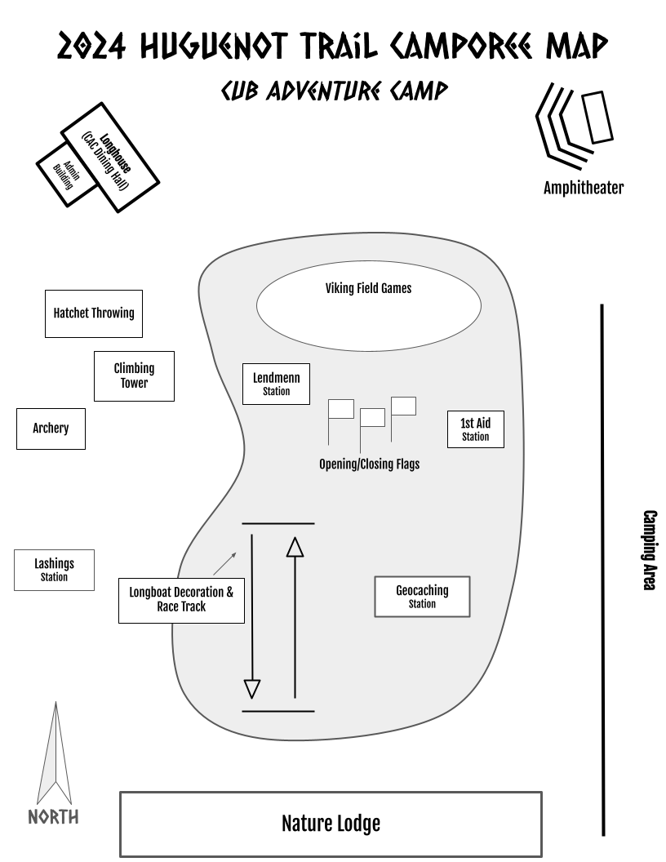

**Group __________ Climbing/Kubb**

|  |  |  |  |
| --- | --- | --- | --- |
|  | **Patrol 1 - Hunters** | **Patrol 2 - Gatherers** | **Patrol 3 - Explorers** |
| * Were clans able to make it to the top of the tower? |  |  |  |
| * How far up the climbing tower did the clans make it? |  |  |  |
| * How long did it take the vikings to make it to the top? |  |  |  |
|  |  |  |  |
| * What clan managed to win the most? |  |  |  |
| * Did the patrol show sportsmanship and teamwork? |  |  |  |
| * Did the clans show good spirit while playing? |  |  |  |
|  | **Total Gold :** | **Total Gold :** | **Total Gold :** |

**Group __________ 3D Archery**

|  |  |  |  |
| --- | --- | --- | --- |
|  | **Patrol 1 - Hunters** | **Patrol 2 - Gatherers** | **Patrol 3 - Explorers** |
| * How close to the centers of the targets did the vikings shoot? |  |  |  |
| * Did everyone try to participate in each aspect of the station? |  |  |  |
| * How well did the clans follow the safety instructions? |  |  |  |
|  |  |  |  |
| * Did the clan participate entirely while showing spirit? |  |  |  |
|  | **Total Gold :** | **Total Gold :** | **Total Gold :** |

**Group __________ Hatchets/Fire**

|  |  |  |  |
| --- | --- | --- | --- |
|  | **Patrol 1 - Hunters** | **Patrol 2 - Gatherers** | **Patrol 3 - Explorers** |
| * How many targets did the clan hit? __/__ |  |  |  |
| * How many hatchets were able to stay on a target? __/ 3 |  |  |  |
| * Did the scouts follow the directions when sharpening knives? |  |  |  |
| * Did the scouts create a fire build that would support a fire? |  |  |  |
|  | **Total Gold :** | **Total Gold :** | **Total Gold :** |

**Group __________ Geocaching**

|  |  |  |  |
| --- | --- | --- | --- |
|  | **Patrol 1 - Hunters** | **Patrol 2 - Gatherers** | **Patrol 3 - Explorers** |
| * How well did the vikings use the devices to find their way? |  |  |  |
| * Did the vikings use their problem-solving skills? |  |  |  |
| * Did the vikings communicate to solve problems? |  |  |  |
| * Did the clan finish the course using effective teamwork? |  |  |  |
|  | **Total Gold :** | **Total Gold :** | **Total Gold :** |

**Group __________ Injury Repair**

|  |  |  |  |
| --- | --- | --- | --- |
|  | **Patrol 1 - Hunters** | **Patrol 2 - Gatherers** | **Patrol 3 - Explorers** |
| * How many skills were they able to demonstrate/explain? __/__ |  |  |  |
| * Did they provide their clan’s first aid kit? |  |  |  |
| * Did the clan demonstrate the ability to follow directions? |  |  |  |
| * Did the clan manage to apply proper first aid methods? |  |  |  |
|  | **Total Gold :** | **Total Gold :** | **Total Gold :** |

**Group __________ Lashings**

|  |  |  |  |
| --- | --- | --- | --- |
|  | **Patrol 1 - Hunters** | **Patrol 2 - Gatherers** | **Patrol 3 - Explorers** |
| * Were clans following all directions? |  |  |  |
| * Did the clan already know how to tie? Did they come prepared? |  |  |  |
| * Did the clan demonstrate scout spirit? |  |  |  |
| * Were members of the clan participating in the entire station? |  |  |  |
|  | **Total Gold :** | **Total Gold :** | **Total Gold :** |

**Group __________ Team Games**

|  |  |  |  |
| --- | --- | --- | --- |
|  | **Patrol 1 - Hunters** | **Patrol 2 - Gatherers** | **Patrol 3 - Explorers** |
| * Was the clan able to make it to the end without making the bells ring? |  |  |  |
| * Was the clan able to find the clan in the maze? |  |  |  |
| * How long did the clan take to make it through the maze? |  |  |  |
| * Were members of the clan demonstrating sportsmanship and resilience? |  |  |  |
|  | **Total Gold :** | **Total Gold :** | **Total Gold :** |

**Camporee Spirit Stick Assessment Rubric**

**(For Awarding Camporee Spirit Stick)**

Station____________________________________________________

Clan Name____________________________________________ Tribe Number(s) _____________

Clan/Tribe Participation ________________

Scout Spirit ________________

Intra-Clan Communication ________________

Teamwork ________________

Skills Growth/Development ________________

Total ________________