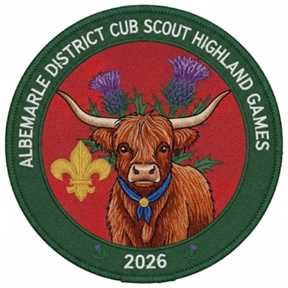

October 23rd – 25th 2026

The Proclamation from the Duke of Albemarle

To all Lairds, Chieftains, and the Brave Wee Youth Clans (Cub Scout Packs) of the Mighty Albemarle District!

Let it be known across the valleys, swamps, and shorelines that George Monck, the 1st Duke of Albemarle—Lord Proprietor of the Carolinas and Commander-in-Chief of Scotland—has issued a grand challenge!

All able-bodied wee lads and lassies are hereby summoned to march upon the Currituck Rural Center (located at 184 Milburn Sawyer Rd, Powells Point, in our fair Province of Carolina) for a legendary weekend of camaraderie, courage, and Highland high-jinks!

Gather your kith and kin from the 23rd through the 25th days of October, in the Year of our Lord 2026, for the ultimate test of athletic prowess and skill at the Albemarle District Cub Scout Highland Games!

Our clan champions shall compete in time-honored feats of strength and cunning, including (but not limited to) Archery, The Wee Caber Toss, Welly / Hammer Tossing, Haggis Hurl, Tug O’ War and Guising (trick or treating). Bonus Attraction: A rare, face-to-face encounter with a majestic Coo (Cow)!

Every Clan is strongly encouraged to adopt their own official family tartan and fly their colors proudly over the encampment. Furthermore, tastefully worn kilts are highly encouraged for both the wee ones and their grown-up chieftains!

Heed this call, pack your tents, and prepare for glory! Will your Clan rule the Highlands?
Given under my hand and seal by Order of the Duke of Albemarle,

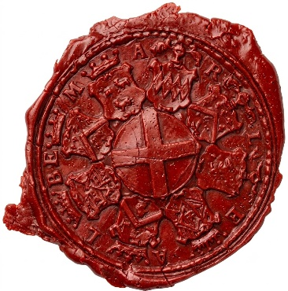

Introduction
This Cub Scout Family Camping Weekend is an opportunity to experience Scouting with others!

There will be a variety of activities to include things for nature enthusiasts, fishermen, marksmen (aspiring marksmen), sports fans, and more. The program schedule is jam packed with activities; however, if a Scout tires out or a program doesn’t interest you, feel free to do your own thing. However, please try not to arrive late to sessions, as safety briefings must start on time.

Participants are invited to camp from Friday evening through Sunday, or any portion in between. Families are welcome to arrive on Friday to set-up camp and relax (this makes Saturday easier). Likewise, after a day of activity on Saturday, you are welcome to take it easy Saturday night and make your way home on Sunday A.M.

No food will be provided this weekend. Campers have the benefit of creating a thrilling menu of steak and crab legs or keeping it simple. Regardless, be prepared to clean up what you bring. Please check the program schedule when planning your meals to ensure you have enough time to prepare, eat, and tidy up.

Programing:

THE STRUCTURE OF THE COMPETITION
Wearing of Clan Tartans – The word clan comes from a Gaelic word meaning “children”, which denotes “family”. This is precisely what our Cub Scout Packs are – families. Some clans express their unity by possession of common emblems or symbolic colors. Well known are the tartans, or plaid textile designs of Scottish clans. At our Highland Games, it is suggested that your clan adopt and wear their tartan! The tartan may be worn as kilts, armbands, t-shirts, Scottish Hats, scarfs etc. An award will be given to the unit judged to have the best Scottish Spirite.

Please coordinate what Tartan your Clan will be using with Nicole Bowling (docsbear@gmail.com) to ensure we don’t have multiple units showing up using the same tartan pattern.

A Word About Kilts
Wearing of a kilt for the Highland Games is highly encouraged. However traditional attire under the kilt is strongly discouraged both due to Youth Protection Regulations and the anticipated weather for this time of year. Compression shorts, thermal leggings or even sweatpants should be worn under the kilt to protect each scout/scouters privacy and to keep you warm.

Scoring

The Camporee will have several competition-themed activities. Awards will be given out at the end of the camporee for best performance in various activities. Fishing and Archery will not be scored. Scoring will be handled at each station during the weekend.

Unit Scottish spirit will be scored upon wearing of tartan and Scottish attire as well as decoration of the campsite using a Scottish or Halloween theme. Judges will score campsites on Saturday afternoon. Points will be deducted for safety hazards.

POINTS DEDUCTED FOR VEHICLES IN CAMPSITES. VEHICLES SHALL BE PARKED IN THE DESIGNATED PARKING AREA AFTER UNLOADING OF GEAR ON ARRIVAL.

THE HIGHLAND GAMES

Please familiarize yourselves and your Scouts with each of the games and events. All of which we want to make sure that safety is first. Scouts will be competing for their unit in each event.

Haggis Throw
Traditionally participants stand on top of a whiskey barrel and must see how far they can throw a haggis whilst still leaving it intact.
We will be using a zip lock bag filled with grain to simulate a Haggis. Each clan will be presented a makeshift haggis, Scouts should stand atop an upturned bucket and throw the haggis as far as they can in the style of the shot put (holding the bag in the palm of one hand, bending their elbow to bring this hand to their shoulder, and quickly extending their arm to launch the Haggis). The Haggis must be caught by other members of the clan and remain intact to be scored. The distance for the longest thrown intact haggis will be recorded as the Clans best score. No points for ruptured Haggis. This is a game of finesse.

Tossing the Wellie
Legend has it that this originated when Scottish husbands wore their muddy boots in the house. In retaliation, the wives threw the boots back at the husbands as they ran from the house to avoid the wives’ wrath. This game is all about distance and staying between the lines.

Hammer Hurl
To simulate a hammer, throw a tennis ball will be placed inside of sock. The longest throw for your clan is recorded to compete against other clans.

Merida’s Archery Range
An archery range lead by a Scouting America Rangemaster will be setup. Each Cubscout will have the chance to shoot several arrows at their designated target. In order to put safety first and foremost this station will not be scored. Make Merida proud.

The Wee Caber Toss
Using the length of a carboard tube as a makeshift caber, Cub Scouts should clasp their hands together and sit the caber on their palms, leaning it against their shoulder. They should walk quickly forwards for a few steps before launching it as far as they can straight in front of the. Scoring will be by distance for cabers successfully launched in the 12 o’clock position from the thrower.

Fishing for Nessie
Each scout will have the chance to fish for local sunfish and bass on the property. Youth under 16 are covered because they will be fishing under the instruction of a licensed adult. Adults must have their own license to participate. Currituck County Parks and Recreation requires catch and release of any fish caught on the property. Fishing rods and bait will be provided but you can bring your own if you wish.

Tug-O-War (Participants Min. 4, Max. 10 per unit)
This will be a single-elimination event. The number of scouts on each side will not exceed 10 but could be less if one of the Clans has fewer Scouts. Teams will use the equal number of members as their smallest team. The final rounds will be held in the afternoon for all to see.

Prehistoric Portal of Time (New Scout Activity Station 9AM-12 Noon)

New scouts and their families are encouraged to stop by the main arena area to experience some special dinosaur related activities.
**Camping and Campsites will be by Pack. Each pack will be assigned an area and should have a designated campsite entrance, gathering area, washing station, cooking and eating area, and tent area. Decertations are highly encouraged.

**Friday Night – Movie Night – Approx. 7-8:30 pm

** There are six session slots on Saturday for Scouts and families to attend with their pack. Packs will be assigned session times upon arrival. There will be Fishing – Team Competitions – Feats of individual strength – Shooting Sports - and even an opportunity to meet a cow up close. Unit leaders must attend the sessions with their units and help the Volunteer Session Leaders run safe and engaging programs.

** Saturday Evening ‘Campfire and Campsite Trick or Treating’
There will be opportunities to go from campsite to campsite trick or treating so bring your costume and decorations. Plans are also underway for an exciting and engaging campfire program!! Stay Tuned.

General Information FAMILY CAMP INFORMATION
When – October 23 – 25 2026 - Be prepared. There is no rain date for this event. All units
should prepare for foul weather.

What- An opportunity to practice Scout skills for the weekend and enjoy some time in the great outdoors with the family.

Who - All Cub Scouts, siblings and parents or guardians of Cub Scouts.
Where - Currituck County Rural Center: 184 Milburn Sawyer Road, Powells Point, NC 27966
Contact – Nicole Bowling – docsbear@gmail.com

How to Register – Registration is online at https://scoutingevent.com/596-116654-265851

Cost - $40 per family if paid in full by 10/20/26; $45 per family if paid after 10/20/26

THERE WILL BE NO ON-SITE REGISTRATION

Program Schedule

Friday
 | 5:00-7:00 PM Optional Check-in (for Friday night campers)
7:00-8:30 Movie Night
9:00-10:00 Leader Meeting and Cracker Barrell (1-2 leader per unit)
Saturday | 6:00-8:00 AM Breakfast Time  7:00-8:00 Optional Check-in (for Saturday arrivals) 8:15-8:30 Flag Raising & Session Assignments  9:00-12:00 Prehistoric Portal of Time (New Scouts)  8:30-9:30 Session #1  9:45-10:45 Session #2  11:00-12:00 PM Session #3  12:15-1:30 Lunch Time (In Campsites)  1:45-2:45 Session #4  3:00-4:00 Session #5  4:15-5:30 Tug-O-War Competition  5:30-6:45 Dinner Time (In Campsites)  7:00-8:00 Guising (Tricker or Treat)  8:00-8:45 Campfire Program  9:00 In bed 9:30 pm Lights Out (Uber Quiet, No Noise)
Sunday | 8:00-8:45 AM Breakfast  9:00-9:20 Scouts Own Service and Awards at the Flagpole  9:30-12:00 Pack-up and Check-out with Admin

Check-in
Plan on arriving between 5:00 PM and 7:00 PM on Friday (if you choose to camp Friday evening). If you plan to arrive on Saturday, please show up prepared for program and complete your registration between 7:00 AM and 8:00 AM and be ready for the 8:15 AM flag raising ceremony.

Upon arriving
Check-in at the CHECK IN BOOTH at the entrance. Staff will verify the number of campers with your contingent, confirm paperwork is in order, and assign you to a campsite. Please then immediately find your Pack Leader and let them know of your arrival.
For camper safety, during program sessions absolutely no vehicles will be allowed into camp unless they are packing or unpacking campsites during the following times: Friday 5-7 PM, Saturday 7-8 AM or 5:30 to 7 PM, and Sunday after 9:30 AM. Vehicles are only allowed on paved road and must be in the designated parking areas.

Check-out
Contingents may check-out after the conclusion of program on Saturday evening or stay until Sunday morning. Please come to INFORMATION AND FIRST AID to check out and have your camping area checked for cleanliness and please let your unit leader know of your departure. Please check out by NOON on Sunday.

Adult Leadership
The Boy Scouts of America is a volunteer run program. Weekend events are staffed by volunteers. Every unit that participates in this event is expected to provide some form of contribution to the success of the event and activities conducted. The event staff counts on each unit to have at least one adult leader to help facilitate the session programming or help with the information/medical tent.

Emergency Procedures

Safety

It is essential for everyone’s safety that every member of your unit fully understands that these procedures exist - their life, your life, or someone else’s life could depend on it. Please be sure to follow only instructions delivered by the staff chain of command. Likewise, if an emergency arises, or is brought to your attention, please notify the nearest staff member immediately so that we may launch the appropriate procedures. Do not attempt to resolve an emergency alone. Notify the nearest staff member.

Fires, Stoves, Tents & Open Flames
For safety reasons, there are to be no open flames in tents. This ban on open flames in tents includes a ban on the use of matches, candles, kerosene, propane, or liquid lanterns in tents. Lighting in tents is to be provided by battery-powered lanterns or flashlights only. It is, however, acceptable to use a lantern under a dining fly. All cooking stoves are to be attended while they are burning. Fires are only to be built in portable (elevated) above ground fire pits and must be extinguished so that they are cold to the touch when unattended. Spraying aerosol cans of any type (insecticide, deodorant, hair spray, etc.) are also prohibited in tents. The propellants in these products will damage the waterproofing treatment on the canvas or other materials.

Youth Protection Policies
Leaders are asked to review the Guide to Safe Scouting before attending camp and ensure compliance by their unit with policies as detailed in the Guide, particularly with respect to youth protection policies. Failure to comply with Guide to Safe Scouting and youth protection policies will result in disciplinary action. Key portions of the youth protection policies found in the Guide to Safe Scouting are reproduced below. Other Guide to Safe Scouting policies are also contained elsewhere in this guide.
Adult leaders must always respect the privacy of youth members and protect their own privacy. Except in emergencies, adults and youth may not enter each other’s designated sleeping and shower areas. No Scout may share a tent with an adult who is not their own parent or guardian.

Medical Matters

Medicals
According to BSA policy, all Scouts and leaders should complete an Annual Heath and Medical Record form (parts A&B only) for all Scouting activities. This is just the health history form (excluding the physician's portion). IT IS THE RESPONSIBILITY OF THE UNIT to obtain and maintain copies of these forms for members of their unit for all activities they conduct. Medical forms will NOT be turned in at check-in. The official BSA form is located here: https://www.scouting.org/health-and-safety/ahmr/

Prescription Medications
All prescription drugs are kept and administered by the unit. It is to be kept in a secured location out of the reach of the children. If medication requires refrigeration, it can be checked in with the Health Officer at check-in. Provide a list of medication, dosage, and to whom you are administering medication to when you check in with the Health Officer. By law, medications must be in a container with a typed label from the pharmacy. Medications will be given only in accordance with the label. Handwritten changes will not be accepted.

2022 Albemarle Cub-O-Ree

Medical Treatment
The cost of medical treatment away from camp will be billed to the camper’s primary insurance carrier. Registered Tidewater Council units are covered by supplemental insurance, which covers certain deductibles and other expenses for injuries and illnesses incurred at camp. Parents must make arrangements for treatment of pre-existing conditions. Tidewater Council’s policy does not cover out-of- council units; those units need to submit a certificate of insurance from their home council or unit prior to arriving at camp.

Before You Leave Home
Check to make sure you have all of the following: Medicals: Check for completeness of parts A & B only.
*These will be the responsibility of the unit Fees Paid: Final payment is to be made.
Other: Review packing checklists and make sure Scouts have any special equipment needed for programs, and applicable unit equipment is packed.

Alcoholic Beverages & Drugs
Alcohol and illegal drugs are strictly prohibited. Prescription drugs must be kept by the unit in a secured location out of the reach of the children.

Cell Phone Policy
We request that Scouts and adults not take cell phones to program sessions or, at the very least, to turn them off during sessions. Use of cell phones during program sessions is inconsiderate to other participants and, in some cases can be extremely dangerous (Scouts using axes, climbing, lighting fires, etc., should not be distracted by a ringing phone).

Electronic Devices
Radios, cell phones, CD players, video games, and other personal electronic devices detract from the camping experience and provide an inviting target for theft. Do not bring them into camp. If you permit them during travel to and from camp, please leave them in the car during your stay at camp. Youth campers are not permitted to have two-way radios or pagers in camp, as these have proven to be highly disruptive of the camp routine.

Initiations, Hazing & Military Training
Corporal punishment, hazing, initiation of any sort, and military training and drill are not permitted in the Boy Scouts of America.

Leaving the Site
Anyone leaving the camp at any time during the event must sign out at the camp Information and First Aid Station and sign in upon their return. We strongly discourage Scouts from leaving camp during the event. Scouts may only leave with a parent, guardian or other individual designated in writing by a parent. Photo IDs are required. An adult unit leader must accompany a Scout to the office to check out.
Adults leaving camp must ensure that the unit still has two-deep leadership.

Money & Valuables
Each family is responsible for the safeguarding of their money and personal property. It is recommended that expensive cameras, watches, and personal entertainment devices be left at home. Regardless, all items should be clearly marked, with name and unit number.

Pets
No pets are allowed in camp. Please ensure that anyone planning to visit your unit during the week is also aware of this rule, with the exception of documented service animals.

Restricted Areas
Campers and families are restricted to their campsites, program areas while in use, and designated trails. Scouts and campers must be under direct supervision of their parents or unit leaders at all times. Please respect private property and locked camp facilities that are not in use. Restricted areas are noted on your camp map.

Smoking /Vaping
Anyone under 21 years old is prohibited from using tobacco in any form while at camp. Adults who smoke/vape must do so out of sight of any youth members. Smoking/vaping is prohibited in any tent or building. Cigarette butts must be field-stripped and placed in a trash receptacle.

Trailers
During check-in, every unit is permitted to have one trailer at the perimeter of their campsite until checkout.

Uniform and Dress Code
The BSA field uniform (sometimes referred to as the Class-A uniform) is the encouraged uniform for flag ceremonies. Pack Class-B T-shirts are encouraged for all other parts of the program. Shirts that promote alcohol, tobacco, or are otherwise inconsistent with Scouting values are not allowed.
Not having a uniform should not prevent any Scout from attending camp; however, every effort should be made to ensure that every Scout has one, using every means available: unit and council fundraising activities, financial assistance from your chartered organization, recycling “experienced” uniforms, etc.
Closed-toe shoes must be always worn.

Weapons, Knives, Full Axes, Fireworks, Firearms
Personal firearms, ammunition, bows, and arrows are not permitted in camp. Also, no water guns are permitted at camp. Pocketknives may be carried by adult leaders and any Scout who has earned the Whittling Chip. Fireworks of any kind are prohibited in camp.

Photo Release Information-
During the weekend, photographs or video footage may be taken for promotional purposes. If a parent does not wish for their child to be photographed, you must notify the council office prior to your unit’s arrival at camp. The parent must provide a signed letter stating that their child is not to be photographed. We will depend on the unit leader to make us aware of any individuals that may not be photographed once they arrive on the property. PLEASE SHARE THIS INFORMATION WITH PARENTS.


ALBEMARLE CUBOREE REGISTRATION

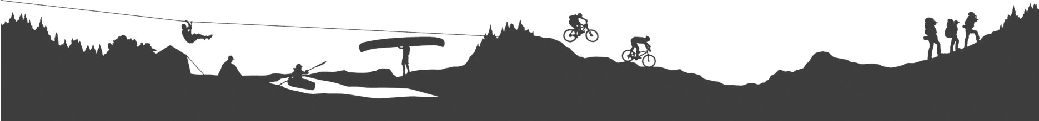
The Tidewater Council, Boy Scouts of America would like to invite you to the Currituck County Rural Center for the
ACCT # 1-6801-164-20 SW = 7108
Rev: 7/31/22
2026 Cuboree.

October 23- 25, 2026

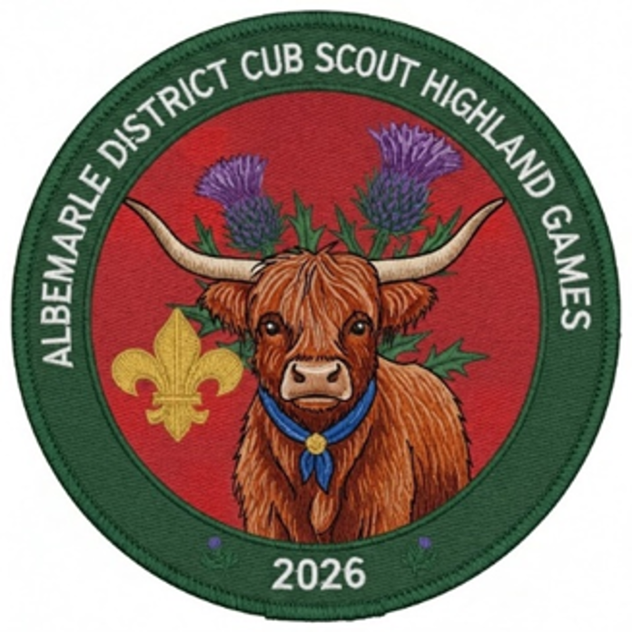

Cuboree Camping Weekends are an opportunity to enjoy some time in the great outdoors and get away from the busy buzz of the city for the weekend.
There will be a variety of activities to include things for fishermen, marksmen (aspiring marksmen), water lovers, athletic people, cooks, and more. The program schedule is jam packed with activities; however, if a Scout tires out or a program doesn’t interest you feel free to do your own thing. However please try not to arrive late to sessions as safety briefings must start on time.
Participants are invited to camp from Friday through Sunday, or any portion in between. Families are welcome to arrive on Friday to escape the city and set-up camp and relax (this makes Saturday easier). Likewise, after a day of craziness on Saturday you are welcome to take it easy Saturday night and make your way home on Sunday.
Register by submitting one copy of this form per Family.
Camping is available beginning at 5 pm on Friday through Sunday at noon.

Family Specific Details
Camping: | - Yes | - No
Arriving: | - Friday | - Saturday
Trailer: | - Yes | - No
Special Accommodations:

Program Rates
Rate When paid in full by 10/20/22
$40/Family
Late Fee
Add $5 per Family paying AFTER 10/20/26

ScoutinG Information
Pack #:
District:
Council:

Contact Information
Name:
Position:
Address:
Email:
Phone:

Payment Information
How Many Family Members are you Bringing?
FAMILY Basic 1 x $50
# SCOUT(S)
# ADULTS(S)
# SIBLING(S)
Late Fees: |  |  | x10
 | T | OTAL | Pmt: | $

Register/PAY ONLINE
https://scoutingevent.com/596-AlbemarleCuboree2026#
Please see the leader guide for additional information.

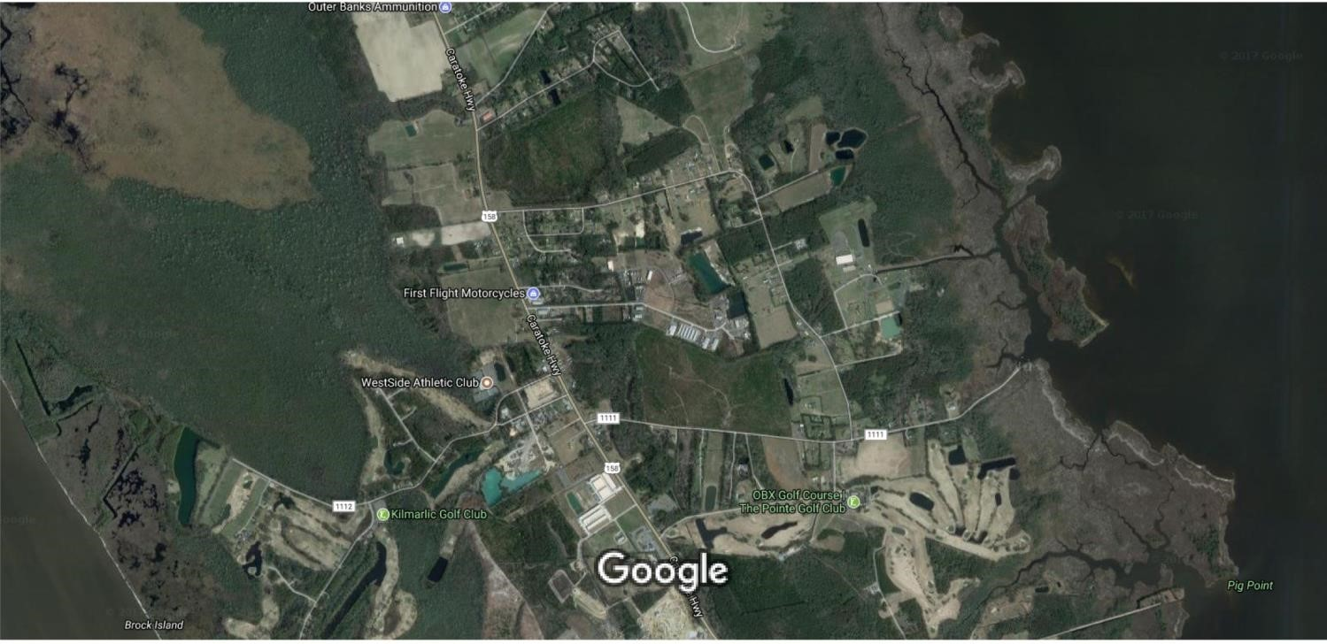
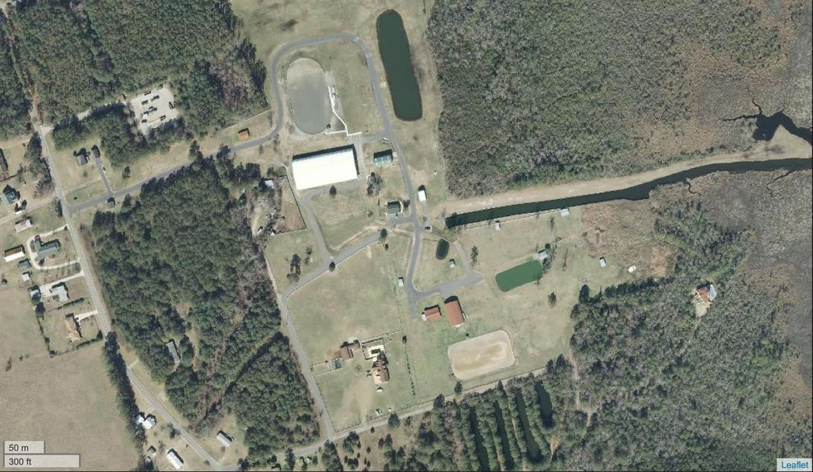
Currituck County Rural Center: 184 Milburn Sawyer Rd, Powells Point, NC 27966
From Va,
Elizabeth City, Hertford & Edenton
N. Spot Rd
S . Spot Rd
From the
Outer Banks

Page 12 of 12

