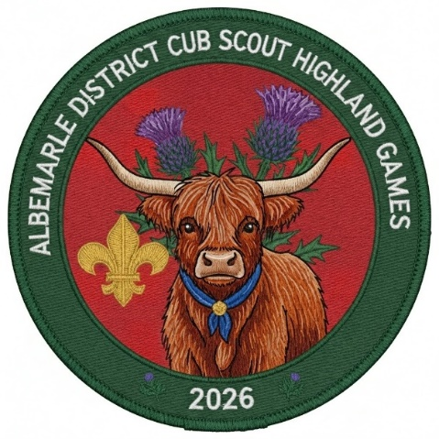
To all Lairds, Chieftains, and the Brave Wee Youth Clans (Cub Scout Packs) of the Mighty Albemarle District!
Let it be known across the valleys, swamps, and shorelines that George Monck, the 1st Duke of Albemarle—Lord Proprietor of the Carolinas and Commander-in-Chief of Scotland—has issued a grand challenge!
All able-bodied wee lads and lassies are hereby summoned to march upon the Currituck Rural Center (located at 184 Milburn Sawyer Rd, Powells Point, in our fair Province of Carolina) for a legendary weekend of camaraderie, courage, and Highland high-jinks!
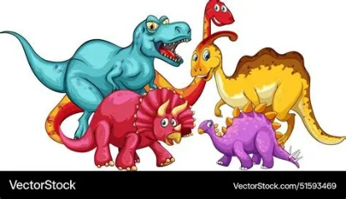
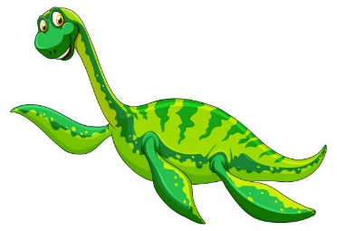
Gather your kith and kin from the 23rd through the 25th days of October, in the Year of our Lord 2026, for the ultimate test of athletic prowess and skill at the Albemarle District Cub Scout Highland Games! Step through the portal to the time of the legendary Nessie and her Dinosaurs kin. Portal will only be there for a short time for scouts to see.

Our clan champions shall compete in time-honored feats of strength and cunning, including (but not limited to) Archery, The Wee Caber Toss, Welly / Hammer Tossing, Haggis Hurl, Tug O’ War and Guising (trick or treating). Bonus Attraction: A rare, face-to-face encounter with a majestic Coo (Cow)!
Every Clan is strongly encouraged to adopt their own official family tartan and fly their colors proudly over the encampment. Furthermore, tastefully worn kilts are highly encouraged for both the wee ones and their grown-up chieftains!
Heed this call, pack your tents, and prepare for glory! Will your Clan rule the Highlands?
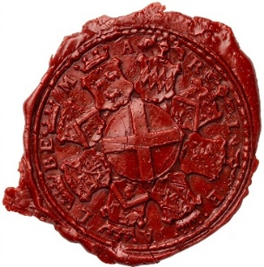
Given under my hand and seal by Order of the Duke of Albemarle,

URL to event: https://scoutingevent.com/596-AlbemarleCuboree2026
Contact: Nicole Bowling for more information
docsbear@gmail.com

