Scout Night with the Edenton Steamers
Parent Guide / Rules / Information
Arrive at Hicks Field Front Gate Parking lot at 111 E. Freemason St., Edenton, NC 27932 30 minutes before start time in uniform to have the chance to stand on the field for the National Anthem.
Please See Parking Diagram Below:
Due to the construction of the new Edenton JA Holmes High School, please be patient and note the new parking locations for fans. Parking nearest to the entrance is reserved and handicap parking only.
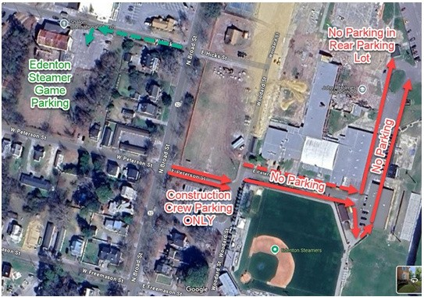
Fans can be dropped off at E. Freemason Street near the Grandstand area.
Upon Arrival:
Please check in with your district executive, Mary Perrine, to receive your pre-paid entry ticket. You should be able to find her at the entry gate with a clipboard for sign-in. No outside food or beverage permitted in the stadium.
Admission:
$6.50 ticket admission includes only entry to the game. No food or beverage included; concessions may be purchased separately at the game. Tickets can be purchased on Black Pug at scoutingevent.com/596-Steamers26.
A Scout is Clean:
Leave Historic Hicks Field better than you find it! Please be sure to clean up after yourself and your family to ensure that Tidewater Council continues to be able to partner with the Edenton Steamers to hold this event.

