***

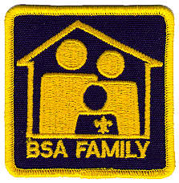

**2025 Cub Scout November Family**

**Camping Weekend**

November 7th – November 9th , 2025

**GUIDE BOOK**

(Last Updated 8/2/25)

Scouting America, Tidewater Council

1032 Heatherwood Drive

Virginia Beach, VA 23455

[www.TidewaterBSA.com](http://www.TidewaterBSA.com)

Pipsico Scout Reservation

57 Pipsico Road

Spring Grove, VA 23881

[www.PipsicoBSA.com](http://www.PipsicoBSA.com)

Table of Contents

Family Camp Information 3

Introduction 4

General Events/Activities 4

Field Events 4

Hay Rides/Camp Tour/Story Telling 4

Pumpkin Bake Off 4

Tentative Program Schedule 5

General Event Information: 6

Medical Matters- 7

Emergency Procedures 7

Youth Protection Policies 7

General Policies- 8

Appendix A: Evaluation Form 10

Appendix B: How to Get to Camp 11

# Family Camp Information

**When** November 7th – 9th , 2025 (Friday – Sunday)

Be Prepared. There is no rain/snow date for events. All units should prepare for foul weather.

**What** An immersive crime solving camping experience for scouts and their families. A weekend of fun, fellowship, and adventure awaits at Pipsico Scout reservation

**Where** Pipsico Scout Reservation

[](https://scoutingevent.com/596-FallFestival24)57 Pipsico Road  
Spring Grove, VA 23881

**Contact**

Wes Sherman   
Staff Advisor   
Email: [william.sherman@scouting.org](mailto:william.sherman@scouting.org)

Staci Van Kirk & Cory Van Kirk  
Event Co-Chairs  
Email: staci.vankirk@scouting.org

**Register Online registration will open 9/8/25-** Limited to first 250 Youth

Register/ Pay online by [clicking here](https://scoutingevent.com/596-FallFestival25). *If you have trouble registering, view these 3 min. videos:* [Part 1](https://youtu.be/6WedI9ASv-Q) - [Part 2](https://youtu.be/cWKUAG3H8cE).. You CAN register online AND pay online using funds from your unit’s Council Store account. Transactions and reservations are not complete until check-out is done with payment posted. Prior to arriving at the event, please finish the registration process by entering the names of all participants, both youth and adult, attending the event (this allows for fast check-in on Friday).

**Cost** **$25** per Scout, **$14** per adult when paid in full by October 27, 2025

**$35** per Scout, **$24** per adult when paying on or after October 27, 2025

NO REGISTRATIONS WILL BE ACCEPTED AFTER NOVEMBER 3, 2025

THERE WILL BE NO ON-SITE REGISTRATION.

**Reductions & Refunds**

If for any reason this event is canceled due to government regulations 100% of fees paid will be refunded. Other refund requests must be made on Council’s Refund Application prior to the event and are subject to a 15% surcharge processing fee. Funds will be returned to the payee/unit via their store account or by check. Refunds will be granted only in the case of documented illness or family emergency. **NO refunds** can be given if notified **within 14 days of the event** as pre-paid expenses will already have been incurred. No refunds for partial attendance will be granted.

Registrants must pay for slots upon registration. Reductions in registrations can **ONLY** be made up to **14 days before the event**, unless the event sells out. Should the event sell out, the unit will be financially responsible for the full reservation. This is to limit over-booking on popular events. *Requesting a reduction* can **ONLY** be completed by submitting a Council Refund Application to the event contacts and is subject to a 15% processing fee.

# Introduction

This Cub Scout Fall Family Camp Weekend is an opportunity to get away from fast pace of our cities and towns for the weekend and enjoy some time in the great outdoors at Pipsico Scout Reservation.

There will be a variety of activities to include things for nature enthusiasts, marksmen (aspiring marksmen), crafty folks, game fans, and more. Participants will be organized into groups and rotate between different stations. The program schedule is jam packed with activities; however, if a Scout tires out or a program doesn’t interest you, feel free to do your own thing. Please try not to arrive late to sessions as safety briefings must start on time.

Participants are invited to camp from Friday through Sunday, or any portion in between. Families are welcome to arrive on Friday to escape the city and set-up camp and relax (this makes Saturday easier). Likewise, after a day of craziness on Saturday you are welcome to take it easy Saturday night and make your way home on Sunday.

No food will be provided this weekend. This allows families to make the foods their scouts enjoy. Please be prepared to clean up what you bring. Water is available in all sites, and dumpsters are located at the entrance to camp for any waste. Please check the program schedule when planning your meals to ensure you have enough time to prepare, eat, and tidy up.

# General Events/Activities

General events include numerous activities for you, your unit, and your family to participate in! Scouts, Scouters, families, and siblings are all invited to participate in these activities and are staffed by event volunteers.

## http://www.midwestoutdoors.com/images/archeryTarget.jpgField Events

Numerous field day events including BB’s, Archery, and Sling Shots will be part of your stations during the day on Saturday. The Climbing Tower and Bouldering Wall will be open for youth in Kindergarten and higher. Siblings not yet registered in Kindergarten will not be allowed on the Climbing Tower or Bouldering Wall.

## Games and Crafts

The Order of the Arrow youth will be on hand to run a fun spy game and detective crafts. There will also be a camp wide scavenger hunt that everyone can participate in.

## Dessert Bake Off

Cakes, pies, cobblers, and cookies galore! Our Bake Off is open to all units. There will be 2 categories: Unit/Family Baked and AOL Den Baked; create your entry on a camp fire or camp stove and bring your entry to the OA shelter in Base Camp by 6:30 PM. At least one person is to stay with your entry for the judging, or write your name and unit number legibly on the bottom (underside) of the plate or bowl of your entry. Please allow enough for 8 servings and bring something to serve on and eat with. (We encourage multiple entries) The 2 winners will be announced at the evening Campfire Program and be awarded a prize!

# Tentative Program Schedule

|  |  |  |
| --- | --- | --- |
| Friday |  |  |
|  | 5:00 PM-9:00 PM | Check-in (for Friday night campers)*  (*yellow gates are closed after 8:30 PM to block vehicle access for youth safety after dark) |
|  | 10:00 PM | Lights out (Uber Quiet Until 7 AM) |
| Saturday |  |  |
|  | 7:00 - 8:30 AM | Breakfast Time (In Campsites) |
|  | 8:00 AM  8:30 AM | Leader’s Meeting- OA Shelter (Shelter in Main Field) *  (*yellow gates are closed to block vehicle access for youth safety)  Morning Flag Ceremony |
|  | 9:00 - 10:30 AM | Session #1 |
|  | 10:45 - 12:15 PM | Session #2 |
|  | 12:15 - 2:00 PM | Lunch Time/ Siesta (In Campsites) |
|  | 2:00 - 3:30 PM | Session #3 |
|  | 3:45 - 5:15 PM | Session #4 |
|  | 5:15 - 7:15 PM | Dinner Time (In Campsites) |
|  | 6:30 PM | Dessert Competition Entries to Base Camp OA Shelter |
|  | 7:30 – 8:30 PM | Campfire Program (Dining Hall Amphitheater) |
|  | 10:00 PM | **Lights Out (Uber Quiet, No Noise, It’s Sleepy Time)** |
| Sunday |  |  |
|  | 8:00 - 10:00AM | Check-out (Clean up your areas, check out at Burton for inspection and have a safe trip home!) |
|  |  |  |
|  |  |  |

**\* For the safety of the people walking on the roads, vehicles are strictly prohibited from driving in camp during Program 8:30 AM – 5:30 PM. If you are leaving Saturday you must wait until after 5:30 if you must drive to your site to load gear. Pull carts are available in the parking lot for use anytime.**

# General Event Information:

## Check-In

If you choose to camp Friday evening, check-in will be conducted from **5:00 PM till 9:00 PM** on Friday evening adjacent to the Burton Center (Located within Camp Lions, a sub camp of Pipsico Scout Reservation). Please look for the registration table located adjacent to the parking area. **Do not arrive early**, there will be no one to check you in, you may **NOT** enter the campsites prior to check-in.

For the safety of Scouts walking through camp, vehicles pulling unit trailers are allowed beyond the yellow gates inside Base Camp. The trailer must be unhooked and parked in the designated area adjacent to your campsite. No unit trailers are to be parked past the wooden post located inside the campsites. Tow vehicles are to be **immediately** moved to the front parking lot. All other vehicles are to stay in the parking lots and any addition gear or Scouts will have to hike in or can utilize one of the FEW available carts, located at the Burton Center. Your cooperation is greatly appreciated.

## Check Out

Contingents may check-out after the conclusion of program on Saturday evening or stay until Sunday morning. **For camper safety, during program sessions absolutely no vehicles will be allowed into camp for packing up campsites.** Please come to the Burton Center (camp office) to check out and have your camping area checked for cleanliness. Please ensure that your camping area is left better than what you found it (Leave No Trace) and that your latrines have been swept clean and toilet lids are down. If your group plans to leave on Sunday, you MUST be checked out by 10:30 AM. Patches will be given out upon checkout.

## Meals

All meals will be provided and prepared by the individual participants/ Family/ Units. **NO MEALS ARE PROVIDED FOR THIS EVENT.** Units will need to provide and prepare meals in their respective campsites.

## Adult Leadership

Scouting America volunteers will staff these events. Scouting America is a volunteer run program. Every event is chaired and run by volunteers. Any help adult leadership from your unit can provide is appreciated.. Staff positions are available for direct program support as well as logistical support. Please contact the event chair in advance ([staci.vankirk@scouting.org](mailto:staci.vankirk@scouting.org)) of the names and contact information for those volunteers in your unit who may help contribute to the event’s success.

## Camp Rules

The Scout Oath and the Law

The Guide to Safe Scouting

Outdoor Ethics

NO fireworks, pets, and firearms

Scouts are not permitted to roam through campsites during scheduled activities.

Scouts are not permitted to leave the boundaries of the campground.

## Campsites/Camping

Campers need to provide their own tents and beddings. All Pipsico tents and cots will be in storage. Sites will be assigned based on registration date and family size.

## Trading Post

The Pipsico Trading Post will be OPEN throughout the weekend for your convenience. In addition to program materials, our Trading Post offers a variety of snacks and drinks, and a wide selection of camping supplies, Scouting materials, and special Pipsico Scout Reservation souvenirs. Remember that the proceeds from the Trading Post support your Scouting programs! Feel free to bring some extra spending money for your retail therapy.

## Water and Bath Facilities

Drinking water is available within every campsite and most program areas. Hot showers (Both male and female) are available at the pool shower facilities and at the Westside Showerhouse by Site 9. Primary bathroom facilities are latrines inside of each campsite and “enclosed” toilet facilities are available (both male and female) at the pool, at the Westside Showerhouse, the front of the Reservation in the Gregson Center, and at the Burton Center in Base Camp (Camp Lions).

# Medical Matters-

## Medicals

According to Scouting America Policy, all Scouts and leaders should complete an Annual Heath and Medical Record form (parts A&B only) for all Scouting activities. This is just the health history form (excluding the physician’s portion). **IT IS THE RESPONSIBILITY OF THE UNIT** to obtain and maintain copies of these forms for members of their unit at this event. Medical forms will NOT be turned in at check-in, however, unit leaders are required to inform the camp health officer or designee **at check-in** of campers with limitations, special needs or life-threatening circumstances. The official BSA form is located here: [http://www.Scouting.org/filestore/HealthSafety/pdf/680-001_AB.pdf](http://www.scouting.org/filestore/HealthSafety/pdf/680-001_AB.pdf)..

## Medical Treatment

All units should bring a unit first aid kit and treat injuries within their capabilities. Units must report all injuries and other medical situations to the camp staff at the Health Lodge, even those they treat themselves. Qualified medical personnel will be on duty at the Health Lodge. If necessary, the camp staff will contact emergency medical services and ambulance services using 911. Unit leaders are expected to control all medications within their units.

## Prescription Medications

All prescription drugs are kept and administered by the unit. It is to be kept in a secured location out of the reach of the children. If medication requires refrigeration, it can be checked in with the Health Officer at check-in. Provide a list of medication, dosage (Medical part B) and to whom you are administering medication to when you check in with the Health Officer. By law, medications must be in a container with a typed label from the pharmacy. Medications shall be given only in accordance with the label. Handwritten changes will not be accepted.

# Emergency Procedures

Pipsico Scout Reservation maintains emergency procedures to meet, and in some cases, exceed the standards set by Scouting America. It is essential for everyone’s safety that every member of your unit fully understands that these procedures exist - their life, your life, or someone else’s life could depend on it. Please be sure to follow only instructions delivered by the staff chain of command. Likewise, if an emergency arises, or is brought to your attention, please notify the nearest staff member immediately so that we may launch the appropriate procedures. Do not attempt to resolve an emergency situation alone. Notify the nearest staff member. **In the event that an emergency arises, an alarm will sound** from the program administration building (Burton Center). When this alarm is heard, **all units and participants are required to assemble at Awesome Field** in front of the flag poles and await further instruction.

# Safeguarding Youth Policies

Leaders are asked to review the Guide to Safe Scouting before attending camp and ensure compliance by their unit with policies as detailed in the Guide, particularly in respect of youth protection policies. Failure to comply with Guide to Safe Scouting and youth protection policies will result in disciplinary action. Key portions of the youth protection policies found in the Guide to Safe Scouting are reproduced below. Other Guide to Safe Scouting policies are also contained elsewhere in this guide.

Adult leaders must respect the privacy of youth members and protect their own privacy at all times. Except in emergencies, adults and youth may not enter each other’s designated sleeping and shower areas. Two registered adult leaders 21 years of age or over are required to attend this event. At least one (1) female adult over the age of 21 is required whenever female youth are present. No Scout may share a tent with an adult who is not his/ her own parent or guardian. Separate tenting arrangements must be provided for male and female youth. Youth sharing tents must be no more than two years apart in age.

# General Policies-

## Alcoholic Beverages & Drugs

Alcohol and illegal drugs are prohibited. All prescription drugs are kept and administered by an adult within the unit. (See the Prescription Medications section above.)

## Cell Phone Policy

We would request that Scouts not to take cell phones to program sessions or, at the very least, to turn them off during sessions. Use of cell phones during program sessions is inconsiderate to other participants and, in some cases can be extremely dangerous (Scouts participating in shooting sport activities, should not be distracted by a ringing phone). Use of cell phones inside the pool shower facilities is prohibited.

## Fires, Cooking, and Open Flames

Fires will be authorized depending on the status of State and County fire prohibitions in effect for the weekend of the event. The staff will update units on the current fire policy at check-in. All fires are permitted ONLY in the designated fire rings at each camp site or in unit provided above-the-ground fire barrels. Lanterns can be used in the campsites if elevated off of the ground. All units should plan to cook using propane stoves or fully contained charcoal grills elevated off of the ground or in established fire-rings. Dutch oven or charcoal cooking will be allowed if the charcoal is raised off the ground or contained in an established fire-ring or fire barrel. Do not dig into the ground to form fire pits. Units must post water buckets or a fire extinguisher in the fire area. Cutting of live trees, shrubs, or vegetation is prohibited. Wood is available in the Ax Yard. **We prohibit brining wood from off property.**

For safety reasons, there are to be **no open flames in tents**. This ban on open flames in tents includes a ban on the use of matches, candles, kerosene, propane or liquid lanterns in tents. Lighting in tents is to be provided by battery-powered lanterns or flashlights only. It is, however, acceptable to use a lantern under a dining fly. All cooking fires, campfires and stoves are to be attended while they are burning. Fires are only to be built in designated areas and must be extinguished so that they are cold to the touch when unattended.

Initiations, Hazing & Military Training

Corporal punishment, hazing, initiation of any sort, and military training and drill are not permitted in the BSA.

## Liquid Fuels

Adult leaders only may use stoves and lanterns requiring liquid fuel. Extra fuel must be turned over to the Quartermaster for safekeeping in locked storage.

## Money & Valuables

Each family must decide how much spending money a Scout should take to camp. Each Scout is, however, responsible for the safeguarding of his money and personal property. It is recommended that expensive cameras, watches, and personal entertainment devices be left at home. Regardless, all items should be clearly marked, with the boy’s name and unit number.

## Pets

No pets are allowed in camp. Please ensure that anyone planning to visit you or your unit during the weekend is also aware of this rule.

## Restricted Areas

The following areas are off limits to all campers: The ranger’s home and maintenance areas, camp staff living areas, the kitchen and food storage areas (except for authorized adult volunteers,) any program area where staff is not present, and the cliffs along the James River. Scouts may visit the waterfront for beach combing or fishing only when staff is present or when accompanied by an adult leader.

## Smoking & Vaping

Anyone under 21 years old is prohibited from using tobacco in any form while at camp. Adults who smoke must do so out of sight of any youth members. Smoking is prohibited in any tent or building. Cigarette butts must be field stripped and placed in a trash receptacle.

## Taps/Lights Out

A Scout is courteous. All scouts should be in their designated campsites at 9:30 PM to Wind-down the day’s activities. Taps is at 10 PM. Unit leaders must ensure that fires and lanterns are out and that all their youth have retreated to their tents and are quiet.

## Telephones

If adult leaders need to receive regular calls at camp, bring a cell phone, or make arrangements to check with their office on a regular schedule. During an emergency, you can contact the Event Chairman (contact information above.)

## Trailers

If your unit plans on bringing a trailer, please provide this information on the registration form. Specific campsites have been designated for unit use when a unit has a trailer. The requesting unit is permitted to have one trailer in the designated area at the perimeter of their campsite until checkout. **Trailers are NOT to be parked past the wooden posts located around the perimeter of each campsite.**

## Trash Disposal

Participants should practice Leave No Trace principles to the maximum extent practicable. If you packed it in - you pack it out! All units are expected to police their camping area and remove all trash to the dumpsters located behind the dining hall or at the front of camp near the barn. Trash that will not fit in the dumpsters becomes the responsibility of the unit to remove from the campground. Do not pile trash next to the dumpsters. If the dumpsters are full at time of checkout then units MUST pack out their trash and dispose of it properly.

## Vehicles in Camp

Since safety is our number one priority, vehicles are not permitted past the Burton Center parking lot unless authorized by the event staff for unit gear drop off. Any vehicle that is authorized to drive beyond the Burton Center must remain on the main road. Absolutely no vehicles are permitted on grass or in campsites. Likewise, no vehicles authorized in camp may block the loading dock at the rear of the Dining Hall. Vehicle owners, and operators, who drive beyond the Burton Center parking lot do so at their own risk. Tidewater Council will not accept responsibility for any vehicle damage within camp.

No other motorized vehicles (golf carts, etc.) will be allowed in camp at any time except for use by designated camp staff. If the need arises for a vehicle to be in camp, approval **MUST** first be obtained from the Event Chair and/ or the Camp Ranger (Evan Sommerfeld). Special arrangements will be available for special needs visitors, Scouts and Scouters as requested.

## Weapons, Knives, Full Axes, Fireworks, & Firearms

Pipsico provides all necessary and appropriate equipment for our shooting programs. Personal firearms, ammunition, bows and arrows are not permitted in camp. Also, no water guns are permitted at camp.

Pocketknives may be carried by adult leaders and any Scout who has earned the Totin’ Chip or appropriate knife safety adventure for their den level. Fireworks & firearms of any kind are prohibited in camp. Law Enforcement Officers (LEO’s), please notify the council prior to camp of any special requirements by your department.

Appendix A: Evaluation Form

Please rate the following on a scale of 1-5 (5 being the best)

Location (site & facilities): 1 2 3 4 5

Guide Book (overall): 1 2 3 4 5

Did it help prepare you for this weekend? 1 2 3 4 5

Was it available in time? 1 2 3 4 5

(1: Way too Late, 5: Right when I needed it.)

Was any information missing? Please elaborate: ___________________________________

Staff (overall): 1 2 3 4 5

Ease of registration: 1 2 3 4 5

Was the staff responsive? 1 2 3 4 5

Demonstrations/ Activities (overall): 1 2 3 4 5

What did we do well?

________________________________________________________________________________________________________________________________________________________________________________________________________________________

What could have been done better?

________________________________________________________________________________________________________________________________________________________________________________________________________________________

What would you like to see added? (Suggestion to better this event)

________________________________________________________________________________________________________________________________________________________________________________________________________________________

Would you like to help plan the next Cub Family Camp?

_____Yes, count me in. _____Don't know, call me when it's time. _____I might be able to help out in a limited capacity.

Name: ________________________________ Phone: ___________________

E-mail:________________________________ Unit: ___________________

Suggestions: (What did we do wrong? What did we get right? How can we improve for next year?) (Continue on reverse, if required.)

# Appendix B: How to Get to Camp

Pipsico is located at **57 Pipsico Road Spring Grove, Virginia, 23881**, midway between Norfolk and Richmond.

Pipsico is centrally located to a host of attractions including the first permanent English settlement at Jamestown, just a short distance away via the nearby ferry.

Many other fascinating historical sites from the first 250 years of American history are within easy driving distance (an hour or so). Among these are Colonial Williamsburg, numerous restored colonial plantations, the Revolutionary War battlefield at Yorktown, and Civil War battlefields around Richmond and Petersburg.

For those who want more modern adventure, local amusement parks include Busch Gardens and Water Country USA. A short drive from camp brings visitors to the naval base in Norfolk, the Atlantic Ocean beaches and boardwalk at Virginia Beach, and much more.

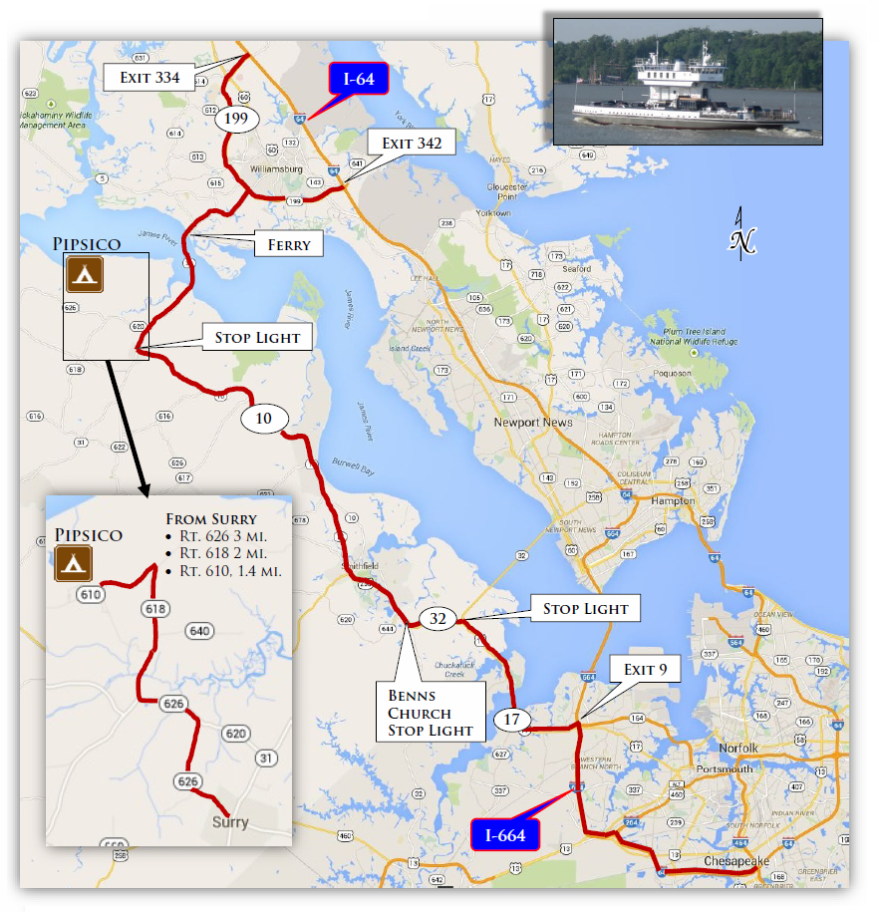

**Detailed Directions can be found online:** [**http://pipsicobsa.com/resource-bank/**](http://pipsicobsa.com/resource-bank/)